Radiotherapy and chemotherapy in gynecology
Objectives
It sounds strange as much as interesting that radiotherapy which is mostly used as adjuvant to surgery can be used alone in some gynecological cancers. Adenocarcinoma of the endometrium and squamous cell carcinoma may be treated alone by radiotherapy. Despite 5 year survival by surgical therapy is higher than radiotherapy yet radiotherapy is the only option is some woman like those beyond stage 2_{b.} On the other hand new and important advances were introduced in the treatment of ovarian cancer by chemotherapy. Ovarian tumors are the only gynecological in which chemotherapy play possible curative role. Those topics will be reviewed in this lecture in abbreviated manner so the undergraduate candidates have some insight to those subjects.
Nature of radiation
Madam Curie who was a Polish physicist has dedicated her life to the radioactive material that all what we achieve today goes back to her classical work. Madam Curie has discovered that metals as well as material with large atomic number emits 3 types of radiation and those are
- Alpha radiation a relatively large particle consists of helium gas atom 2 protons and 2 neutrons.
- Beta radiation which has much more penetrative ability and consists of electrons in high speed.
- Gamma radiation that we use in medicine is electromagnetic radiation with very high frequency and energy especially when the radioactive element is more purified and concentrated. In fact her death by leukemia was caused by ultra exposure to this radiation.
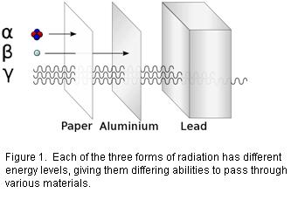

Electromagnetic radiation
Electromagnetic radiation is defined as the change in electrical field which is accompanied by change in magnetic field and both has the same value and phase. In addition they are perpendicular to each.
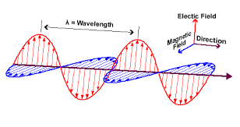
Origin of electromagnetic radiation
Virtually all sources of EMR is the electrons orbiting the nucleus. When a material is subject to a source of energy electrons jumps to a higher orbit. The power from the source induces jumping of electrons to higher orbit. When it descends to the original orbit it emits electromagnetic radiation in a defined quantum per each electron. The amount of EMR from one electron is called photon and the energy it carries is directly dependent to the frequency according to the formula shown bellow
E=Kf
Where K is Planck constant= 6.6 * 10⁻³⁴
F=frequency of the EMR
It should be stressed that gamma radiation is the only part used to treat malignant diseases. Though alpha and beta radiation has destructive effect on malignant cells yet they affect normal cells also. They cause a wide spread damage to the nearby organs which may end in fistula, ulceration as well as burning of the vaginal skin in local radiotherapy. And that is why they are given in multiple divided doses in accordance with the size of the tumor and rate of reduction in dimension per one dose.

Gamma radiation relative to others
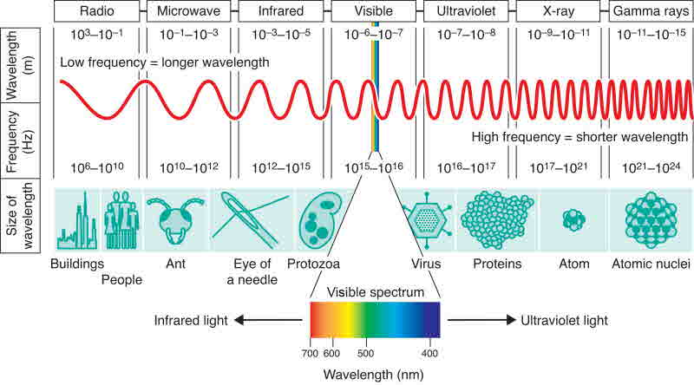

As it is shown from the above picture gamma radiation has the highest energy among others and that is why they are used in the treatment of malignancy. Their energy as assessed by the frequency can be controlled accurately by controlling the frequency from the device it produces in external radiotherapy. Such devices are called linear accelerators and the energy needed accurately can be calculated for each individual according to the thickness of abdominal wall and fatty tissue underneath. While in internal radiotherapy the amount of radioactive as well as the time of session is used. External radiotherapy is called tachytherapy while internal radiotherapy by radioactive materials is called brachytherapy.
Radiotherapy in carcinoma of the uterine body and cervix
Linear accelerators or tachtherapy
Linear accelerator is the device which is used to produce gamma radiation in tachytherapy. Simply an electron beam is accelerated by passing through a cylinder which is 5-10 million volts positively charged and from special high voltage unit. Then the accelerated electrons hit a rotating ring of negatively charged volts so electrons are converted into energy in the form of gamma radiation. In modern linear accelerator a lot of flexible arms are directed to the tumor center after being feed with many slices of tomography so the maximum energy is delivered to the tumor and ensuring avoid the normal tissue. The amount needed per one tumor is also calculated by the device so the entry point as well as the amount needed per one session is accurately calculated. The computer built in the device performs all the calculations. Usually multiple ports are used to avoid skin burning and the at least 2 points are chosen
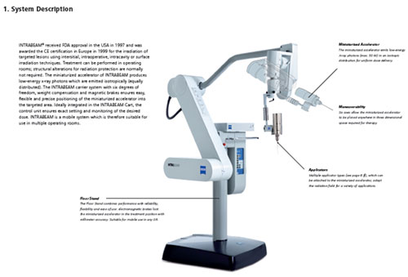
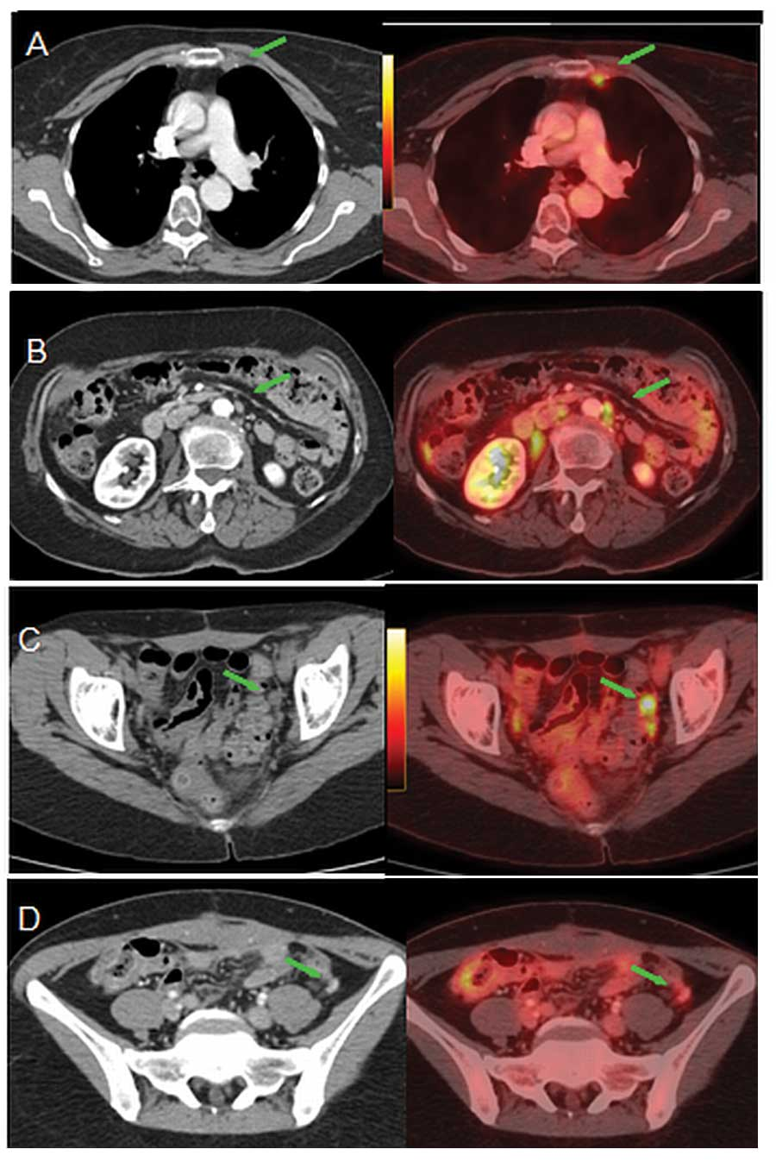

Unit of measurements
The Centi Gray has been chosen as alternative to the old RAD and is defined as the amount of radiation (energy) absorbed by the tumor. The amount of radiation reaching the tumor depends on the thickness of abdominal wall as well as if any other organ in front of the beam; accurate calculates of the dose needed to treat the mass of tumor is accurately calculated by Cy units to ensure maximum uptake. Generally the average total amount is about 1000 Cy for cervical carcinoma while for uterine body is 1500 Cy.
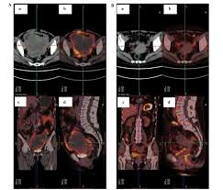

Method of delivering brachy therapy
Internal radiation is either given at the same time with external or shortly after some external radiotherapy courses until the tumor shrink enough to ensure maximum exposure to the radiation with minimum exposure of normal tissue to alpha and beta radiations. In uterine body carcinoma a tandem attached to large ovoid is inserted to the uterine cavity while the ovoid fix it by resting in the posterior vaginal wall. This structure is usually empty at the time of insertion to reduce the risk to the operating staff. After checking its position by x-ray films radioactive sources are inserted into the tandem. The amount inserted and the total duration is calculated to avoid overdose and the associated tumor size. At the end of the session the radioactive material is removed followed by the tandem. This ensures minimum exposure of the staff to the radiation hazard. Radioactive needles may be used also which are inserted directly into the tumor in cervical carcinoma.
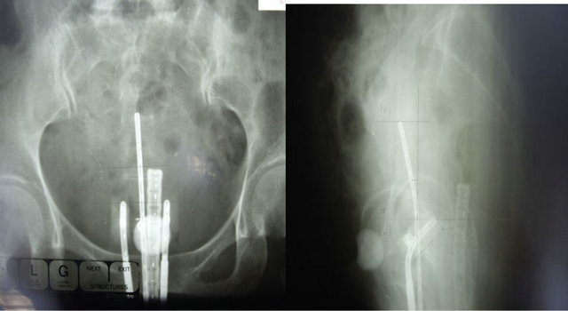

Radioactive materials used in cervical and endometrial carcinoma
Technetium is the most commonly isotope used in endometrial carcinoma while radium is the isotope ms commonly used in cervical carcinoma. Those materials have fairly stable half life and bind easily to sulfate, phosphate and other radicals. They are relatively safe with food shields to operating staff and generally they are easily dose controlled isotopes. It should be stressed that radiation with concomitant chemotherapy mostly in the form of cisplatin, carboplatin and palitaxel may be used to enhance the tumor regression
Five years survival in radiotherapy versus surgery
While the 5 years survival may reach 95% in surgery there is increasing and growing evidence that the 5 years survival in modern radiotherapy is increasing. The overall 5 years survival is 75% for both cervical and uterine carcinoma. Radiotherapy is chosen as the first line in treatment when the patient is old, have ischemic heart and brain and extreme obesity any conditions that make surgery hazardous to the patient. Otherwise surgery in stage I is best in both cancers than radiotherapy.
Side effects of radiation
The side effects of radiotherapy may be short or long terms yet those are the most encountered during a course of radiotherapy
- Skin burning and ulceration
- Hemorrhagic cystitis with severe hematuria
- Intractable radiation enteritis with vomiting and diarrhea
- Fistula whether urinary or rectal are not un common
- Bone marrow depression with anemia and leucopenia
- Remote complications include vaginal dryness and sthenosis
- Secondary vaginal atresia
- Premature menopause from exposure of the ovary to mal directed radiation.
Advances in chemotherapy of the ovary
Overview
The standard management of ovarian cancers especially the epithelial ovarian tumors has remained the same. Initially laparotomy is done with midline incision for both staging as well as for debulking surgery. After that 1 year is left for multiple courses of chemotherapy mainly by cisplaton, carboplatin and paclitaxel. After 1 year second look surgery is done to remove what has been left behind the first surgery. Unfortunately up to 40% of the patients, who shows well response to chemotherapy during 1 year before; still have active region which is beyond the safe removal converting the woman from real remission of the disease to a palliative category. The search for alternatives went into two directions.
Non adjuvant chemotherapy in which irrespective of the findings in the first laparotomy new regimes may be developed which are more aggressive followed by laparotomy to remove the residual. The researchers are still in the assessment despite many claims that such therapy gives results far exceed the adjuvant chemotherapy. The use of anti molecular specific chemotherapy which inhibits certain tumor associated growth factors have gained more popularity and the following 3 are the most commonly used
- Anti angiogenic agent; especially with advanced epithelial stage 3 and 4 ovarian tumor. This agent is secreted by all ocarian tumors and highly important to its initial growth and spread. Bevacizumab 15mg/ day has been shown to increase significantly the 5 years survival if used concomitantly with platinum chemotherapy. Patients with BRCA antigen positive tumors are the best responders to this agent.
- Epidermal growth factor inhibitors Erlotinib is the most potent among those agents. Epidermal growth factor is mostly secreted by epithelial tumors in advanced stage. Still the 5 years survival is grossly increased by the oral administration of erlotinib which inhibits tyrosine kinase.
- Insulin growth factor is one of the tumor specific factors essential for their growth and spread. AMG 479 is a monoclonal antibody which inhibits insulin growth factor. Commonly it is the first line after debulking surgery used.

