Examination of the nose
The nasal examination is essential part of diagnosis in nasal diseases after an accurate history has been taken.the essential symptoms are nasa obstruction ,facial pain, headache, rhinorrhea, post nasal drip, sneezing, abnormal sense of smell, snoring, epistaxis. A previous history of trauma or allergy also be important. On examination the relevant findings can be elicited nasal deviation, turbinates hypertrophy,nasal polyps, septal deviation. So history, examination, and other investigations all are important to reach diagnosis and give the patient appropriate treatment.
General steps before examination
As we mention in ear examination you should follow the general steps of greeting, introduce yourself, and put the patient in suitable and comfortable position, regardin position in nasal examination sit with your knees together and to the right side of the patient's legs, this more elegant than siiting with your legs astride thr patient's. the electric lamp at eye level over the patient's lest shoulder.
Inspection of the external nose
Examine the external nose for any congenital or acquired deformity,swelling, any scars or skin bruising, erythema, or ulceration,examine the shape and size of the nose in relation to the other parts of the face,any hump or saddle nose,the width and projection of the tip, the deviation of the nose columella and nares, turn the patient's head to the left and right to check the profile. Look for any surgical scars of of previous surgeries like scar of lateral rhinotomy. Lift the tip of the nose to examine the vestibule and caudal dislocation of the septum.
The patency of the nasal airway is assessed by occluding each nostril in turn with thumb and asking the patient to sniff.
The nasal cavity
The examination of the ant. Part of the nasal cavity called the anterior rhinoscopy and the post nasal space(nasopharynx) called posterior rhinoscopy. The anterior rinoscopy is carried out using a killian nasal speculum,or thudichum nasal speculum. Gently introduce this into the nose remembering that the nasal mucosa is very sensitive. Assess the mucosa its color, vascularity and crusting. Examine the septum fr its position in relation to the nasal airways, is it deviated to one side or is it dislocated off the maxillary crest. Note any lesions or septal perforation. Eaxamine the lateral nasal wall and evaluate the size and color of the turbinate. Examine the presence of any polyps, tumors and its relation to the septum, turbinates and airways. If better view is needed the nasal mucosa can be shrunk using alocal anaesthetic/vasoconstrictor
Rigid endoscope or flexible one can also be used for better inspection of the lateral nasal wall and the anatomy and any pathology of the middle meatus.
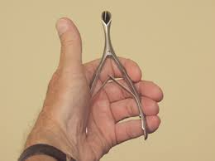
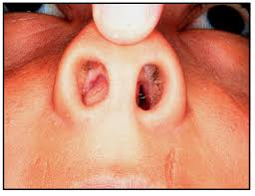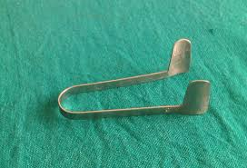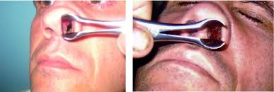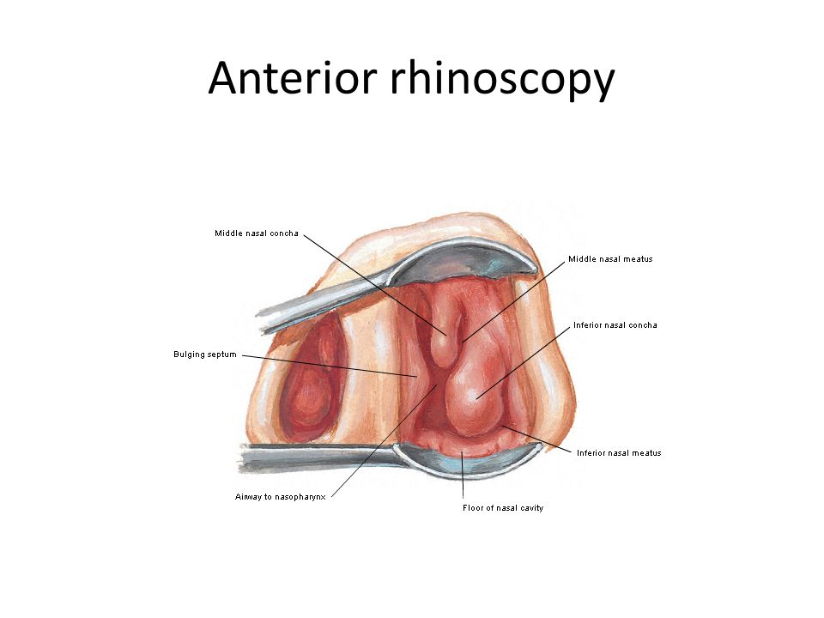

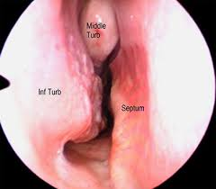
The posterior rhinoscopy either be done by using post nasal mirror or rigid or flexible endoscope. In case of using post nasal mirror explain the procedure to the patient warm the the mirror and pass it through the mouth while gently holding the tongue down with a tongue depressor. Inspect the posterior nasal septum, the post. Choanae through wich the post. Ends of the inferior turbinates may be visible. In the lateral wall the Eustachian tube cushion also examine if there is adenoids, tumors, choanal part os antrochoanal polyp.
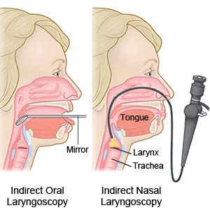
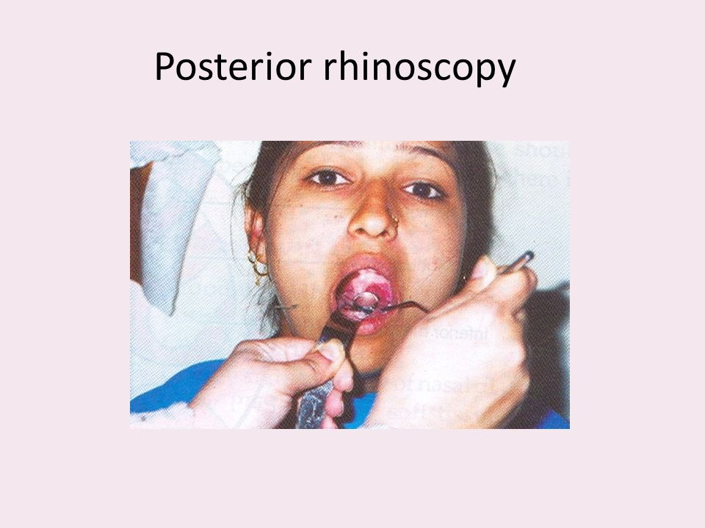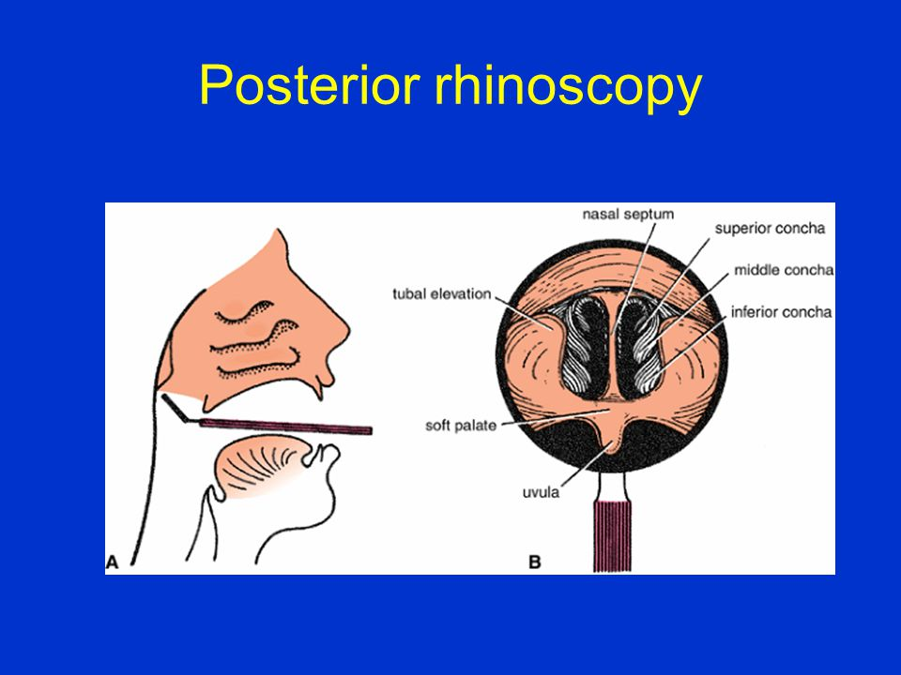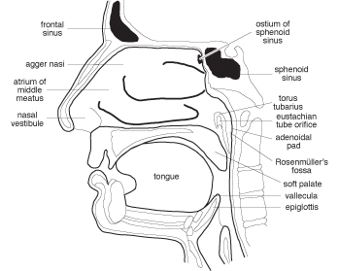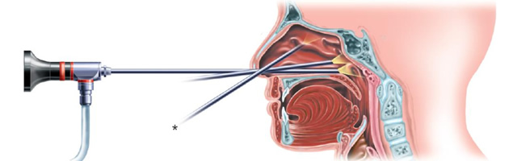
Oral examination
Inspect and percuss the upper teeth. The floor of the maxillary sinus lies over thealeveolar process of the maxilla and the roots of the 2nd premolar and 1st molar teeth.
Neck
Inspect and palpate the neck for the presence of lymphadenopathy.

