Examination of the throat
The symptoms associated with throat disease include hoarseness, dysphagia, sorethroat, lump in the throat, referred otalgia, cough, lump in the neck, an weight loss.
Examination of the throat include all parts of the pharynx (nasopharynx, oropharynx, hypopharynx), larynx in addition to oral cavity examination and the neck.
Common findings are patients with vocal crd paralysis, vocal cord nodules, vocal crd oedema, vocal cord nodules, laryngeal papillomas, occasionally neoplasm.
General steps
As mentioned previously in ear examination
Put the patient in suitable comfortable position opposite the surgeon with electric bulsl eye lamp positioned at eye level over the left shoulder a head mirror to reflect light from the lamp or an electric head light can be used, the surgeon should sit with knees together and legs to the right side of the patient.
The oral cavity and oropharynx
Inspect the lips for perioral lesions. Ask the patient if there is any tenderness in the mouth. Take 2 metal tongue depressors and insert them to retract the buccal mucosa on each side. Ask the patient to protrude the tongue and move it from side to side and then up to the palate and down. This should allow the inspection of the dorsal, ventral surface and the lateral border of the tongue, and the floor of the mouth,its also test the hypoglossal n. the 2 tongue depressors are then used so that the buccal mucosa,teeth and aleveolar ridges and the opening of the parotid gland(opposite the upper 2 molar) can be examined. Then depress the tongue. Check over the palate, tonsils, and the posterior pharyngeal wall. Ask the patient to says (aah) and check the movement of the palate.then remove the tongue depressor and put glove on, bimanually palpate the floor of the mouth overlying the submandibular ducts for calculi or masses. Palpate the base of the tongue for tumour.
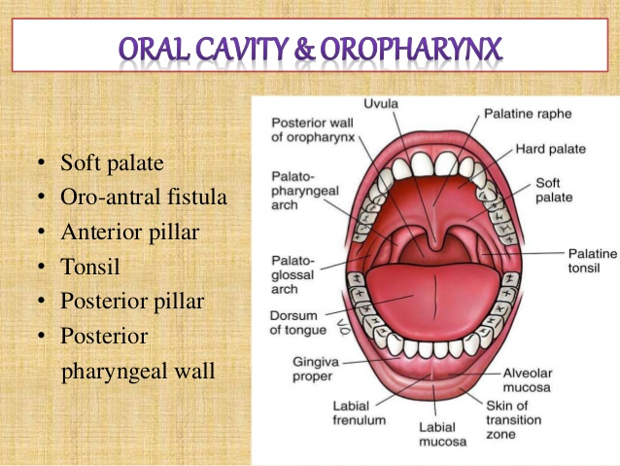
Post nasal space examination(nasopharynx)
Mentioned previously in nasal examination.
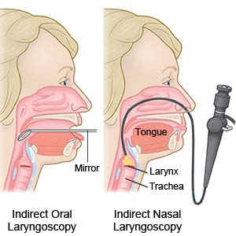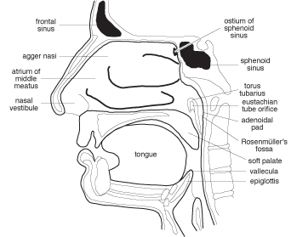
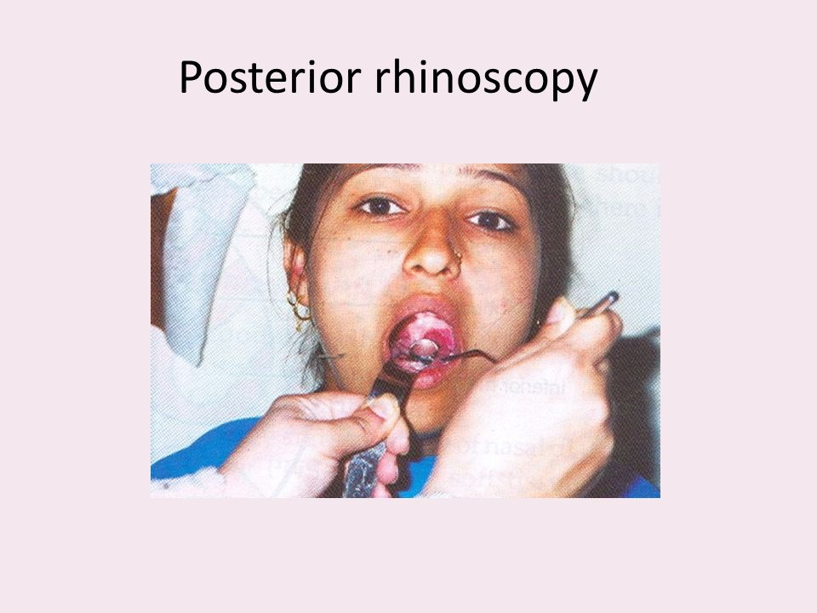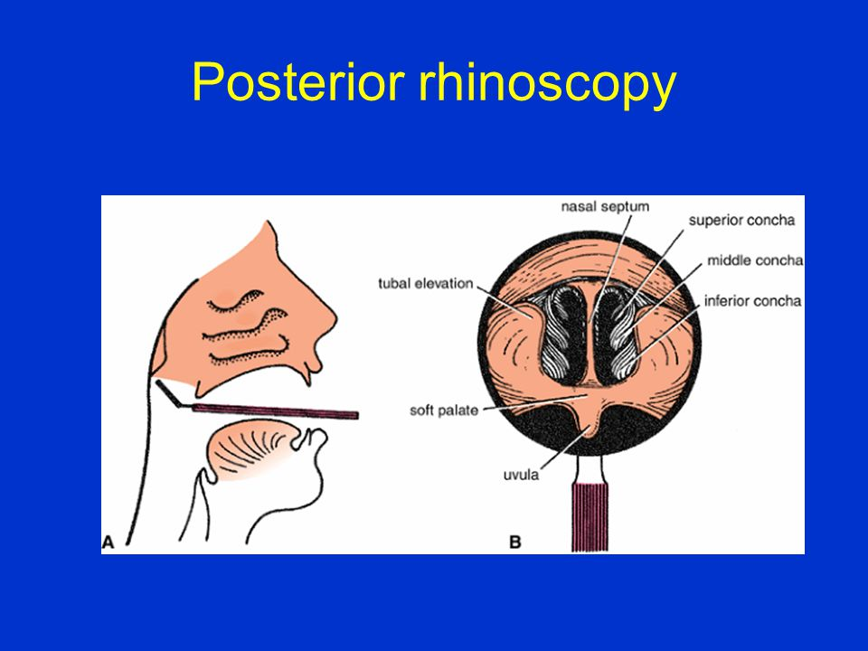
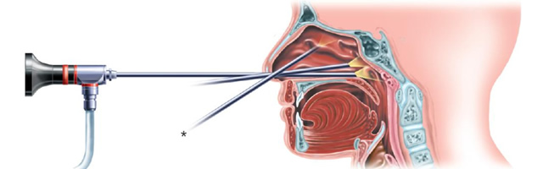
The hypopharynx and larynx examination
The examination called indirect laryngoscopy and we either ues laryngeal mirror or fiberoptic nasopharyngolaryngoscope.
The hypopharynx consist of 3 subsites pyriform fossa, postcricoid area and posterior pharyngeal wall. The larynx subdivided into 3 subsites supraglottic, glottic and subglottic.
Explain to the patient what you are do. Warm a laryngeal mirror and check its temperature on the back of your hand. Ask the patient to protrude the tongue and gently grasp it with swab held in the left hand. The patient then be requested to breath normally through the mouth as the mirror is introduced gently up to the soft palate. If the patient nose breathes and arches up the tongue , view it is possible to obtain some improvement by asking the patient to make a (hah) noise breathing in and out. Inspect the base of the tongue, the vallecula and the upper part of the epiglottis. Examine the posterior pharyngeal wall, and then both sides of epiglottis the arytenoids, the aryepiglottic folds and the vocal cords. Note any inflammation, ulceration, or exophytic lesion. The movements of the vocal cords are studied by askig the patient to say (ee) followed by a deep breath and (ee) again. Note any abnormal movements or fixation of the cords. In case the patient unable to cope with examination due to overacting gag reflex use local anaesthesia like lidocaine and spraying the oropharynx to anaesthetized the softpalate and uvula, tell the patient to avoid food and drink for the next hour because the gag reflex is impaired and to avoid burning the throat and aspiration. For more thorough examination we use fiberoptic to gain more assessment and in those patients that can not withstand examination with laryngeal mirror despite the use of local anaesthesia. Some patients still need to be assessed under a general anaesthesia.
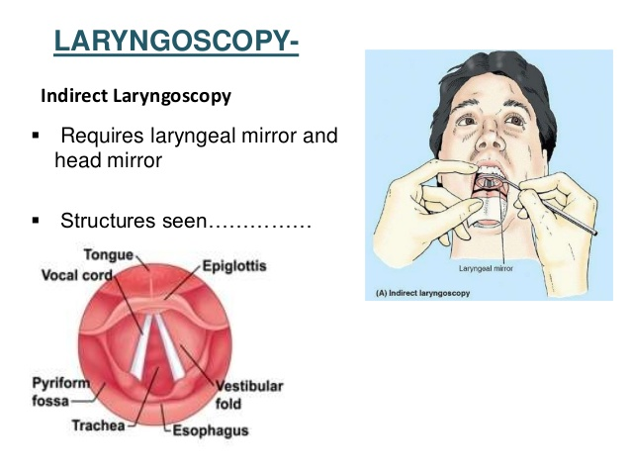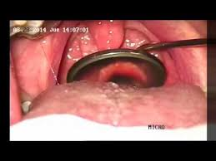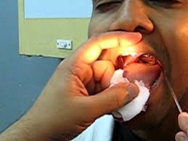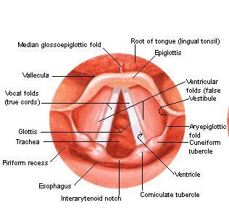
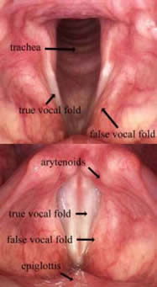
Examination of the neck
Check the neck for any obvious skin lesion or ulceration. Be careful not to overlook a fading wound. Check that the patient does not has a stoma. Ask the patient to swallow and watch the larynx move. A thyroid goiter may also be ssen moving with the larynx. An enlarged neck mass may be visible.
The neck should be palpated from behind and in an orderly sequence so that no areas are missed. Be gentle. Ask the patient if there is any tenderness. Start at the mastoid bone and palpate down the line of trapezius muscle and in the posterior triangle down the cavicle. Feel for suprasclavicular and infraclavicular nodes. Then palpate down the line deep to the anterior border of the sternocleidomastoid muscle for deep cervical lymphnodes. When your fingers reach suprasternal notch, palpate up the anterior triangle, feeling thetrachea, thyroid gland, laryngeal cartilages and hyoid bone. Loss of normal laryngeal crepitus(Trotters sign) may indicate a post cricoids neoplasm. Feel for submental lymph nodes, sub mandibular nodes,, the parotid gland, pre auricular nodes, and finally occipital nodes. If a lump is felt note it is site, size, shape, consistency, and fixation to adjacent tissues or skin. If you think a lump is cystic see if it transilluminates. In case of lump in the ant. Triangle see wether it moves on swallowing. In case of pulsatile lump or attached to the carotid, auscultate and listen for a bruit.
It is also important to assess the speech and the stridor.

