University of Mustansiriya Dr.Shatha AL-Khateeb
College of Medicine Lec. 3 (1-13)
Clinical Biochemistry Dept. 2017-2018

Vitamin D
Vitamin D is a group of fat-soluble secosteroids responsible for intestinal absorption of calcium and phosphate. Although vitamin D is commonly called a vitamin, it is not actually an essential dietary vitamin , as it can be synthesized in adequate amounts by most mammals exposed to sunlight. So, vitamin D is called the sun-shine vitamin.
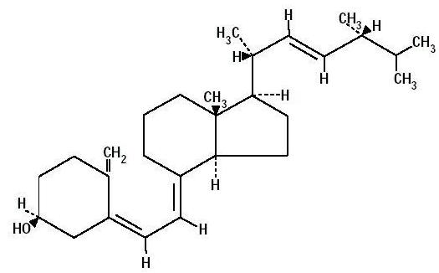
A substance is only classified as an essential vitamin when it cannot be synthesized in sufficient quantities by an organism, and must be obtained from its diet. Vitamin D plays an essential role as a hormone in the regulation of calcium and phosphorus metabolism.
Vitamin D for humans is obtained from sun exposure, food and supplements. It is biologically inert and has to undergo two hydroxylation reactions to become active in the body. The active form of vitamin D in the body is called Calcitriol (1,25-Dihydroxycholecalciferol).
Calcitriol promotes the absorption of calcium and phosphorus from food in the gut and reabsorption of calcium in the kidneys - this increases the flow of calcium in the bloodstream. This is essential for the normal mineralization of bone and preventing hypocalcemic tetany.

Calcitriol: is the physiological active form of vitamin D, it increases the blood calcium level.
Calcitonin: is the peptide hormone released from thyroid gland, it decreases the blood calcium.
Hypocalcemic tetany is a low calcium condition in which the patient has overactive neurological reflexes, spasms of the hands and feet, cramps and spasms of the voice box (larynx). Calcitriol also plays a key role in the maintenance of many organ systems.
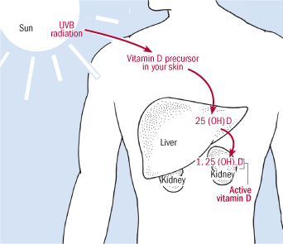
Vitamin D itself is biologically inert. It is metabolised to 25-OH Vitamin D in the liver and then to the active form 1, 25-OH Vitamin D by 1 α hydroxylase in the kidneys. In the circulation most of the Vitamin D is bound to Vitamin D binding protein and a smaller amount to albumin.

Structure

Vitamin D are a group of steroid compound, there are two forms of vitamin D:

1-The naturally produced D3 or cholecalciferol which is obtained from animal sources in the diet,or made in the skin by the action of ultraviolet light from the sun light on 7-dehydrocholestrol.

2-Artificially produced from D2 or ergocalciferol,which is the form made in the laboratory and it is the form most readily available for pharmaceutical use.

These two forms are differing slightly in the structure of their side chains,both ergocalciferol and cholecalciferol are converted about equally in humans to hormonally active dihydroxy forms.
Chemically, the various forms of vitamin D are secosteroids; i.e., steroids in which one of the bonds in the steroid rings is broken. The structural difference between vitamin D₂ and vitamin D₃ is in their side chains. The side chain of D₂ contains a double bond between carbons 22 and 23, and a methyl group on carbon 24.
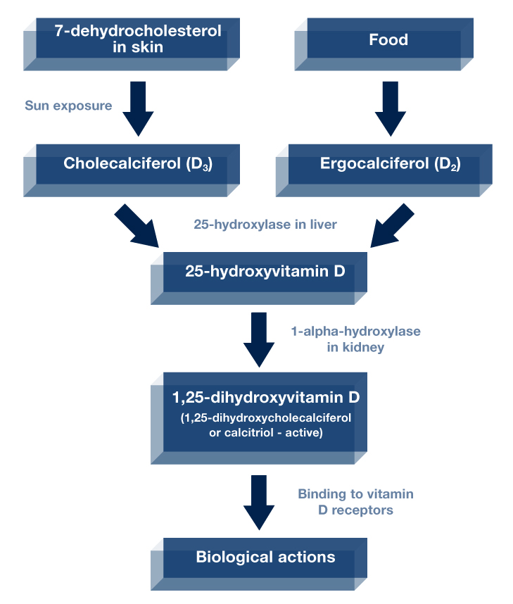

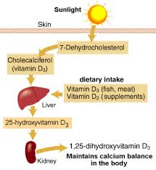

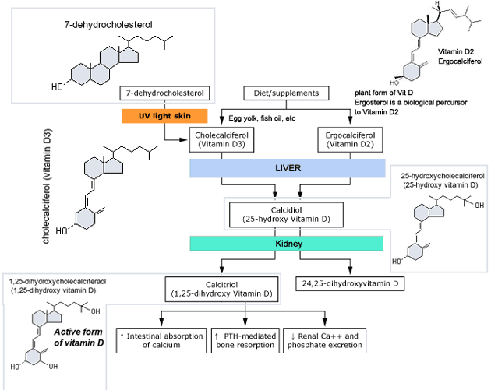

Sources of Vitamin D
Food
Very few foods in nature contain vitamin D. The flesh of fatty fish (such as salmon, tuna) and fish liver oils are among the best sources .Small amounts of vitamin D are found in beef liver, cheese, and egg yolks. Vitamin D in these foods is primarily in the form of vitamin D₃ and its metabolite 25(OH) D3. Some mushrooms provide vitamin D₂ in variable amounts. Mushrooms with enhanced levels of vitamin D₂ from being exposed to ultraviolet light under controlled conditions are also available.

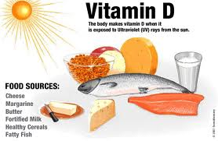

Sun exposure
Most people meet at least some of their vitamin D needs through exposure to sunlight. Ultraviolet (UV) B radiation with a wavelength of 290–320 nanometers penetrates uncovered skin and converts coetaneous 7-dehydrocholesterol to previtamin D₃, which in turn becomes vitamin D₃.

Season, time of day, length of day, cloud cover, smog, skin melanin content, and sunscreen are among the factors that affect UV radiation exposure and vitamin D synthesis. Vitamin D (and store it in the liver and fat) from exposure to sunlight during the spring, summer, and fall months even in the far north latitudes.

Dietary supplements
In supplements and fortified foods, vitamin D is available in two forms, D₂ (ergocalciferol) and D₃ (cholecalciferol) that differ chemically only in their side-chain structure. Vitamin D₂ is manufactured by the UV irradiation of ergosterol in yeast, and vitamin D₃ is manufactured by the irradiation of 7-dehydrocholesterol from lanolin and the chemical conversion of cholesterol.

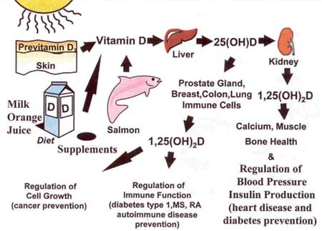

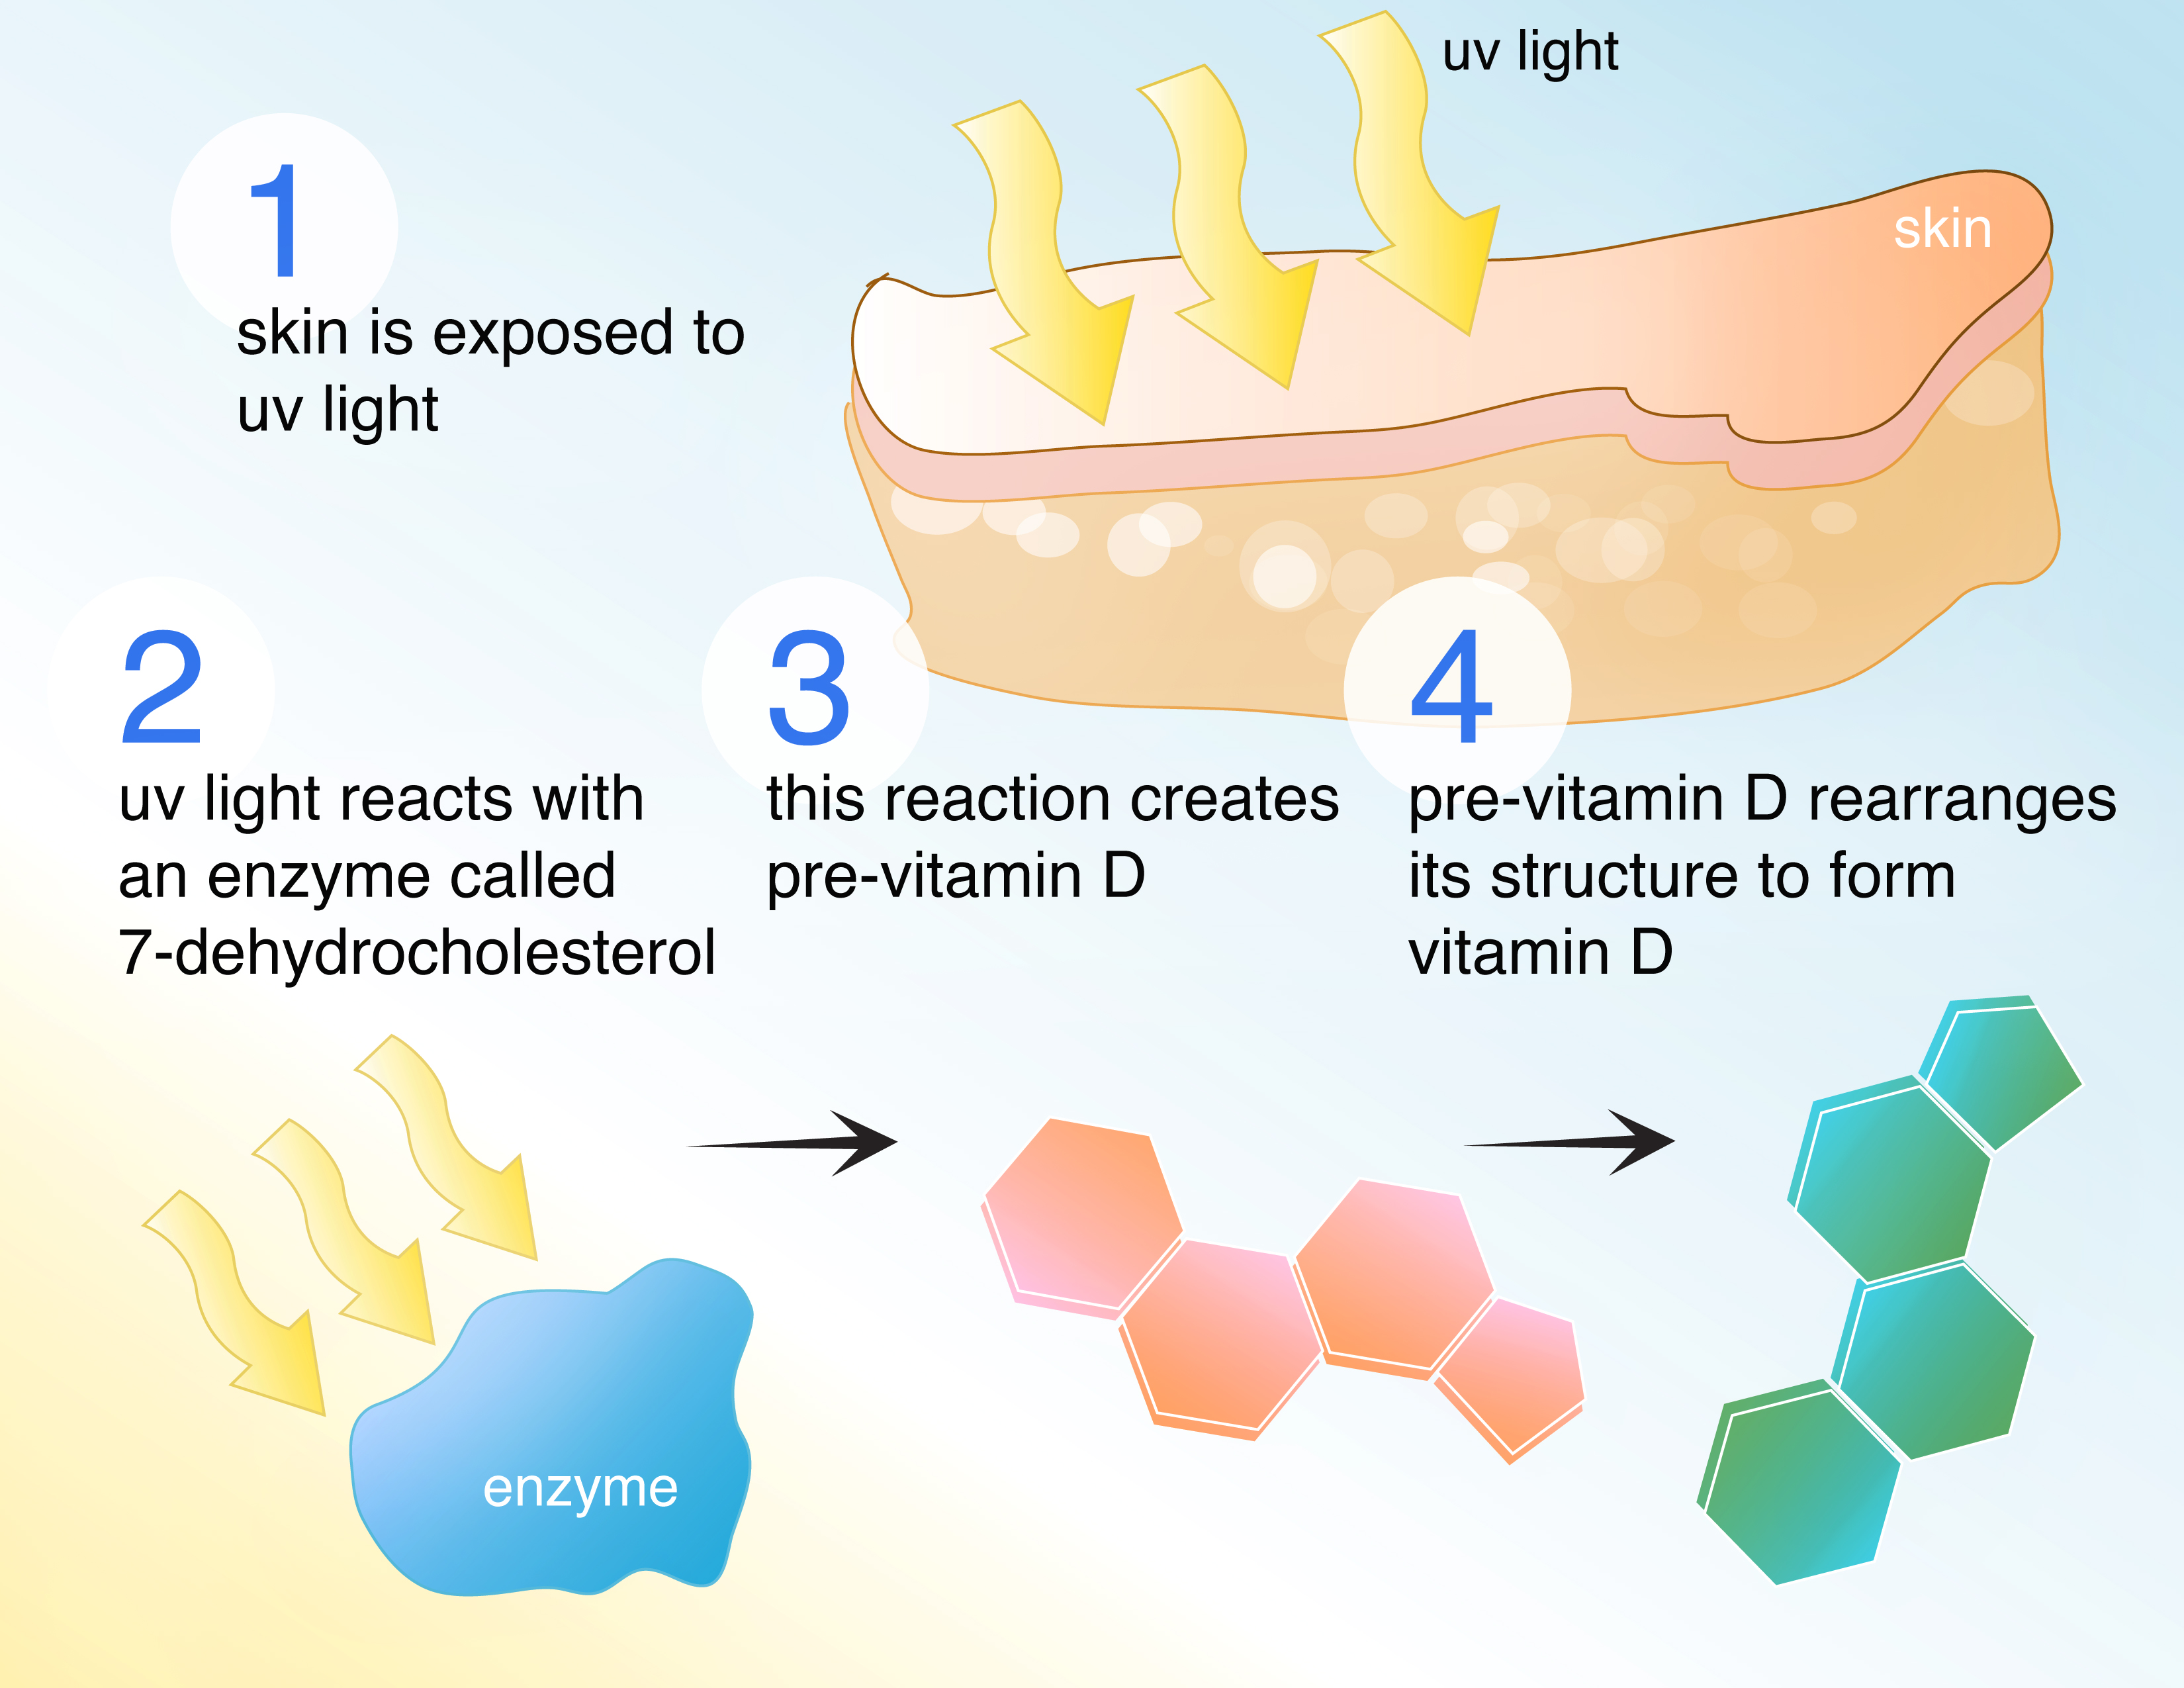

METABOLISM
Vitamin D3 produced in the epidermis must be further metabolized to be active. The first step, 25-hydroxylation, takes place primarily in the liver, although other tissues have this enzymatic activity as well. There are several 25-hydroxylases.
25OHD is the major circulating form of vitamin D. However, in order for vitamin D metabolites to achieve maximum biologic activity they must be further hydroxylated in the 1α position by the enzyme CYP27B1; 1,25(OH)2D is the most potent metabolite of vitamin D and accounts for most of its biologic actions.
The 1α hydroxylation occurs primarily in the kidney, although as for the 25-hydroxylase, other tissues have this enzyme. Vitamin D and its metabolites, 25OHD and 1, 25(OH) 2D, can also be hydroxylated in the 24 position. In the absence of 25-hydroxylation this may serve to activate the metabolite or analog as 1, 25(OH) 2D and 1, 24(OH) 2D have similar biologic potency. However, 24-hydroxylation of metabolites with an existing 25OH group reduces their activity and leads to further catabolism.
The activity of the 1, α- hydroxylase depends on:
a-Parathyroid hormone and plasma calcium: a low level of plasma calcium stimulates 1,α- hydroxylase through the secretion of parathyroid hormone.
b-Plasma Phosphate: reduced plasma phosphate activates the 1,α- hydroxylase but independent of parathyroid hormone.
c-Insulin,growth hormone prolactin and estrogen are affect (increase) the production of active form of vitamin D.
The most potent inhibitor of the 1,α- hydroxylase is the product of the reaction 1:25 dihydroxycholecalciferol.
Hepatic production of 25OHD. The next step in the bioactivation of D2 and D3, hydroxylation to 25OHD, takes place primarily in the liver although a number of other tissues express this enzymatic activity. 25OHD is the major circulating form of vitamin D and provides a clinically useful marker for vitamin D status.
Renal production of 1, 25(OH) 2D. 1,25(OH)2D is the most potent metabolite of vitamin D, and mediates most of its hormonal actions especially those involving the vitamin D receptor (VDR), 1,25(OH)2D is produced from 25OHD by the enzyme 25OHD-1αhydroxylase (CYP27B1).
Renal production of 24, 25(OH) 2D. The kidney is also the major producer of a second important metabolite of 25OHD, namely 24, 25(OH) 2D, and the enzyme responsible is 25OHD-24 hydroxylase.
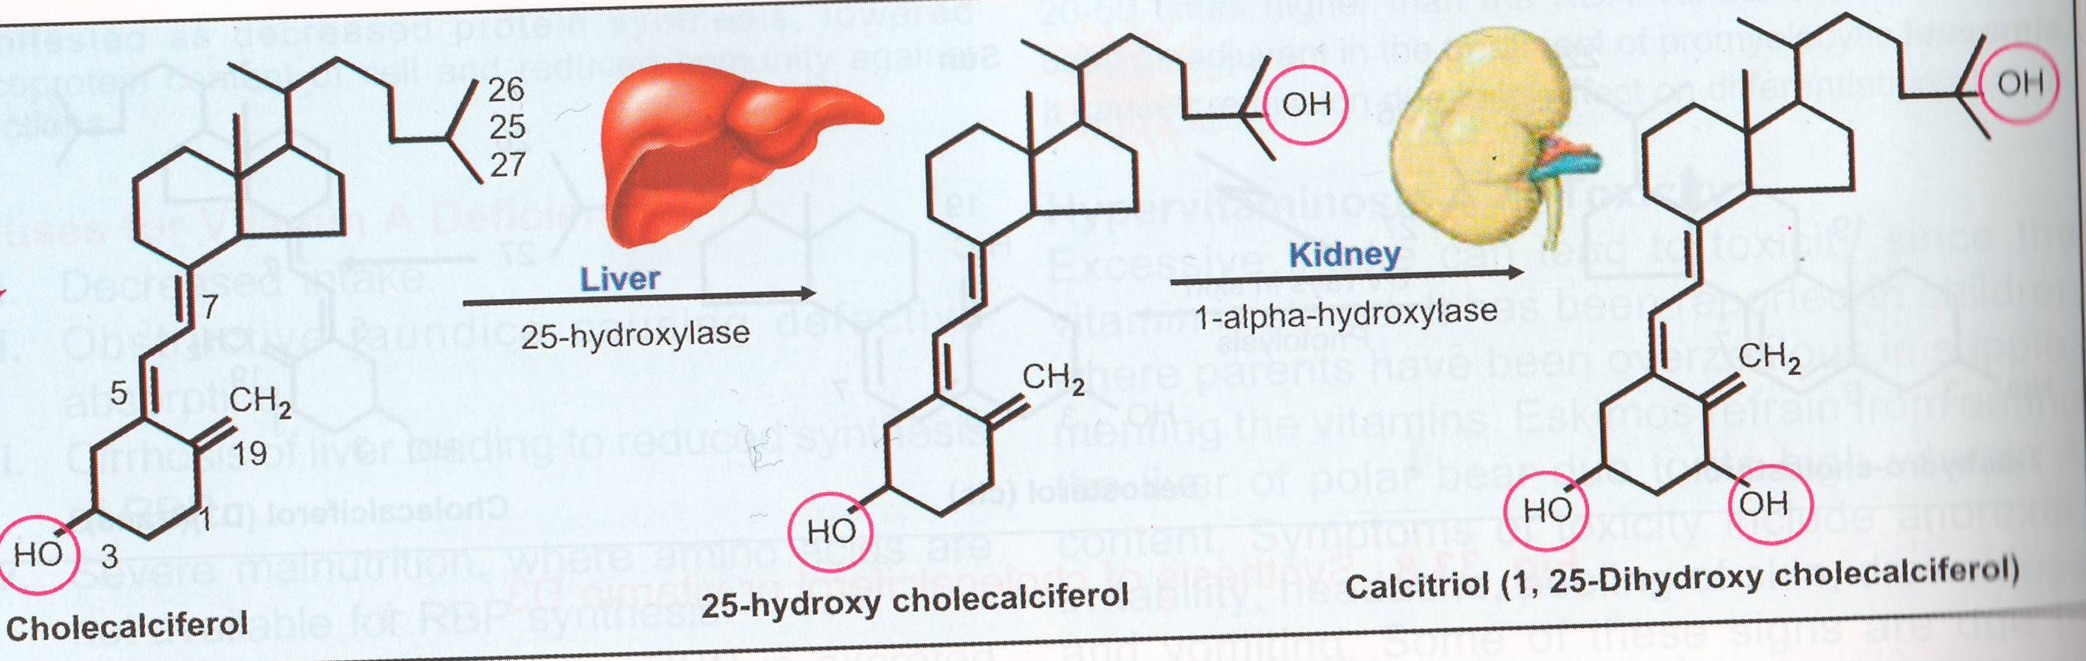
Generation of Calcitriol

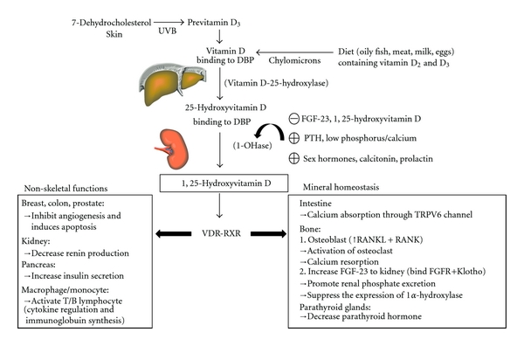

Fig. shows the synthesis and metabolism of vitamin D in the regulation of mineral homeostasis and nonskeletal functions. When under exposed to solar UVB (ultraviolet B), 7-dehydrocholesterol in the skin is converted to provitamin D₃ which is immediately converted to vitamin D3. Vitamin D can also be obtained from dietary vitamin D₂ and D₃ incorporated into chylomicrons. Vitamin D in the circulation is bound to DBP (vitamin D-binding protein), which transports it to the liver where it is converted to 25-hydroxyvitamin D by vitamin D-25-hydroxylase. The biologically inactive 25-hydroxyvitamin D must be converted in the kidneys to active 1,25-hydroxyvitamin D by 1-OHase (25-hydroxyvitamin D₃ 1α-hydroxylase). Serum PTH (parathyroid hormone), low phosphorus/calcium, sex hormones, calcitonin, and prolactin can increase (⊕) the renal production of 1,25-hydroxyvitamin D. However, FGF-23 (fibroblast growth factor 23) and 1,25-hydroxyvitamin D have feedback functions to inhibit (⊝) 1-OHase. Finally, the active 1,25-hydroxyvitamin D can bind to VDR-RXR (vitamin D receptor-retinoic acid x-receptor complex) in the intestine, bone, and parathyroid glands and then exert the classical function of mineral homeostasis. In addition, it also has nonskeletal functions when bound to VDR-RXR in other organs (breast, colon, prostate, kidney, pancreas) or immune cells (macrophages/monocytes). FGFR: FGF-23 receptor; TRPV6: transient receptor potential cation channel, subfamily V, member 6; RANKL: receptor activator of nuclear factor-κB ligand; RANK: the receptor for RANKL on preosteoclasts.

Transport In Blood
The vitamin D metabolites are transported in blood bound primarily to vitamin D binding protein (DBP) (85-88%) and albumin (12-15%).
Conditions such as liver disease and nephrotic syndrome resulting in reduced DBP and albumin levels will lead to a reduction in total 25OHD and 1, 25(OH) 2D levels without necessarily affecting the free concentrations .However, vitamin D intoxication can increase the degree of saturation sufficiently to increase the free concentrations of 1, 25(OH) 2D and so cause hypercalcemia without necessarily raising the total concentrations.
The sites of action are:
1-Intesinal villi cells.
2-Bone osteoblasts.
3-Kidney distal tubular cells.

Mechanism of action
Vitamin D is carried in the bloodstream to the liver, where it is converted into the prohormone calcidiol. Circulating calcidiol may then be converted into calcitriol, the biologically active form of vitamin D, either in the kidneys or by monocyte-macrophages in the immune system.
When synthesized by monocyte-macrophages, calcitriol acts locally as a cytokine, defending the body against microbial invaders. Following the final converting step in the kidney, calcitriol (the physiologically active form of vitamin D) is released into the circulation. By binding to vitamin D-binding protein (VDBP), a carrier protein in the plasma, calcitriol is transported to various target organs.
Calcitriol mediates its biological effects by binding to the vitamin D receptor (VDR), which is principally located in the nuclei of target cells. The binding of calcitriol to the VDR allows the VDR to act as a transcription factor that modulates the gene expression of transport proteins, which are involved in calcium absorption in the intestine.
Vitamin D-binding protein (VDR) activation in the intestine, bone, kidney, and parathyroid gland cells leads to the maintenance of calcium and phosphorus levels in the blood (with the assistance of parathyroid hormone and calcitonin) and to the maintenance of bone content.
One of the most important roles of vitamin D is to maintain skeletal calcium balance by promoting:
- Calcium absorption in the intestines.
- Promoting bone resorption by increasing osteoclasts number.
- Maintaining calcium and phosphate levels for bone formation.
- Allowing proper functioning of parathyroid hormone to maintain serum calcium levels.
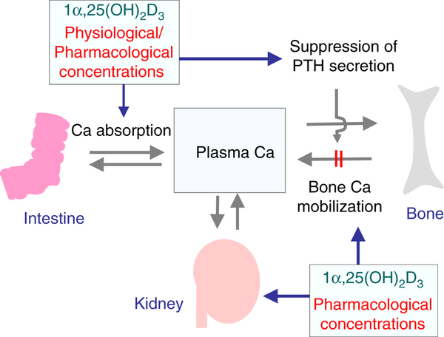

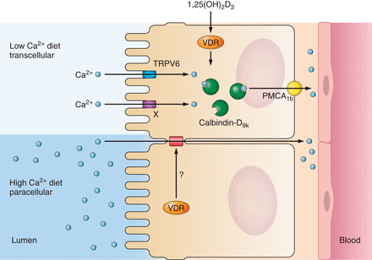

Effects of 1,25(OH)₂D₃ in the intestine. An important function of 1,25(OH)₂D₃ is the stimulation of transcellular intestinal calcium transport by increasing the expression of the apical membrane calcium channel TRPV6 and calcium binding protein calbindin-D_{9k}. The extrusion of calcium is across the basolateral membrane by PMCA1b. This process is especially enhanced when dietary calcium intake is low.

The kidneys regulate vitamin D activity by converting the inactive form of vitamin D [25(OH) vitamin D₃] to its active form (1,25-OH₂ vitamin D₃).

Decreased levels of active vitamin D lead to a decrease in intestinal absorption of calcium with a resultant increase in parathyroid hormone levels. Vitamin D also regulates osteoblast differentiation, thereby affecting bone matrix formation and mineraliztion.

Vitamin D Deficiency
Vitamin D deficiency can result in weak, brittle bones. Children who don't get enough may have rickets, and adults with vitamin D deficiency are at a greater risk for osteoporosis.
Vitamin D deficiency is known to cause several bone diseases including:
- Rickets, a childhood disease characterized by impeded growth, and deformity, of the long bones.
- Osteomalacia, a bone-thinning disorder that occurs exclusively in adults and is characterized by proximal muscle weakness and bone fragility.
- Osteoporosis, a condition characterized by reduced bone mineral density and increased bone fragility.
- Muscle aches and weakness (in particular proximal limb girdle).
- Muscle twitching (Fasciculations).
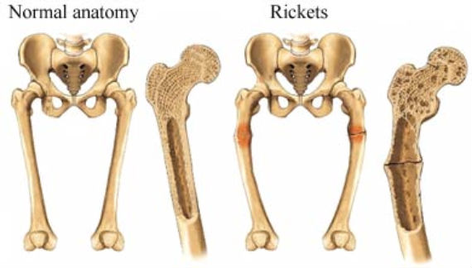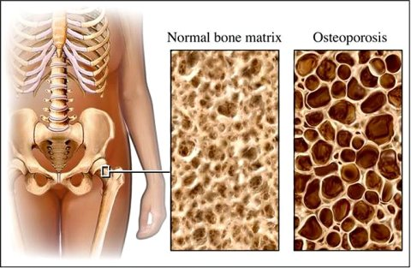
Vitamin D deficiency can occur for a number of reasons:
Obtaining sufficient vitamin D from natural food sources alone is difficult. For many people, consuming vitamin D-fortified foods and, arguably, being exposed to some sunlight are essential for maintaining a healthy vitamin D status. In some groups, dietary supplements might be required to meet the daily need for vitamin D.
1-Don't consume the recommended levels of the vitamin over time.
This is likely if someone follow a strict vegetarian diet, because most of the natural sources are animal-based, including fish and fish oils, egg yolks, cheese, fortified milk, and beef liver.
2-Breastfed infants
Vitamin D requirements cannot ordinarily be met by human milk alone, which provides <25 IU/L to 78 IU/L. (The vitamin D content of human milk is related to the mother's vitamin D status, so mothers who supplement with high doses of vitamin D may have correspondingly high levels of this nutrient in their milk.
3-Older adults
Older adults are at increased risk of developing vitamin D insufficiency in part because, as they age, skin cannot synthesize vitamin D as efficiently, they are likely to spend more time indoors, and they may have inadequate intakes of the vitamin.
4-Exposure to sunlight is limited.
Because the body makes vitamin D when the skin is exposed to sunlight, may be at risk of deficiency if homebound, live in northern latitudes, wear long robes or head coverings for religious reasons, or have an occupation that prevents sun exposure.
5-Have dark skin.
The pigment melanin reduces the skin's ability to make vitamin D in response to sunlight exposure.
6- People with fat malabsorption (Digestive tract cannot adequately absorb vitamin D).
As a fat-soluble vitamin, vitamin D requires some dietary fat in the gut for absorption. Individuals who have a reduced ability to absorb dietary fat might require vitamin D supplements. Fat malabsorption is associated with a variety of medical conditions including some forms of liver disease, cystic fibrosis, and Crohn's disease.
7-Kidneys cannot convert vitamin D to its active form. As people age their kidneys are less able to convert vitamin D to its active form, thus increasing their risk of vitamin D deficiency.
8-Obesity.Vitamin D is extracted from the blood by fat cells, altering its release into the circulation. People with a body mass index of 30 or greater often have low blood levels of vitamin D.
Hypervitaminosis

Hypervitaminosis D is a state of vitamin D toxicity. An excess of vitamin D causes abnormally high blood concentrations of calcium (hypercalcemia), which can cause over calcification of the bones, soft tissues, heart and kidneys. It can also damage the kidney and produce kidney stones. In addition, hypertension can result.
Excessive exposure to sunlight does not result in vitamin D toxicity since excess provitamin D3 and D3 are destroyed by sunlight itself.
Hypervitaminosis D symptoms appear several months after excessive doses of vitamin D are administered.

Long term effects of supplementary oral intake
Excessive exposure to sunlight poses no risk in vitamin D toxicity through overproduction of vitamin D precursor, cholecalciferol, regulating vitamin D production. During ultraviolet exposure, the concentration of vitamin D precursors produced in the skin reach an equilibrium, and any further vitamin D that is produced is degraded. This process is less efficient with increased melanin pigmentation in the skin.
Endogenously synthesized vitamin D₃ travels mainly with vitamin D-binding protein, which slows hepatic delivery of vitamin D and the availability in the plasma.
Orally administered vitamin D produces rapid hepatic delivery of vitamin D and increases plasma calcifediol.
Liver Dysfunction
The liver plays a vital role in the conversion of Vitamin D to the prohormone Calcidiol. If the liver is overburdened with toxins (drugs, alcohol, estrogen, additives, preservatives, environmental toxins, processed foods, etc.) it cannot perform optimally. Your over burdened liver spends too much time and energy trying to detox your body, thus the Vitamin D to calcidiol conversion suffers.
Kidney Dysfunction
The active form of Vitamin D, calcitriol is produced in the kidneys from calcidiol. Low functioning kidneys caused by renal failure or chronic kidney disease (CKD) will lead to low levels of active Vitamin D.
Things that can lead to kidney dysfunction are: accidents; injuries; complications from surgeries; drug overdoses; overloads on antibiotics, aspirin, and acetaminophen; chemotherapy; diabetes; and high blood pressure.

