**Immunodeficiency (ID)**

If individuals experience defects in the functioning of any of the components of the immune system, clinical manifestations will occur.

*ID may affect **lymphoid lineage**, or **myeloid lineage**.

It can occur in any of the 4 major components of the immune system, so the types of defects are:

1. Defects of phagocytic cells.

2. Defects of humoral immunity.

3. Defects of T lymphocytes and sever combined immunodeficiencies.

4. Defects of complement.

Immunodeficiency can be either * **congenital** (primary) results from genetic or developmental defect in the immune system, so present at birth, although it may not manifest itself until later in life.

Or * **acquired** (secondary), result from exposure to various agents that lead to loss of immune function.

***1. Congenital ID: (primary ID)*** It affect either **adaptive** (involve T or B lymphocyte), or **innate** function (phagocyte or complement). Most of the primary ID are inherited.

Consequences of ID depend on number & type of component involved, i.e.

**A.** defect in components early in hematopoietic development, affect entire immune system, as Reticular dysgenesis (stem cell defect → so affect maturation of all leukocytes resulting in general failure of immunity → ↑ susceptibility to infection that lead to death of patient early in life.

**B.** defect in more highly differentiated component, this have consequences that are more specific & less sever. For e.g. an individual with selective IgA deficiency may enjoy a full life span, troubled only by a greater than normal susceptibility to infections of the respiratory and genitourinary tracts.

***2.*** ***Acquired (Secondary) ID:*** called also agent induced ID.

Causes: 1. Unknown. 2. Drugs as corticosteroid, cytotoxic drug, and immune suppressive drugs. 3. Radiation. 4. Infection e.g. AIDs by HIV.

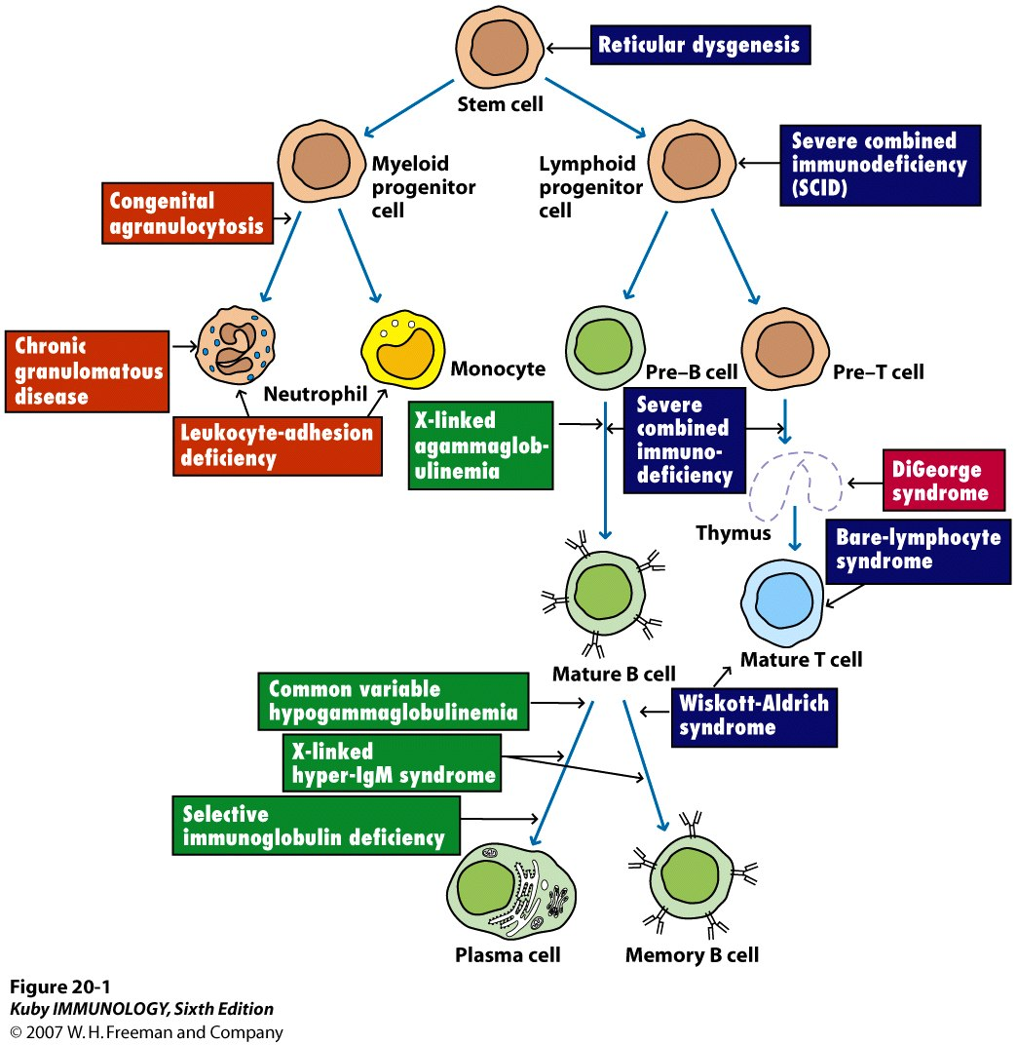

**Types of immune deficiency diseases**:

1. ***Defects of phagocytic cells as for example:***

|  |  |  |
| --- | --- | --- |
| **Disease** | **Molecular defect(s)** | **Symptoms** |
| Chronic granulomatous disease(CGD)* | Def of NADPH oxidase; failure to generate superoxide anion & other O2 radicals, so the microorganisms will be ingested but not killed. | **1.** Recurrent infections with catalase-positive bacteria & fungi.  **2.** Patients not subject to infection by those bacteria, such as pneumococcus, that generate their own hydrogen peroxide. |
| Leukocyte adhesion deficiency(LAD)** | Absence of CD18(LFA-1) (leukocyte integrins). | **1.** Recurrent & chronic infection.  **2.** Fail to form pus. |
| Chediak- Higashi Syndrome | Defect in organelle membrane which inhibits normal fusion of lysosomes  Fail to destroy ingested microbes | Recurrent infection with bacteria (chemotactic and degranulation defects, absent NK activity, partial albinism) |

**\*Chronic Granulomatous Disease (CGD):** patients are very susceptible to opportunistic infection with bacteria & fungi. CGD is due to a defect in the intracellular microbicidal activity of neutrophils as a result of a lack of NADPH oxidase activity → no hydrogen peroxide or superoxides, so the microorganism will be ingested but not killed. The addition of IFN-γ has been shown to restore function to CGD granulocytes and monocytes in vitro. This observation prompted clinical trials of IFN-γ for CGD patients.

**\*\*Leukocyte Adhesion deficiency syndrome (LAD):** cell-surface molecules belonging to the integrins family of proteins function as adhesion molecules and are required to facilitate cellular interaction.

These patients have defective adhesion (LFA-1) proteins on the surface of their phagocyte → neutrophil adhere poorly to endothelial cell surface & phagocytosis of the bacteria is inadequate.

1. ***Defects of humoral immunity.***

The B-cell defect is usually not detected for the first few months of life because of the passive transfer of Ig from the mother through the placenta and/ or colostrums. It makes different range of diseases, from complete absence of mature B-cell, plasma cell, immunoglobulin, to selective absence of only certain class of Ig. These patients are subjected to recurrent bacterial infection, but normal immunity to viral & fungal infection, because T-cell branch is not affected. These patients tend to have infection by encapsulated bacteria (staphylococcus, streptococcus, and pneumococcus), as Ab is critical for opsonization & clearance of these organisms.

|  |  |  |  |
| --- | --- | --- | --- |
| **Disease** | **Molecular defect** | **Symptoms/signs** | **Treatment** |
| Bruton X-linked hypogammagloulinemia | Deficiency of tyrosine kinase, so blocks B-cell maturation. | 1. Low Ig of all classes.  2. No circulating B cell.  3. B-cell maturation stopped at pre-B stage  4. Normal CMI. | 1. Monthly gammaglobulin replacement.  2. Antibiotic for infection. |
| X-linked hyper-IgM syndrome**\*** | Deficiency of CD40L on activated T cell. | 1. Higher serum titer of IgM only.  2. Normal B & T cell number.  3. Susceptibility to extracellular bacteria & opportunists. | Antibiotic & gammaglobulin. |
| Selective IgA deficiency | Deficiency of IgA | Repeated sinopulmonary & GIT infections. | Antibiotic, not immunoglobulin |
| Common variable immunodef | Unknown | 1. Onset in late teens.  2. B cell present in peripheral blood.  3. Ig level decrease with time.  4. Increase autoimmunity & atopy. | Antibiotics |
| Transient hypogammaglobulinemia of infancy | Delayed onset of normal IgG synthesis | Susceptibility to pyogenic bacteria. | Antibiotic & in severe cases gammaglobulin replacement. |

**\*X-linked hyper-IgM syndrome (XHM):** The defect is in the gene encoding the CD40 ligand (CD40L), which maps to the X chromosome. T-helper cells from patients with XHM fail to express functional CD40L on their membrane. Since an interaction between CD40 on the B cell and CD40L on the T-H cell is required for B-cell activation, the absence of this co-stimulatory signal inhibits B-cell response to T-dependent antigens. The B-cell response to T-independent antigens, is unaffected by this defect, accounting for the production of IgM antibodies. Class switching and formation of memory B-cells both require contact with T-H cells by a CD40–CD40L interaction. The absence of this interaction in XHM results in the loss of class switching to IgG, IgA, or IgE isotypes and in a failure to produce memory B cells.

In addition, XHM individuals fail to produce germinal centers during a humoral response, which highlights the role of the CD40–CD40L interaction in the generation of germinal centers.

**Selective deficiencies of Ig classes:** A number of immunodeficiency states are characterized by significantly lowered amounts of specific immunoglobulin isotypes. Of these, IgA deficiency is the most common. The defect in IgA deficiency is related to the inability of IgA B cells to undergo normal differentiation to the plasma-cell stage. IgG2 and IgG4 may also be deficient in IgA-deficient patients.

No causative defect in IgA genes has been identified, and the surface IgA molecules on these patients’ B cells appear to be expressed normally. A gene outside of the immunoglobulin gene complex is suspected to be responsible for this fairly common syndrome.

Other immunoglobulin deficiencies have been reported, but these are rarer.

**Common variable immunodef (CVI):**  is characterized by a profound decrease in numbers of antibody-producing plasma cells, low levels of most immunoglobulin isotypes (hypogammaglobulinemia), and recurrent infections. The condition is usually manifested later in life than other deficiencies and is sometimes called late onset hypogammaglobulinemia or, incorrectly, acquired hypogammaglobulinemia. However, CVI has a genetic component and is considered a primary immunodeficiency, although the exact pattern of inheritance is not known. Infections in CVI sufferers are most frequently bacterial and can be controlled by administration of immunoglobulin. In CVI patients, B cells fail to mature into plasma cells.

***3. Defects of T lymphocytes and sever combined ID.***

Although patients with defects in B lymphocytes can deal with many pathogens adequately, defects in T lymphocytes are observed throughout the immune system (because of the central role of T cells in activation, proliferation, differentiation, and modulation of all naturally occurring immune responses). The impact on the cell-mediated system can be severe, with a reduction in both delayed-type hypersensitive responses and cell-mediated cytotoxicity.

Defects in the cell mediated system are associated with increased susceptibility to viral, protozoan, and fungal infections. Intracellular pathogens such as *Candida albicans, Pneumocystis carinii*, and *Mycobacteria* are often implicated, reflecting the importance of T cells in eliminating intracellular pathogens. Infections with viruses that are rarely pathogenic for the normal individual (such as cytomegalovirus or even an attenuated measles vaccine) may be life threatening for those with impaired cell-mediated immunity. Defects that cause decreased T-cell counts generally also affect the humoral system, because of the requirement for T-H cells in B-cell activation. Generally there is some decrease in antibody levels, particularly in the production of specific antibody after immunization.

The onset of infections begins early in infancy, and the prognosis for these infants is early death unless therapeutic intervention reconstitutes their defective immune system.

**B and T-cell deficiency divided into these categories:**

1. **Selective T-cell deficiency**:

|  |  |  |
| --- | --- | --- |
| **Disease** | **Defect** | **Clinical manifestation** |
| DiGeorge syndrome | Thymic aplasia. | Depression of T cell number with absence of responses. |
| MHC class I deficiency | Failure of TAP 1 molecule to transport peptide to endoplasmic reticulum. | 1. CD8+ Tcell def.  2. CD4+ T cell normal.  3. Recurrent viral infection.  4. Normal Ab formation. |
| MHC class II def (Bare lymphocyte syndrome) | Defects in transcription factors. | 1. Def of CD4+ T cell.  2. Hypogammagloulinemia.  3. Clinically as severe combined ID. |

**DiGeorge syndrome** The immune defect includes a profound depression of T-cell numbers and absence of T-cell responses. Although B cells are present in normal numbers, affected individuals do not produce antibody in response to immunization with specific antigens.

1. **Combined partial B and T-cell deficiency:**

|  |  |  |
| --- | --- | --- |
| Ataxia telangiectasia | Defect in kinase involved in the cell cycle. | 1. Gait abnormality.  2. Telangectasia (capillary distortion in the eye).  3. Def of IgA & IgE production. |

1. **Complete functional B and T cell deficiency:**

|  |  |  |
| --- | --- | --- |
| Sever combined ID (SCID). | Defects in common γ chain of IL-2 receptor. | 1. Opportunistic (fungal) infection.  2. Low level of circulating lymphocyte. |

The family of disorders termed **SCID** stems from defects in lymphoid development that affect either T cells or both T and B cells. All forms of SCID have common features despite differences in the underlying genetic defects. Clinically, SCID is characterized by a very low number of circulating lymphocytes.

There is a failure to mount immune responses mediated by T cells. The thymus does not develop, and the few circulating T cells in the SCID patient do not respond to stimulation by mitogens, indicating that they cannot proliferate in response to antigens. Myeloid and erythroid (red blood- cell precursors) cells appear normal in number and function, indicating that only lymphoid cells are depleted in SCID.

SCID results in severe recurrent infections and is usually fatal in the early years of life. Although both the T and B lineages may be affected, the initial manifestation of SCID in infants is almost always infection by agents, such as fungi or viruses, which are normally dealt with by T-cell immunity. The B-cell defect is not evident in the first few months of the affected infant’s life because antibodies are passively obtained from transplacental circulation or from mother’s milk.

1. ***Defects of complement.***

Deficiencies of complement or its regulation as in these cases:

|  |  |  |
| --- | --- | --- |
| **Components** | **Deficiency** | **Signs/diagnosis** |
| Classic pathway | C1q,C1r,C1s,C4,C2 | 1. Marked increase in immune complex disease  2. Increased infection with pyogenic bacteria. |
| Both pathways | C3 | 1. Recurrent bacterial infection.  2. Immune complex disease. |
| C5,C6,C7,C8 | Recurrent meningococcal & gonococcal infections. |
| Def of regulatory proteins. | C1-INH (hereditary angioedema). | 1. Overuse of C1, C4 or C2.  2. Edema at mucosal surfaces. |

**Myeloid lineage defect**:

It affects innate immunity Most of these defects result in impaired phagocytic processes that are manifested by recurrent microbial infection of greater or lesser severity. There are several stages at which the phagocytic processes may be faulty; these include cell motility, adherence to and phagocytosis of organisms, and killing by macrophages. as for e.g.

**1. Reduction in neutrophil count.** If complete absence → called agranulocytosis. If reduced to < 1500/mm³ → called neutropenia. These may be due to congenital defect of the stem cell.

🡪Congenital neutropenia is often due to a genetic defect that affects the myeloid progenitor stem cell; it results in reduced production of neutrophils during hematopoiesis.

🡪In congenital agranulocytosis, myeloid stem cells are present in the bone marrow but rarely differentiate beyond the promyelocyte stage. As a result, children born with this condition show severe neutropenia, with counts of less than 200 neutrophils/mm³. These children suffer from frequent bacterial infections beginning as early as the first month of life;

Or it may be acquired after radiation or drug, or it may be transient after certain bacterial & viral infection.

Neutrophils have a short life span, and their precursors must divide rapidly in the bone marrow to maintain levels of these cells in the circulation. For this reason, agents such as radiation and certain drugs (e.g., chemotherapeutic drugs) that specifically damage rapidly dividing cells are likely to cause neutropenia. Occasionally, neutropenia develops in such autoimmune diseases as Sjögren’s syndrome or systemic lupus erythematosus; in these conditions, autoantibodies destroy the neutrophils. Transient neutropenia often develops after certain bacterial or viral infections, but neutrophil counts return to normal as the infection is cleared.

**2. Chronic Granulomatous Disease**. Discussed before.

***Secondary immunodeficiency***

**First form of 2nd ID** is of unknown origin as acquired hypogammaglobulinemia, with its major symptom, recurrent infection, manifests itself in young adults. The patients generally have very low but detectable levels of total immunoglobulin. T-cell numbers and function may be normal, but there are some cases with T-cell defects and these may grow more severe as the disease progresses. The disease is generally treated by immunoglobulin therapy.

**Second form of 2nd ID**, known as agent-induced immunodeficiency, results from exposure to any of a number of chemical and biological agents that induce an immunodeficient state. These are drugs used to combat autoimmune diseases such as rheumatoid arthritis or lupus erythematosus. Corticosteroids, which are commonly used for autoimmune disorders, interfere with the immune response in order to relieve disease symptoms.

Similarly, a state of immunodeficiency is deliberately induced in transplantation patients who are given immunosuppressive drugs, such as cyclosporine A, in order to blunt the attack of the immune system on transplanted organs.

**Third form of 2nd ID** is a severe immunodeficiency caused by the infectious agent called human immunodeficiency virus 1, or HIV-1. The disease that HIV-1 causes, acquired immunodeficiency syndrome (AIDS).

Complete evaluation of AIDS patients showed that they had in common a marked deficiency in cellular immune responses and a significant decrease in the subpopulation of T cells that carry the CD4 marker (T helper cells.)

* The first step in HIV infection is viral attachment and entry into the target cell.
* HIV-1 infects T cells that carry the CD4 antigen on their surface; in addition, certain HIV strains will infect monocytes and other cells that have CD4 on their surface. The preference for CD4 cells is due to a high-affinity interaction between a coat (envelope or **env**) protein of HIV-1 and cell-surface CD4. Although the virus binds to CD4 on the cell surface, this interaction alone is not sufficient for entry and productive infection.
* Expression of other cell-surface molecules, coreceptors present on T cells and monocytes is required for HIV-1 infection. The infection of a T cell, is assisted by the Tcell coreceptor CXCR4, virus called (T-tropic strains) because it infect T cell. An analogous receptor called CCR5 functions for the monocyte or macrophage with the HIV-1 strain called (M-tropic strains).



**Pathogenesis of HIV Infection and AIDS**

***HIV disease begins with acute infection, which is only partly controlled by the host immune response, and advances to chronic progressive infection of peripheral lymphoid tissues.***

* ***Acute (early) infection is characterized by infection of memory CD4+ T cells in mucosal lymphoid tissues and death of many infected cells.*** Because the mucosal tissues are the largest reservoir of T cells in the body and the major site of residence of memory T cells, this local loss is reflected in considerable depletion of lymphocytes. In fact, within 2 weeks of infection, a large fraction of CD4+ T cells may be destroyed.

***The transition from the acute phase to the chronic phase of infection is accompanied by dissemination of the virus, viremia, and the development of host immune responses.***

* **Chronic Phase**🡪 lymph nodes and the spleen are sites of continuous HIV replication and cell destruction. During this period of the disease, the immune system remains competent at handling most infections with opportunistic microbes, and few or no clinical manifestations of the HIV infection are present. Therefore, this phase of HIV disease is called the **clinical latency period**. 🡪Although the majority of peripheral blood T cells do not harbor the virus**, destruction of CD4+ T cells within lymphoid tissues steadily progresses during the latent period**, and the number of circulating blood CD4+ T cells **steadily declines**. 🡪Early in the course of the disease, the individual may continue to make new CD4+ T cells, and therefore these cells can be replaced almost as quickly as they are destroyed. At this stage, up to **10%** of CD4+ T cells in lymphoid organs may be infected 🡪Eventually, over a period of **years**, the continuous cycle of virus infection, T cell death, and new infection leads to a **detectable loss of CD4+ T** cells from the lymphoid tissues and the circulation.

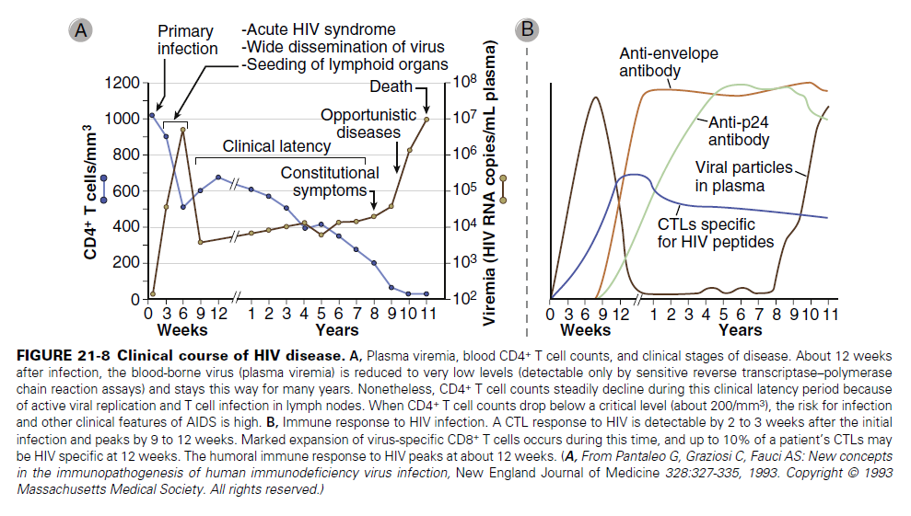

**Mechanisms of Immunodeficiency Caused by HIV**

HIV infection ultimately results in **impaired** function of both the **adaptive and innate immune systems**. The most prominent defects are in cell-mediated immunity, and they can be attributed to several mechanisms, including direct cytopathic effects of the virus and indirect effects.

**🡪Direct**

***An important cause of the loss of CD4+ T cells in HIV infected individuals is the direct effect of infection of these cells by HIV***. The budding of viral particles, may lead to increased plasma membrane permeability and the influx of lethal amounts of calcium, which induces apoptosis, or osmotic lysis of the cell caused by the influx of water. In addition HIV infection activates the inflammasome pathway and leads to a form of cell death (apoptosis).

**🡪Indirect**

Chronic activation of the T cells may predispose the cells to **apoptosis**. **HIV-specific CTLs** are present in many patients with AIDS, and these cells can kill infected CD4+ T cells. A**ntibodies against HIV envelope proteins** may bind to HIV-infected CD4+ T cells and target the cells for antibody-dependent cell-mediated cytotoxicity.

**Immune Responses to HIV**

HIV-specific humoral and cell-mediated immune responses develop after infection but generally provide limited protection.

* **Innate**

production of antimicrobial peptides (defensins), and activation of NK cells, dendritic cells, and the complement system.The role of these responses in combating the infection is not established.

* **The initial adaptive immune response**

characterized by:

# expansion of CD8+ T cells specific for HIV peptides. These CTLs control infection in the early phase but ultimately prove ineffective **because** of the emergence of viral escape mutants (variants with mutated antigens).

# CD4+ T cells also respond to the virus, and these CD4+ T cells may contribute to viral control in a number of ways. An effective CD4+ T cell response is required as a source of help for the generation of CD8+ memory T cells, but CD4+ T cells have also been shown to mediate cytolytic responses against HIV-infected cells.

# Antibody responses to a variety of HIV antigens are detectable within 6 to 9 weeks after infection. 1)The early antibodies are generally **not** neutralizing and are thus **poor inhibitors** of viral infectivity or cytopathic effects. 2)Neutralizing antibodies against viral antigens develop 2 to 3 months after primary infection, but even these antibodies **cannot cope with a virus** that is able to rapidly change the most immunodominant epitopes of its envelope glycoproteins.

**Mechanisms of Immune Evasion by HIV**

1. HIV has an extremely high mutation rate and in this way it may evade detection by antibodies or T cells generated in response to viral proteins.
2. HIV-infected cells may evade CTLs through **down regulation of class I MHC molecule expression.**
3. Other mechanisms of inhibiting cell mediated immunity these include a preferential inhibition of TH1 cytokines, activation of regulatory T cells, and suppression of dendritic cell functions.

**Clinical Course of HIV Infection**

1. **The acute phase of the illness**, also called acute HIV syndrome, is the period of viremia characterized by non-specific symptoms of infection typically 3 to 6 weeks after infection. In many patients, however, the infection is occult and there are no symptoms.
2. **The chronic phase of clinical latency** may last for many years. During this time,

🡪 Patients are asymptomatic or suffer from minor infections. 🡪Within 2 to 6 months after infection, the concentration of plasma virus stabilizes at a particular set-point, which differs among patients. The level of the viral setpoint and the number of blood CD4+ T cells are clinically useful predictors of the progression of disease. 🡪As the disease progresses, patients become susceptible to other infections, and immune responses to these infections may stimulate HIV production and accelerate the destruction of lymphoid tissues.

1. **HIV disease progresses to the final and once almost invariably lethal phase, called AIDS**, when the blood CD4+ T cell count drops below 200 cells/mm3. HIV viremia may climb dramatically as viral replication accelerates. Patients with AIDS suffer from combinations of *opportunistic infections*, *neoplasms, cachexia* (HIV wasting syndrome), *kidney failure* (HIV nephropathy), and *CNS degeneration* (AIDS encephalopathy). WHY??

# Because CD4+ helper T cells are essential for both cell mediated and humoral immune responses to various microbes, the loss of these lymphocytes is the main reason that patients with AIDS become susceptible to many different types of infections.

**Diagnosis of AIDS**

-RT-PCR (Reverse transcriptase –Polymerase Chain reaction) – detects viral load. A rise in the level of circulating HIV-1 (viral load) in the plasma. have assumed a major role in determination of the patient’s status and prognosis.

-ELISA (Enzyme linked immunosorbent assay) Abs against HIV proteins (sensitive and specific) but not diagnostic

-Western Blot: Infected individuals who have developed Abs (wks-6 months after infection)

- CD4+:CD8+ T cell counts, greatly diminished numbers of CD4- T cells (200 cells/mm3).

- Impaired or absent delayed-hypersensitivity reactions