Computed tomography (CT)
CT is special X-ray tests that produce cross-sectional images of the body using x-rays and a computer. It was developed in 1970 by a British engineer named Godfrey Hounsfield.
The CT scanner sends numerous x-rays beams through the body and a set of electronic x-ray detectors measuring the amount of radiation being absorbed throughout the body to build cross- sectional images (slices).
Cross – sections are reconstructed from measurements of attenuation coefficients µ of the x-ray beam. Attenuation: is reductions in intensity of x-ray beam as it traverses matter either by absorption or deflection.
Linear attenuation coefficient µ of the tissue depends on:
- the composition of the material
- the density of the material
- the photon energy
The component of CT- scanner
The CT-scanner is made up of three primary systems including;
a-The gantry b- computer c- operating console
Gantry assembly:
Include; 1- x-ray tube 2- detector array
3- High voltage generator 4- the patient support and positioning couch
These subsystems receive electronic commands from the operating console and transmit data to computer for image production and analysis.
X-ray tube in CT-scanning have special requirements:
Operate low tube current, anode heat capacity must be at least 500.000HU (heat unit) and high speed rotators for best heat dissipation. X-ray tubes are energized differently depending on the scanner design.
Detectors assembly
Two types of detectors are used
- Scintillation detectors
- Gas detectors

Scintillation detectors: sodium iodide (NaI) was used in earliest scanners .Now it replaced by bismuth germinate, Cesium iodide and cadmium tungstate.
The space between detectors varies from design to another. Scintillation detectors transform the x-ray energy into visible light, detected by a photo diode converted into electrical signal. Fig.1
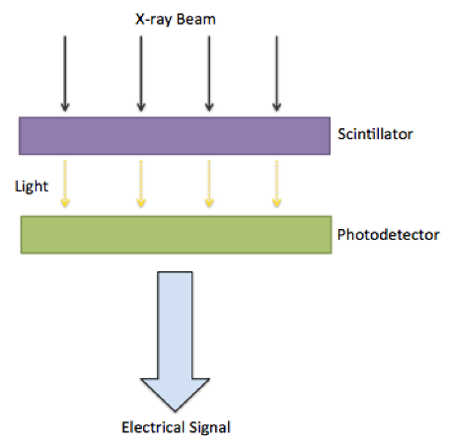
Scintillation detectors have relatively high detection efficiency, about 90% of x-ray incident on detector will absorbed and contributed to output signal. But unfortunately, its not possible to pack the detectors, therefor the detector interspace may occupy 50%of total area intercepting the x-ray nearly 45%. The results about 55% of remained x-ray will contribute the patient dose without contributing the image.

Gas Detectors they are constructed of a large metallic chamber with baffles spaced only at 1mm intervals. The detectors filled with high atomic number inert gas such as xenon. Ionization of the gas by x-ray producing electrical signal, the total efficiency is 45% similar to scintillation detectors. Fig.2

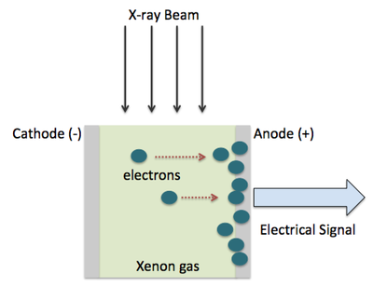

Collimation
The function of collimation is to
- Reduce patient dose (scattered radiation)
- Enhance image contrast
In CT-scanner there are two types of collimation
- Pre patient collimation
Is mounted on tube housing or adjacent to it, its functions are
- Limit the area of the patient
- Determine the slice thickness
- Determine the patient dose

- Pre detector collimation
- Reduce the scatter radiation incident on the detector
- Help define the slice thickness
High voltage generation
All CT-scanner operate on 3-phase power .This is useful for higher x-ray tube rotor speed and for pulsed system.
Patient positioning and support couch
Patient couch is more important components of CT-scanner, supporting patient comfortably. It made of low atomic number material such as carbon fiber.
It should be smoothly and accurately motor driven. Then precise position of patient is possible.
The computer is specially designed to collect and analyze signal from detector. To create cross-sectional images and to displays the image on TV- monitor. The computer reconstruction the cross sectional anatomy is accomplished with mathematical equations called (Algorithm).
The operating console is the master control center of CT-scanner. It is used to input all of the factors related to taking a scan. Typically, this console is made up of computer, keyboard and multiple monitors. Often there are two different control consoles one use by the CT-scanner operator to control variables as the thickness of the slice mechanical movement of patient couch, and other radiographic technique factors.
The physician's viewing console allows the doctor to view the image without interfering with the normal scanner operation. It also enables image manipulation, if this is required for diagnosis. Data storage on magnetic tapes or floppy disks are available.

Simple CT- system
Consist of: collimated x-ray beam, single detector the x-ray source and detector are connected so they move synchronously, they move in translate –rotate mode.
When the source – detector system make one translation, across the patient the internal structures of the body attenuate the x-ray beam according to their
- mass density b- atomic number
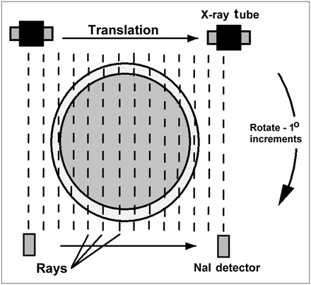
(Fig.3)
The intensity of radiation detected varies according to this attenuation and form a projection ,at the end of this translation the source –detector system will return to its starting position and the entire system will rotate at angle Ɵ and begin a second translation. Each translation produce projection, if this process is repeated many times a large number of projections will be generated. The whole process of rotate and traverse is repeated many times such that the total rotation is at least 180⁰. These projections are not displayed visually but are stored in numerical form in the computer. The computer processing of these projections to reconstruct an image. As in Fig.3
Characteristics of CT-scan Image
In CT- scanners the x-rays form a stored electronic image that displayed as a matrix.
Digital techniques are normally used in CT-scan, so that:
- Consider the object plane as a slice and the thickness of the slice (Z) variable (may vary from 1mm – 15mm).
- The slice subdivided into matrix of attenuating elements with linear attenuation coefficients µ (x, y).
That’s mean, CT-scan image consist of many cells each cell has a number and display as a density or brightness level on computer monitor, in CT all matrix are square and two dimensional. Matrix is define as series of boxes in columns and rows, each box (cell) in matrix called pixel . (Pixel = picture element) and the pixel is two dimension area. (Figure 4)
The pixel size x thickness of the slice = Voxel, (Voxel = volume element).
(Fig.4) 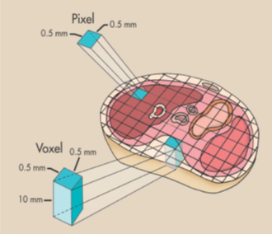

The numerical value or information contain in each pixel is CT-number or Hounsfield unite.
Image with small pixels displays much more detail than an image made up of larger pixels, therefore increasing the matrix size, will produce smaller pixels.
The size of image matrix depend on the capacity of computer, but most digital image system provides:
256 x 256
512 x512
1024 x1024
The product of matrix size and pixel size is called field of view (FOV), which determine the diameter of the area being examined and the image area.
Scan field of view (SFOV) : is the actual area of interest scanned by CT, the area selected by CT technique before scanning by determines the number of detectors needed to collect data for particular scan. SFOV must be larger than area of interest because any anatomy outside the scan box would not be recorded by the detectors, resulting in outfield artifacts.
CT- number
Each pixel will be displayed on the monitor as a level of brightness and on photographic image as a level of optical density. These levels corresponding to a range of CT-number from (- 1000 → +1000) for each pixel.
Where: a CT- number of (- 1000) corresponding to air
CT- number of (0) corresponding to water
CT- number of (+1000) corresponding to dense bone.
The precise CT- number of any given pixel is related to the x-ray attenuation coefficient µ of the tissue contained in the voxel.

The degree of x-ray attenuation is determined by:
a-the average energy of the x-ray beam.
b-effective atomic number of the absorber.
The equation of CT-number is
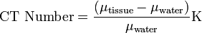
Where : µ_{tissue is} attenuation coefficient of the pixel under analysis.
µ_{water is} attenuation coefficient of the water.
K is constant usually = 1000
In digital CT- scan reconstructed image is converted into a gray scale with higher values assigned to brighter points and lower number assigned to darker points, i.e. the highest value is white while the lowest value is black. by varying the window width and the window level.
Window width (WW)( contrast) : determine the range of CT-numbers displayed by the gray scale.
CT numbers above the range are displayed as white and CT-numbers below the range are displayed as black.
Window level (WL) (brightness) : determines the center CT-number value displayed by the gray scale range.
The choice of WW and WL is dictated by clinical need Optimal visualization of the tissues of interest in the CT image can only be achieved by selecting the most appropriate window width and window level. Different settings of the WW and WL are used to visualize for example soft tissue, lung tissue or bone. As shown in( Fig. 5)
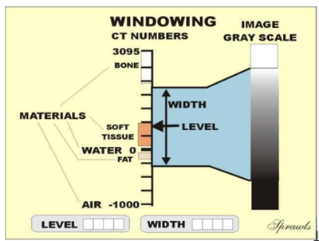

Fig. 5

CT-scanners generation
1-First generation scanners
- Translate –rotate
- Use collimated x-ray beam (pencil beam )
- Use single detector
- The system single beam and single detector translating across the patient and rotating between successive translations.
- It required 180 translations
- Each translations separated by 1⁰- degree rotation
- A single slice image is generated following many such motions
- Scan time almost 5 min.
2-Second generation scanners
- Also translate- rotate type
- Use multiple detector up to 30 intercepting a fan shaped beam
- Use bow tie filter to equalization intensity reaching the detector
- X-ray and detectors rotate together to image different angle and this repeated until single slice is scanned
- Scan time took 5-90 second per slice
3- Third generation scanners
- Rotate –rotate type
- X-ray tube and detector array were rotated concentrically about the patient
- Use curve linear detector array containing 30-60 detector
- Use fan beam the width of the fan beam 30-60⁰
- Scan time takes about 0.3 second. This is the most commonly used
4- Fourth generation scanners
- Rotate -fixed type
- The source of x-ray only rotates and x-ray beam is fan shaped
- There is a fixed complete ring of detectors
- Scanning time takes 1second
- This not commonly use today

5- Electron beam scanner
Sometimes described as 5th generation
- An electron beam is deflected by an electromagnetic field onto a fixed array of tungsten anode target underneath the patient
- The electromagnetic field sweeps the electron beam across the target creating hundreds of x-ray beams firing through the patient to the detector above the patient
- Fast scanning of 50-250 milliseconds
- Mainly used for certain cardiac imaging

(Fig.7) show the four CT scanner generation

