Parasitology
Lecture 11 Protozoa 13.3.2018 د. وسام
Apicomplexa:
The phylum: Apicomplexa are a large group of protozoa, characterized by:
- The presence of an apical complex (apicoplast) that functions in the invasion of host cell.
- They are unicellular, spore-forming, and exclusively parasites of animals or human.
- Motile by gliding motility. Motile structures such as flagella or pseudopods are absent except in certain gamete stages.
- Is a diverse group including organisms such as coccidia (Cryptosporidium sp., Isospora belli, Sarcocystis and Toxoplasma gondii) gregarines, piroplasms and haemosporina (Plasmodium spp.).
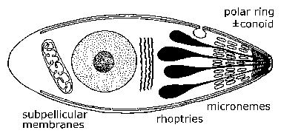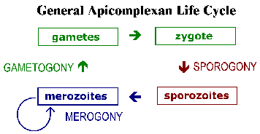
General Apicomplexan structures
- Most members have a complex life-cycle, involving both asexual (schizogony or merogony) and sexual (gametogony and sporogony) reproduction.
- Typically, a host is infected via an active invasion by the oocyst containing numerous sporocyst, which divide to produce sporozoites that enter its cells.
- Within the host cells, the sporozoites transform in to trophozoites (schizonts), and each releasing merozoites internally. Eventually, the cells burst, releasing merozoites which infect new cells.
- This may occur several times, until some merozoites transform into male (microgametocyte, each one will develops into several microgametes) and female (macrogametocyte, each one will develops into one macrogamete), which forming gametes that fuse to create new cysts (oocyst).
- There are many variations on this basic pattern, however, and many Apicomplexa have more than one host.

Coccidia
- Are microscopic, spore-forming, single-celled parasites.
- Are obligate, intracellular parasites (they must live and reproduce within host cells).
- Coccidiosis is a parasitic disease of the intestinal tract of humans and animals, caused by coccidian protozoa belong to four genera: Cryptosporidium sp., Isospora belli, Sarcocystis and Toxoplasma gondii).
- The disease spreads from one host to another by contact with infected feces, or ingestion of infected tissue.
- Diarrhea, which may become bloody in severe cases, is the primary symptom.
- Have a complex life cycle, involving both asexual (schizogony or merogony) and sexual (gametogony and sporogony) reproduction.
- The infective oocysts in species of Isospora belli and Sarcocystis produce two internal sporocysts, each with four sporozoites; in Cryptosporidium the sporocyst stage is omitted.
- Only two species of coccidian known to undergo schizogony and gametogony in man, viz., Isospora belli & Cryptosporidium.
Cryptosporidium (cryptosporidiosis)
- The first human cases of cryptosporidiosis were reported in 1976.
- Initially it was believed to be a rare and exotic infection.
- Now recognized as a common human pathogen and a frequent cause of diarrhea in humans.
- In immunocompetent individuals this diarrhea is self-limiting and last about two weeks.
- The disease is quite serious and potentially life-threatening in immunodeficient patients (especially AIDS) and is characterized by a profuse watery diarrhea.

Life cycle

All known stages of this parasite found in the brush border of the mucosal epithelium of stomach and intestine. Cryptosporidium is capable of completing its life cycle in one host (monoxenous). Sporulated oocysts, containing 4 sporozoites, are excreted by the infected host through feces and possibly other routes such as respiratory secretions Transmission of Cryptosporidium parvum, C. muris and C. hominis occurs mainly through contact with contaminated water (e.g., drinking or recreational water) or exposure to infected animals Following ingestion (and possibly inhalation) by a suitable host, excystation occurs.
In contrast to other coccidia, Cryptosporidium sporozoites do not invade the enterocytes. Instead they induce an extension and fusion of the microvilli resulting in the parasite becoming surrounded by a double membrane of host origin. Even though the parasite is surrounding by host membranes it is not intracellular and is referred to as being 'extracytoplasmic'. A junction, called the 'feeder organelle' or the 'adhesion zone', forms between the parasite and the host enterocyte. The parasite, now called a trophozoite, likely derives nutrients from the host cell via this junction. The trohozoites within the brush border of epithelial cells (, ) of the gastrointestinal tract or other tissues such as the respiratory tract, undergo asexual multiplication (schizogony or merogony) (, , ) and then sexual multiplication (gametogony) producing microgamonts (male) and macrogamonts (female) . Upon fertilization of the macrogametes by the microgametes (), oocysts (, ) develop that sporulate in the infected host. Two different types of oocysts are produced, the thick-walled oocyst, which is commonly excreted from the host, and the thin-walled oocyst , which is primarily involved in autoinfection. Oocysts are infective upon excretion, thus permitting direct and immediate fecal-oral transmission.

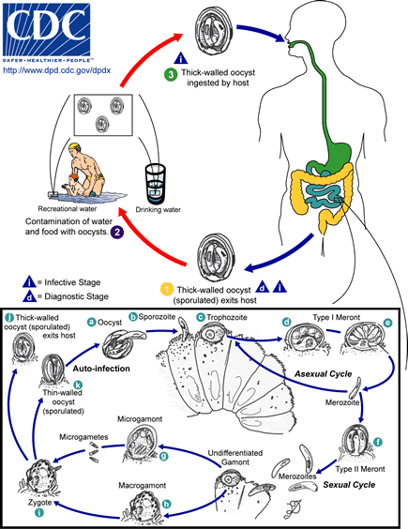

Pathogenesis:
The most common clinical manifestation of cryptosporidiosis is a mild to profuse watery diarrhea. This diarrhea is generally self-limiting and persists from several days up to one month. Recrudescences are common. Abdominal cramps, anorexia, nausea, weight loss and vomiting are additional manifestations which may occur during the acute stage. The disease can be much more severe for persons with AIDS which manifests as a chronic diarrhea lasting for months or even years.
Diarrhea can have osmotic, inflammatory, or secretory components.
- Osmotic diarrhea : epithelia malfunction [epithelial cells damaged or killed:] which lead to:
  - Impaired absorption: villus atrophy (blunting) (↓ Na⁺ absorption) and ↑ intercellular permeability.
  - Enhanced secretion: crypt cell hyperplasia ↑ Cl⁻ secretion.
- Inflammatory diarrhea [inflammation in lamina propria] mucosal invasion and leukocytes in stools. This phenomenon could also contribute to the secretory process via cytokines and neurohormones. For example, macrophages secreting tumor necrosis factor-alpha (TNF-α) or other cytokines may stimulate fibroblasts and other cells in the lamina propria to secrete prostoglandins (PGE) and other products (eg., reactive oxygen intermediates). These products may then promote secretion and impair absorption.
- Secretary diarrhea (toxin associated & watery): The watery nature of the diarrhea has suggested the presence of an enterotoxin. However, there is no evidence for a toxin-mediated secretory diarrhea despite efforts to identify such a toxin.
Diagnosis: stool examination for detection of Oocysts.
Treatment: In immunocompetent persons is self-limited diarrhea. Rapid loss of fluid managed by fluid and electrolyte replacement.
Epidemiology:
- Fecal- oral disease.
- two distinct transmission cycles in humans involving two different populations of Cryptosporidium:
1) An exclusively anthroponotic (i.e., human-to human) cycle caused by genotype 1 (or C. hominis) and
2) A zoonotic cycle caused by genotype 2 (or C. parvum).

- Factors Favoring Waterborne Cryptosporidiosis:
- small size of oocysts (4-5 mm)
- reduced host specificity and monoxenous development
- close associations between human and animal hosts
- large number of oocysts excreted (up to 100 billion per calf per day)
- low infective dose (<30)
- robust oocysts; resistant to chlorine
Control: Improvement in sanitary and hygienic conditions is indicated.

Isospora belli (coccidiosis belli)

- I. belli is a rare infection of normal humans.
- The infection occurs via the oral-fecal route.
- Infects the epithelial cells of S.I. and produces self limiting diarrhea in normal individuals.
- It has worldwide distribution but more common in tropical regions and areas with poor sanitation.

Life cycle:
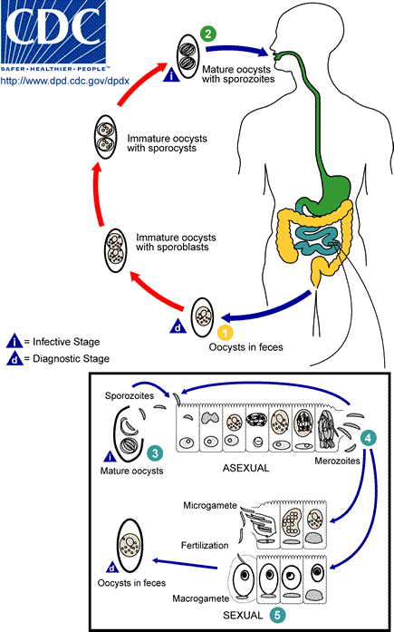

At time of excretion, the immature oocyst contains usually one sporoblast (more rarely two). In further maturation after excretion, the sporoblast divides in two sporoblasts. The sporoblasts secrete a cyst wall, thus becoming sporocysts; and the sporocysts divide twice to produce four sporozoites each. Infection occurs by ingestion of sporocysts-containing oocysts: the sporocysts excyst in the small intestine and release their sporozoites, which invade the epithelial cells and initiate schizogony . Upon rupture of the schizonts, the merozoites are released, invade new epithelial cells, and continue the cycle of asexual multiplication. Trophozoites develop into schizonts which contain multiple merozoites. After a minimum of one week, the sexual stage begins with the development of male and female gametocytes. Fertilization results in the development of oocysts that are excreted in the stool

Pathogenesis:
Infection causes acute, non bloody diarrhea with crampy abdominal pain, which can last for weeks and result in malabsorption and weight loss. In immunodepressed patients, and in infants and children, the diarrhea can be severe. Eosinophilia may be present (differently from other protozoan infections).

Diagnosis: Microscopic demonstration of oocysts in stool examination.
Treatment: Trimethoprim is the drug of choice.
Control: Improvement in sanitary and hygienic conditions is indicated.

Cyclospora (Cyclosporosis)
- The first human cases of Cyclospora cayetanenis were reported in 1979.
- It was originally referred to as cyanobacteria-like bodies or coccidian-like bodies (CLB).
- The organism was confirmed to be a coccidian parasite with an oocyst structure in 1994.
- Molecular studies indicate a close relationship to Eimeria, an important veterinary parasite of poultry and other livestock.
- C. cayetanenis has a worldwide distribution, but appears to be especially prevalent in Latin America, the Indian subcontinent, and Southeast Asia.
- In developed countries the infections are usually associated with either food borne outbreaks or traveler's diarrhea.
Life cycle:
The life cycle of Cylcospora is similar to Isospora . The infection is acquired through the ingestion of oocysts. The structure of the Cyclospora oocyst is different from that of Isospora. The oocyst of Cyclospora contains two sporocysts which each contain two sporozoites, while the oocyst of Isospora contains two sporocysts which each contain four sporozoites.

Pathogenesis:
- Cyclospora primarily infects epithelial cells in the upper portion of the small intestine.
- Symptoms are similar to the gastroenteritis caused by Isospora and Cryptosporidium which typically includes cycles of watery diarrhea and periods of apparent remission.
- As is also the case for Cryptosporidium and Isospora, the diarrhea caused by Cyclospora in AIDS patients is much more severe than in immunocompetent persons.
Epidemiology:
- Soil transmitted infection in endemic areas.
- Several outbreaks in the United States and Canada have been associated with food borne transmission [fresh produce imported from endemic areas (South and Central America)]. In particular, berries and leafy vegetables have been identified as the probable contaminated item.
- The majority of the cases in Europe and Australia have been associated with travel to endemic countries.
Diagnosis, treatment and control: like Isospora.

Blastocystis hominis
- It has been previously considered as yeasts, fungi, or ameboid, flagellated, or sporozoan protozoa.
- Recently based on molecular studies, B. hominis has been placed within an informal group, the stramenopiles.
- Stramenopiles a heterogeneous evolutionary assemblage of unicellular and multicellular protists including brown algae, diatoms, chrysophytes, water molds, slime nets, etc.

Pneumocystis jirovecii

Pneumocystis jirovecii (previously classified as Pneumocystis carinii) was previously classified as a protozoa. Currently, it is considered a fungus based on nucleic acid and biochemical analysis.

End of lecture 11 protozoa

