Parasitology
Lecture 13 Protozoa 27.3.2018 د. وسام

Microsporidia (Microspordiosis)
- The term microsporidia is also used as a general nomenclature for the obligate intracellular parasites belonging to the Kingdom: protozoa, phylum Microsporidia. Previously, they were grouped with Sporozoa.
- They are obligate intracellular, spore-forming unicellular parasites.
- More than 1,200 species belonging to 143 genera have been described as parasites infecting a wide range of vertebrate (domestic and wild animals) and invertebrate hosts.
- Microsporidia, are characterized by the production of resistant spores that vary in size, depending on the species. No mitochondria!may be closer to fungi than protozoa!
- They possess a unique organelle, the polar tubule or polar filament, which is coiled inside the spore as demonstrated by its ultrastructure.
- There are at least 15 microsporidian species that have been identified as human pathogens
- Microsporidia have only recently been documented to parasite humans, and more research is needed to understand this infectious disease.
- Infection in humans, Microsporidiosis, is primarily found in patients with compromised immune systems; especially those infected with HIV or have undergone organ transplants.
- Some species have also been known to parasite those with health immune systems.
- After infection they influence their hosts in various ways and all organs and tissues are invaded.
- Some species are lethal, and a few are used in biological control of insects.
- Most Microsporidia develop in the cytoplasm, a few are surrounded by a parasitophorous vacuole.
Morphology
- Microsporidia are primitive eukaryotes with well defined nuclei and plasma membrane, but lack some typical organelles found in more typical eukaryotes mainly mitochondria and they have 70S ribosomes, and have simple Golgi membranes.
- Microsporidia spores are all round and oblong and those associated with human infection tend to be about 1-4 µm in size (often mistaken with bacteria).
- All have a characteristic coiled polar tube, tubule or filament, layered polarplast, a posterior vacuole (thought to function as Golgi) and a protective exospore made of proteins and chitin.
- Chitin is responsible for the spores’ high environmental resistance.
- The spores stain poorly with haematoxylin and stained better with Gram, acid-fast, Giemsa or modified trichome stains. They are G +ve.
- The spore is protected by a wall, consisting of three layers:
- an outer electron-dense exospore.
- a median, wide and structureless endospore, containing chitin.
- a thin internal plasma membrane.
- In most cases there are two closely associated nuclei, forming a diplokaryon, but sometimes there is only one.
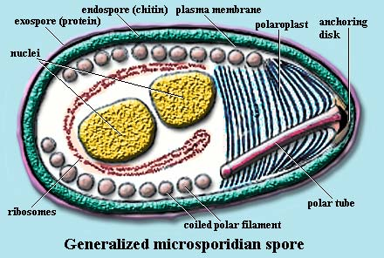
Life Cycle: The infective form of microsporidia is the resistant spore and it can survive for a long time in the environment. The spore aid transmission to the new host in contaminated water and food. In water, spores usually live more than one year at 4C⁰; in infected tissues, they survive even longer. The spore extrudes its polar tubule and infects the host cell. The spore injects the infective sporoplasm into the eukaryotic host cell through the polar tubule. Inside the cell, the sporoplasm undergoes extensive multiplication either by merogony or schizogony . This development can occur either in direct contact with the host cell cytoplasm or inside a vacuole termed parasitophorous. Either free in the cytoplasm or inside a parasitophorous vacuole, microsporidia develop by sporogony to mature spores. During sporogony, a thick wall is formed around the spore, which provides resistance to adverse environmental conditions. When the spores increase in number and completely fill the host cell cytoplasm, the cell membrane is disrupted and releases the spores to the surroundings. These free mature spores can infect new cells thus continuing the cycle.
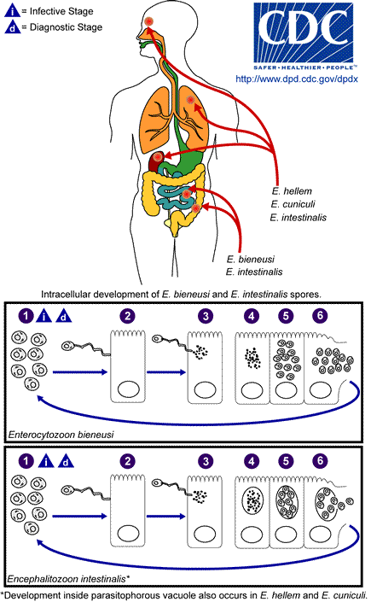
Pathogenesis:
Human microsporidiosis represents an important and rapidly emerging opportunistic disease, occurring mainly, but not exclusively, in severely immunocompromised patients with AIDS. Additionally, cases of microsporidiosis in immunocompromised persons not infected with HIV as well as in immunocompetent persons also have been reported. The clinical manifestations of microsporidiosis are very diverse, varying according to the causal species with diarrhea being the most common. Other organs (other than SI) such as eye, lung, kidney, liver, gall bladder, muscles and brain may also infect.
Epidemiology
- Microsporidia are extremely widespread.
- They infect nearly every organism on earth from honey-bees and silkworm to mammals and birds.
- Relatively little is known about the epidemiology of microsporidia.
- Though active microsporidia spores have been found in water sources in developed and developing nations, microsporidiosis remains primarily a disease of HIV and AIDS patients.
- Microsporidia has been reported to infect 39% of AIDS patients with diarrhea and 30% of AIDS patients with Cryptosporidium.
- Among non-HIV-infected, but immune-suppressed individuals, microsporidia have infected organ transplant recipients, children, the elderly, patients with malignant disease and diabetes.
- In healthy immune-competent seronegative populations, self-limiting diarrhea occurred in travelers and as a result of a food borne outbreak associated with contaminated cucumbers.
- Vertical transmission of microsporidia is frequently reported. In the case of insect hosts, vertical transmission often occurs as transovarial transmission, where the microsporidian parasites pass from the ovaries of the female host into eggs and eventually multiply in the infected larvae.
Diagnosis:
- Microscopic examination of the stained clinical smears, especially the fecal samples.
- Transmission electron microscopy (TEM).
- Immunofluorescence assays (IFA).
- Molecular methods (mainly PCR)
Treatment:
Microsporidial infections are difficult to treat because of their intracellular habit and the resistant nature of the spores. The treatment of microspordiosis varies according to site of infection and clinical manifestation.
(Unbidden) Microsporidian species | Clinical manifestation
Anncaliia algerae | Keratoconjunctivitis, skin and deep muscle infection
Enterocytozoon bieneusi | Diarrhea, acalculous cholecystitis
Encephalitozoon cuniculi and Encephalitozoon hellem | Keratoconjunctivitis, infection of respiratory and genitourinary tract, disseminated infection
Encephalitozoon intestinalis (syn. Septata intestinalis) | Infection of the GI tract causing diarrhea, and dissemination to ocular, genitourinary and respiratory tracts
Microsporidium spp. | Infection of the cornea
Nosema sp., Anncaliia connori | Ocular infection
Pleistophora sp. | Muscular infection
Trachipleistophora anthropophthera | Disseminated infection
Trachipleistophora hominis | Muscular infection, stromal keratitis, (probably disseminated infection)
Tubulinosema acridophagus | Disseminated infection
Vittaforma corneae (syn. Nosema corneum) | Ocular infection, urinary tract infection

End of lecture 13 protozoa

