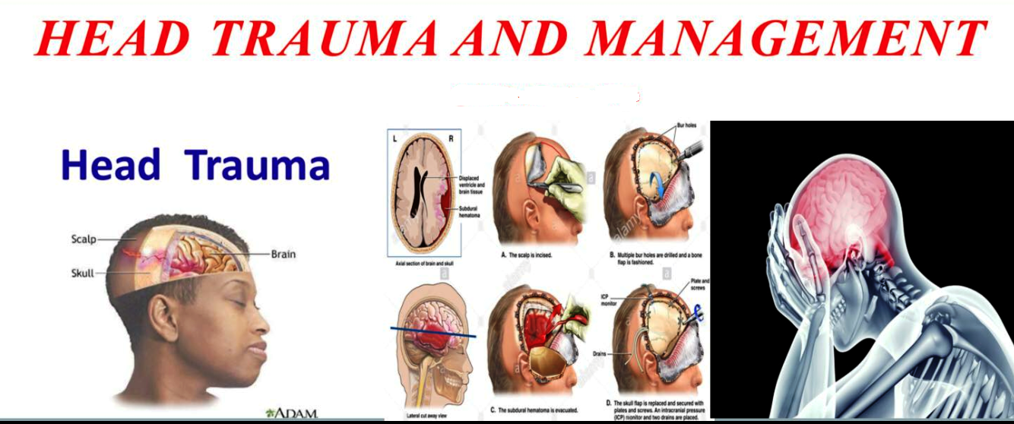
Dr mohamed al Tamiami :5th class lecture 1 on

Head injury is defined as traumatic injury involving the cranium and intracranial structures
Traumatic brain injury and head injury are often used interchangeably
Maxillofacial injuries are not part of head injuries

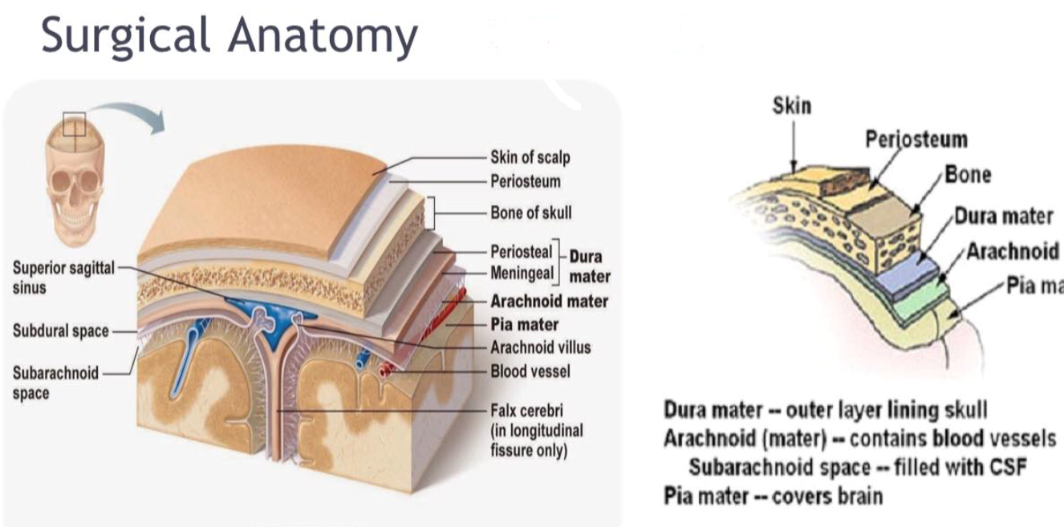

Head injury is an enormous public health problem, it is one of the most common causes of admission to the ER and ICU world wide
The most common causes of head injury include road traffic accidends, falls, assaults, sports and penetrating traumas
It occurs in all age groups, with peak incidence at 16-25 years to be more common in males
Pathophysiology
Brain is containrd within the skull, arigid and inelastic container, hence only small rise in volume within the intracranial compartment can be tolerated before pressure increases dramatically
An important concept in TBI pathophysiology is the cerebral perfusion pressure(CPP), which is the difference between mean arterial pressure and the intracranial pressure
Classification
Type of injury: open (penetrating) or closed(blunt)
Site of injury (vault, basal) or ( boney , soft tissue, brain, meningeal spaces)
Pathology of injury (focal or diffused)
Severity of injury (mild, moderate, severe)
Blunt injury
A moving head strikes affixed object or a moving object strikes an immobile head resulting into scalp injuries or fractured skull or locally contused brain
Injuries resulting from rapid deceleration of head causes motion of brain with in the cranial cavity and hitting the inner table boney protuberances resulting into brain surfaces contusion( coup, countercoup, intermediate coup) in low velocity injuries or diffused axonal injuries and brain concussion in high velocity ones
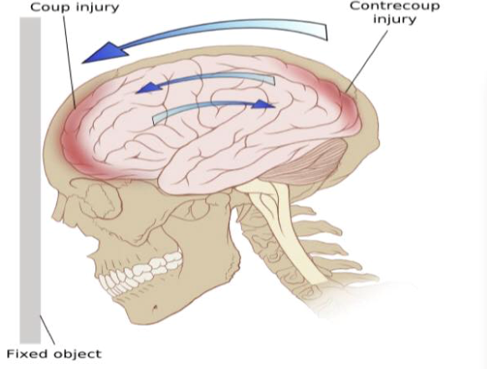
coup is a macroscopical damage occurs directly under the site of impact while countercoup occurs on the opposite site of impact

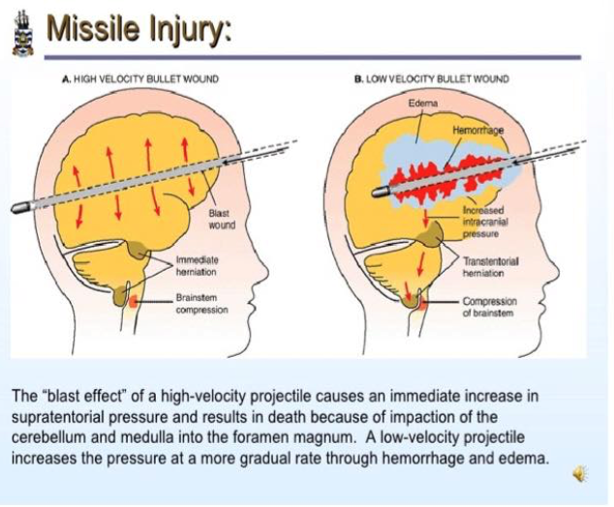
Penetrating injuries
High velocity :bullets
Low velocity : knifes, Arrows, Screwdrivers etc

Brain injuries
It can be classified as primary or secondary injuries
primary injury is defined as the initial damage that occurs immediately as a result of trauma and may include cerebral concussion, contusion, laceration, diffused axonal injury while
secondary injuries are the result of neurophysiological and anatomical changes resulting from the ongoing metabolic cascade of events as a response to primary injury and can happen minutes to days after the original trauma and may include cerebral oedema, cerebral ischemia, intracranial hematomas, infection, epilepsy and brain herniation
cerebral concussion is a slight distortion causing temporary physiological changes leading to transient loss of consciousness with complete recovery
cerebral contusion is more severe degree of damage with bruising and cerebral oedema leading to diffused or localized changes
cerebral lacerations are tearing of brain surface and blood collection in different spaces with displacement of dural spaces
diffused axonal injuries occur as aresult of mechanical shearing following acceleration-deceleration forces with disruption or tearing of axons at the grey white matter interfaces

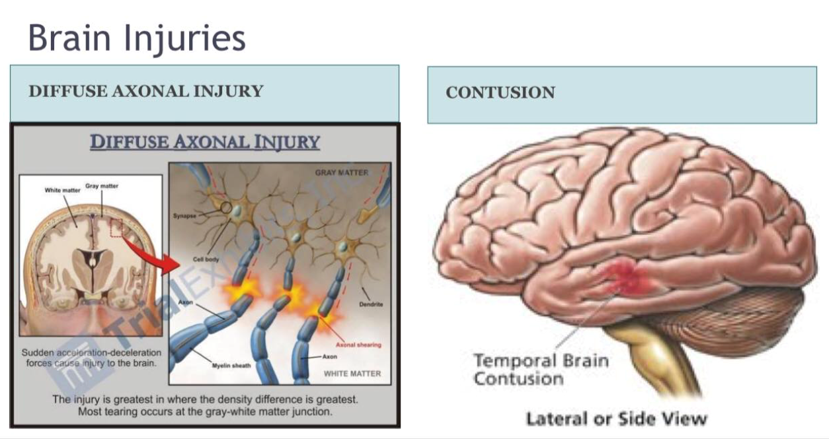

Effects of brain injury( secondary injury)
Brain oedema an accumulation of fluid both intra and extracellular due to congestion and dilatation of blood vessels, it may be diffused or localized
Brain necrosis results from hemorrhagic destruction and infarction
Brain ischemia is due to raised ICP resulting into alteration of brain perfusion which itself aggrevates ischemia and this forms vicious cycle that leads to more diffused ischemia of brain
Herniation syndromes are due to raised ICP and can be classified as either supra or infratentorial herniation
supratentorial herniations include subfalcine(central), external, transtentorial ( central) and uncal :the patient has compression of ipsilateral cranial nerve 3 and mid brain
infraentorial herniation include infratentorial compartment herniaion through foramen magnum where there will be obsrucion of of cerebral aqueduct and brain stem damage
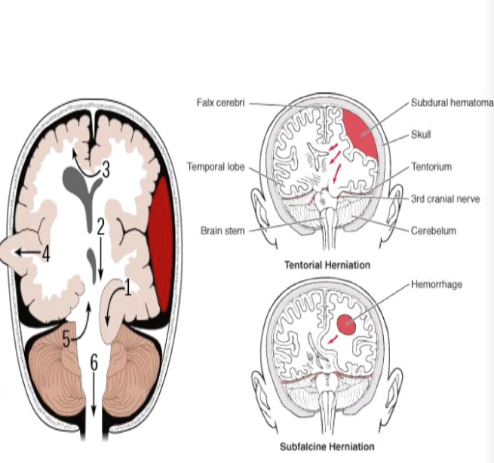

Clinical approach
History to include questions regarding mechanism of injury, loss of consciousness or amnesia, primary level of consciousness and its progress, current symptoms, probable hypoxia or hypotention,preexisting medical condition and medications if any
Evaluation utilizing ATLS guidelines, ABCDE approach, resuscitation and primary survey, neurological assessment and then secondary survey
Neurological assessment include level of consciousness, Glasgow coma scale, pupillary examination, vital signs, reflexes, limb movements
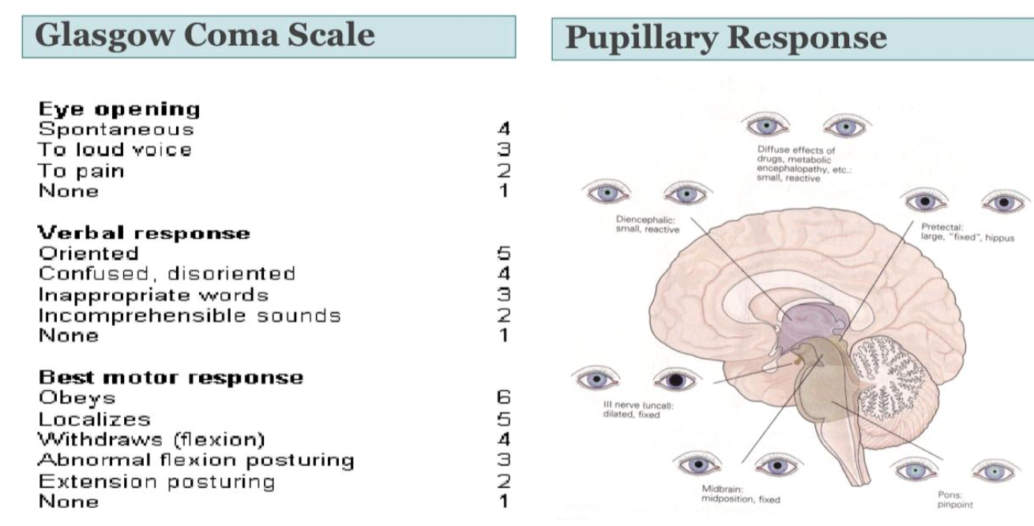
Secondary survey includes general repeated assessment and search for other injuries together with review of ABCDE parameters and ICP monitoring

Invesigaions
Basic tests ( CBC, electrolytes, sugar, b group)
Skull xray and cervical xray for suspected cases or unconscious paients
CT and MRI brain
Investigations for other injuries like abdominal US
Intracranial pressure monitoring

