The monitoring of fetal well-being during labour
2018
DR .DINA AKEEL SALMAN
Objective
- At the end of this lecture 4th year student will be able to:
- Explain the fetal heart rate pattern
- Identify reassuring and non-reassuring fetal heart pattern
- Describe and differentiate among intervention for managing specific fetal heart rate pattern

Women must be made aware in the antenatal period of the options available for fetal monitoring during labor
Fetal monitoring
1. Monitoring and assessment in early labour
Offer intermittent auscultation of the fetal heart rate to women at low risk of complications in established first stage of labour. Abdominal palpation should be performed to determine the optimal area for listening to the fetal heart.
• Use either a Pinard stethoscope or Doppler ultrasound (document what device used)
• Carry out intermittent auscultation immediately after a contraction for at least 1 minute, at least every 15 minutes, and record it as a single rate
• Record accelerations and decelerations if heard
• Palpate the maternal pulse hourly, or more often if there are any concerns, to differentiate between the maternal and fetal heartbeats
• Enquire about the presence of fetal movements as a marker of fetal wellbeing
- If there is a rising baseline fetal heart rate or decelerations are suspected on intermittent auscultation, actions should include:
1. Carrying out intermittent auscultation more frequently, for example after 3 consecutive contractions initially.
2. Thinking about the whole clinical picture, including the woman’s position and hydration, the strength and frequency of contractions and maternal observations. If a rising baseline or decelerations are confirmed, further actions should include:
A. Informing the coordinator that the management has changed from intermittent auscultation to continuous electronic fetal monitoring.
B. Advising continuous CTG, and explaining to the woman why it is needed
C. Transferring the woman to Obstetric-led care, provided that it is safe and appropriate to do so. The maternal pulse should be palpated at the initial assessment, hourly throughout labour and if an FHR abnormality is detected, to differentiate between the two heart rates.
2. Monitoring in established labour
• First stage of labour: the fetal heart rate should be auscultated as a minimum every 15 minutes for a minimum of one minute after a contraction
• Second stage of labour: the fetal heart rate should be auscultated after every contraction, or at least every 5 minutes
• Hourly maternal pulse on the partogram to differentiate between fetal heart and maternal pulse.
Monitoring in established labour
1. Amount and color of amniotic fluid
A. Clear liquor of normal amount is reassuring
B. Absent liquor, blood stained, meconium attained raised the suspicion
2. The cardiotocograph (CTG)
Is a continuous tracing of the fetal heart rate used to assess fetal wellbeing, together with an assessment of uterine activity. Cardiotocography is sometimes called electronic fetal monitoring (EFM). The CTG recordings obtained with the pregnant woman positioned comfortably in a left lateral or semi-recumbent position to avoid compression of the maternal vena cava. Two external transducersare placed on the mother’s abdomen, each attached with a belt. One transducer is a pressure-sensitive contraction tocodynometer (stretchgauge) that measures the pressure required to flatten a section of the abdominal wall. This correlates with the internal uterine pressure and indicates if there is any uterine activity (contractions). The second transducer uses ultrasound and the Doppler effect to detect motion of the fetal heart, and measures the interval between successive beats, thereby allowing a continuous assessment of fetal heart rate. Recordings are then made for at least30 minutes with the output from the CTG machine producing two ‘lines’ traced onto a running piece of paper, one a tracing of fetal heart rate and a second a tracing of uterine activity. The mother may be given a button to press to record any fetal movements that she has felt. In addition, the CTG machine may record fetal movements detected via the tocodynometer.
2.1 Principles for intrapartum CTG trace interpretation
• When reviewing the CTG trace, assess and document contractions and all 4 features of fetal heart rate:
1. Baseline rate
2. Baseline variability
3. Presence of accelerations
4. Presence or absence of decelerations (and concerning characteristics of variable decelerations* if present)
1. Baseline fetal heart rate Use the following categorizations for baseline fetal heart rate:
• Reassuring: 110 to 160 beats/minute
• Non-reassuring: 100 to 109 beats/minute or 161 to 180 beats/minute
• Abnormal: below 100 beats/minute or above 180 beats/minute
2. Baseline variability; the interval between successive fetal heart rate (beat to beat) varies.
Use the following categorizations for fetal heart rate baseline variability:
• Reassuring: 5 to 25 beats/minute
• Non-reassuring: less than 5 beats/minute for 30 to 50 minutes
More than 25 beats/minute for 15 to 25 minutes
• Abnormal: less than 5 beats/minute for more than 50 minutes
more than 25 beats/minute for more than 25 minutes
3. Accelerations
The presence of fetal heart rate accelerations, even with reduced baseline variability, is generally a sign that the baby is healthy. The absence of accelerations on an otherwise normal CTG trace does not indicate fetal acidosis.
4. Decelerations
When describing decelerations in fetal heart rate, specify:
• Their timing in relation to the peaks of the contractions
• The duration of the individual decelerations
• Whether or not the fetal heart rate returns to baseline.
Types of decelerations
The type of the deceleration is distinguished on the basis of its waveform.
• Gradual decrease and return to baseline with time from onset of the deceleration to nadir >30 second
• Abrupt decrease in FHR of > 15 beats per minute with onset of deceleration to nadir < 30 seconds
Early deceleration:
Gradual decrease in FHR with onset of deceleration to nadir >30 seconds. The nadir occurs with the peak of a contraction.as in figure 1
Late Deceleration:
Gradual decrease in FHR with onset of deceleration to nadir >30 seconds. Onset of the deceleration occurs after the beginning of the contraction, and the nadir of the contraction occurs after the peak of the contraction.as in figure 2

Variable:
Abrupt decrease in FHR of > 15 beats per minute measured from the most recently determined baseline rate. The onset of deceleration to nadir is less than 30 seconds. The deceleration lasts > 15 seconds and less than 2 minutes. A shoulder, if present, is not included as part of the deceleration. As in figure 3

Figure 1

Early deceleration:  Gradual decrease in FHR with onset of deceleration to nadir >30 seconds. The nadir occurs with the peak of a contraction. | 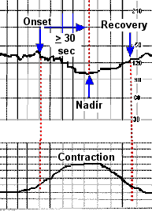
Late Deceleration:  Gradual decrease in FHR with onset of deceleration to nadir >30 seconds. Onset of the decleration occurs after the beginning of the contraction, and the nadir of the contraction occurs after the peak of the contraction.  Figure 2 | 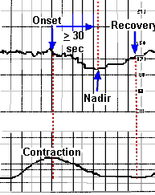
Variable:  Abrupt decrease in FHR of > 15 beats per minute measured from the most recently determined baseline rate. The onset of deceleration to nadir is less than 30 seconds. The deceleration lasts > 15 seconds and less than 2 minutes. A shoulder, if present, is not included as part of the deceleration.  Figure 3 | 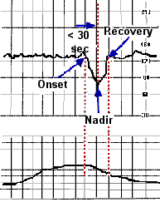
The overall impression can be described as either: OR INTERPRETATION OF CTG
Reassuring
Suspicious
Pathological
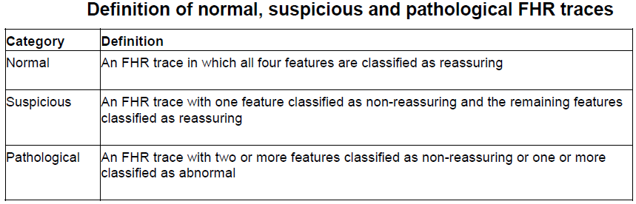

Management of CTG traces
If there is a stable baseline fetal heart rate between 110 and 160 beats/minute and normal variability, continue usual care as the risk of fetal acidosis is low.
Acute bradycardia
If there is an acute bradycardia, or a single prolonged deceleration for 3 minutes or more:
- Urgently seek obstetric help.
- If there has been an acute event (for example, cord prolapse, suspected placental abruption or suspected uterine rupture), expedite the birth or correct any underlying causes, such as hypotension or uterine hyper stimulation.
- Start one or more conservative measures.
- Lateral position ;avoid the compression of inferior vena cava and aorta by gravid uterus
- Oxygen ; is administered 6-8L/min to the mother by mask to improve fetal O2
- 3. Correction of dehydration by IV crystalloid to improve intravascular volume and uterine perfusion
- Correction of maternal hypotension
- Stop oxytocin
- Tocotytic ; given if the uterus hypertonic if the fetal heart rate remain non reassuring need further test by fetal blood sampling

.Fetal blood sampling

Be aware that for women with sepsis or significant meconium (see ongoing assessment), fetal blood sample results may be falsely reassuring, and always discuss with a consultant obstetrician:
1. Whether fetal blood sampling is appropriate
2. Any results from the procedure if carried out.

Fetal blood sampling obtained if the cardiotocograph trace remains pathological. When considering fetal blood sampling, take into account the woman's preferences and the whole clinical picture. When considering fetal blood sampling,explain the following to the woman and her birth companion(s) Why the test is being considered and other options available, including the risks, benefits and limitations of each.
The blood sample will be used to measure the level of acid in the baby's blood, which may help to show how well the baby is coping with labour.
The procedure will require her to have a vaginal examination using a device similar to a speculum.
A sample of blood will be taken from the baby's head by making a small scratch on the baby's scalp.
A caesarean section or instrumental birth (forceps or ventouse) may be advised, depending on the results of the procedure

Take fetal blood samples with the woman in the left-lateral position. Use either pH or lactate when interpreting fetal blood sample results. Use the following classifications for fetal blood sample results:
PH: – normal: 7.25 or above; observe CTG and repeat the sample one hour later
Borderline: 7.21 to 7.24 –repeat the sample in 30 mim
Abnormal: 7.20 or below; Expedite delivery
Or
Lactate: normal: 4.1 mmol/l or below
Borderline: 4.2 to 4.8 mmol/l
Abnormal: 4.9 mmol/l or above

- SURGICAL
Cesarean delivery should be done with a 15 degree lateral tilt till the baby is delivered.

