**Family and Community Medicine Dept**

**Third Grade/ 2018-19 (1st term) Prof Dr Najlaa Fawzi**

**“Students” t-test**

**Objectives:**

- Define t –test

- Identify the criteria for applying t-test

- Describe the applications of t –test

- Outline the assumptions of t-test

- Outline one sample t-test

- Out line independent groups t-Test (pooled t –test).

**A t-test** is one of the most frequently used procedures in statistics.

Student’s t-Test (’Student’ pseudonym of William Gosset).

**A t-test:** is an analysis of two populations means through the use of statistical examination; a t-test with two samples is commonly used with small sample sizes, testing the difference between the means of samples when the variances of two normal distributions are not known.

t- Test tell the researcher if the difference between two means is larger than would be expected by chance (i.e. statistically significant).

The t-test provides information about the results of the comparisons between the two means. Perhaps the most important element of reporting the t-test is its significance level.

The significance level tells if the difference observed between the means was greater than would be expected by chance (typically p < .05).

**t = (m - μ) / (SD/√n)**

**t- Test the degrees of freedom will be (n– 1).**

**Criteria for applying t-test**

1. Quantitative data

2. Random samples (two samples only)

3. Variables normally distributed

4. Sample size less than 30.

* **Note**

d. f ≤ 30 → we have to use t test

d. f 31- 60 → t test is preferred on Z test.

**Applications of the t- test**

1- One sample t-test, tests the mean of a single group against a known mean. {Sample mean and population mean}.

2-Independent Samples t-test (pooled t –test)

Compare the means for two small groups.

3- Paired t-test compares means from the same group at different times.

**Assumptions made in the use of t-test are:**

1- Samples are randomly selected

2- Samples are independents

3-Variables follow normal distribution

4-Sample variances are same in both the groups under study. The variances of the two populations are equal.

**One sample t-test**

**Basis:** To test whether a sample mean differs significantly from a known population mean.

**Example:** Mean Hb level of 25 preschool children was observed to be 10. 6 g/dl; SD 1.15 g/dl. Is it significantly different from mean Hb level of the population of 11 g/dl? Using α 0.05.

**Data:** represent the mean Hb level (10.6g/dl) of 25 preschool children, with SD of 1.15g/dl. And population mean Hb level was 11 g/ dl.

**Assumption:** we assume that the sample is randomly selected from normally distributed population.

**Hypothesis:**

**Ho:** there is no significant difference in mean Hb level of the sample from those in the population. m= μ

**HA:** there is a significant difference between mean Hb level of the sample from that in the population. m ≠ μ.

**Level of significance:**

**α =** 0.05

**5%** chance factor effect

**95%** influencing factor effect

**d. f** = n-1

**d. f** = 25 -1 =24

**Critical point = tabulated t = d. f & (1- α /2) {from t distribution table).**

d. f (24) & 1- α /2 (0.975) = 2.064

**Testing significance:**

**calculated t = m - μ / (SD/√n)**

**calculated t = m - μ /SE of difference**

**SE = SD/√n=** 1.15 /√25= 0.23

**Cal t** **=** (10.6 – 11) = -1.74

**Decision and conclusion:**

Cal t < tab t (1.74<2.064)

Cal t falls in acceptance area of Ho.

We not reject H0

P > 0.05

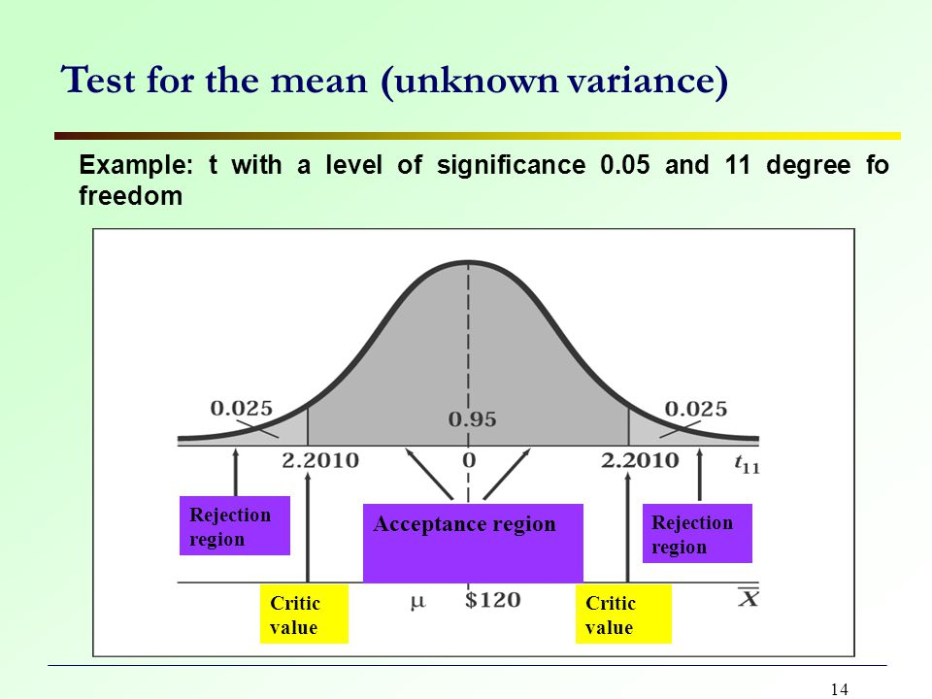

The difference between the mean Hb levels of 25 preschool children and that of population was not significant.

**Independent Groups t-Test (pooled t –test)**

**Basis:** To test whether two independent sample means come from different populations. The two groups represent the independent variable.

There is no relationship between the individuals in one sample as compared to the other. Both samples are simple random samples from their respective populations.

**Example:** study was carried out on two groups of new born babies, first group comprise 15 babies from high social class their mean birth weight was 2.91kg, SD 0.27. Second group comprise 10 babies’ low social class, with mean birth weight of 2.26 kg, SD 0.22.

Does the socioeconomic status have effect on the birth weight? α 0.01.

**Data:** mean birth weight of two groups of new born babies. First group of 15 babies from high social class their mean birth weight 2.91kg, SD 0.27, and the second group of 10 babies from low social class, their mean birth weight was 2.26 kg, SD 0.22.

**Assumption:**

1- The two samples are independent.

2- Samples are randomly selected

3- Each from normally distributed populations.

4- The variances of the two populations are equal.

**Hypothesis:**

**Ho:** there is no significant difference between mean birth weight of babies from high social class and the mean birth weight of babies from low social class. The social class had no significant effect on birth weight. m1 = m2.

**HA:** there is significant difference between mean birth weight of babies from high social class and the mean birth weight of babies from low social class. The social class had significant effect on birth weight. m1≠ m2.

**Level of significant:**

α 0.01

99% effect of factor under study (social class)

1% effect of chance factor

df = n1+ n2 -2 OR (n1-1) + (n2-1)

df= 15+10 -2 = 23

tab t df (23), 1- α/ 2

1- α/ 2= (0.995)

tab t= 2.807

**Testing significance:**

calculated t = m1-m2 / SE [**SE of difference]**

**Calculated t** = (m1-m2) / Sp √ (1/n1+1/n2)

**Sp (pooled variance) = √ [(n1-1) S1 2 + (n2-1) S22 / (n1 + n2 - 2)]**

Sp= √ (0.27)2(15-1) + (0.22)2(10-1)/15+10-2

Sp=0.25

**Sp√ (1/n1+1/n2**

SE= 0.25 √ 1/15+1/10

SE=0.25X 0.407= 0.101

**Calculated t =**2.91-2.26/0.101 = 6.435

**Decision:**

Since Cal t (6.435) > tab t (2.807)

Reject H0 Accepted HA.

p <0.01

**Conclusion:** The socioeconomic statutes has effect on birth weight.

