Respiratory and Neurological Diseases in Pregnancy

Objective learning:
1-Impact of respiratory and neurological conditions during pregnancy .
2-Effect of pregnancy on respiratory and neurological disorders.
3-Proper management of respiratory and neurological disoreders during pregnancy

Respiratory infection
the recent outbreak of H1N1 and influenza A have increased the number of maternal death due to respiratory infection.all women are adviced to have seasonal flu vaccine during pregnancy.viral pneumonia follows the more complicated courses in pregnancy.Prompt treatment and early involvment of respiratory and infectious disease specialist in addition to the intensive care is essential .bacterial pnumonia should be treated with antibiotics as ampicilline and cephalosporin are the first choice and erythromycin if atypical organism is suspected

Asthma during pregnancy
The general prevalence of asthma appears to be increasing. Recent studies report that asthma 3.7–8.4% of pregnant women. Therefore, asthma has become one of the most common medical illnesses complicating pregnancy.

Effect of Asthma on Pregnancy

Potential maternal complications include hyperemesis gravidarum, pneumonia (women with asthma account for > 60% of pneumonia cases in pregnancy), preeclampsia, vaginal bleeding, more complicated labors, and more cesarean deliveries.
Fetal complications can include intrauterine growth restriction, preterm birth, low birthweight, neonatal hypoxia, and increased overall perinatal mortality. Women with severe asthma are at the highest risk. However, patients are at little or no increased risk when the disease is effectively treated and controlled.

Management during Labor and Delivery
1-The medications that were being administered prior to the onset of labor should be continued during labor. Adequate control should be maintained because labor has been reported to trigger an acute attack in approximately 10% of women with asthma.
2-Adequate hydration should be maintained and
3-pain relief provided as necessary. Fentanyl is considered a good analgesic choice for these patients. Analgesics and/or narcotics, which can cause histamine release, should be avoided because of the possibility of respiratory depression and bronchospasm.
4-Continuous O₂ monitoring is mandatory to ensure that O₂ saturation is > 95% at all times.
5-Epidural anesthesia is preferred because it reduces O₂ consumption and minute ventilation. General anesthesia may trigger an attack, but the risk may be reduced by pretreatment with atropine ,which have a bronchodilatory effect. An anesthesiologist experienced in the care of pregnant women should be consulted ahead of time when anticipating anesthesia needs.
Medications to avoid include
1-prostaglandin F₂ because it may cause bronchospasm. Prostaglandin E₂, either gel or suppository, is safe for women with asthma and can be used if necessary from the obstetric standpoint. Oxytocin is safe and considered the medication of choice for induction.
2-Ergot derivatives should be avoided because they may precipitate bronchospasm. If postpartum hemorrhage occurs, oxytocin is the best choice. If a prostaglandin is needed, then prostaglandin E₂ is preferred.
3-Aspirin and nonsteroidal anti-inflammatory drugs (eg, indomethacin) may trigger severe bronchospasm as well as ocular, nasal, dermal and gastrointestinal inflammation in 3–8% of asthmatic patients and are best avoided.
4-Magnesium is safe for asthma but with careful monitoring to avoid respiratory depression.
Fetal monitering
1-An ultrasound examination in early pregnancy is useful to confirm dating and to provide a baseline to evaluate future growth assessment.
2-In labour There is unanimous agreement that all patients with asthma should undergo continuous fetal monitoring during labor and delivery.
Breastfeeding
Inhaled b₂ agonists,steroids (inhaled), and ipratropium are safe while breastfeeding. Systemic (oral or parenterally administered) steroids may enter into breast milk but only in small amounts if the total daily dosage contains less than 40 mg of prednisone (or equivalent steroid).
Tuberculosis
Tuberculosis in adults is mainly (> 95%) a disease of the pulmonary parenchyma caused by Mycobacterium tuberculosis. Transmission usually occurs by inhalation of droplets produced by infected individuals when coughing.
Clinical Findings
Most cases of tuberculosis can be diagnosed on the basis of a history of cough, weight loss, positive tuberculin skin test, and chest x-ray film.
Chest X-Ray Film(With the abdomen shielded and preferably after the first trimester,)
Obstetric management
Routine antepartum obstetric management includes
- adequate rest and nutrition, family support,
2-correction of anemia if present, and regular follow-up visits.
3-Immediate neonatal contact is allowed if the mother has received treatment for inactive disease and no evidence of reactivation is present.
A mother with active disease should receive at least 3 weeks of treatment before coming into contact with her baby, and the baby must also receive prophylactic INH.
4-There are no absolute contraindications to breastfeeding once the mother is noninfectious. Although antituberculosis drugs are found in breast milk, the concentrations are so low that the risk of toxicity in the infant is minimal.
5-Immunization of the newborn with bacille Calmette-Guérin (BCG) vaccine remains controversial. If prompt use of INH as prophylaxis is unlikely or if the mother has INH-resistant disease, BCG vaccination of the infant should be considered.
Prognosis
If the pregnant patient is adequately treated with antituberculosis chemotherapy for active disease, tuberculosis generally has no deleterious effect either during the course of pregnancy or the puerperium or on the fetus. Tuberculosis is not a reason for recommending a therapeutic abortion.

Epilepsy and Seizure Disorders
Epilepsy is defined as 2 or more unprovoked seizures. Seizures associated with epilepsy can be generalized convulsive (tonic-clonic or grand mal), complex partial (loss of awareness or staring with mild motor movements), focal motor or sensory (Jacksonian with no loss of awareness, absence or petit mal (brief eye blinking with no postictal confusion). The onset of epilepsy is not increased during pregnancy.
More than 95% of patients who have seizures during pregnancy have a history of epilepsy or have been receiving anticonvulsant therapy.
Causes of seziures in pregnancy
•1-epilepsy
•1- eclampsia
•3-meningitis ,encephalaits
•4-space occupying lesion
•5-cerebral vascular accident
•6-metabolic abnormality(hypoglycemia)
clinical findings
A detailed history from the patient and observers helps to distinguish true seizures from other forms of loss of consciousness, such as syncopal episodes, hysteric attacks, or hyperventilation. These problems do not commonly involve a postictal confusional state, nor do they usually involve loss of bladder or bowel control or tongue biting. Noncentral nervous system causes, such as hypoxia, hypoglycemia, hypocalcemia, and hyponatremia, also must be excluded.

Diagnosis
Detailed neurologic work-up is required in patients whose first seizure occurs during pregnancy:
- Electroencephalogram (EEG) is useful to confirm the type of epilepsy and therefore provide the appropriate drug therapy.
2-CT scan with shielding or MRI
3- lumbar puncture are useful for detailing the cause of the seizure and are not contraindicated during pregnancy.
Treatment
Treatment of epilepsy should consist of the medication that has been most beneficial for the patient and at the lowest possible dose to maintain seizure control.
During pregnancy, anticonvulsant levels change as a result of ¹decreased protein binding, ²increased plasma volume, and ³alterations in the absorption and excretion of drugs.Noncompliance, morning sickness, and hyperemesis gravidarum are other reasons for low drug levels. Therefore, blood level measurements of antiseizure medications are used to monitor and maintain a therapeutic range. Levels should be checked at least each trimester and prior to delivery.
Breakthrough seizures can result from poor sleep in the third trimester because the patient cannot obtain a comfortable sleeping position.
Complications and prognosis
Antiepileptic drugs and seizures can negatively affect a fetus. Seizures can cause
1-maternal and fetal injury,
2-spontaneous abortion, premature labor
3-fetal bradycardia.
4-All antiepileptic drugs cross the placenta, and may have teratogenic effects. The risk of anomalies among infants exposed to anticonvulsants is approximately 2-fold greater than in the general population.
The most common defects fall into 2 categories: major and minor malformations. Major malformations include orofacial clefts, neural tube defects, and congenital heart disease. Minor malformations consists of craniofacial anomalies (low-set ears, widely spaced eyes, etc), short neck, and hypoplastic fingernails.
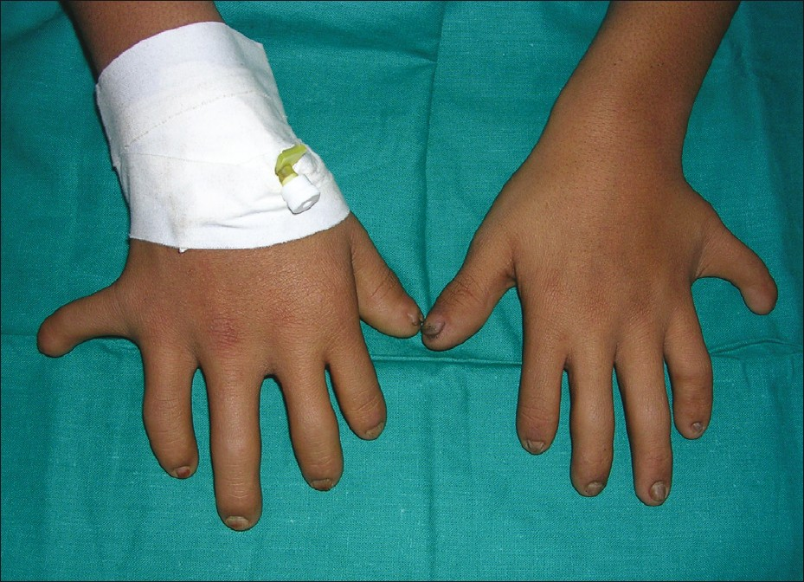

The fetal hydantoin syndrome (associated with phenytoin) was the first described association between antiepileptic drugs and birth defects.It is characterized by mental retardation, small-for–gestational-age size, craniofacial anomalies, and limb defects. 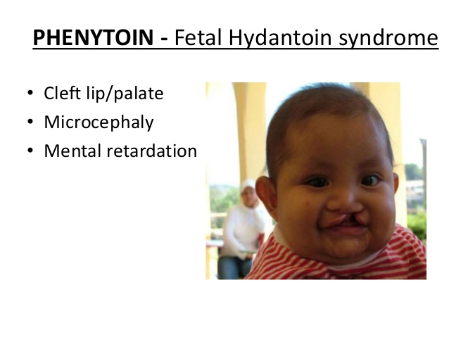
Treatment with 2 or more antiseizure medications approximately doubles the risk for malformations.
Precoceptional counselling
Women with existing seizure disorders who are contemplating pregnancy should be 1-tested to determine whether they still require anticonvulsant therapy—particularly if anticonvulsants were started during childhood or if the patient has been seizure-free for 2–5 years.
2-The patient should be counseled regarding folic acid supplementation (4 mg/d) starting at least 3 months preconceptionally to possibly reduce the chance of neural tube defects.
3-If the patient is taking an antiseizure medication metabolized by the P450 liver enzyme system, she should take vitamin K 10 mg/d from week 36 until delivery to prevent hemorrhage in her baby.
4- intramuscular vitamin K the infant will receive after delivery.
5-Antiepileptic drugs pass into the breast milk to varying degrees, depending on protein binding characteristics. The benefits of breast milk usually outweigh the small risk from the medication to the infant

