***Prolonged labour: ( Dystocia)*  Dr Ban Hadi \ F.I.C.O.G. 2019 

**Objectives:** by the end of this lecture, 4th year student should be able to

1. Define dystocia
2. Summarize the important points in history and examination to reach the diagnosis
3. Predict the management option for different case scenarioes
4. Determine the type of dystocia by different partograph's patterns

**Abnormal labour**

Labour becomes abnormal when there is:

1. Poor progress (as evidenced by a delay in cervical dilatation or descent of the presenting part)
2. The fetus shows signs of compromise.
3. There is a fetal malpresentation
4. A multiple gestation
5. A uterine scar
6. Labour has been induced

**Risk factors for abnormal labour**

Small woman

**•** Big baby

**•** Dysfunctional uterine activity

**•** Malpresentation

**•** Malposition

**•** Early membrane rupture

**•** Soft-tissue/pelvic malformation

Progress in labour is dependent on three variables:

**1. The power**, i.e. the efficiency of uterine contractions

**2. The passenger** (fetal size, presentation and position)

**3. The passages** (the uterus, cervix and bony pelvis).

**Poor progress in labour:**

***Poor progress in the first stage of labour:***

***Primary arrest***: defined as cervical dilatation of less than 2 cm in 4 hours, usually associated with failure of descent and rotation of the fetal head.

***Secondary arrest’*** occurs when progress in the active first stage is initially good but then slows or stops altogether, typically after 7 cm dilatation

***Poor progress in the second stage of labour****:*

Delay in 2nd stage is diagnosed if delivery is not imminent after 2 hours in a nulliparous woman and 1 hour for a parous woman in the 2nd stage of labour. With epidural use the birth of the baby is expected to take place within 3 hours of the start of the second stage in nulliparous woman, and 2 hours in parous woman.

**Causes of poor progress in labour:**

Abnormalities can be classified as abnormalities of the power, the passenger and the passages

***A. Dysfunctional uterine activity***

This is the most common cause of poor progress in labour. It is more common in primigravidae and perhaps in older women and is characterized by weak and infrequent contractions which can be exacerbated by epidural use.

**How would you assess uterine activity?**

1. By **clinical examination**: palpate the uterine fundus and measure the duration of contraction and its interval

2. By using **external uterine tocography**. However, this can only provide information about the frequency and duration of contractions.

3. **Intrauterine pressure catheters** are available and these do give a more accurate measurement of the pressure being generated by the contractions, but they are rarely necessary.

**Efficient uterine contractions**: when the frequency is four to five contractions per 10 minutes and each lasts for 40-50 seconds. Fewer contractions than this does not necessarily mean progress will be slow,

but more frequent examinations may be indicated to detect poor progress earlier.

***B. Abnormal fetal size, presentation and position***

Such as fetal macrosomia, conjoined twin, brow presentation and occiput posterior position.

***Malpresentation:*** defined as anything other than a vertex, as it is vital to good progress in labour is the tight application of the fetal presenting part on to the cervix in normal vertex presentation.

Presentations that can be delivered vaginally at term are: vertex, face (mento-ant.) and breech.

Presentations that are not deliverable vaginally at term are: face (mento-post., brow and shoulder.

Face presentations may apply themselves poorly to the cervix and the resulting progress in labour may be poor, although vaginal birth is still possible. Brow presentations are associated with the mento-vertical diameter, which is simply too large to fit through the bony pelvis unless flexion occurs or hyperextension to a face presentation. Brow presentation therefore often manifests as poor progress in first stage, often in a multiparous woman. Shoulder presentations cannot deliver vaginally and once again poor progress will occur. Malpresentations are more common in women of high parity because of uterine laxity and some carry a risk of uterine rupture if the labour is allowed to continue.

***Malposition:*** normal position is occiput ant., malposition is occiput post. and occiput transverse

***C.Abnormalities of the birth canal (the ‘passages’)***

The bony pelvis may cause delay in the progress of labour as in **android pelvis**. Abnormalities of the uterus and cervix can also delay labour. Unsuspected **fibroids** in the lower uterine segment can prevent descent of the fetal head. Delay can also be caused by ‘**cervical dystocia’**, a term used to describe a non-compliant cervix which effaces but fails to dilate because of severe scarring, usually as a result of a previous cone biopsy. Caesarean section may be necessary. It is rare for the soft tissues of the pelvic floor to cause significant delay in labour.

***Cephalopelvic disproportion:***

Cephalopelvic disproportion (CPD) implies anatomical disproportion between the fetal head and maternal pelvis.

***Causes of CPD: It can be due to***

1. A large head
2. A small pelvis
3. A combination of the two. Women of small stature with a large baby in their first pregnancy are likely candidates to develop this problem.
4. The pelvis may be unusually small because of previous fracture

or metabolic bone disease.

1. Rarely, a fetal anomaly will contribute to CPD. Obstructive hydrocephalus may cause macrocephaly, and fetal thyroid and neck

tumours may cause extension at the fetal neck.

1. Relative CPD is more common and occurs with malposition

of the fetal head. The occipito-posterior position is associated

with deflexion of the fetal head and presents a larger skull

diameter to the maternal pelvis

**Diagnosis of Cephalopelvic disproportion is suspected in labour if**:

1. Progress is slow or actually arrests despite efficient uterine contractions
2. The fetal head is not engaged
3. Vaginal examination shows severe moulding and caput formation
4. The head is poorly applied to the cervix.
5. Hematuria

**Management of prolonged labour:**

**A. Diagnosis:**

Partograph will diagnose long labour before obstructed labour develops, so **history should include:**

- Age, parity, gestational age

- Duration of labour, partograph abnormalities, duration of ruptured membranes (amount and colour of liquore)

- Duration of bearing down

- Antenatal records and complications as APH and medical problems

- Past Obstetric history: Previous prolonged labour, fetal death, instrumental delivery and caesarean sections

**Examination:**

- ***General exam***. Body weight, features of maternal distress: exhaustion, ketosis, dehydration, tachycardia, fever and scanty urine.

- ***Abdominal exam***.

Frequency and intensity of uterine contractions in 10 minutes

Lie, presentation, engagement, estimated fetal weight

The retraction ring (bandl's ring) is seen in obstructed labour and felt between the tonically contracted upper segment of the uterus and the distended, tender and stretched lower segment, it is the site of uterine rupture.

- fetal heart auscultation for possible fetal compromise

- ***Vaginal exam***. Pelvimetry in primigravida, cervical dilatation, fetal presentation, position and station. State of membranes, color and liquore amount. Dry hot vagina, excessive caput and moulding with high head indicates CPD.

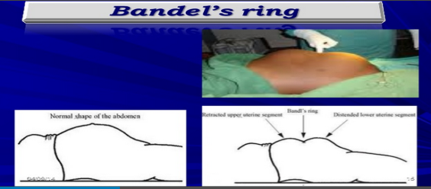

**B. Treatment**:

**Treatment of poor progress in the 1st stage of labour**:

1. Good hydration, adequate pain relief, empty bladder, cross match blood and emotional support.

2. When poor progress in labour is suspected it is usual to recommend repeat vaginal examination 2, rather than 4, hours after the last exam. and plot on partograph.

3. If delay is confirmed, the woman should be offered artificial rupture of membranes (ARM) and, if there is still poor progress in a further 2 hours; use an oxytocin infusion to augment the contractions. The infusion is commenced at a slow rate initially, and increased carefully every 30 minutes. Continuous EFM is necessary as excessively frequent and augmented contractions may cause fetal compromise.

4. Women can be offered an epidural anaesthesia

5. Augmentation with oxytocin in the presence of malposition, malpresentation or obstructed labour due to CPD may cause rupture uterus so delivery by caesarean section is indicated.

6. If progress fails to occur despite 4–6 hours of augmentation with oxytocin, a Caesarean section will usually be recommended

7. Active management of third stage of labour because of risk of PPH

**Treatment of poor progress in the 2nd stage of labour**:

1. Rehydration and intravenous oxytocin for inefficient uterine cont.
2. Instrumental birth can be considered for prolonged second stage if the safety criteria have been fulfilled
3. Caesarean delivery if the instrumental birth attempt is unsuccessful or unsafe, or if elements of obstructed labour present
4. A resistant perineum resulting in significant delay may be an indication for an episiotomy.

**Treatment of CPD:**

1. Oxytocin can be given carefully to a primigravida with mild to moderate CPD as long as the cardiotocography is reactive. Relative disproportion may be overcomed if the malposition is corrected (i.e. conversion to a flexed OA position).

2. Oxytocin must never be used in a multiparous woman where CPD is suspected

3. A Caesarean section is indicated in cases of CPD with elements of obstructed labour

**Note**: Extreme caution must be exercised when you augment labour in a multiparous woman as excessive uterine contractions in a truly obstructed labour may result in uterine rupture which is extremely rare in primiparous women. Previous scar is a risk.

**Patterns of abnormal progress in labour:**

The use of a partograph to plot the progress of labour improves the detection of poor progress. The main aim of partograph is the early diagnosis of prolonged labour before the complications of obstructed labour develop.

Normal labour progress should be at or to the left of the alert line of partograph as shown below: 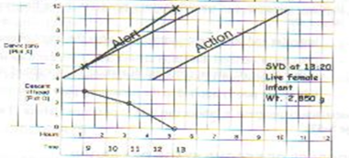

**Patterns of abnormal labour are:**

***1. Prolonged latent phase*** occurs when the latent phase is longer than the normal time limits (20 hrs in nulliparous and 14 hrs in multiparous women). It is more common in primiparous women and probably results from a delay in the chemical processes that occur within the cervix which soften it and allow effacement. Prolonged latent phase can be extremely frustrating and tiring for the woman.

**Management**: It is best managed away from the labour suite with simple

analgesics, mobilization and reassurance.

However, intervention in the form of ARM or oxytocin infusion will increase the likelihood of poor progress later in the labour and the need for Caesarean birth.

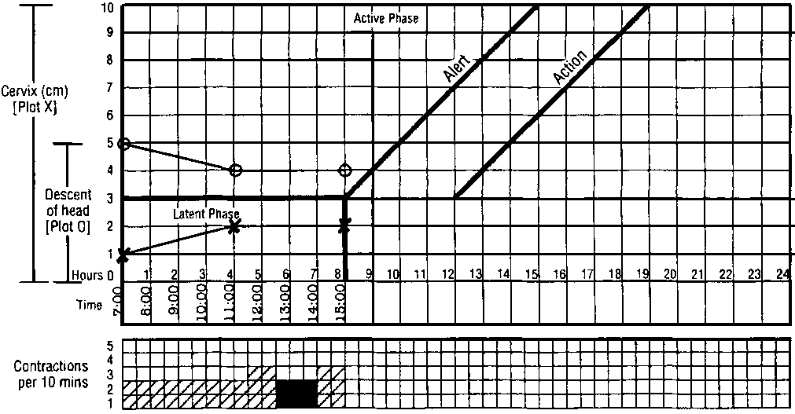

***2. Primary dysfunctional labour***: **primary arrest** is the term used to describe poor progress in the active phase of labour ( <2 cm cervical dilatation/4 hours) and is also more common in primiparous women. It is most commonly caused by inefficient uterine contractions, but can also result from CPD and malposition of the fetus.

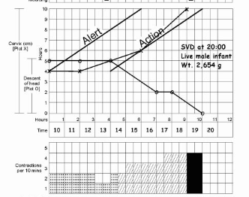

***3. Secondary arrest of cervical dilatation***: occurs when progress in the active phase of first stage is initially good but then slows, or stops

altogether, typically after 7 cm dilatation. Although inefficient uterine contractions may be the cause, fetal malpositions, malpresentations and CPD are more common than in primary dysfunctional labour

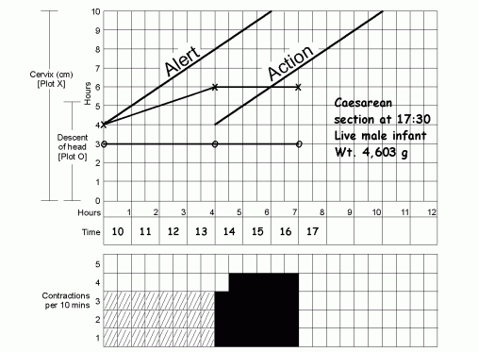

***4.Arrest of descent of presenting part:*** when the descent of the presenting part stops as assessed by abdominal and vaginal examination, fetal malpositions, malpresentations and CPD are possible causes.

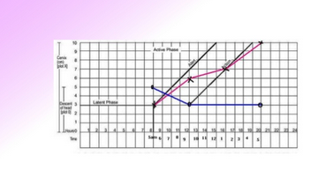

Abnormalities of the partograph



**Complications of prolonged labour:**

***Maternal*** : maternal exhaustion and dehydration, rupture of uterus, increased operative intervention, maternal injury, shock, postpartum hemorrhage, puerperal sepsis and maternal death

*Late maternal complications*: urinary fistula and infertility

***Fetal*** : birth asphyxia, acidosis, intracranial hemorrhage, meconium aspiration, fetal trauma, death and neonatal infection

*Late fetal complications*: cerebral palsy and mental retardation

***End of lecture***