Scalp

Anatomy of the Scalp
The scalp extends from the supra-orbital margins anteriorly to the superior nuchal line posteriorly & slopes on each side to the superior temporal line. The forehead is common to both the scalp & face. The scalp is composed of 5 layers indicated by the letters of the word SCALP:
- Skin: the skin of the scalp is the thickest in the body with numerous hairs & abundant sebaceous glands.
- Connective tissue: a dense fibro-fatty connective tissue binds the overlying skin to the underlying aponeurosis. It contains the vessels & nerves of the scalp.
- Aponeurosis: the epicranial aponeurosis of occipitofrontalis (galea aponeurotica) is a thin tendinous sheet that extends between the occipital & frontal bellies of occipitofrontalis muscle. Laterally it blends with the temporalis fascia just above the zygomatic arch. The subaponeurotic space is the potential space beneath the epicranial aponeurosis.
- Loose areolar tissue: this tissue occupies the subaponeurotic space. It extends anteriorly into the upper eyelids & bleeding anywhere beneath the aponeurosis may appear as a black eye by the blood tracking down through the space. This area also called the dangerous area of the scalp because the emissary veins which open here may transmit the infection from the scalp to the cranial venous sinuses.
- Pericranium: is the outer periosteum of the cranial vault. It becomes continuous with the inner periosteum of the bones (endocranium) at the sutures & thus a subperiosteal haematoma outlines the concerned bone.

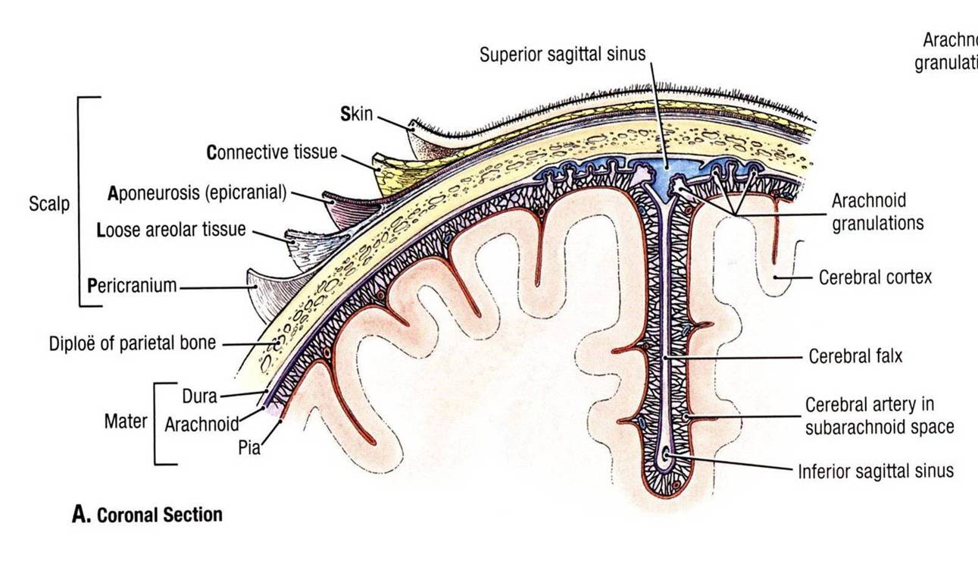

Muscles of the scalp
Occipitofrontalis is the muscle of the scalp. It consists of 2 bellies on each side connected by the epicranial aponeurosis. Occipitalis (posterior belly) arises from the superior nuchal line and attaches to the back of the aponeurosis. It’s supplied by the posterior auricular branch of the facial nerve. Frontalis (anterior belly) arises from the skin & superficial fascia of the eyebrow & attaches to the front of the aponeurosis.
It’s supplied by the temporal branch of the facial nerve. Frontalis elevates the eyebrows & produces wrinkles in the skin of the forehead. Occipitalis mainly anchors the aponeurosis posteriorly.

note: The first three layers of the scalp can be moved forward or backward as one unit, the loose areolar tissue of the fourth layer of the scalp allowing the aponeurosis to move on the pericranium.
(e.g. layers 1, 2, 3 will slide together as ONE LAYER
Arteries of the scalp
The scalp has a rich blood supply; therefore, the smallest cuts bleed profusely. The arteries supplying the scalp are:
- The supratroclear & supraorbital arteries: are branches of the opthlamic artery. They wind around the supra-orbital margin & ascend the forehead & scalp as far backwards as the vertex of the skull, accompanied by the corresponding nerves. The supratrochlear artery lies closer to the midline.
- The superficial temporal artery: is the smaller terminal branch of the external carotid artery. It ascends from the level of the neck of the mandible deep to the zygomatic arch & in front of the auricle & auriculotemporal nerve. It ends by dividing into frontal & parietal branches to the supply the skin of the scalp over the corresponding eminences.
- The posterior auricular artery: is a branch from the external carotid artery. It runs along the level of the upper border of the posterior belly of digastric muscle to reach the outer surface of the mastoid process. It gives cutaneous branches to the scalp behind the auricle. In addition it gives muscular & glandular (to parotid gland) branches and a stylomastoid branch (through the stylomastoid foramen to the facial nerve).
- The occipital artery: is a branch from the external carotid artery. It runs along lower border of the posterior belly of digastric to reach the inner surface of the mastoid process.it runs across the apex of the posterior triangle of the neck , then it pierces trapezius 2-3 cm from the midline & runs with the greater occipital nerve to supply the back of the scalp as high as the vertex.
Nerves & Arteries of the Scalp

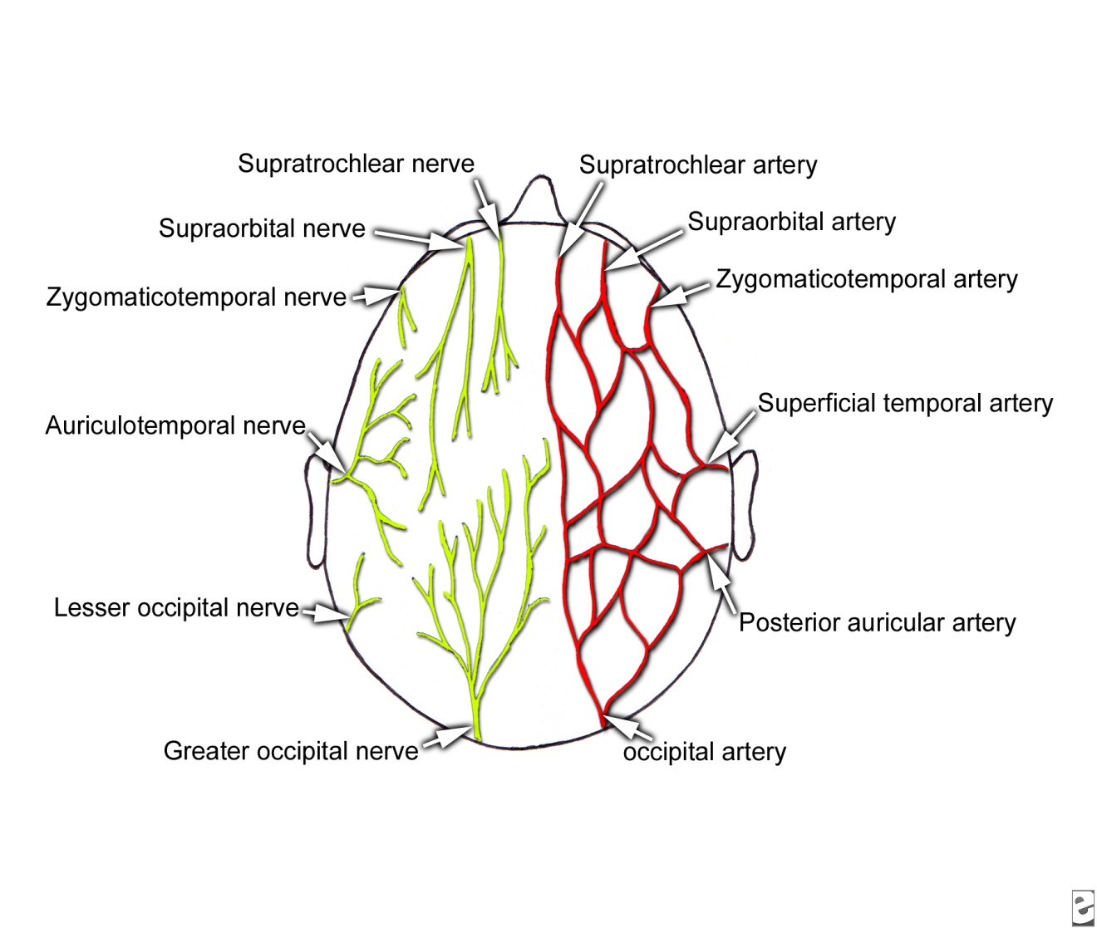

Veins of the scalp
The supratrochlear & supraorbital veins unite at the medial angle of the eye (medial canthus) to form the facial vein. The superficial temporal vein unites with the maxillary vein in the parotid gland to form the retromandibular vein. The posterior auricular vein unites with the posterior division of the retromandibular vein to form the external jugular vein. The occipital vein usually drains into the suboccipital venous plexus which in turn drains into the vertebral venous plexus or the internal jugular vein.
The veins of the scalp connect freely to one another and to 2 other types of veins:
- The intracranial sinuses: are thin-walled large calibered veins inside the cranial cavity that drain blood from intracranial structures eventually leading to the internal jugular vein.
- The diploic veins: these are 4 paired veins that lie between the diploe of the flat bones of the skull. They’re the frontal, anterior temporal, posterior temporal & occipital diploic veins.
The emissary veins are the small messenger veins that connect the superficial veins, the diploic veins & the intracranial venous sinuses to each other across the bones of the skull.

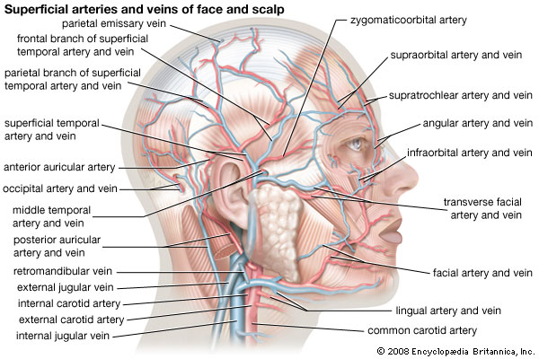

Sensory nerves of the scalp
- The supratrochlear & supraorbital nerves: are branches of the ophthalmic division of the trigeminal nerve. They run with the corresponding arteries & supply the skin of the forehead & scalp to the level of the vertex.
- The zygomaticotemporal nerve: is a branch from the maxillary division of the trigeminal nerve. It supplies the skin of the temporal region of the scalp.
- The auriculotemporal nerve: is a branch from the mandibular division of the trigeminal nerve. It ascends with & behind the superficial temporal artery & supplies the skin of the temple.
- The lesser occipital nerve: is a branch from the cervical plexus (C2) that supplies the scalp of the lateral part of the occipital region & the skin of the medial surface of the auricle.
- The greater occipital nerve: is a branch of the posterior ramus of C2 that supplies the back of the scalp as high as the vertex.
- The great auricular nerve is a branch of the cervical plexus, arises from the anterior rami of the C2 and C3 spinal nerves, ascends on the surface of the sternocleidomastoid muscle, and innervates a small area of the scalp just posterior to the ear.
- The third occipital nerve is a branch of the posterior ramus of the C3 spinal nerve, pierces the semispinalis capitis and trapezius muscles, and supplies a small area of the lower part of the scalp.
Lympahatic drainage
The scalp doesn’t contain lymph nodes. Its lymph vessels drain to the nodes of the neck:
- The anterior part (& forehead) drains into the submandibular nodes.
- The lateral part above the ear drains into the preauricular (superficial parotid) nodes.
- The part above & behind the ear drains into the mastoid nodes.
- The back of the scalp drains into the occipital nodes.

Clinical anatomy
- The subaponeurotic space extends anteriorly into the upper eyelids & bleeding anywhere beneath the aponeurosis may appear as a black eye by the blood tracking down through the space. This area also called the dangerous area of the scalp because the emissary veins which open here may transmit the infection from the scalp to the cranial venous sinuses.

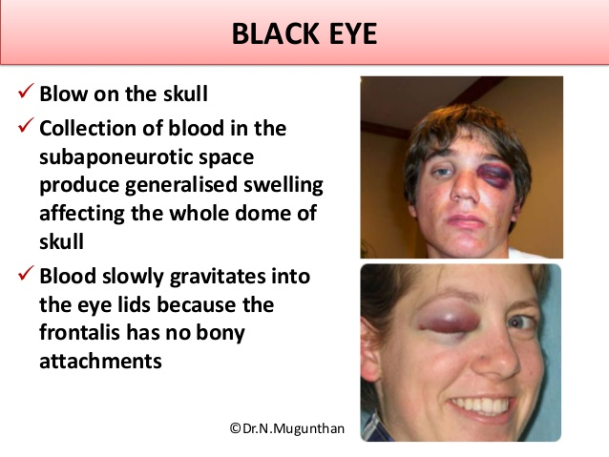

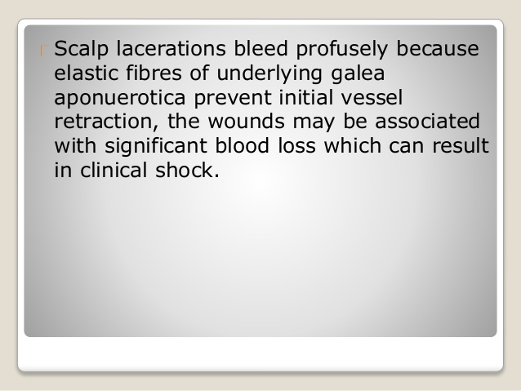
- The scalp has an extremely rich blood supply from the external carotid arteries, so lacerations of the scalp tend to bleed profusely. Importantly, scalp bleeding is predominantly arterial, because of two reasons. First, in the erect position the venous pressure is extremely low. Second, the vessels do not retract and close when lacerated because the connective tissue in which they are found holds them open.

- cephalhaematom is a hemorrhage of blood between the skull and the periosteum of a newborn baby secondary to rupture of blood vessels crossing the periosteum.

