Parasitology Trematoda Lecture 2
29-1-2020 د. حذام
Hepatic flukes:
3. Dicrocoelium dendriticum (Dicrocoeliasis):
- Adult lancet flukes have pearly bodies shaped like long, thin transparent leaves. About (5 to 15 mm) long and 2 mm wide with smooth tegument, live in the smaller bile ducts.
- Testes are located anterior to the ovary, in the anterior half of the body.
- The uterus is long uterine coil in the posterior half of the body.
- Egg is ovoid thick shelled dark brown in color have abroad convex operculum and mature miracidium.
- The primary hosts are mammals such as sheep, cattle, pigs, rabbits, deer, and woodchucks. The first intermediate hosts are land-dwelling snails, and the second intermediate hosts are ants.
Life cycle:
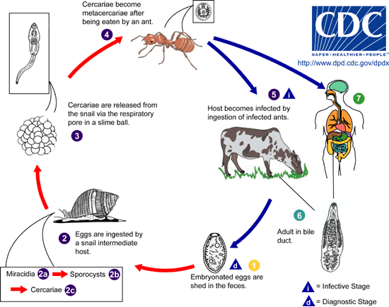
Ruminants are the usual definitive hosts for Dicrocoelium dendricitum, although other herbivorous animals, carnivores, and humans can serve as definitive hosts. Embryonated eggs are shed in feces. The eggs are ingested by a land snail. When the miracidia hatch, they migrate through the gut wall and settle into the adjacent vascular connective tissue, where they become mother sporocysts .The sporocysts migrate to the digestive gland where they give rise to several daughter sporocysts. Inside each daughter sporocyst, cercariae are produced. The cercariae migrate to the respiration chamber where they are shed in slime ball from the snail. After a slime ball is ingested by an ant, the cercariae become free in the intestine and migrate to the hemocoel where they become metacercariae . Many ants may serve as the second intermediate host. After an ant is eaten by the definitive host, the metacercariae excyst in the small intestine. The worms migrate to the bile duct where they mature into adults. Humans can serve as definitive hosts after accidentally ingesting infected ants.
Pathogenesis:
Similar to that of Fasciola hepatica but less marked. The main symptoms are biliary colic, hepatic & abdominal distress, diarrhea, vomiting and chronic constipation.
Diagnosis: Stool examination to identify Egg in stool.
Treatment: Praziquantil.
Control: 1. Human feces should not be used as fertilizer.
2. Control of snail.
3. Human should not consume raw vegetables and fruits.

4. Clonorchis sinensis : clonorchiasis (Chinese or oriental liver fluke).

- Live in the small and medium sized biliary ducts for 15 years or more.
- Worms are lancoelat or spatulate, flat & transparent (10-25 mm X 3-5 mm).
- Size Oral sucker is globose in shape with small acetabulum.
- The egg is ovoid thick light yellowish brown shell with convex operculum with small knob at the opposite end fully emberyonated when laid.
Life cycle:
Embryonated eggs are discharged in the biliary ducts and in the stool. Eggs are ingested by a suitable snail intermediate host . Each egg releases a miracidia, which go through several developmental stages (sporocysts, rediae , and cercariae ). The cercariae are released from the snail and after a short period of free-swimming time in water, they come in contact and penetrate the flesh of freshwater fish, where they encyst as metacercariae . Infection of humans occurs by ingestion of undercooked, salted, pickled, or smoked freshwater fish. After ingestion, the metacercariae excyst in the duodenum and ascend the biliary tract through the ampulla of Vater. In addition to humans, carnivorous animals can serve as reservoir hosts.

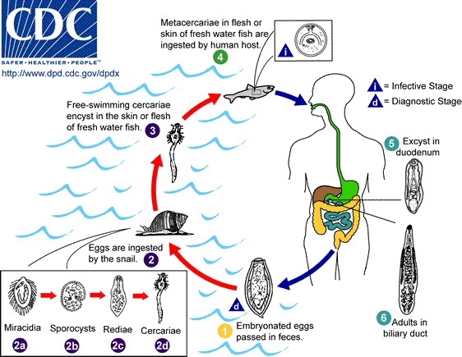

Epidemiology: Endemic areas are in Asia (Korea, China, Taiwan, and Vietnam) or in non endemic areas lick United States (in such cases, the infection is found in Asian immigrants).
Pathogenesis: Most pathologic manifestations result from inflammation and intermittent obstruction of the biliary ducts. In the acute phase, abdominal pain, nausea, diarrhea, and eosinophilia can occur. In long-standing infections, cholangitis, cholelithiasis, pancreatitis, and cholangiocarcinoma can develop, which may be fatal.
Diagnosis: Microscopic demonstration of eggs in the stool.
Treatment: Praziquantel or albendazole are the drugs of choice.
Control: 1. Human feces should not be used as fertilizer.
2. Control of snail.
3. Human should not consume raw fish.
- Opisthorchis spp: Oriental liver fluke: This parasite similar to Clonorchis sinensis in:
Life cycle. Mode of transmission. Diagnosis. Treatment and control.
Differs from Clonorchis sinensis in: Morphology & Epidemiology.

End of lecture 2: Trematodes

