Parasitology Trematoda Lecture 1 د. حذام
Trematoda (Flatworms= Flukes المخرمات ) 29-1-2020
Objective: define the trematodes as a class of helminthes by listing the main morphological features, their life cycle, mode of transmission and their prevalence around our world. In this lecture we will describe the life cycle, mod of acquiring the infection and the pathogenesis of intestinal flukes.
- Trematodes are unsegmented helminthes, which are flat & broad, resembling leaf of a tree or flatfish (Fluke = flatfish,).
- The name Trematode comes from their having large prominent suckers with a hole in the middle (Greek trema = hole).
- Class trematoda constitute a major division of class Platyhelminthes, and are divided into two subclasses (Digenea & Aspidogastrea).
- Nearly all trematodes are parasites of molluscs and vertebrates.
- The Digenea, are obligate parasites of both molluscs and vertebrates including man.
- Digenea i.e. require two hosts, the definitive hosts in which they pass the sexual or adult stage are vertebrates (include human), and the intermediate hosts in which they pass their asexual or larval stages are freshwater molluscs or snails.
- They have a complicated life cycle in one or more hosts.
- The final stage usually is hermaphroditic (monoecious), and alternately reproduce sexually and asexually but in Schistosoma it is dioecious in most Digenea.
The mature worm
- Trematodes varies in size and shape some are long & fleshy other are microscopic some are thin & flabby other are more or less cylindrical.
- In addition to a sucker that surrounds the mouth (oral sucker), a median ventral sucker or acetabulum (ventral sucker) also present.
Tegument
- The tegument (found in all parasitic Platyhelminthes) is a non ciliated, cytoplasmic syncytium that overlays layers of muscle.
- The epidermis is essentially a single cell (a syncytium formed by fusion of multiple cells that are located below the muscle in the parenchyma.
- Actin spines are found in many species and help the worms to anchor themselves
- The tegument protects the parasite against its host (e.g. against digestive enzymes).
- The tegument (“skin”) is highly active in nutrient uptake
- Under the tegument there are circular, longitudinal and oblique muscle fiber and a loose paranchymatus material surrounding the internal organs.

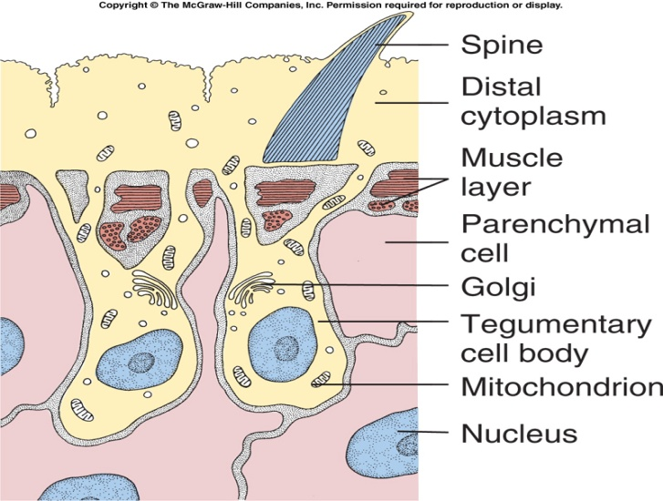
Digestive system: Mouth esophagus provided with a muscular pharynx pair of ceca (simple or branched and end blindly).
Nervous system: Large saddle like nerve commissures located at the anterior portion of the worm dorsal to the pharynx.
Execratory system: Consist of median posterior bladder empties through a posterior por. Primary & secondary collecting tubules are bilaterally symmetric, connecting to the capillaries with terminal “flame cells” (solenocytes).
Genital system: All digenetic trematoda except the Schistosoma are hermaphroditic. Each organism is typically self- fertilized.
Male reproductive organs:
Testes commonly two vas efference vas defference seminal vesicle, prostate gland muscular cirrus cirral sac open into common genital atrium which is provided with genital pore.
Female reproductive system:
Single ovary oviduct seminal recepticl, laurer’s canal, vitallaria, paired and common vitelline gland collecting ducts ootype surrounded by Mehlis gland and coiled uterus.

Life cycle:
In the definitive host, in which sexual reproduction occurs, which end by shedding of eggs.
      - Eggs (operculated, except in Schistosomes) are commonly shed along with host feces.
- Miracidium (little boy): free-swimming, highly motile ciliated larval forms. Miracidium is infective to the intermediate host, usually snail, in which asexual reproduction occurs. Miracidia have simple eyes (they avoid light) and several chemical and mechanical receptors which they use to find the intermediate snail host.
- Sporocysts: in snail the miracidium shed its cilia and become sac like 1st generation sporocysts (sporocyst= bladder containing seed), which will produce the 2nd generation sporocyst (Redia), which it will develop into free living cercaria (tailed larva).
- Redia: Redia have features of the adult fluke like oral and ventral sucker, a gut and “birth pore” to release cercaria. Redias are mobile in the snail and can prey on sporocysts and redia of the same or other species (competition).
- Cercaria: are the stages that leave the intermediate host and infect the final host. There can be many consecutive waves of “shedding” from the snail. Depending on the group, free cercaria either:
- Attached to the skin of the definitive host discards its tail penetrates into tissue grow, mature in this host (Schistisoma).
- Crawls on to aquatic plants drops its tail round up and encysted by covering itself with material secreted by cytogenous gland and become metacercaria.
- Shed its tail and penetrate into tissue of aquatic animal in which it become encysted metacercaria.
Schistosoma
Hepatic flukes:
Clonorchis sinensis Oriental.
Fasciola hepatica Worldwide.
Dicrocoelium dendricitum Worldwide.

1. Fasciola hepatica (sheep liver fluke) (Fascioliasis)
- Definitive host: Sheep, Cattle, Humans (Accidental) & Other Mammals.
- Large flukes 30 mmX13 mm. It is the largest and most common liver fluke found in human
- Flattened at the posterior end thin conical projection anterior end.
- Extensive branching of intestinal ceca.
- Extensive branching of testes.
- Extensive branching of vitelline follicles.
- Inhabit the large bill ducts and gall bladder.
- Occasionally found ectopically in peritoneal cavity.
- Eggs are large, thick shelled and small operculum. Unemberyonated when laid.

Life cycle:
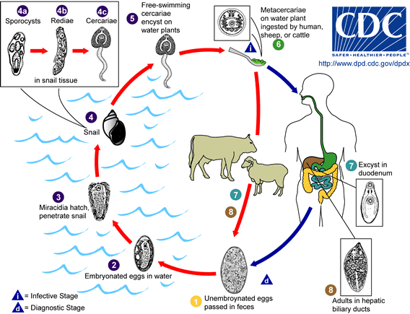
Immature eggs are discharged in the biliary ducts and in the stool. Eggs become embryonated in water, eggs release miracidia, which invade a suitable snail intermediate host (Lymnaeid snail). In the snail the parasites undergo several developmental stages (sporocysts, rediae , and cercariae ). The cercariae are released from the snail and encyst as metacercariae on aquatic vegetation (water cress). Mammals and Humans can become infected by ingesting metacercariae-containing freshwater plants, especially water cress. After ingestion, the metacercariae excyst in the duodenum and migrate through the intestinal wall, the peritoneal cavity, and the liver parenchyma into the biliary ducts, where they develop into adults.In humans, maturation from metacercariae into adult flukes takes approximately 3 to 4 months.
Epidemiology: infections with F. hepatica are found in areas where sheep and cattle are raised, and where humans consume raw watercress, including Europe, the Middle East, and Asia.
Pathogenesis + symptoms & sings:
A. During the acute phase (caused by the migration of the immature fluke through the hepatic parenchyma), manifestations include right abdominal pain, hepatomegaly, fever, vomiting, diarrhea, abdominal rigidity; profuse sweating, urticaria and eosinophilia, and can last for months.
B. In the chronic phase (caused by the adult fluke within the bile ducts), the symptoms are more discrete and reflect:
1. Traumatic damage eosionophilic inflammation in the hepatic parenchyma & bile duct.
2. Hyperplasia with leukocystic infiltration & fibrosis of the large bile duct.
3. Intermittent biliary obstruction and inflammation, empyema of the gall bladder, cholecystitis.
4. The mature worm found in abscess pocket in blood vessels.
5. Occasionally, ectopic locations of infection (such as intestinal wall, lungs, subcutaneous tissue, and pharyngeal mucosa) can occur.
False fascioliasis (pseudofascioliasis): Refers to the presence of eggs in the stool resulting not from an actual infection but from recent ingestion of infected livers of sheep or cattle containing adult with eggs.

Diagnosis:
- Stool Samples (Yellow-Brown Eggs).
- Duodenal or Biliary Aspirate
- Antibody Test (Can detect 2 Weeks after Infection).
- Ultrasound (Visualize Adults in Bile Duct). 5. CT Scan (Reveals Burrows in Liver).

False fascioliasis can be avoided by having the patient follow a liver-free diet several days before a repeat stool examination.
Treatment: Fasciola hepatica infections may not respond to praziquantel. The drug of choice is triclabendazole with bithionol as an alternative.

Control:
  - Wash Aquatic Vegetables (water cress) in 6% Vinegar for 5-10 minutes
  - Better herding and personal practices by keep herds away from aquatic areas
  - Human feces should not be used as fertilizer
  - Controls Intermediate snail Host
2. Fasciola gigantica
This parasite differs from Fasciola hepatica in:
It’s greater in length. Larger acetabulum. More anterior position of testes. Larger size of the egg.
Natural hosts are cattle & sheep. Clinical symptoms are as that of Fasciola hepatica. Infections have been reported, more rarely, in Asia, Africa, and Hawaii.
End of lecture 1: Trematode

