Parasitology Trematoda Lecture 4
5-2-2020 د. حذام
Blood flukes or Schistosomes:
- Bilharz in 1851 described trematode worms recovered from postmortems in Egypt, demonstrated relationship to hematuria and eggs with terminal spine in the urine. He also described terminal and lateral spine eggs in the same female worm and concluded that only one species Infected man. This was S. hematobium. Schistosomiasis often known as “ Bilharzia “.
- Parajá da Silva in Brazil in1908 described schistosomes which produced lateral spine eggs and showed that the adults were also different from S. hematobium, and thus showed that S. mansoni was a different species.
- Manson later in 1908 described schistosomiasis in patients in the West Indies and this was called S.mansoni.
- In ancient Egyptian papyri the typical symptom of chronic Shistosoma haematobium is described and the disease named a dripping penis.
- Shistosoma eggs have been recovered from both Chinese and Egyptian mummies.
- Recent World Health Organization estimates indicate that 200 million people are infected worldwide, with over 600 million people at risk of infection (this suggests that one quarter of the population in endemic areas are infected).
- Usually the infection is acquired in childhood, peaking in the age group of 15–20 years.
- Schistosomiasis is caused by digenetic blood trematodes schistosomes (spilt body in the ventral side of the male "gynecophoric canal" at which the female is held). The three main species infecting humans are Schistosoma haematobium, S. japonicum, and S. mansoni. In addition, other species of schistosomes, which parasitize birds and mammals, can cause cercarial dermatitis in humans.
Schistosoma haematobium: Urinary schistosomiasis (urinary bilharziasis, red water fever)
- The natural habitat of this worm is the vesicle venules.
- The male is large 10-15 mm X 1 mm and this muscular male attached by its sucker to the wall of the vessels holding the female in its sex canal= gynecophoric canal & enabling the female to extend its anterior extremity into the smaller venules in which it deposits its eggs. Where they obstruct the blood flow, destruction of the venules & pressure exerted by the worm, increase in size of the eggs and the mobility of the organ cause rapture blood vessel and discharge the eggs into surrounding tissue.
- 4-5 small subglobose testes behind the ventral sucker.
- Female is delicate measuring 20 mm X 0.25 mm.
- The uterus is long.
- The mature egg of S. haematobium is rounded at one pole and has a terminal spine at the other pole (170 µm X 30 µm straw color & transparent. On oviposition the eggs are immature but when shed from the tissue they are fully embryonated.
- Bulinus snail is the intermediate host.
- Human become infected when forked tail cercaria which it is the infective stage of this parasite, penetrate the skin.
Life cycle
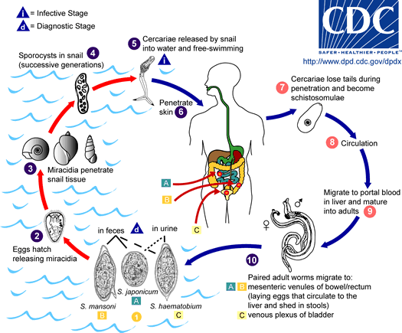
Eggs are eliminated with urine. Under optimal conditions the eggs hatch and release miracidia, which swim and penetrate specific snail intermediate host (Bulinus snail). The stages in the snail include 2 generations of sporocysts and the production of cercariae (after 4-8 weeks of development) . Upon release from the snail, the infective cercariae swim, penetrate the skin of the human host, and shed their forked tail, becoming schistosomulae . The schistosomulae migrate through several tissues and stages to their residence in the veins (,). Adult worms of S. haematobium in humans reside in the venous plexus of bladder, but it can also be found in the rectal venules. The females deposit eggs in the small venules of the perivesical systems. The eggs are moved progressively toward the lumen of the bladder and ureters, and are eliminated with urine.
Pathogenesis: The pathogenesis divided into three consecutive periods:
- Prepatent period: from skin penetration until the mature worm reaches the pelvic venules, in this period petechial haemorrhage, papular pruritic rash and small foci of oesnophilic and inflammatory changes in lung & liver.
- Acute stage of active egg deposition, extrusion and trapping of eggs in perivascular tissue.
- Chronic stage of stable egg output, tissue proliferation and repair by fibrosis and granuloma formation.
Prepatent period:
Schistosome dermatitis (swimmer’s itch): resulting from contact with cercaria of Schistosome. The lesion consist of an initial pickling sensation accompanied by erythema and local or general urticaria, petechial haemorrhage, papular pruritic rash, soon the irritation subsides leaving a macula at the site of penetration but in few hours the reaction reach its maximum between second and third day, then gradually decreased.
Acute stage:
- Toward the end of prepatent period the patient may be symptomless or having increasing malaise and afternoon fever, moderate hepatic pain or epigastric distress and oesinophilia (Katayama syndrome).
- Egg deposition and extrusion cause local damage to the tissue of the victim and urinary bladder.
- Hematuria is the first evidence of infection characterize by painless passage of the blood at the end of micturition. Then painful urination (dysuria) may occur.
- Later there is discharge of pus cells and necrotic tissue debris, decrease in the interval between urination (frequent urination).
- Ulceration and irritation of the epithelia of the bladder by the spins of eggs lead to polyp formation which may undergo malignant changes (scarring of the bladder)
- Numerous eggs calcified giving the inner surface of bladder sandy appearance and calculi may form in the lumen (calcification of the bladder) .
Chronic stage:
- Extensive fibrosis of the bladder neck obstructs the urinary flow (anurea) and lead to hydrouretes and hydronephrosis the later may be associated with bacteriurea.
- In female the vulva is hyperplastic and indurates skin may occur. If worm mature in the rectal vein, there may be sever tenesmus with dysentery.
- The worm may live for 20-30 years but the average life span is less than 5 years.
- squamous cell carcinoma of the bladder (the International Agency for Research on Cancer has classified Schistosoma haematobium as a human carcinogen).
Epidemiology: Man is the only the important final host of S. haematobium . This worm is endemic in Africa and the Middle East. In Iraq it found in south part as well as north part following the distribution of irrigation system.
Diagnosis
- Eggs detection
- Microscopic identification of eggs in urine.
- Detection will be enhanced by centrifugation and examination of the urine sediment.
- Quantification is possible by using filtration through a Nucleopore membrane of a standard volume of urine followed by egg counts on the membrane.
- Tissue biopsy (the bladder) may demonstrate eggs when a urine examination is negative.
- Miracidial hatching test.
- Serological & immunological tests:
- Total L IgE examination.
- Specific IgE (Rast test) P3 antigen.
Treatment: Praziquantel [Biltricide (bil= bilharzia, tri= three sp, cide= kill)] in dose of 20-40 mg/Kg body weight as a single oral dose.
Control:
- Educate people to not urinate or defecate in fresh water supplies
- Eliminate snail vectors by making the water habitat unsuitable (increase water flow, remove vegetation)
- Provide piped water to avoid direct contact with cercariae
- Mass drug treatment of communities to reduce reservoir of infection

End of lecture 4: Trematodes

