***Dr Ban Hadi*  *Urinary incontinence***

**F.I.C.O.G. 2020**

**Objectives:** by the end of this lecture, the 5th year student should be able to:

1. Define urinary incontinence
2. Summarize the types of urinary incontinence
3. Differentiate between its types by history taking
4. Demonstrate on menniquene the examination of a case with urinary incontinence
5. Interpretate the results of investigations
6. Predict the management option for different case presentations

**Definition** : Urinary incontinence is defined as the involuntary loss of urine that is objectively demonstrable and is a social or hygienic problem

**The prevalence** increases with age, with approximately 5 % of women between 15 and 44 years of age being affected, rising to 20 % of those older than 65 years

**Common symptoms associated with incontinence**

• Stress incontinence is a symptom and a sign and means loss of urine on physical effort. It is not a diagnosis

* • Urgency means a sudden desire to void.
* • Urge incontinence is an involuntary loss of urine associated with a strong desire to void.
* • Overflow incontinence occurs without any detrusor activity when the bladder is over-distended.
* • Frequency is defined as the passing of urine seven or more times a day, or being awoken from sleep more than once a night to void

**Classification of incontinence:**

**Urethral causes**

• Urethral sphincter incompetence (urodynamic stress incontinence)

• Detrusor over-activity or the unstable bladder

• Retention with overflow

• Congenital causes: Epispadias

• Miscellaneous like immobility and cognitive impairment

**Extra-urethral causes:** Congenital causes and Fistula

**Pathophysiology of urinary incontinence**

Under normal circumstances, in a woman with a healthy lower urinary tract, urine will leave the bladder via the urethra only when the intravesical pressure exceeds

the maximum urethral pressure. In general terms and in the majority of cases of urinary incontinence, the bladder pressure exceeds the urethral pressure because the urethral sphincter mechanism is weak (urodynamic stress incontinence) or because the detrusor pressure is excessively high (detrusor overactivity).

**In urodynamic stress incontinence** the factors that maintain positive urethral closure pressure at rest may be inadequate when there is an increase in intra-abdominal

pressure. This is particularly likely to occur if the bladder neck and proximal urethra are poorly supported or have descended through the pelvic floor, as in cases of concomitant cystourethrocele.

**An abnormally high detrusor pressure** may occur in detrusor overactivity when there is inability to inhibit detrusor contractions. In cases of a low compliance,

incontinence may occur when there is a failure of the bladder to accommodate a large volume of urine for a small rise in pressure

**Urodynamic stress incontinence USI:** is noted during filling cystometry, and is defined as the involuntary leakage of urine during increased abdominal pressure in the absence of a detrusor contraction

**Risk Factors for stress Urinary Incontinence**

Multiparity (particularly vaginal births).

• Forceps delivery*.

• Perineal trauma.

• Long labour*.

• Epidural analgesia.

• Birthweight >4 kg.

• Increasing age.

• Postmenopause.

• Obesity studies have shown that significant weight loss among obese women is associated with major improvements in urinary leakage symptoms.

• Connective tissue disease.

• Chronic cough (e.g. bronchiectasis or chronic obstructive pulmonary disease).

• Doxazocin (alpha-adrenergic antagonist) for hypertension causes relaxation of the urethral sphincter*.

**Diagnosis:**

***History***: risk factors and symptoms,

Risk factors as cough, constipation, high parity and difficult deliveries

Stress incontinence is the usual symptom, but urgency, frequency and urge incontinence may be present. The patient may present with symptoms of prolapse.

The severity of symptoms vary from mild cases where incontinence occurs with heavy exercise such as lifting heavy weight to severe cases where incontinence develops simply on changing position in bed.

***Examination:*** general as obesity, abdominal look for masses and scars

Cough test: stress incontinence may be demonstrated when the patient coughs with full bladder in dorsal position.

Vaginal examination using sim's speculum should assess for prolapse, atrophy, fistula and pelvic masses

**Q Tip test**: A sterile swab stick is inserted into the bladder cavity. As the patient strains, in continent women the angle between the horizon and the swab should not exceed 30 degree. While women with stress incontinence the angle may reach up to 60 degree which indicates urethral hypermobility.

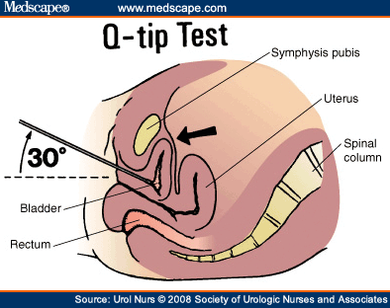

***Investigations***

1-**Mid-stream specimen of urine**: to exclude infection

2-**Frequency/volume chart**: (urinary or bladder diary) provides an objective assessment of a patient’s fluid input and urine output.

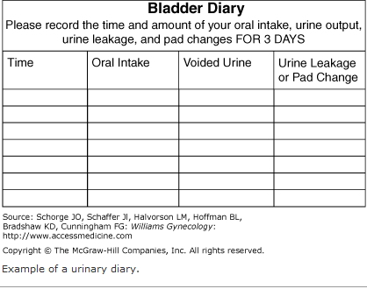

3-**Pad test**: by measuring the weight gain of a perineal sanitary towel

4-**Uroflowmetry**: is the measurement of urine flow rate. A flow rate < 15 mL \ s on more than one occasion is considered abnormal in females.

: 5-**Cystometry**

involves the measurement of the pressure volume relationship of the bladder. It measures the abdominal pressure, intravesical pressure and detrusor pressure

The following are parameters of normal bladder function.

• Residual urine of < 50 mL.

• First desire to void between 150 and 200 mL.

• Capacity between 400 and 600 mL.

• Detrusor pressure rise of < 15 cmH20 during filling and standing.

• Absence of systolic detrusor contractions.

• No leakage on coughing.

• A voiding detrusor pressure rise of < 70 cmH20 with a peak flow rate of > 15 mL\s for a volume > 150 mL

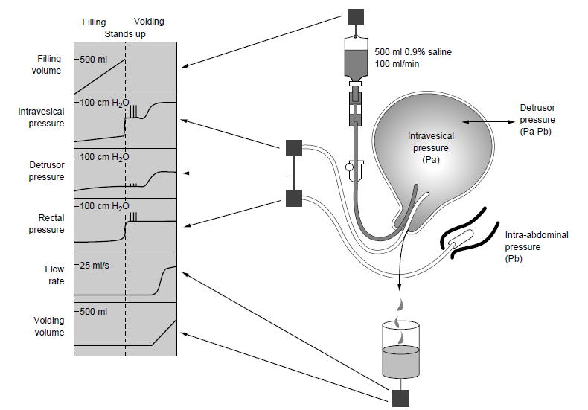

6- other investigations in selected cases like: Videocystourethrography,Urethral pressure profilometry, Cystourethroscopy, Ultrasound and IVU can be performed when there is hematuria, recurrent UTI, fistula, urgency and dysurea

**Treatment of Urodynamic stress incontinence:**

**A. Non surgical:**

*:* ***Simple measures***

Treatment of urinary tract infection, restriction of fluid intake, reduce caffeine intake, modifying medications (e.g. diuretics) and treating chronic cough and constipation play an important role in the management of most types of urinary incontinence.

***Prevention***

1.Shortening the second stage of delivery and reducing traumatic delivery may result in fewer women developing stress incontinence.

2.Hormone replacement therapy for postmenopausal women may be of benefit.

3.Pelvic floor exercises either before or during pregnancy.

***Conservative treatment:*** is indicated when

1- The incontinence is mild,

2- The patient is medically unfit for surgery

3-The patient does not wish to undergo an operation

4- Women who have not yet completed their families.

5-Prior to surgery in case of a long waiting list

**1- Non pharmacological**

1**- Pelvic floor muscle training**: Also known as *Kegel exercises,* PFMT entails voluntary contraction of the levator ani muscles. As with any muscle building, exercise sets should be performed numerous times during the day, with some reporting up to 50 or 60 times each day. The aim is to enhance the tone of levator ani muscle. 40 -60 % of cases improve with this exercise

2-**Perineometry** : A perineometer is a cylindrical vaginal device which can

be used to assess the strength of pelvic floor contractions

It can be used to help an individual to contract her pelvic floor muscles appropriately and is also useful in detecting improvement following pelvic floor exercises.

* *3-****Weighted vaginal cones***These are currently available as sets of five or three
* all of the same shape and size but of increasing weight (20–90 g)*.*

*4-****Maximal electrical stimulatio****n*

* 5-**Vaginal devices** may be useful for use during exercise on a short term basis.

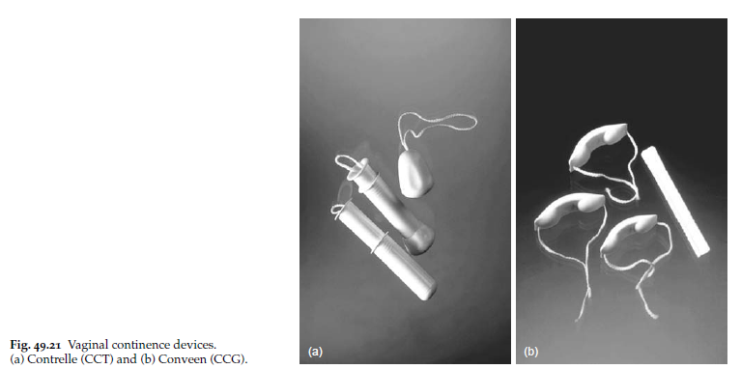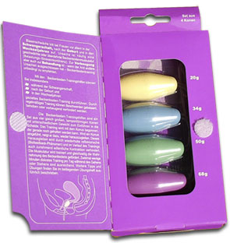

Vaginal cones vaginal devices

**2 –Pharmacological**

Duloxetine, *α1-adrenoceptor agonists,* oestrogens and tricyclic antidepressants have all been used for the treatment of stress incontinence

**B. Surgical treatment of Urodynamic stress incontinence:**

Aim of surgery:

To provide suburethral support; restoration of the proximal urethra and bladder

neck to the zone of intra-abdominal pressure transmission; to increase urethral resistance;

.

***1-Vaginal procedures:***

**Retropubic tape procedures TVT (tension free vaginal tape)** the most popular surgical treatment for stress incontinence. In this operation a synthetic inert tape is inserted through vaginal incision and passed bellow the urethra by trocar and attached to the anterior abdominal wall.

**Complications** include bladder and urethral injury, stricture and retention of urine

* 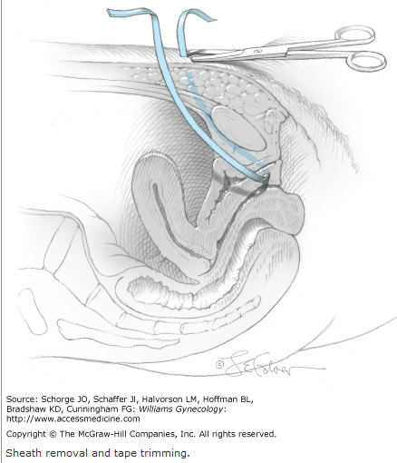
* **Transobturator tape procedures TOT**: In this operation a tape is inserted through vaginal incision and passed bellow the urethra then through the lower part of obturator membrane into the medial aspect of thigh. It requires special needle. This operation is widely used now days.
* **Complications:** hemorrhage, infection and the patient may have chronic pelvic pain
*  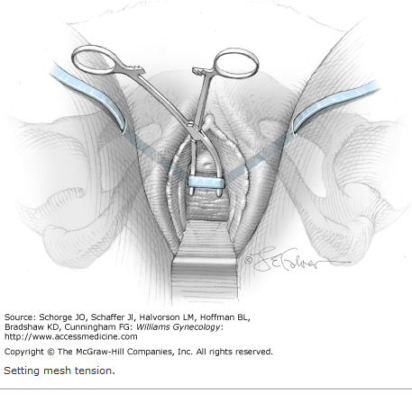
* The success rate of TVT and TOT is more than 90%

**Anterior colporrhaphy**: is still performed for stress incontinence. Although it is usually the best operation for a cystourethrocele, the cure rates for urodynamic stress incontinence are poor compared to suprapubic procedures. The success rate is about 60%

* **Urethral bulking agents**: are minimally invasive surgical procedures for the treatment of urodynamic stress incontinence and may be useful in the elderly and those women who have had previous failed operations and have a fixed, scarred fibrosed urethra.
* 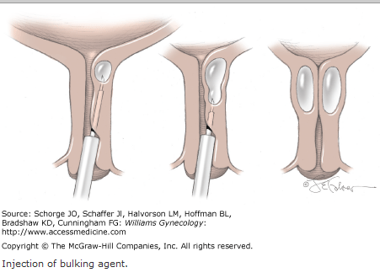

***2-Abdominal:*** performed through an abdominal incision

* **Burch colposuspension**: In this operation the Para urethral tissues are sutured to the ipsilateral iliopectineal ligament to elevate the bladder base. The success rate is over 90%.
* 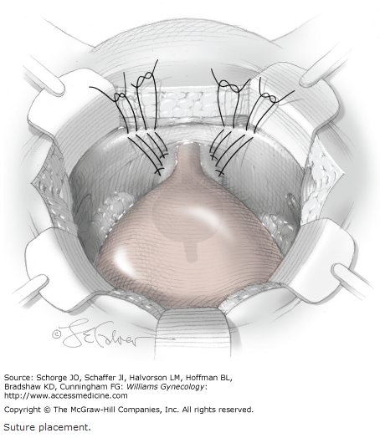
* **Marshall–Marchetti–Krantz procedure:** is a suprapubic operation in which the paraurethral tissue at the level of the bladder neck is sutured to the periostium and/or perichondrium of the posterior aspect of the pubic symphysis.is less popular due to the risk of periostitis.

***3-Laparoscopi*c** colposuspension

**4- Complex**

* **Artificial sphincter** May be employed when conventional surgery fails. This
* is implantable and consists of a fluid-filled inflatable cuff which is surgically placed around the bladder neck.

**Detrusor overactivity DO:**

Previously called detrusor instability, is **a urodynamic observation** characterized by involuntary detrusor contractions during the filling phase which may be spontaneous or provoked (such as drinking or changing position).

This is primarily a disease of unknown cause in which the bladder contracts strongly to expel the minimum amount of urine which is normally tolerated by normal balder, and there is excessive cholinergic stimulation of the detrusor muscle.

**Risk factors for detrusor overactivity**

• Childhood bedwetting.

• Obesity.

• Smoking.

• Previous hysterectomy.

• Previous continence surgery

**Clinical presentation**

The combination of symptoms of urgency, frequency and nocturia is termed the **overactive bladder** (OAB). When detrusor contractions observed during cystometry the diagnosis of **detrusor overactivity** is established.

In most of the cases physical examination reveals nothing; However; mass, prolapse and atrophy should be excluded and cough test is performed to exclude USI.

Neurological exam as bladder hyperreflexia may be the earliest sigh of multiple sclerosis.

Investigations: same as USI

**Treatment**

**Bladder retraining** Instruct to void every 1.5 h during the day; she must not void between these times, she must wait or be incontinent.Increase voiding interval by half an hour when initial goal achieved, and continue with 2-hourly voiding and so on.

**Drug therapy**

***Imipramine:*** is a tricyclic antidepressant drug which has also anticholinergic properties. In a dose of 25 mg for 3 months up to 90 % of women get improvement

***Tolterodine*** is a competitive muscarinic receptor antagonist with relative functional selectivity for bladder muscarinic receptors.

***Oxybutynin***  is anticholinergic drug which has special affinity to the detrusor muscle. It is much superior to imipramine***.***

**Desmopressin** is a synthetic vasopressin analogue. It has strong antidiuretic effects without altering blood pressure.

**Intravesical therapy** intravesical administration of Botulinum toxin may offer an alternative to surgery in those women with intractable detrusor overactivity

**Neuromodulation** Stimulation of the dorsal sacral nerve has been developed for use in patients with both idiopathic and neurogenic detrusor overactivity

**Surgery**

1-Clam cystoplasty: increasing the detrusor volume by ileal patch

2-detrusor myectomy

3-urinary diversion

**Retention with overflow**

Insidious failure of bladder emptying may lead to chronic retention and finally, when normal voiding is ineffective, to overflow incontinence

*Symptoms*

Symptoms include poor stream, incomplete bladder emptying and straining to void, together with overflow stress incontinence. Often there will be recurrent urinary tract infection. Cystometry is usually required to make the diagnosis, and bladder ultrasonography or intravenous urogram may be necessary to investigate the state of the upper urinary tract to exclude reflux.

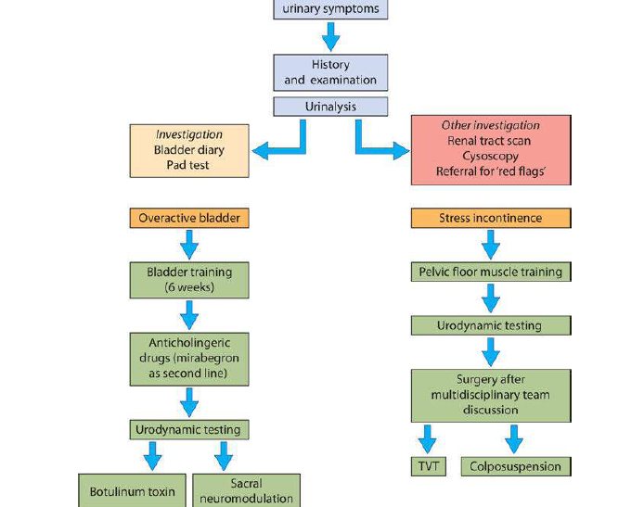

End of lecture (Text books Gynecology by ten teachers and Dewhurt's)