Genitourinary Fistula Dr Ban Hadi F.I.C.O.G.2018
Objectives: by the end of this lecture, the 5th year student should be able to:
- Define genitourinary fistula.
- List its possible causes
- Describe its different types
- Demonstrate on the menniquene the examination of a fistula
- Interpretate the results of investigations
- Determine the treatment suitable for a case with fistula
Definition: A genitourinary fistula is defined as an abnormal communication between the urinary (ureters, bladder, and urethra) and the genital (uterus, cervix, and vagina) systems
The most common type of genitourinary fistula is the vesicovaginal fistula
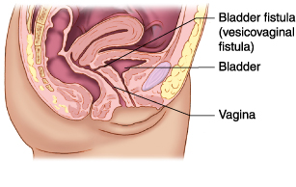

Pathophysiology
Knowledge of the principles and phases of wound healing are important in understanding the pathogenesis of genitourinary fistula. After injury, tissue damage and necrosis stimulate inflammation, and the process of cell regeneration begins. Initially at the injury site, new blood vessels form, termed angiogenesis. Three to five days after injury, fibroblasts proliferate and subsequently synthesize and deposit extracellular matrix, in particular collagen. This fibrosis phase determines the final strength of the healed wound. Collagen deposition peaks about seven days after injury and continues for a number of weeks. Subsequent maturation and organization of the scar, termed remodeling, augments wound strength. These phases are interdependent and are intrinsically involved in wound healing. Any disruption of this sequence eventually results in fistula formation. Most fistulas tend to present 1 to 3 weeks after tissue injury, a time during which tissues are most vulnerable to alterations in the healing environment, such as hypoxia, ischemia, malnutrition, radiation, and chemotherapy. Edges of the wound eventually epithelialize and a chronic fistulous tract is thus formed.
Classification
Anatomical classification
Classification of Genitourinary Fistula Based on Anatomic Communication

 | Urinary Tract
 | Ureter | Bladder | Urethra
Vagina | Ureterovaginal | Vesicovaginal | Urethrovaginal
 | Vesicoureterovaginal
Cervix | Ureterocervical | Vesicocervical | Urethrocervical
Uterus | Ureterouterine | Vesicouterine | Not reported

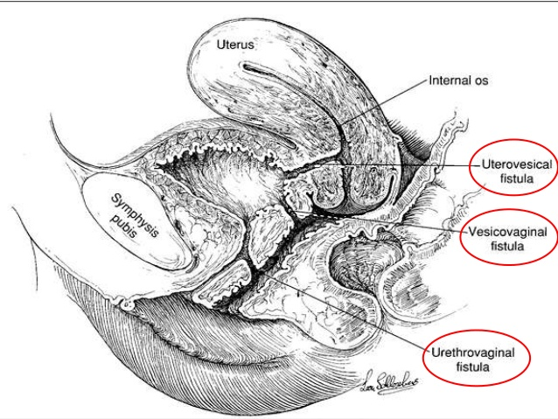
Vesicovaginal fistulas can also be characterized by their size and location in the vagina. They are termed high vaginal when found proximally in the vagina, low vaginal when noted distally, or midvaginal when identified centrally. For instance, post-hysterectomy vesicovaginal fistulas are often proximal or high in the vagina, and located at the level of the vaginal cuff.
Etiology
- Congenital
Congenital genitourinary fistulas are rare, These fistulas are usually associated with other renal or urogenital abnormalities
- Acquired
Most vesicovaginal fistulas do not arise from developmental abnormalities but follow either obstetric trauma or pelvic surgery.
1-Obstetric Trauma
In developing countries, 90% of genitourinary fistulas arise from obstetric trauma,
- Obstructed labor or malpresentation of the presenting fetal part can cause pressure or ischemic necrosis of the anterior vaginal wall and bladder, subsequently resulting in fistula formation.
- Damage by instruments such as foreceps.
Malnutrition and limited health care in many of these countries further complicates wound healing. In contrast, in most developed countries, fistulas uncommonly follow obstetric procedures or deliveries.
- On rare occasion, cesarean deliveries, usually those accompanied by obstetric complications, have led to complex urinary fistulas

2-Pelvic Surgery
In developed countries, iatrogenic injury during pelvic surgery is responsible for 90 % of vesicovaginal fistulas and the accepted incidence of fistula formation after pelvic surgery is 0.1 to 2%, hysterectomy is the most common surgical cause.
Prevention: Because most genitourinary fistulas have an operative etiology,
- Intraoperative recognition of lower urinary tract injury is essential.
- Use of intraoperative cystoscopy has been shown to improve the detection rate of lower urinary tract injuries.
3-Radiation
Radiation therapy induces an endarteritis, which leads to tissue necrosis, and subsequent potential fistula formation. This modality is a frequent underlying cause and 6 % of genitourinary fistulas are thought to result from radiation. Although most damage following radiation treatment develops within weeks and months, fistulas associated with radiation therapy may present up to 20 years after the original insult.
4-Malignancy
Tissue necrosis and deterioration is commonly associated with malignancy and may lead to urinary fistula formation. Thus, tissue biopsy should routinely be performed in a woman with a fistula and history of malignancy.
5-Trauma and Foreign Body
Trauma sustained during sexual activity or sexual assault can result in genitourinary fistula formation and has been estimated to cause 4 percent of these defects. Foreign bodies such as a neglected pessary. foreign bodies introduced during surgery such as collagen injected transurethrally and synthetic materials used in urethral sling have been reported.
6.Miscellaneous causes like: lymphogranuloma venereum, tuberculosis, pelvic inflammation, and syphilis; inflammatory bowel disease; and conditions that interfere with healing, such as poorly controlled diabetes mellitus, smoking, local infection, peripheral vascular disease, chronic steroid use, and malignancy are risk factors.

Clinical Presentation
Vesicovaginal fistula classically presents with unexplained continuous urinary leakage from the vagina after a recent operation. Depending on the size and location of the fistula, the amount of urine will vary. Occasionally small-volume, intermittent leakage is mistaken for postoperative stress incontinence. For this reason, patients with new-onset urinary leakage should be examined thoroughly to exclude fistula formation. Other less specific symptoms of genitourinary fistula include fever, pain, ileus, and bladder irritability.
Vesicovaginal fistula may present days to weeks after the initial surgery, and those following hysterectomy typically present at 1 to 3 weeks. Some fistulas, however, have longer latent periods and can cause symptoms a number of years later.
Diagnosis
1-History: a thorough history regarding: details of presenting symptoms, obstetric deliveries, prior surgeries, previous management of fistula, and treatment of malignancy, especially involving pelvic surgery and radiation therapy should be documented.
2-Physical examination visual inspection during physical examination will identify the defect. A meticulous assessment for other fistulous tracts should be performed, and their location and size noted.
3-Vaginoscopy has been described by some to improve fistula identification. For this evaluation, a laparoscope is inserted into a vagina, whose walls are held apart by a translucent plastic speculum
During evaluation, it is mandatory to differentiate urinary leakage through a fistula (extraurethral leakage) from stress urinary incontinence (transurethral leakage). Moreover, occasionally the source of fluid present in the vagina is unclear and a small amount of urine can easily be mistaken for vaginal discharge. Measurement of the vaginal fluid's creatinine content, however, is an inexpensive test that may be used to confirm urine. Although levels of creatinine in urine can vary, with mean levels reaching 113.5 mg/dL, a value greater than 17 mg/dL is consistent with urine
4-Dye Instillation
Bladder instillation of visually distinct solutions such as methylene blue or indigo carmine can often indicate the location.
When the presence of a urinary fistula is uncertain, or the location in the vagina cannot be identified, a modified tampon test or three-swab test is recommended During testing, gauze is packed sequentially into the vaginal canal. A diluted solution of methylene blue or indigo carmine is instilled into the bladder in a retrograde fashion using a catheter. After the patient has engaged in 15 to 30 minutes of routine activity, the gauze is removed serially from the vagina and inspected for presence of dye. The specific gauze colored with dye suggests where in the vagina a fistulous tract is located—a proximal or high location in the vagina for the innermost gauze, and a low or distal fistula for the outermost. If the distally placed sponge is stained with dye, however, it is important to confirm that it was not contaminated by stress incontinence.
5-Cystourethroscopy
It allows localization of the fistula, determination of its proximity to the ureteral orifices, and assessment of surrounding bladder mucosa viability.
6-intravenous urography
is used to assess integrity of the upper collecting system and ureteral involvement in the fistula.
7-Retrograde pyelography
generally has the same diagnostic value as intravenous urography. It has higher diagnostic accuracy in detecting ureterovaginal fistulas
8-Voiding Cystourethrography
This radiologic study can also demonstrate leakage into the vagina and help confirm the presence, location, and number of fistulous tracts.

Treatment
Conservative Treatment
Occasionally, genitourinary fistulas may spontaneously close during continuous bladder drainage using an indwelling urinary catheter with antibiotics use.
Generally, the larger the fistula, the less likely it is to heal without surgery. In 10 % of cases, urinary fistulas close spontaneously after 2 to 8 weeks of transurethral catheterization, especially if the fistula is small (2 to 3 mm diameter)
If the fistula has not closed within 4 weeks, however, it is unlikely to do so, probably secondary to collagen deposition and epithelialization of the fistulous tract
Surgical Treatment
1.The classical technique involves excision of the fistulous tract. After excision of the fistula, the vaginal epithelium is undermined and widely mobilized. The bladder mucosa is closed, followed by subsequent closure of two layers of fibromuscular tissue. A watertight repair is confirmed and the vaginal epithelium is reapproximated.
2.Abdominal (Transperitoneal) :Difficult fistulas or those requiring supravesical urinary diversion require an abdominal approach
3.Laparoscopic
4.Interpositional Flaps: Viability of the surrounding tissue is an important consideration in the repair of genitourinary fistula. When intervening tissues for fistula closure are weak and poorly vascularized, various tissue flaps ( such as omentum and muscles) may be placed vaginally or abdominally between the bladder and the vagina to lend support and blood supply

Urethrovaginal and Other Genitourinary Fistulas
Although vesicovaginal fistulas are the most common type of genitourinary fistula, other fistulas can exist and may be described based on their communication between anatomic structures. Urethrovaginal fistulas commonly result from surgery involving the anterior vaginal wall, in particular, anterior colporrhaphy and urethral diverticulectomy. As with vesicovaginal fistula, obstetric trauma remains the most common cause of urethrovaginal fistulas in developing countries. Here, prolonged labor with ensuing tissue necrosis results in development of fistulas. Frequently, patients present with continuous urinary drainage into the vagina or with stress urinary incontinence. The principles of repair are similar: layered closure, tension-free repair, and postoperative bladder drainage. Other types of genitourinary fistula can also occur

End of lecture

