ALMustansiriyah University/College of Medicine
4th stage
Dr.Nabeeha N. Akram

MALNUTRITION

A pathological state due to a relative or absolute deficiency or excess of one or more essential nutrients; clinically manifested or detected only by biochemical, anthropometric or physiological tests.

Classification:
1.Undernutrition: Marasmus
2. Over-nutrition: Obesity ,Hypervitaminoses
3.Specific Deficiency: Kwashiorkor ,Hypovitaminoses.
4.Mineral Deficiencies
5.Imbalance: Electrolyte Imbalance

Etiology:
A.child related:
Low birth wt,Absence or early cessation of breast feeding
Delay weaning
Incorrect dietary habit
Recurrent infection :diarrhea, measles
B.Maternal factor:
Maternal malnutrition
Ignorance about feeding
separation

C. socio-economical factor:
Poverty and unemployment
Large family size
Unhygienic living condition
Disadvantaged children
D. cultural factor: wrong believes
E. community factor:
Natural/man made disaster
Generalized economic depression
Inadequate primary health care

Marasmus

Marasmus results from the body's physiologic response to inadequate calories and nutrients. Loss of muscle mass and subcutaneous fat stores can be confirmed by inspection or palpation and quantified by anthropometric measurements.

The head may appear large but generally is proportional to the body length.
Edema usually is absent. The skin is dry and thin, and the hair may be thin, sparse, and easily pulled out.

Marasmic children may be apathetic and weak and may be irritable when touched. Bradycardia and hypothermia signify severe and life- threatening malnutrition.

Inappropriate or inadequate weaning practices and chronic diarrhea are common findings in developing countries.
Stunting (impaired linear growth) results from a combination of malnutrition, especially micronutrients, and recurrent infections.

Kwashiorkor

Kwashiorkor results from inadequate protein intake in the presence of fair to good caloric intake. The hypoalbuminemic state results in pitting edema that starts in the lower extremities and ascends with increasing severity. Other factors, such as acute infection, toxins, and possibly specific micronutrient or amino acid imbalances, are likely to contribute to the etiology.

The disease of displaced child ,as commonly seen after weaning due to delivery of new child to starchy food (sugar baby??)

The major clinical manifestation of kwashiorkor is that the body weight is near normal for age; weight alone does not accurately reflect the nutritional status because of edema.

Physical examination reveals a relative maintenance of subcutaneous adipose tissue and a marked atrophy of muscle mass. Edema varies from a minor pitting of the dorsum of the foot to generalized edema with involvement of the eyelids and scrotum. The hair is sparse, easily plucked, and appears dull brown, red, or yellow-white. Nutritional repletion restores hair color, leaving a band of hair with altered pigmentation followed by a band with normal pigmentation (flag sign).
Skin changes are common and range from hyperpigmented hyperkeratosis to an erythematous macular rash (pellagroid) on the trunk and extremities. In the most severe form of kwashiorkor, a superficial desquamation occurs over pressure surfaces (“flaky paint” rash).

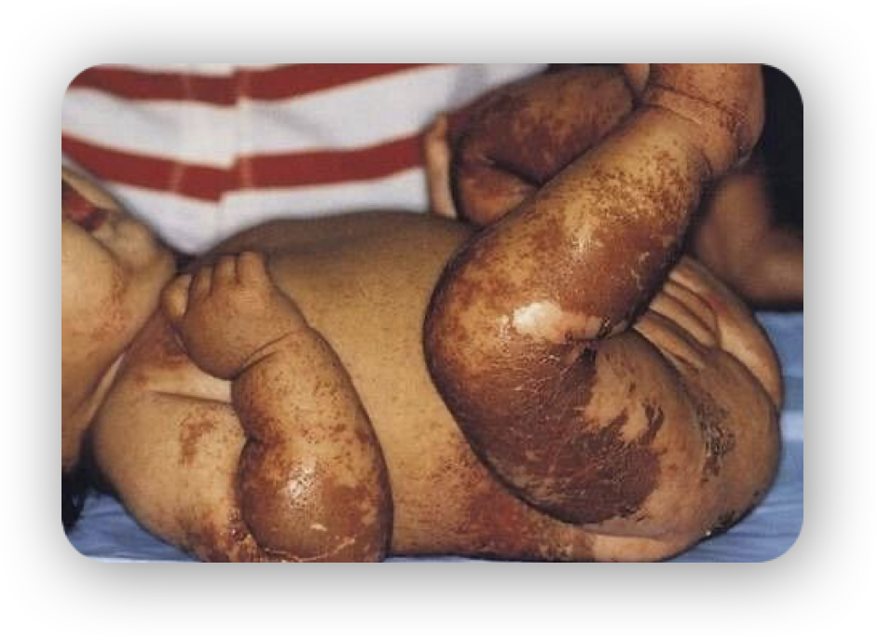

Angular cheilosis, atrophy of the filiform papillae of the tongue, and monilial stomatitis are common.
Enlarged parotid glands and facial edema result in moon facies;
apathy and disinterest in eating are typical of kwashiorkor.

Examination of the abdomen may reveal an enlarged, soft liver with an indefinite edge. Lymph node and tonsils are commonly atrophic.

Chest examination may reveal basilar rales.

The abdomen is distended, and bowel sounds tend to be hypoactive.

SEVERE CHILDHOOD UNDERNUTRITION
(Protein-Energy Malnutrition)

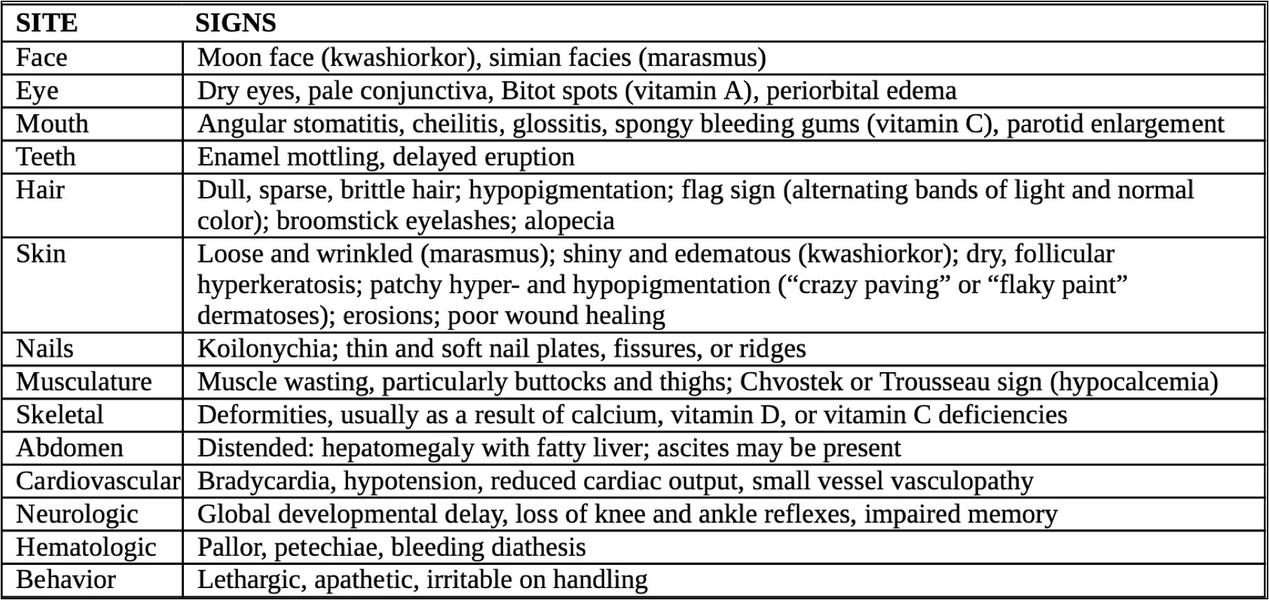

Assessment of nutritional status
Malnutrition must be recognised and accurately defined for rational decisions to be made about refeed­ing.
Evaluation is divided into assessment of past and present dietary intake, anthropometry and laboratory assessments .
Dietary assessment
Parents are asked to record the food the child eats during several days. This gives a guide to food intake.
Anthropometry
In addition to weight and height, skinfold thickness of the triceps reflects subcutaneous fat stores and can be assessed by measuring it. (as shown in fig A)
While it is difficult to measure skinfold thickness accurately in young children, mid­ upper arm circumference, which is related to skeletal muscle mass, can be measured easily and repeatedly and is independent of age in children 6 months to 6 years.It is especially useful for screening children for malnutrition in the community. (Fig B,C)
Laboratory investigations
These are useful in the detection of early physiologi­cal adaptation to malnutrition, but clinical history,
examination and anthropometry are of greater value than any single biochemical or immunological measurement.

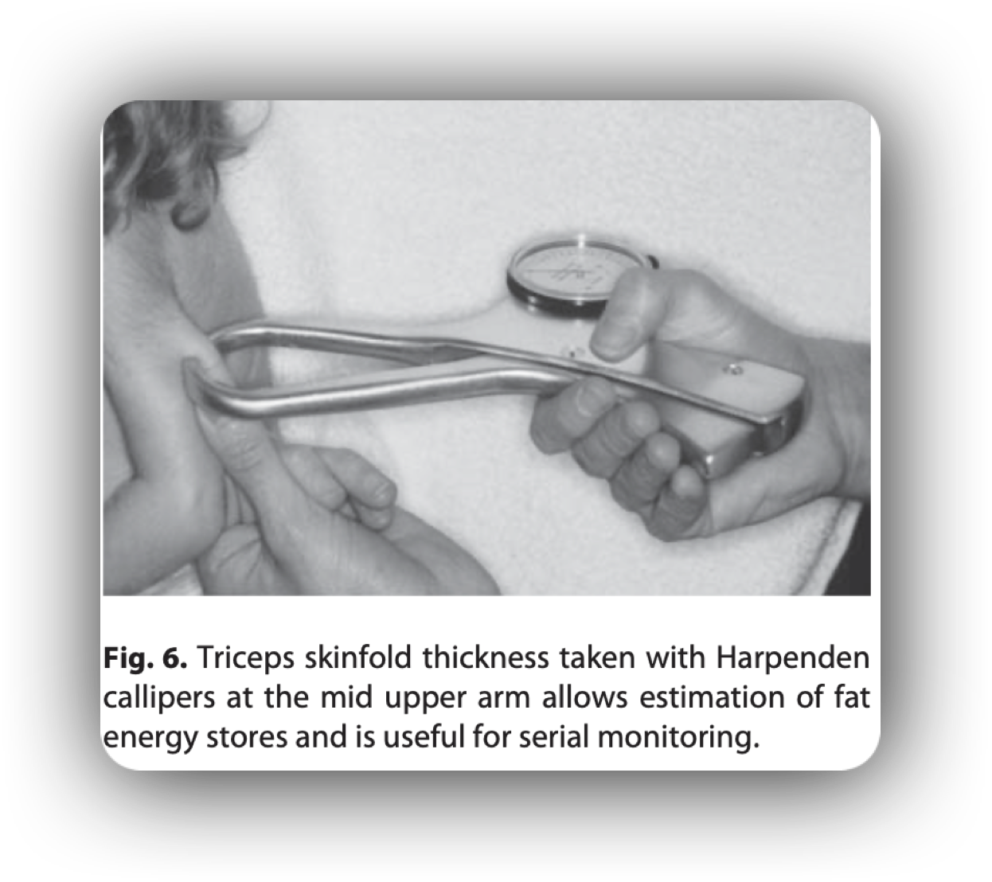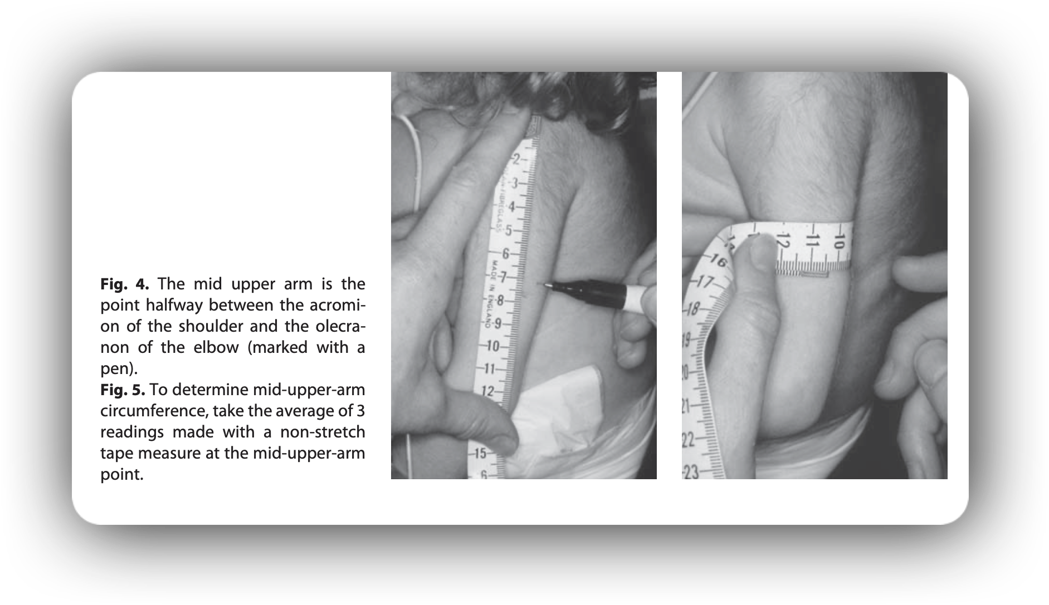

Investigations
CBC,CRP,GUE,GSE,RBS,RFT,TSP,S. albumin(low in both)

Treatment

Rx. of PEM involve 3 phases:
1-Stabilization phase (1st wk)
2-Rehabilitation phase (2nd wk-6th wk)
3-follow-up. (7th wk till recovery)

Stabilization phase (1st wk):- It involves Rx & Pv of infection, hypoglycemia, anemia, dehydration & correction of electrolyte disturbances, and vitamins & micronutrient deficiency (except iron).

feeding with F75 formula (75 kcal/100 ml)

2. Rehabilitation phase (2nd wk-6th wk):- It involves feeding with F100 formula (100 kcal/100 ml) to give 100 kcal/kg/day. If oral feeding is not tolerated, give it by NG tube.
3.follow-up phase (7th wk till recovery):- By feeding to cover catch-up growth and also the provision of emotional stimulation with the aid of family & the community.

Re-feeding Syndrome

It usually complicates the acute nutritional rehabilitation after aggressive enteral or parenteral alimentation due to the development of severe hypophosphatemia after the cellular uptake of phosphate during the 1st wk of starting therapy.

Other features of Refeeding syndrome include: hypokalemia, hypomagnesemia, sodium retention, hyperglycemia, & vitamins deficiency (especially thiamin).

C.M. of hypophosphatemia especially when serum Pi is ≤ 0.5 mmol/L include:

-weakness
-rhabdomyolysis
-neutrophil dysfunction, hemolysis, thrombocytopenia
-seizures, altered consciousness
-arrhythmias, cardiorespiratory failure, & sudden death
Inv. Monitor serum Pi, K, Mg & Ca frequently in the 1st 2 wk after Rx.
Rx. Slowly ↑ feeding with supplementation of minerals (especially phosphate) & vitamins (especially thiamin) as well as the correction of other electrolytes disturbances, especially hypokalemia & hypomagnesemia

Complications of Malnutrition

Malnourished children are more susceptible to infection, especially sepsis, pneumonia, and gastroenteritis. Hypoglycemia is common after periods of severe fasting but may also be a sign of sepsis. Hypothermia may signify infection or, with bradycardia, may signify a decreased metabolic rate to conserve energy. Bradycardia and poor cardiac output predispose the malnourished child to heart failure, which is exacerbated by acute fluid or solute loads. Micronutrient deficiencies also can complicate malnutrition. Vitamin A and zinc deficiencies are common in the developing world and are an important cause of altered immune response and increased morbidity and mortality.

Depending on the age at onset and the duration of the malnutrition, malnourished children may have permanent growth stunting (from malnutrition in utero, infancy, or adolescence) and delayed development (from malnutrition in infancy or adolescence). Environmental (social) deprivation may interact with the effects of the malnutrition to impair further development and cognitive function.

Vitamin and Mineral Deficiencies

Water-Soluble Vitamins
Ascorbic Acid
A deficiency of ascorbic acid results in the clinical manifestation of scurvy. Infantile scurvy is manifested by irritability, bone tenderness with swelling, and pseudoparalysis of the legs. The disease may occur if infants are fed unsupplemented cow's milk in the first year of life or if the diet is devoid of fruits and vegetables. Subperiosteal hemorrhage, bleeding gums and petechiae, hyperkeratosis of hair follicles, and a succession of mental changes characterize the progression of the illness. Anemia secondary to bleeding, decreased iron absorption, or abnormal folate metabolism are also seen in chronic scurvy.

B Vitamins

Thiamine

Thiamine deficiency occurs in alcoholics and has been reported in adolescents who have undergone bariatric surgery for severe obesity. Infantile beriberi occurs between 1 and 4 months of age in breast fed infants whose mothers have a thiamine deficiency (alcoholism), in infants with protein-calorie malnutrition, in infants receiving unsupplemented hyperalimentation fluid, and in infants receiving boiled milk.

Acute wet beriberi with cardiac symptoms and signs predominates in infantile beriberi. Anorexia, apathy, vomiting, restlessness, and pallor progress to dyspnea, cyanosis, and death from heart failure. Infants with beriberi have a characteristic aphonic cry; they appear to be crying, but no sound is uttered. Other signs include peripheral neuropathy and paresthesias

Riboflavin
Ariboflavinosis is characterized by an angular stomatitis; glossitis; cheilosis; seborrheic dermatitis around the nose and mouth; and eye changes that include reduced tearing, photophobia, corneal vascularization, and the formation of cataracts.

Subclinical riboflavin deficiencies have been found in diabetic subjects, children in families with low socioeconomic status, children with chronic cardiac disease, and infants undergoing prolonged phototherapy for hyperbilirubinemia.

Niacin
Pellagra, or niacin deficiency disease, is characterized by weakness, lassitude, dermatitis, photosensitivity, inflammation of mucous membranes, diarrhea, vomiting, dysphagia, and, in severe cases, dementia.

Vitamin B6

The pyridoxal and pyridoxamine forms of the vitamin are destroyed by heat; heat treatment was responsible for vitamin B6 deficiency and seizures in infants fed
improperly processed formulas. Goat's milk is deficient in vitamin B6. Dietary deprivation or malabsorption of vitamin B6 in children results in hypochromic microcytic anemia, vomiting, diarrhea, failure to thrive,
listlessness, hyperirritability, and seizures. Children receiving isoniazid or penicillamine may require additional vitamin B6 because the drug binds to the
vitamin. Vitamin B6 is unusual as a water-soluble vitamin, in that very large doses (≥500 mg/day) have been associated with a sensory neuropathy.

Folate

Folate deficiency, characterized by hypersegmented neutrophils, macrocytic anemia, and glossitis, may result from a low dietary intake, malabsorption, or vitamin-drug interactions. Deficiency can develop within a few weeks of birth because infants require 10 times as much folate as adults relative to body weight but have scant stores of folate in the newborn period.

Folate is particularly heat labile. Heat-sterilizing home-prepared formula can decrease the folate content by half. Evaporated milk and goat's milk are low in folate. Patients with chronic hemolysis (sickle cell anemia, thalassemia) may require extra folate to avoid deficiency because of the relatively high requirement of the vitamin to support erythropoiesis. Other conditions with risk of deficiency include pregnancy, alcoholism, and treatment with anticonvulsants (phenytoin) or antimetabolites (methotrexate).

First occurrence and recurrence of neural tube defects are reduced significantly by maternal supplementation during embryogenesis. Because closure of the neural tube occurs before usual recognition of pregnancy, all women of reproductive age are recommended to have a folate intake of at least 400 μg/day as prophylaxis.

Vitamin B12
Vitamin B12 deficiency in children is rare.Early diagnosis and treatment of this disorder in childhood are important because of the danger of irreversible neurologic damage.

Most cases in childhood result from a specific defect in absorption Such defects include congenital pernicious anemia (absent intrinsic factor), juvenile pernicious anemia (autoimmune), and deficiency of transcobalamin II transport. Gastric or intestinal resection and small bowel bacterial overgrowth also cause vitamin B12 deficiency.
Exclusively breast fed infants ingest adequate vitamin B12 unless the mother is a strict vegetarian without supplementation. Depression of serum vitamin B12 and the appearance of hypersegmented neutrophils and macrocytosis (indistinguishable from folate deficiency) are early clinical manifestations of deficiency.

Vitamin B12 deficiency also causes neurologic manifestations, including depression, peripheral neuropathy, posterior spinal column signs, dementia, and eventual coma. The neurologic signs do not occur in folate deficiency, but administration of folate may mask the hematologic signs of vitamin B12 deficiency, while the neurologic manifestations progress. Patients with vitamin B12 deficiency also have increased urine levels of methylmalonic acid.

Most cases of vitamin B12 deficiency in infants and children are not of dietary origin and require treatment throughout life. Maintenance therapy consists of repeated monthly intramuscular injections, although a form of vitamin B12 is administered intranasally.

Fat-Soluble Vitamins
Fat-soluble vitamins generally have stores in the body, and dietary deficiencies generally develop more slowly than for water-soluble vitamins.

Absorption of fat-soluble vitamins depends on normal fat intake, digestion, and absorption. The complexity of normal fat absorption and the potential for perturbation in many disease states explains the more common occurrence of deficiencies of these vitamins.

Vitamin A
The clinical manifestations of vitamin A deficiency in humans appear as a group of ocular signs termed xerophthalmia.

The earliest symptom is night blindness, which is followed by xerosis of the conjunctiva and cornea. Untreated, xerophthalmia can result in ulceration, necrosis, keratomalacia, and a permanent corneal scar.

Clinical and subclinical vitamin A deficiencies are associated with immunodeficiency; increased risk of infection, especially measles; and increased risk of mortality, especially in developing nations. Xerophthalmia and vitamin A deficiency should be urgently treated.

Hypervitaminosis A also has serious sequelae, including headaches, pseudotumor cerebri, hepatotoxicity, and teratogenicity.

Vitamin E
Vitamin E deficiency occurs in children with fat malabsorption secondary to liver disease, untreated celiac disease, cystic fibrosis, and abetalipoproteinemia.

In these children, without vitamin E supplementation, a syndrome of progressive sensory and motor neuropathy develops; the first sign of deficiency is loss of deep tendon reflexes. Deficient preterm infants at 1-2 months of age have hemolytic anemia characterized by an elevated reticulocyte count, an increased sensitivity of the erythrocytes to hemolysis in hydrogen peroxide, peripheral edema, and thrombocytosis.

All the abnormalities are corrected after oral, lipid, or water-soluble vitamin E therapy.

Vitamin K
Hemorrhagic disease of the newborn, a disease more common among breast fed infants, occurs in the first few weeks of life. It is rare in infants who receive prophylactic intramuscular vitamin K on the first day of life. Hemorrhagic disease of the newborn usually is marked by generalized ecchymoses, gastrointestinal hemorrhage, or bleeding from a circumcision or umbilical stump; intracranial hemorrhage can occur, but is uncommon. The American Academy of Pediatrics recommends that parenteral vitamin K (0.5-1 mg) be given to all newborns shortly after birth.

Vitamin D
Vitamin D deficiency appears as rickets in children and as osteomalacia in postpubertal adolescents.

Inadequate direct sun exposure and vitamin D intake are sufficient causes, but other factors, such as various drugs (phenobarbital, phenytoin) and malabsorption, may increase the risk of development of vitamin- deficiency rickets. Breast fed infants, especially those with dark-pigmented skin, are at risk for vitamin D deficiency.

