Genital prolapse
- Understand the normal anatomy and support
- Identify the risk factors and etiology of genital prolapse
- Describe the different types of genital prolapse
- explain the clinical features and examination
- Describing the available treatment options (medical, surgical)

Normal Pelvic Anatomy and Supports
The bony pelvis acts like a basket, supporting the muscular attachments, pelvic organs, vessels, and nerves contained within it. The pelvic organs, including the vagina, uterus, bladder, urethra, and rectum, are supported within the pelvis by the bilaterally paired and posteriorly fused levator ani muscles. The anterior separation between the levator ani is called the levator hiatus. Inferiorly, the levator hiatus is covered by the urogenital diaphragm. The urethra, vagina, and rectum pass through the levator hiatus and urogenital diaphragm as they exit the pelvis. The endopelvic fascia is a visceral pelvic fascia that invests the pelvic organs and forms bilateral condensations referred to as ligaments (i.e., pubourethral, cardinal, and uterosacral ligaments). These ligaments attach the organs to the fascia of the pelvic side walls and bony pelvis. Damage to the vagina and its support system allows the urethra, bladder, rectum, and small bowel to herniate and protrude into the vaginal canal.
The perineal body is a central point for the attachment of the perineal musculature. Although the contents of the abdominal cavity bear down on the pelvic organs, they remain suspended in relation to each other and to the underlying levator sling and perineal body.
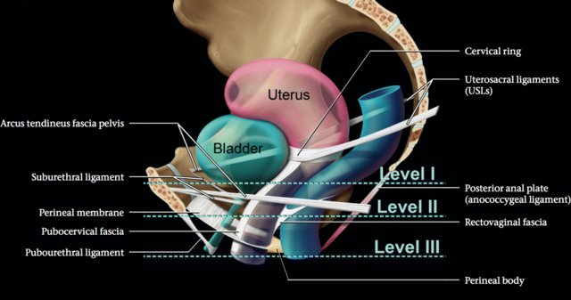

Pelvic Organ Prolapse
Pelvic organ prolapse (POP) refers to the protrusion of the pelvic organs into the vaginal canal or beyond the vaginal opening. It occurs because of a weakness in the endopelvic fascia investing the vagina, along with its ligamentous supports. Defects in vaginal support may occur in isolation (e.g., anterior vaginal wall only), but they are more commonly combined. The nomenclature of POP has evolved such that older terms such as cystocele, rectocele, and enterocele have been replaced by more anatomically precise terms.
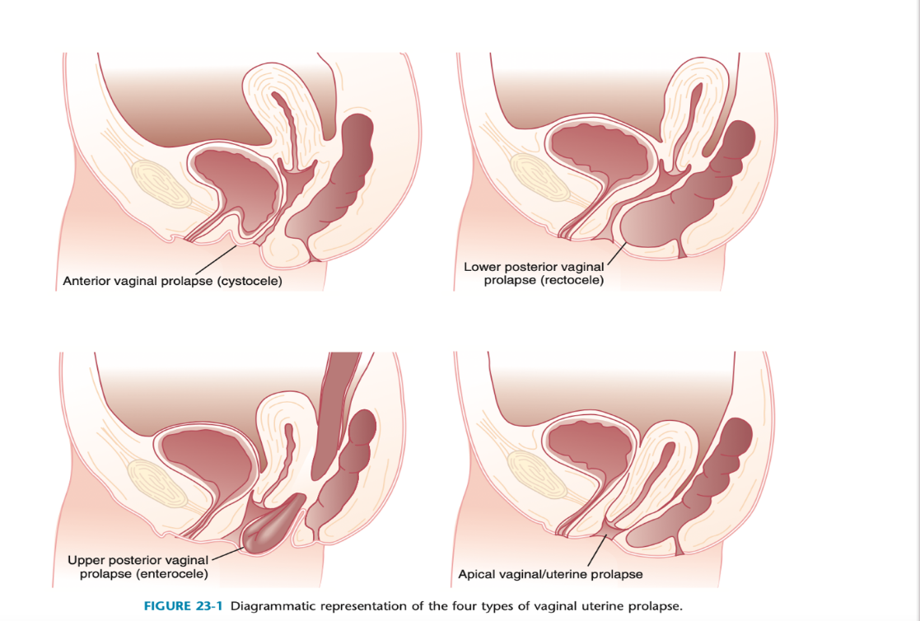
Pathophysiology
Pelvic organ support is maintained by complex interactions between the levator ani muscle, vagina, and pelvic floor connective tissue.
When the levator ani muscle has normal tone and the vagina has adequate depth, the upper vagina lies nearly horizontal in the standing female. This creates a "flap-valve" effect in which the upper vagina is compressed against the levator plate during periods of increased intra-abdominal pressure. It is theorized that when the levator ani muscle loses tone, the vagina drops from a horizontal to a semi-vertical position. This widens or opens the genital hiatus and predisposes pelvic viscera to prolapse. Without adequate levator ani support, the visceral fascial attachments of the pelvic contents are placed on tension and are thought to stretch and eventually fail.
ANTERIOR VAGINAL PROLAPSE (CYSTOCELE)
The anterior vagina is the most common site of vaginal prolapse. Women with this type of defect will describe symptoms of vaginal fullness, heaviness, pressure, and/or discomfort that often progress over the course of the day and are most noticeable after pro- longed standing or straining. Women may have to apply manual pressure to empty their bladder completely. Other symptoms include stress urinary incontinence (SUI), urinary urgency, and frequency. Significant anterior vaginal wall prolapse that protrudes beyond the vaginal opening (hymen) can cause urethral obstruction caused by kinking, resulting in urinary retention or incomplete bladder emptying. Anterior vaginal wan prolapse includes:
• Urethrocele: urethral descent
• Cystocele: bladder descent
• Cystourethrocele: descent of bl'adder and urethra
POSTERIOR VAGINAL PROLAPSE (RECTOCELE AND ENTEROCELE)
Posterior vaginal defects occur when there is weakness in the rectovaginal septum. Symptoms can be indistinguishable from other types of prolapse because the discomfort, pressure, and the sense of a vaginal bulge are nonspecific. When difficulties with bowel function and defecation occur, lower posterior vaginal prolapse is likely. Straining or the need to manually splint for complete bowel elimination may occur. Upper posterior vaginal wall prolapse is nearly always associated with herniation of the pouch of Douglas, and because this is likely to contain loops of bowel, it is called an enterocele. While Rectocele indicates rectal descent
APICAL VAGINAL UTERINE PROLAPSE
Although vaginal prolapse can occur without uterine prolapse, the uterus cannot descend without carrying the upper or apical portion of the vagina with it. Uterovaginal prolapse means uterine descent with inversion of vagina apex, while Vault prolapse is post-hysterectomy inversion of vaginal apex
Complete procidentia (uterine prolapse through the vaginal hymen) represents failure of all the vaginal supports (Figure 23-2). Hypertrophy, elongation, congestion, and edema of the cervix may sometimes cause a large protrusion of tissue beyond the hymen that may be mistaken for a complete procidentia. Vaginal vault prolapse or eversion of the vagina may be seen after vaginal or abdominal hysterectomy and represents failure of the supports around the upper vagina.
FIGURE 23-2 Complete uterine prolapse (procidentia). Note the lesions on either side of cervical dimple (arrows), representing pressure ulcerations from clothing/undergarments.
ETIOLOGY OF PROLAPSE
- Pregnancy and labour: The pelvic fascia, ligaments, and muscles may become attenuated from excessive stretching during pregnancy, labor, and difficult vaginal delivery, especially with forceps or vacuum assistance.
- Genetic: Two per cent of symptomatic prolapse occurs in nulliparous women, implying that there may be a congenital weakness of connective tissue. Asian women appear less likely than white women to develop prolapse. In addition, genital prolapse is rare in Afro-Caribbean women, suggesting that genetic differences exist
- Increased intraabdominal pressure resulting from a chronic cough, ascites, repeated lifting of heavy weights, or habitual straining as a result of constipation may predispose women to prolapse.
- Menopause: Atrophy of the supporting tissues with aging, especially after menopause, also plays an important role in the initiation or worsening of pelvic relaxation.
- Iatrogenic factors include failure to adequately correct all pelvic support defects at the time of pelvic surgery, such as hysterectomy.
Grading
Three degrees of prolapse are described and the lowest or most dependent portion of the prolapse is assessed whilst the patient is straining:
• 1st: descent within the vagina
• 2nd: descent to the introitus
• 3rd: descent outside the introitus, third-degree uterine prolapse is termed procidentia and is usually accompanied by cystourethrocele and rectocele.
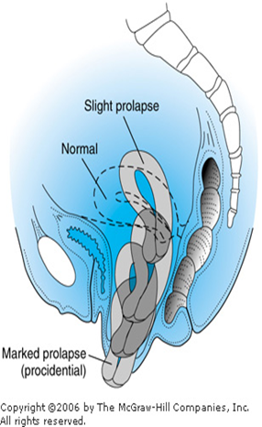

CLINICAL FEATURES
Symptoms: Symptoms of POP mainly affect a woman’s quality of life.
* Feeling of something coming out per vagina .Initially it is reducible but later it becomes irreducible. there may be variable discomfort that the mass comes out when she walks.
* Backache or dragging pain in the pelvis.
* Coital problems such as uncomfortable or difficult intercourse occur in uterine and vaginal prolapse
* Urinary symptoms like difficulty in passing urine, incomplete evacuation .
* If infection----- urgency ,frequency.
* Stress incontinence i.e while doing strenous work there is dribbling of urine.
* Bowel symptom in presence of rectocele like difficulty in passing stool and feeling of incomplete evacuation.
* Excessive white or blood stained discharged per vaginum if there is associated vaginits or decibutis ulcer.
* significant sequelae of POP can occur in neglected cases of procidentia, which may be complicated by excessive purulent discharge, decubitus ulceration, and bleeding. Ureteral obstruction with hydronephrosis is also a possible result of complete procidentia.
Examination:
vaginal examination is facilitated by using a single- blade speculum. While the posterior vaginal wall is being depressed, the patient is asked to strain down. This demonstrates the descent of the anterior vaginal wall consistent with prolapse and urethral displacement. Similarly, retraction of the anterior vaginal wall during straining will accentuate posterior vaginal defects and uncover an enterocele and rectocele if present. Rectal and vaginal examinations are often useful to demonstrate a rectocele and to distinguish it from an enterocele.
Pinch Test
Cough impulse in uterine prolapse leads to the expulsion of the mass PV. in case of first degree prolapse examination is made by introducing speculum and one may see the cervical descent below the level of ischial spines
MANAGEMENT
Prophylactic measures to mitigate the symptoms of POP include identifying and treating chronic respiratory and metabolic disorders, correction of constipation and intra-abdominal disorders that may cause repetitive increases in intraabdominal pressure, and, for menopausal women, administration of estrogen. Failure to recognize and treat significant support defects at the time of concomitant gynecologic surgery may lead to progression of existing prolapse and the development of urinary incontinence or retention and urinary tract infections (UTIs).
Approach to Treatment
For women who are asymptomatic or mildly symptomatic, expectant management is appropriate. However, for women with significant prolapse or for those with bothersome symptoms, nonsurgical or surgical therapy may be selected. Treatment choice depends on the type and severity of symptoms, age and medical co-morbidities, desire for future sexual function and/or fertility, and risk factors for recurrence. Treatment should strive to provide symptom relief, but therapy benefits should always outweigh risks.
Nonsurgical Treatment
- Exercise: When only a mild degree of pelvic relaxation is present, pelvic floor muscle exercises may improve the tone of the pelvic floor musculature.
- Pessaries (Figure 23-4), which provide intravaginal support, may be used to correct prolapse by internally supporting the vagina. Indications of pessary use includes:
  - They can be considered when the patient is medically unfit
  - patient refuses surgery
  - during pregnancy and the postpartum period.
  - They are also useful to promote healing of a decubitus ulcer before surgery.
  - In many patients, pessaries are the treatment of choice, as they are almost risk-free, immediately available, and useful for interim treatment in those wishing to delay surgery.
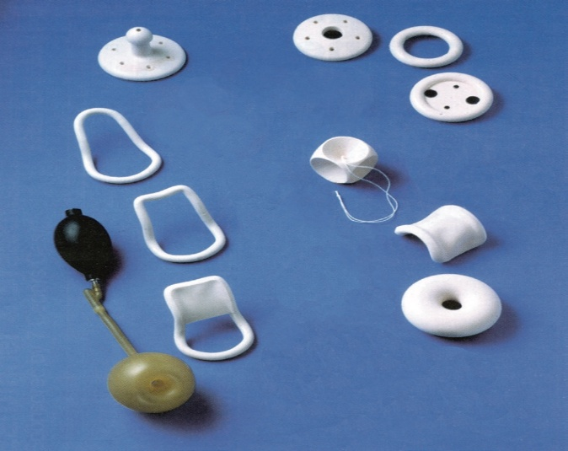
FIGURE 23-4 Some types of vaginal pessaries used for prolapse.
Complications: Pessaries require proper fitting and must be selected in the appropriate type and size. They should be removed, cleaned, and reinserted every 6 to 12 weeks. They may cause vaginal irritation and ulceration. Neglect may result in serious consequences, including fistula formation, impaction, bleeding, and infection. Many patients are capable of caring for their pessaries themselves. In those cases, the patient inserts, removes, and cleans her pessary several times each week, if not daily. It is similar to the care and use of a contraceptive diaphragm.

Surgical treatment
Cystourethrocele Anterior repair (colporrhaphy) is the most commonly performed surgical procedure but should be avoided if there is concurrent stress incontinence. An anterior vaginal wall incision is made and the fascial defect allowing the bladder to herniate through is identified and closed. With the bladder position restored, any redundant vaginal epithelium is excised and the incision closed.
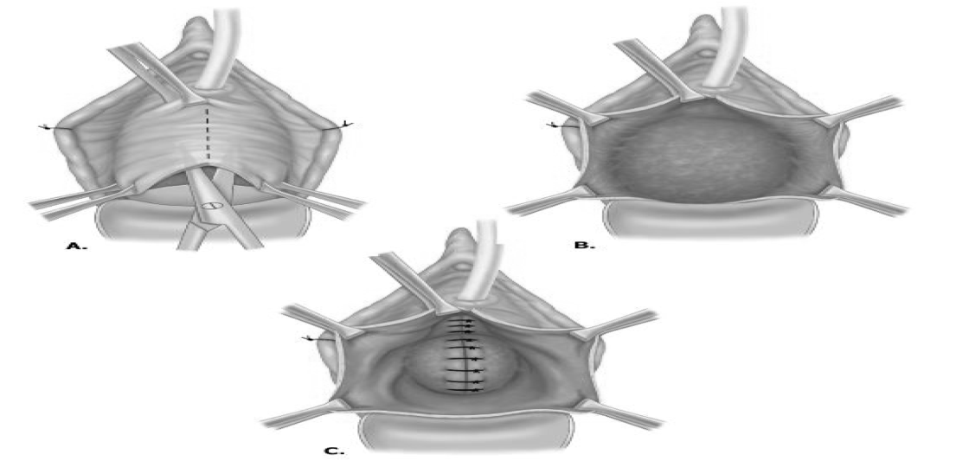

Posterior repair (colporrhaphy) is the most commonly performed procedure. A posterior vaginal wall incision is made and the fascial defect allowing the rectum to herniate through is identified and closed. With the rectal position restored, any redundant vaginal epithelium is excised and the incision closed.
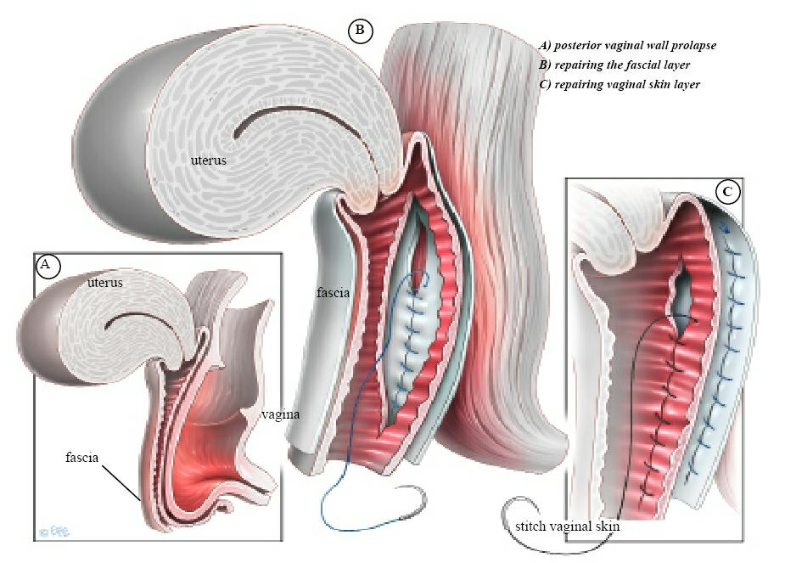

Enterocele
The surgical principles are similar to those of anterior and posterior repair, but the peritoneal sac containing the small bowel should be excised. In addition, the pouch of Douglas is closed by approximating the peritoneum and/or the uterosacral ligaments.

Uterovaginal prolapse

Uterine preserving surgery
Uterine preserving surgery is used largely when a woman still wants to have further children and therefore the uterus has to be preserved. Occasionally, a woman wishes to preserve her uterus and then may choose this option:
• Hysterosacropexy: This may be performed by an open route or a laparoscopic route and a mesh is attached to the isthmus of the cervix and the uterus is suspended by attaching the other part of the mesh to the anterior longitudinal ligament on the sacrum.

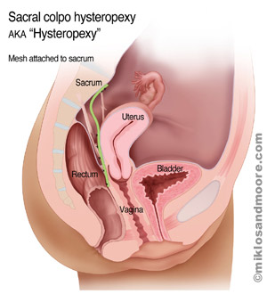

•The Manchester repair: This involves accessing the uterus vaginally amputating the cervix and using the uterosacral cardinal ligament complex to support the uterus. The operation is rarely used now because of problems with complications to the cervix resulting in either cervical stenosis or cervical incompetence and a risk of miscarriage.
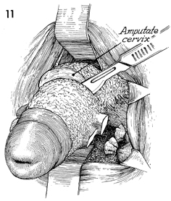

• Le Fort colpocleisis: This operation is used in very frail patients who are unfit for major surgery and are not sexually active. It involves partial closure of the vagina while preserving the uterus.

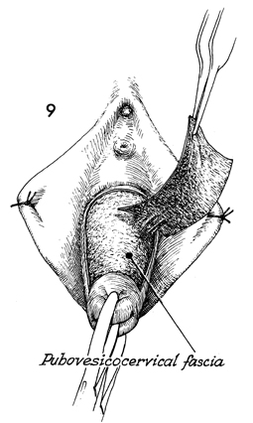
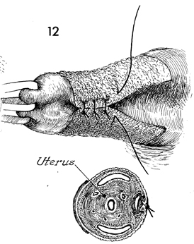

Procedures involving hysterectomy: These procedures involve removal of the uterus:
• Vaginal hysterectomy. Which involves removal of the uterus through the vagina
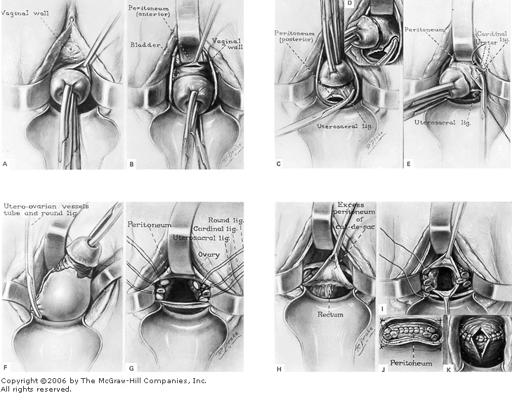

• Total abdominal hysterectomy and sacrocolpopexy: This involves complete removal of the uterus through an abdominal incision,followed by repair of the vault of the vagina and then attaching a mesh to the vault of the vagina and suspending it to the anterior longitudinal ligament on the sacrum.
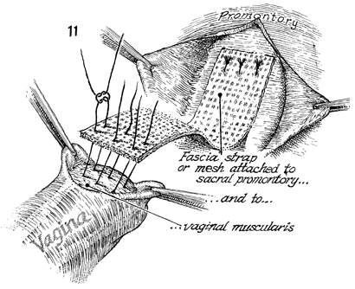
• Subtotal abdominal hysterectomy and sacrocervicopexy: A subtotal hysterectomy is performed leaving the cervix intact. This means the vagina is not entered and there is no vaginal scarring. The cervix is then used as an attachment point for the mesh.
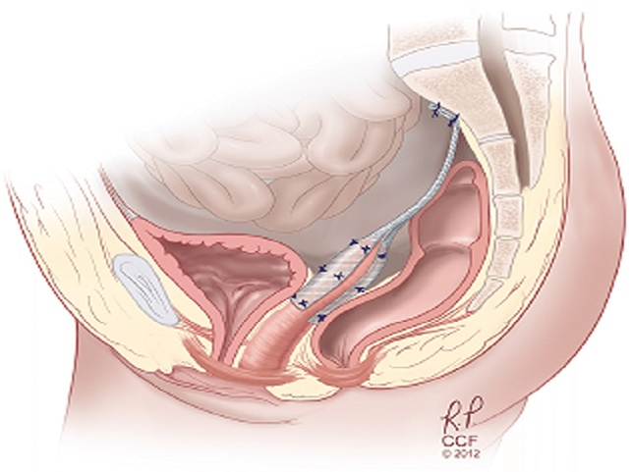

Vault prolapse
Sacrocolpopexy is similar to sacrohysteropexy but the inverted vaginal vault is attached to the sacrum using a mesh and the pouch of Douglas is closed.
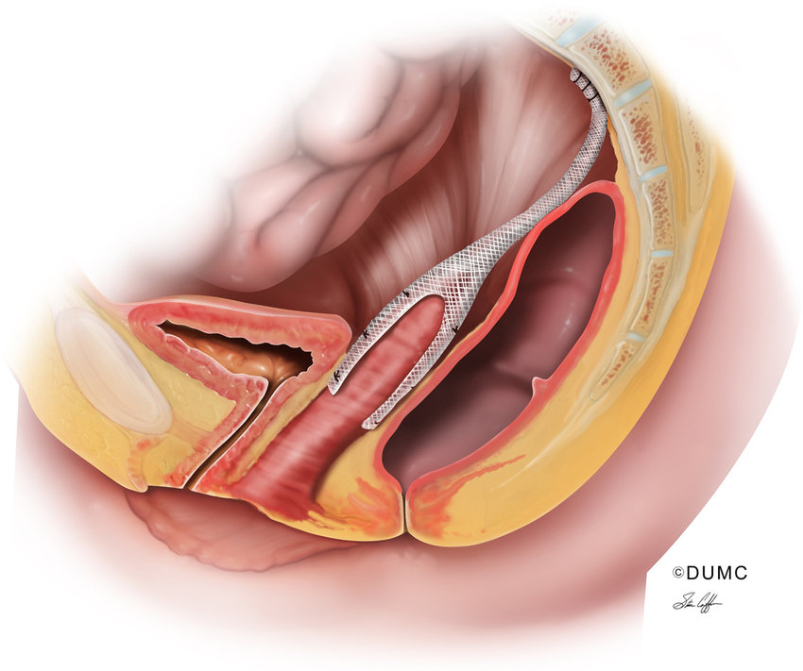

Sacrospinous ligament fixation is a vaginal procedure in which the vault is sutured to one or other sacrospinous ligament.
