Dr.Maryam Virology
Enveloped RNA viruses
Rubella Virus
This virus causes rubella (German measles) and congenital rubella syndrome. Congenital rubella syndrome is characterized by congenital malformations.
Important Properties; Rubella virus is a member of the togavirus family. It is composed of one piece of single-stranded RNA, an icosahedral nucleocapsid, and a lipoprotein envelope. However, unlike the paramyxoviruses, such as measles and mumps viruses, it has a positive-strand RNA and therefore has no virion polymerase. Its surface spikes contain hemagglutinin. The virus has a single antigenic type. Antibody against hemagglutinin neutralizes infectivity. Humans are the natural host.
Summary of Replicative Cycle; Because knowledge of rubella virus replication is incomplete, the following cycle is based on the replication of other togaviruses. After penetration of the cell and uncoating, the plus-strand RNA genome is translated into several nonstructural and structural proteins. Note the difference between togaviruses and poliovirus, which also has a plus-strand RNA genome but translates its RNA into a single large polyprotein, which is subsequently cleaved. One of the nonstructural rubella proteins is an RNA-dependent RNA polymerase, which replicates the genome first by making a minus-strand template and then, from that, plus-strand progeny. Both replication and assembly occur in the cytoplasm, and the envelope is acquired from the outer membrane as the virion exits the cell.
Transmission & Epidemiology
The virus is transmitted via respiratory droplets and from mother to fetus transplacentally. The disease occurs worldwide. In areas where the vaccine is not used, epidemics occur every 6 to 9 years.
Elimination was made possible by the widespread use of the vaccine. As a result, cytomegalovirus is a much more common cause of congenital malformations than is rubella virus.
Pathogenesis & Immunity
Initial replication of the virus occurs in the nasopharynx and local lymph nodes. From there it spreads via the blood to the internal organs and skin. The origin of the rash is unclear; it may be due to antigen/antibody–mediated vasculitis.
Natural infection leads to lifelong immunity. Second cases of rubella do not occur; similar rashes are caused by other viruses, such as Coxsackie viruses and echoviruses. Antibody crosses the placenta and protects the newborn.
Clinical Findings
Rubella; Rubella is a milder, shorter disease than measles. After an incubation period of 14 to 21 days, a brief prodromal period with fever and malaise is followed by a maculopapular rash, which starts on the face and progresses downward to involve the extremities. Posterior auricular lymphadenopathy is characteristic. The rash typically lasts 3 days. When rubella occurs in adults, especially women, polyarthritis caused by immune complexes often occurs.
Congenital Rubella Syndrome; The significance of rubella virus is not as a cause of mild childhood disease but as a teratogen. When a nonimmune pregnant woman is infected during the first trimester, especially the first month, significant congenital malformations can occur as a result of maternal viremia and fetal infection. The increased rate of abnormalities during the early weeks of pregnancy is attributed to the very sensitive organ development that occurs at that time. The malformations are widespread and involve primarily the heart (e.g., patent ductus arteriosus), the eyes (e.g., cataracts), and the brain (e.g., deafness and mental retardation).
In addition, some children infected in utero can continue to excrete rubella virus for months following birth, which is a significant public health hazard because the virus can be transmitted to pregnant women. Some congenital shedders are asymptomatic and without malformations and hence can be diagnosed only if the virus is isolated. Congenitally infected infants also have significant IgM titers and persistent IgG titers long after maternal antibody has disappeared.
Laboratory Diagnosis
Rubella virus can be grown in cell culture, but it produces little cytopathic effect (CPE). If is therefore usually identified by its ability to interfere with echovirus CPE. If rubella virus is present in the patient's specimen and has grown in the cell culture, no CPE will appear when the culture is superinfected with an echovirus. The diagnosis can also be made by observing a fourfold or greater rise in antibody titer between acute-phase and convalescent-phase sera in the hemagglutination inhibition test or ELISA or by observing the presence of IgM antibody in a single acute-phase serum sample.
In a pregnant woman exposed to rubella virus, the presence of IgM antibody indicates recent infection, whereas a 1:8 or greater titer of IgG antibody indicates immunity and consequent protection of the fetus. If recent infection has occurred, an amniocentesis can reveal whether there is rubella virus in the amniotic fluid, which indicates definite fetal infection.
Treatment; There is no antiviral therapy.
Prevention
Prevention involves immunization with the live, attenuated vaccine. The vaccine is effective and long-lasting (at least 10 years) and causes few side effects, except for transient arthralgias in some women. It is given subcutaneously to children at 15 months of age (usually in combination with measles and mumps vaccine) and to unimmunized young adult women if they are not pregnant and will use contraception for the next 3 months. There is no evidence that the vaccine virus causes malformations. Because it is a live vaccine, it should not be given to immunocompromised patients or to pregnant women.
The vaccine has caused a significant reduction in the incidence of both rubella and congenital rubella syndrome. It induces some respiratory IgA, thereby interrupting the spread of virulent virus by nasal carriage.
Immune serum globulins (IG) can be given to pregnant women in the first trimester, who has been exposed to a known case of rubella and for whom termination of the pregnancy is not an option. The main problems with giving IG are that there are instances in which it fails to prevent fetal infection and that it may confuse the interpretation of serologic tests. If termination of the pregnancy is an option, it is recommended to attempt to determine whether the mother and fetus have been infected as described in the "Laboratory Diagnosis" section above.
To protect pregnant women from exposure to rubella virus, many hospitals require their personnel to demonstrate immunity, either by serologic testing or by proof of immunization.

.Rabies Virus
Important Properties
Rabies virus is the only medically important member of the rhabdovirus family. It has a single-stranded RNA enclosed within a bullet-shaped capsid surrounded by a lipoprotein envelope. Because the genome RNA has negative polarity, the virion contains an RNA-dependent RNA polymerase. Rabies virus has a single antigenic type. The antigenicity resides in the envelope glycoprotein spikes.
Rabies virus has a broad host range: it can infect all mammals, but only certain mammals are important sources of infection for humans (see below).
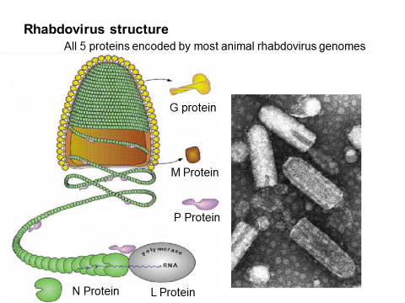
Summary of Replicative Cycle
Rabies virus attaches to the acetylcholine receptor on the cell surface. After entry into the cell, the virion RNA polymerase synthesizes five mRNAs that code for viral proteins. After replication of the genome viral RNA by a virus-encoded RNA polymerase, progeny RNA is assembled with virion proteins to form the nucleocapsid and the envelope is acquired as the virion buds through the cell membrane.
Transmission & Epidemiology
The virus is transmitted by the bite of a rabid animal that manifests aggressive, biting behavior induced by the viral encephalitis. In the United States, transmission is usually from the bite of wild animals such as skunks, raccoons, and bats; dogs and cats are frequently immunized and therefore are rarely sources of human infection. In recent years, bats have been the source of most cases of human rabies in the United States. Rodents and rabbits do not transmit rabies.
Human rabies has also occurred in the United States in people who have not been bitten, so-called "nonbite" exposures. The most important example of this type of transmission is exposure to aerosols of bat secretions containing rabies virus. Another rare example is transmission in transplants of corneas taken from patients who died of undiagnosed rabies.
In the United States, fewer than 10 cases of rabies occur each year (mostly imported), whereas in developing countries there are hundreds of cases, mostly due to rabid dogs. In 2007, the United States was declared "canine-rabies free"—the result of the widespread immunization of dogs. Worldwide, approximately 50,000 people die of rabies each year.
The country of origin and the reservoir host of a strain of rabies virus can often be identified by determining the base sequence of the genome RNA. For example, a person developed clinical rabies in the United States, but sequencing of the genome RNA revealed that the virus was the Mexican strain. It was later discovered that the man had been bitten by a dog while in Mexico several months earlier.
Pathogenesis & Immunity
The virus multiplies locally at the bite site, infects the sensory neurons, and moves by axonal transport to the central nervous system. During its transport within the nerve, the virus is sheltered from the immune system and little, if any, immune response occurs. The virus multiplies in the central nervous system and then travels down the peripheral nerves to the salivary glands and other organs. From the salivary glands, it enters the saliva to be transmitted by the bite. There is no viremic stage.
Within the central nervous system, encephalitis develops, with the death of neurons and demyelination. Infected neurons contain an eosinophilic cytoplasmic inclusion called a Negri body, which is important in laboratory diagnosis of rabies (Figure 39–3). Because so few individuals have survived rabies, there is no information regarding immunity to disease upon being bitten again.

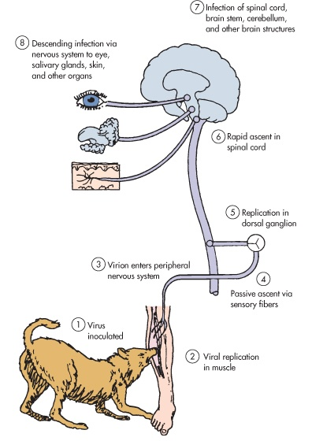

Clinical Findings
The incubation period varies, according to the location of the bite, from as short as 2 weeks to 16 weeks or longer. It is shorter when bites are sustained on the head rather than on the leg, because the virus has a shorter distance to travel to reach the central nervous system.
Clinically, the patient exhibits a prodrome of nonspecific symptoms such as fever, anorexia, and changes in sensation at the bite site. Within a few days, signs such as confusion, lethargy, and increased salivation develop. Most notable is the painful spasm of the throat muscles on swallowing. This results in hydrophobia, an aversion to swallowing water because it is so painful. Within several days, the disease progresses to seizures, paralysis, and coma. Death almost invariably ensues, but with the advent of life support systems a few individuals have survived.

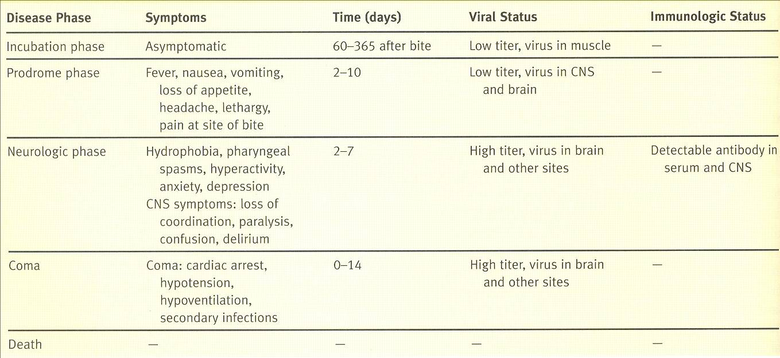
Laboratory Diagnosis
Rapid diagnosis of rabies infection in the animal is usually made by examination of brain tissue by using either fluorescent antibody to rabies virus or histologic staining of Negri bodies in the cytoplasm of hippocampal neurons. The virus can be isolated from the animal brain by growth in cell culture, but this takes too long to be useful in the decision of whether to give the vaccine.
Rabies in humans can be diagnosed by fluorescent antibody staining of a biopsy specimen, usually taken from the skin of the neck at the hairline; by isolation of the virus from sources such as saliva, spinal fluid, and brain tissue; or by a rise in titer of antibody to the virus. Negri bodies can be demonstrated in corneal scrapings and in autopsy specimens of the brain.

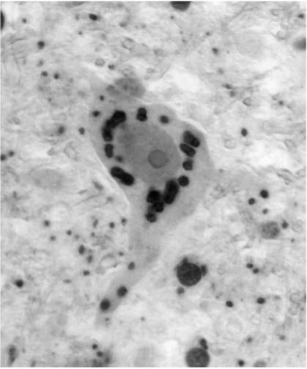
Immunohistochemical staining of intra-cytoplasmic viral inclusions in the neuron of a human rabies patient
( Negri bodies).
Treatment
There is no antiviral therapy for a patient with rabies. Only supportive treatment is available.
Prevention
The rabies vaccine is the only vaccine that is routinely used postexposure, i.e., after the person has been exposed to the virus via animal bite. The long incubation period of the disease allows the virus in the vaccine sufficient time to induce protective immunity.
Postexposure immunization involves the use of both the vaccine and human rabies immune globulin (RIG, obtained from hyperimmunized persons) plus immediate cleaning of the wound. This is an example of passive–active immunization. Tetanus immunization should also be considered.
If the decision is to immunize, both HDCV and RIG are recommended. Five doses of HDCV are given (on days 0, 3, 7, 14, and 28), but RIG is given only once with the first dose of HDCV (at a different site). HDCV and RIG are given at different sites to prevent neutralization of the virus in the vaccine by the antibody in the RIG. As much as possible of the RIG is given into the bite site, and the remainder is given intramuscularly. If the animal has been captured, it should be observed for 10 days and euthanized if symptoms develop. The brain of the animal should be examined by immunofluorescence.

