**ألجامعة المستنصرية /كلية الطب**

**ألمرحلة الرابعة /طب الأطفال**

Rickets

Rickets is a disease of growing bone that is due to an unmineralized protein matrix (osteoid) at the growth plates, thus it occurs only in children before the fusion of the epiphyses. (Defective mineralization in both bone and cartilage of epiphyseal growth plates).

Osteomalacia is present when there is inadequate mineralization of osteoid throughout the bone and occurs in children and adults

**Etiology**

**Vit D disorders:** Nutritional, Congenital, Secondary, Vit D-dependent rickets (type 1 & type 2), and Chronic RF.

• **Calcium deficiency:** Low intake or Malabsorption.

• **Phosphorus deficiency:** Inadequate intake, Disorders of Phosphatonin e.g. XL, AD & AR hypophosphatemic rickets, Hereditary hypophosphatemic rickets with hypercalciuria, Overproduction of phosphatonin.

• **Syndromes & diseases associated with rickets:** Fanconi synd., Distal RTA & Dent disease.

**Vitamin D Physiology**

Cutaneous synthesis is the most important source of Vit D in skin epithelial cells from the conversion of 7 -dehydrocholesterol to 3- cholecalciferol (D3) by ultraviolet B radiation from the sun, but this depends on the amount of sun exposure because less duration, covering the skin with clothing, skin pigmentation, and seasonality (winter sun) are less efficient in Vit D synthesis.

Cutaneous synthesis can be limited because of the ineffectiveness of the winter sun in stimulating vitamin D synthesis; avoidance of sunlight because of concerns about cancer, neighborhood safety, or cultural practices; and decreased cutaneous synthesis because of increased skin pigmentation.

Natural dietary sources of Vit D include: fish liver oil, egg yolk, plants, or yeast. Vit D is fat-soluble, stable to heat, acid, alkali, and oxidation. Bile is necessary for its absorption

There are 2 forms of vitamin D:

D2 (ergocalciferol, synthesized by plants)

D3 (cholecalciferol, synthesized by mammals).

The main source of vitamin D for humans is vitamin D3 through its synthesis in the skin when UV-B in the range of 290 to 315 nm converts 7-dehydrocholesterol into previtamin D3. Through the heat of the skin, previtamin D3 is further transformed into vitamin D3  this is temperature dependant isomerization takes 3 days , which then binds to the vitamin D–binding protein and is transported to the liver and converted to 25-hydroxyvitamin D (25-OH-D) by the action of 25-hydroxylase by p450 enzyme. 25-OH-D, the nutritional indicator of vitamin D, undergoes a second hydroxylation in the kidney and other tissues to become 1,25-dihydroxyvitamin D (1,25-OH2-D). This enzyme 1α hydroxylase in the proximal tubule is up-regulated by PTH and hypo-phosphatemia.

Vitamin D is an important pre-hormone with active metabolites (25-OH-D and 1,25-OH2-D) that are involved in many metabolic processes beyond bone integrity and calcium homeostasis.

The active form of vitamin D in our body is 1,25 VIT D (Calcitriol) (1,25 di-hydroxy cholecalciferol)

1. 1,25-D acts in the intestine causing a marked increase in calcium absorption and to less extent phosphorus absorption.
2. It has a direct effect on bone by mediating resorption (i.e Demineralization).
3. 1,25-D directly suppresses PTH secretion by the parathyroid gland (which is also suppressed by the increase in serum calcium).
4. 1,25-D inhibits its own synthesis in the kidney.

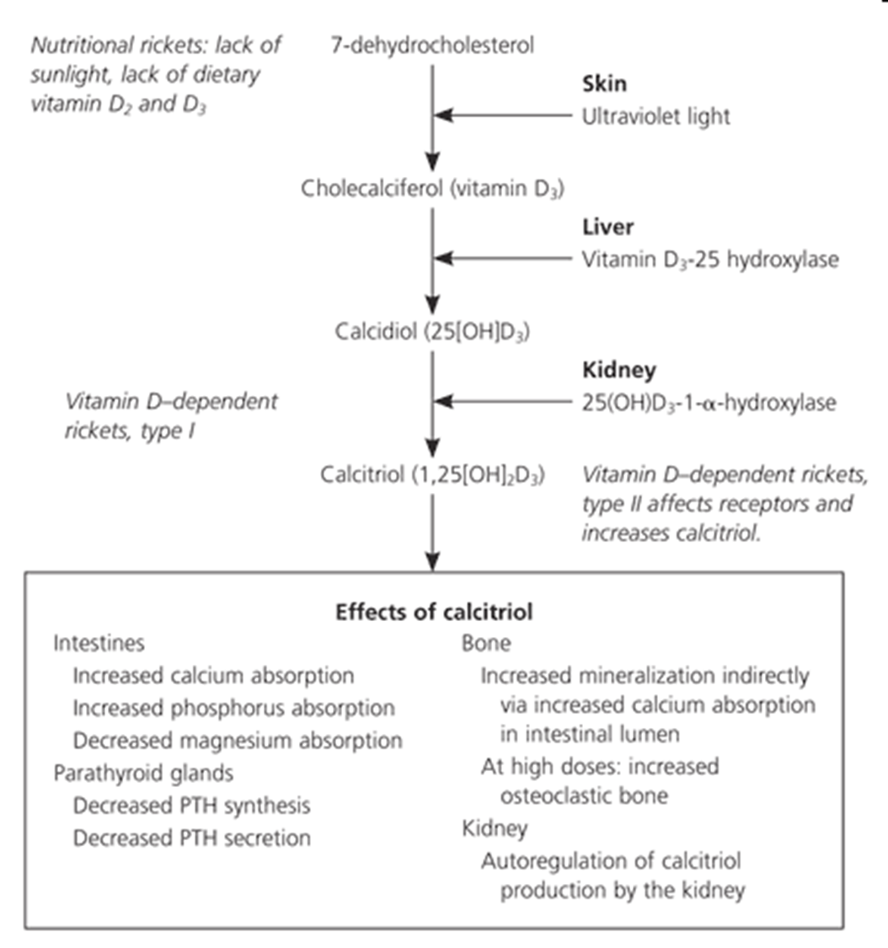

**Nutritional vitamin D deficiency:-**

Etiology: It is the most common cause of rickets globally. It most commonly occurs in infancy due to a combination of poor intake and inadequate cutaneous synthesis.Transplacental transport of vit D (mostly 25-D) typically provides enough Vit D for the 1st 2 mo of life, unless there is severe maternal Vit D deficiency.Infants who receive formula receive adequate Vit D, even without cutaneous synthesis. Because of the low vit D content of breast milk (especially if the mother was also vit D deficient), thus breastfed infants rely on cutaneous synthesis or vit D supplements.

**Risk Factors for Nutritional Rickets**

**Maternal Factors**

*Vitamin D deficiency*

Dark skin pigmentation

Full-body clothing cover

High latitude during the winter/spring season

Other causes of restricted sun (UVB) exposure, e.g., predominant indoor

living, disability, pollution.

*Low-calcium diet*

Poverty, malnutrition, special diets

**Infant/Childhood Factors**

Neonatal vitamin D deficiency secondary to maternal deficiency/vitamin D deficiency

Lack of infant supplementation with vitamin D

Prolonged breastfeeding without appropriate complementary feeding from 6 mo

High latitude during the winter/spring season

Dark skin pigmentation and/or restricted sun (UVB) exposure, e.g., predominant indoor living, disability, pollution, cloud cover Low–vitamin D diet

Low-calcium diet

Poverty, malnutrition, special diets

**Clinical manifestations of rickets**

•General: FTT, listlessness, protruding abdomen, muscle weakness

(Especially proximal), delayed walking, waddling gait, fractures.

• Head: craniotabes, frontal bossing, delayed fontanel closure, delayed dentition with dental caries, craniosynostosis

• Chest: rachitic rosary, Harrison groove, RTI, and atelectasis.

• Back: scoliosis, kyphosis, lordosis.

• Extremities: enlargement of wrists and ankles, valgus or varus deformities, windswept deformity, anterior bowing of the tibia and femur, coxa vara, leg pain.

• Hypo calcemic symptoms: tetany, seizures, strider (due to laryngeal spasm).

Most manifestations of rickets are a result of skeletal changes.

**Craniotabes** is a softening of the cranial bones and can be detected by applying pressure at the occiput or over the parietal bones. The sensation is similar to the feel of pressing into a Ping-Pong ball and then releasing it. Craniotabes may also be secondary to osteogenesis imperfecta, hydrocephalus, and syphilis. It is a normal finding in many newborns, especially near the suture lines, but typically disappears within a few months of birth.

Widening of the costochondral junctions results in a **rachitic “rosary**,” which feels like the beads of a rosary as the examiner's fingers move along the costochondral junctions from rib to rib.

**Growth plate widening** is also responsible for the enlargement at the wrists and ankles.

The horizontal depression along the lower anterior chest known as **the Harrison groove** occurs from the pulling of the softened ribs by the diaphragm during inspiration.

Softening of the ribs also impairs air movement and predisposes patients to **atelectasis and pneumonia.**

**Valgus or varus** deformities of the legs are common; **windswept deformity** occurs when one leg is in extreme valgus and the other is in extreme varus

The clinical presentation of rickets may vary based on the etiology. Changes in the lower extremities tend to be the dominant feature in X-linked hypophosphatemic rickets. Symptoms secondary to hypocalcemia occur only in those forms of rickets associated with decreased serum calcium. The chief complaint in a child with rickets is quite variable. Many children present because of skeletal deformities, whereas others have difficulty walking owing to a combination of deformity and weakness. Other common presenting complaints include failure to thrive (malnutrition) and symptomatic hypocalcemia

**Diagnosis**

1. X-ray of the wrist: shows thickening of the growth plate with fraying & cupping of distal ends of the metaphysis, coarse trabeculation of the diaphysis, and generalized rarefaction. Rachitic changes are most easily visualized on posteroanterior radiographs of the wrist, although characteristic rachitic changes can be seen at other growth plates. Decreased calcification leads to the thickening of the growth plate. The edge of the metaphysis loses its sharp border, which is described as *fraying.* The edge of the metaphysis changes from a convex or flat surface to a more concave surface. This change to a concave surface is termed *cupping* and is most easily seen at the distal ends of the radius, ulna, and fibula. There is a widening of the distal end of the metaphysis, corresponding to the clinical observation of thickened wrists and ankles, as well as the rachitic rosary. Other radiologic features include coarse trabeculation of the diaphysis and generalized rarefaction.
2. The initial laboratory tests in a child with rickets should include

serum calcium (normal or low), phosphorus(low), alkaline phosphatase (high), parathyroid hormone (high), 25-hydroxyvitamin D(low), 1,25-dihydroxyvitamin D (low, normal , high), creatinine, and electrolytes.

Hypocalcemia is a variable finding because the elevated PTH acts to increase the serum calcium concentration. The hypophosphatemia is caused by PTH-induced renal losses of phosphate, combined with a decrease in intestinal absorption. The wide variation in 1,25-D levels (low, normal, or high) is secondary to the upregulation of renal 1α-hydroxylase caused by concomitant hypophosphatemia and hyperparathyroidism. Because serum levels of 1,25-D are much lower than the levels of 25-D, even with low levels of 25-D there is often enough 25-D still present to act as a precursor for 1,25-D synthesis in the presence of upregulated 1α-hydroxylase. The level of 1,25-D is only low when there is severe vitamin D deficiency.

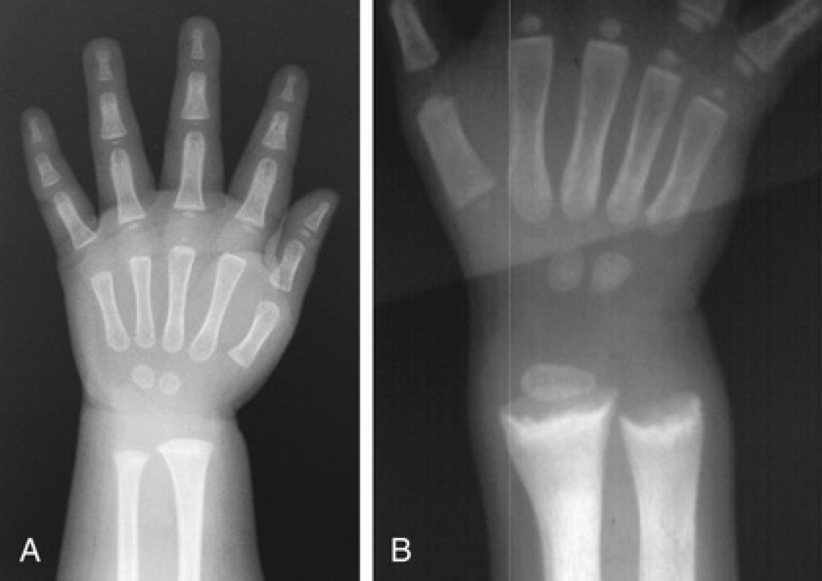

A normal wrist

B rickets

**Treatment of nutritional rickets**

Children with nutritional vitamin D deficiency should receive vitamin D and adequate nutritional intake of calcium and phosphorus. There are 2 strategies for administration of vitamin D.

With **stoss therapy** , vitamin D (300,000-600,000 IU) is administered orally (preferred) or intramuscularly as 2-4 doses over 1 day (vitamin D3 is preferred to D2 because of longer half-life of D3 ). Since the doses are observed, stoss therapy is ideal in patients in whom adherence to therapy is questionable.

The alternative strategy is daily vitamin D with a minimum dose of 2,000 IU/day for a minimum of 3 mo. Either strategy should be followed by daily vitamin D intake of 400 IU/day if <1 yr old or 600 IU/day if >1 yr old. It is important to ensure that children receive adequate dietary calcium (minimum of 500 mg/day) and phosphorus; this dietary intake is usually provided by milk, formula, and other dairy products, although calcium supplements may be needed in some patients.

Children who have symptomatic hypocalcemia might need intravenous (IV) calcium acutely, followed by oral calcium supplements, which typically can be tapered over 2-6 wk in children who receive adequate dietary calcium. Transient use of IV or oral 1,25-D (**calcitriol** ) is often helpful in reversing hypocalcemia in the acute phase by providing active vitamin D during the delay as supplemental vitamin D is converted to active vitamin D. Calcitriol doses are typically 0.05 μg/kg/day. IV calcium is initially given as an acute bolus for symptomatic hypocalcemia (20 mg/kg calcium chloride or 100 mg/kg calcium gluconate). Some patients require a continuous IV calcium drip, titrated to maintain the desired serum calcium level. These patients should transition to enteral calcium, and most infants require approximately 1,000 mg of elemental calcium.

**Prognosis**

Most children with nutritional vitamin D deficiency have an excellent response to treatment, with radiologic healing occurring within a few months. Laboratory test results should also normalize rapidly. Many of the bone malformations improve dramatically, but children with severe disease can have permanent deformities and short stature. Rarely, patients benefit from orthopedic intervention for leg deformities, although this is generally not done until the metabolic bone disease has healed,and there is clear evidence that the deformity will not self-resolve, and the deformity is causing functional problems.

**Prevention**

* Most cases of nutritional rickets can be prevented by universal administration of a daily vitamin D3 containing 400 IU to all breastfed infants beginning in the first few days of life and 600 IU/day for older children.
* Sun exposure (UVB content of sunlight depends on latitude and season)
* Strategic fortification of the habitual food supply
* Normal calcium intake

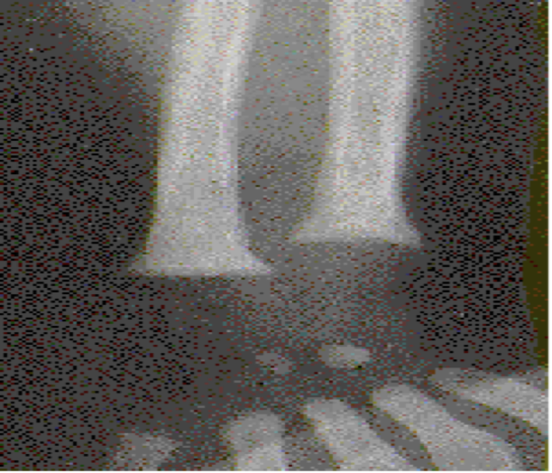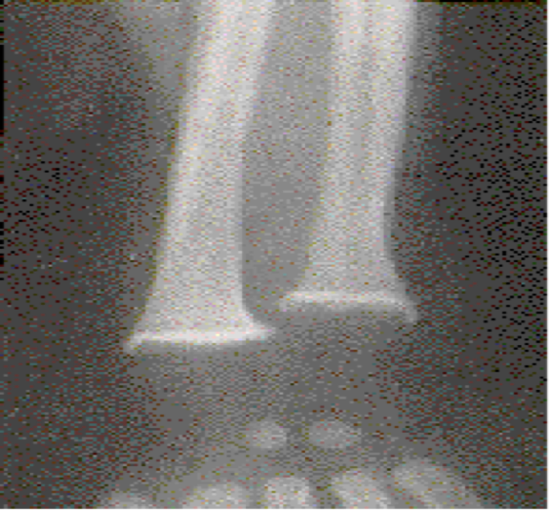 (Healing line)

Rachitic “rosary”

Hands and forearms of a young child with rickets show prominence above the wrist, resulting from flaring and poor mineralization of lower end of the radius and ulna.



Windswept deformity of the legs in an older child with rickets.



Radiographs of the knees in 7 yr old girl. A, At initial presentation, there is widening of the growth plate and metaphyseal fraying. B, Dramatic improvement after 4 mo of therapy with alkali.

**Vitamin D–Dependent Rickets, Type 1**

Children with vitamin D–dependent rickets **type 1A** , an autosomal recessive disorder, have mutations in the gene encoding renal 1α-hydroxylase, preventing conversion of 25-D into 1,25-D. These patients normally present during the 1st 2 yr of life and can have any of the classic features of rickets including symptomatic hypocalcemia. They have normal levels of 25-D but low levels of 1,25-D . Occasionally, 1,25-D levels are at the lower limit of normal, inappropriately low given the high PTH and low serum phosphorus levels, both of which should increase the activity of renal 1α- hydroxylase and cause elevated levels of 1,25-D..

Vitamin D–dependent rickets **type 1B** is secondary to a mutation in the gene for a 25-hydroxylase. Patients have low levels of 25-D but normal levels of 1,25-D.

**Treatment**

Vitamin D–dependent rickets type 1A responds to long-term treatment with

1,25-D (calcitriol). Initial doses are 0.25-2 μg/day, and lower doses are used

once the rickets has healed. Especially during initial therapy, it is important to

ensure adequate intake of calcium. The dose of calcitriol is adjusted to maintain

a low-normal serum calcium level, a normal serum phosphorus level, and a high normal serum PTH level. Targeting a low-normal calcium concentration and a high-normal PTH level avoids excessive dosing of calcitriol, which can cause hypercalciuria and nephrocalcinosis. Therefore, patient monitoring include periodic assessment of urinary calcium excretion, with a target of <4 mg/kg/day.

Vitamin D–dependent rickets type 1B may respond to pharmacologic doses of

vitamin D2 (3,000 U/day) as a result of alternative enzymes with 25-hydroxylase

activity or residual activity of the mutant protein.

**Vitamin D–Dependent Rickets, Type 2**

Patients with vitamin D–dependent rickets **type 2A** have mutations in the gene

encoding the vitamin D receptor, preventing a normal physiologic response to

1,25-D. Levels of 1,25-D are extremely elevated in this autosomal recessive

disorder . Most patients present during infancy, although rickets

in less severely affected patients might not be diagnosed until adulthood. Less

severe disease is associated with a partially functional vitamin D receptor.

Approximately 50–70% of children have **alopecia** , which tends to be associated

with a more severe form of the disease and can range from alopecia areata to

alopecia totalis. Epidermal cysts are a less common manifestation.

Vitamin D–dependent rickets **type 2B** appears to result from overexpression

of a hormone response element–binding protein that interferes with the actions

of 1,25-D. Alopecia may be present.

**Treatment**

Some patients respond to extremely high doses of vitamin D2 (25-D or 1,25-D),

especially patients without alopecia. This response is caused by a partially

functional vitamin D receptor in patients with vitamin D–dependent rickets type

2A, but may also occur in vitamin D–dependent rickets type 2B. All patients

should be given a 3-6 mo trial of high-dose vitamin D and oral calcium. The

initial dose of 1,25-D should be 2 μg/day, but some patients require doses as

high as 50-60 μg/day. Calcium doses are 1,000-3,000 mg/day. Patients who do

not respond to high-dose vitamin D may be treated with long-term IV calcium,

with possible transition to very high dose oral calcium supplements. Treatment

of patients who do not respond to vitamin D is difficult.