كلية الطب الجامعة المستنصرية

المرحلة الرابعة

2023 -2024

**Failure to thrive**

FTT is a description and not a diagnosis. Sub optimal weight gain and growth in infants and toddlers. Growth below the 3rd percentile or change in growth that has crossed 2 major growth percentiles. Remember 3% normal kids fall below 3rd percentile

Patients with malnutrition may present with growth deceleration, faltering growth, or even weight loss, as measured by anthropometric parameters, including weight, height/length,

skinfolds, and mid-upper arm circumference.

Malnutrition may be illness related or non–illness related, or both. Illness-related malnutrition may be caused by one or more diseases, infections, or congenital anomalies, as well as by injury or surgery. Non–illness-related causes include environmental, psychosocial, or behavioral factors

**Causes**

Organic Causes or ( illness related)

Non-Organic Causes (non illness related)

Both may co-exist

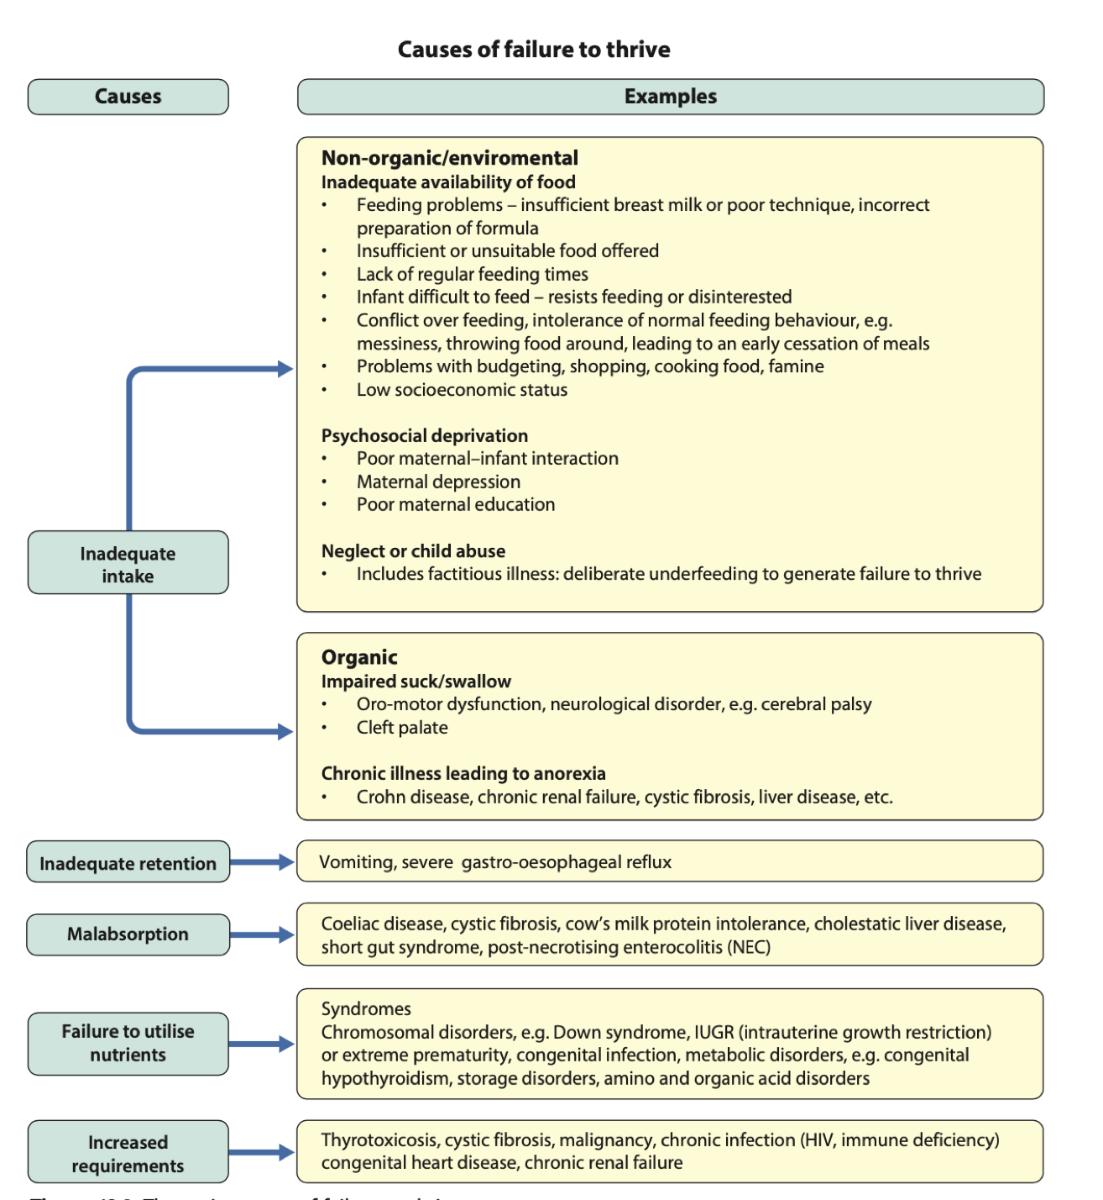

**Organic Causes of Failure to Thrive**

The most common mechanisms for illness-related causes of insufficient growth

Include

**(1)** failure to ingest sufficient calories, or starvation (e.g., cardiac failure,fluid restriction),

**(2)** increased nutrient losses (e.g., protein-losing enteropathy,chronic diarrhea),

**(3)** increased metabolic demands, as seen in extensive burn injuries, and

(**4)** altered nutrient absorption or utilization (e.g., cystic fibrosis,short bowel syndrome).

More than one mechanism can exist simultaneously

*Acute malnutrition* is defined as having a duration of <3 mo .

**Non-organic Failure to Thrive**

It is the commonest cause, one of the earliest indications of serious parent/child interaction dysfunction. It is a form of neglect in which the child's growth is inhibited in the home environment while showing a normal or above growth velocity when placed out of home**.**

**Non-organic (Psychosocial) FTT** include: -

* Inadequate diet because of poverty, food insufficiency, or errors in food preparation.
* Poor parenting skills (lack of knowledge of sufficient diet).
* Child/parent interaction problems (autonomy struggles, coercive feeding, maternal depression).
* Parental cognitive or mental health problems.
* Child abuse or neglect, emotional deprivation.
* Rumination, a rare disorder associated with repeated regurgitation and re chewing of food.

**Clinical manifestation**

It ranges from just poor growth in comparison with their peers to manifestations similar to those of severe malnutrition. In psychosocial FTT there may be signs of neglect e.g., diaper rash, unwashed skin, untreated impetigo, uncut and dirty fingernails, or unwashed clothing. A flattened occiput with hair loss may indicate that the infant has being unattended for prolonged periods. Other features may include delays in social and speech development, avoidance of eye contact, expressionless face, & hypotonia

**Approach to infant with FTT: -**

History and examination: The history in any patient with FTT must include a detailed dietary history with observation of maternal-child interaction.

Physical examination should include all systems of body that may affect growth.

Measure periodically all growth parameters including; weight, length/height &(weight/height) ratio to measure the degree of FTT. It’s the growth velocity that is most important .

In malnutrition, weight is the 1st to be affected, followed by height, whereas head circumference is lastly affected when malnutrition is seriously affected brain growth.

Additional measurements that are useful for following the progress of the acutely malnourished child are mid-upper arm circumference (MUAC) and hand-grip strength. MUAC is a particularly useful anthropometric measure when weight may be distorted by use of corticosteroids or fluid status (e.g., ascites, edema).

For children 6 yr and older, **hand-grip strength** may be a more acute measurement of response to nutritional intervention than MUAC, because muscle function reacts earlier to changes in nutritional status than does muscle mass. The *dynamometer ( see the picture at the end of lecture)* is a simple, noninvasive, and low-cost instrument for measuring baseline functional status and tracking progress throughout the

therapeutic course. Hand-grip strength can help to identify the presence of malnutrition, but the current lack of reference ranges for mild, moderate, and severe malnutrition in large populations limit the ability to use hand-grip strength to quantify the degree of malnutrition.

**4 main goals of physical examination**

* 1.Identification of dysmorphic features suggestive of genetic disorders
* 2. Detection of underlying disease
* 3.assessment of signs of child abuse
* 4.Assessment of possible effects of malnutrition

**Red Flag Signs and Symptoms Suggesting Medical Causes of Failure to Thrive**

1.Cardiac findings suggesting congenital heart disease or heart failure (e.g., murmur, edema, jugular venous distention)

2.Developmental delay

3.Dysmorphic feature

4.Failure to gain weight despite adequate caloric intake

5.Organomegaly or lymphadenopathy

6.Recurrent or severe respiratory, mucocutaneous, or urinary infection

7.Recurrent vomiting, diarrhea, or dehydration



Investigations

CBP & GUE are good initial tests.

Other tests should be judicious & relevant to the findings in history or exam.

The following is a rough outline of the important preliminary investigations that may be initiated:

* Stool and urine microscopy and culture
* Full blood count and film, followed by serum iron and ferritin, B12 and folate as indicated
* Hospitalize and observe feeding
* Creatinine and electrolytes, plus liver and bone function
* Thyroid function and other endocrine investigations
* Sweat test
* Chromosomal analysis
* Metabolic analysis

Treatment

A multidisciplinary team approach is essential for management, with the involvement of a pediatric gastroenterologist, a nutritionist, a social worker, an occupational therapist, a speech and physical therapist, a psychologist and behavioral and developmental specialists).

The goals of management of FTT are following:

· Provision of adequate calories, protein, and other nutrients

· Nutritional counseling to the family

· Monitoring of growth and nutritional status

· Specific treatment of complications or deficiencies

· Long term monitoring and follow up

· Education of the family on social land nurturing techniques

· Supportive economic assistance

Indications of hospitalization for patients with FTT include: -

For further investigations, severe malnutrition, failure of home management & to evaluate the parent-child feeding interaction (especially when psychosocial FTT is suspected).

• Organic causes of FTT should be treated according to the etiology of the organic illness a long with good nutrition.

• Inorganic (Psychosocial) FTT should initially be treated at hospital by giving age-appropriate unlimited diet. If the infant start to gain weight, this is mostly due to Inorganic FTT. However, children with severe malnutrition must be re-fed carefully to avoid re-feeding syndrome.

**Prognosis**

FTT in the 1st yr. of life (regardless of cause) is ominous, because maximal postnatal brain growth occurs in the 1st 6 mo. of life as well as brain grows as much in 1st year as in the rest of the child's life. Thus, all patient with FTT require frequent monitoring & assessment.

Prognosis of patients with organic FTT is variable, whereas ≈ 30% of children with psychosocial FTT may develop developmental delay with social and emotional problems.

Early FTT may be associated with increased risks for cardiovascular disease e.g., dyslipidemia, Hypertension, and glucose intolerance as an adult.

