General Properties and classification of Viruses
Introduction:
Viruses are the smallest infectious agents (ranging from about 20 to 300 nm in diameter) and contain only one kind of nucleic acid (RNA or DNA) as their genome. The nucleic acid is encased in a protein shell, which may be surrounded by a lipid-containing membrane. The entire infectious unit is termed a virion.
The other infectious agents namely, bacteria, fungi, protozoa, and worms, are either single cells or composed of many cells. Cells are capable of independent replication, can synthesize their own energy and proteins, and can be seen in the light microscope. In contrast, viruses are not cells; they are not capable of independent replication, can synthesize neither their own energy nor their own proteins, and are too small to be seen in the light microscope.
Viruses are characterized by the following features:
Viruses are particles composed of an internal core containing either DNA or RNA (but not both) covered by a protective protein coat. Some viruses have an outer lipoprotein membrane, called an envelope, external to the coat. Viruses do not have a nucleus, cytoplasm, mitochondria, or ribosomes. The cells, both prokaryotic and eukaryotic cells, have both DNA and RNA. Eukaryotic cells, such as fungal, protozoal, and human cells, have a nucleus, cytoplasm, mitochondria, and ribosomes. Prokaryotic cells, such as bacteria, are not divided into nucleus and cytoplasm and do not have mitochondria but do have ribosomes; therefore, they can synthesize their own proteins.
- Viruses must reproduce (replicate) within cells, because they cannot generate energy or synthesize proteins. Because they can reproduce only within cells, viruses are obligate intracellular parasites. (The only bacteria that are obligate intracellular parasites are chlamydiae and rickettsiae. They cannot synthesize sufficient energy to replicate independently.)
- Viruses replicate in a manner different from that of cells, i.e., viruses do not undergo binary fission or mitosis. One virus can replicate to produce hundreds of progeny viruses, whereas one cell divides to produce only two daughter cells.
- Table –1 compares some of the attributes of viruses and cells.

Table –1 Comparison of Viruses and Cells

Property | Viruses | Cells
Type of nucleic acid | DNA or RNA but not both | DNA and RNA
Proteins | Few | Many
Lipoprotein membrane | Envelope present in some viruses | Cell membrane present in all cells
Ribosomes | Absent¹ | Present
Mitochondria | Absent | Present in eukaryotic cells
Enzymes | None or few | Many
Multiplication by binary fission or mitosis | No | Yes

¹Arenaviruses have a few nonfunctional ribosomes.
Shape of virus
Viruses range from 20 to 300 nm in diameter; this corresponds roughly to a range of sizes from that of the largest protein to that of the smallest cell. Their shapes are frequently referred to in colloquial terms, e.g., spheres, rods, bullets, or bricks, but in reality they are complex structures of precise geometric symmetry. The shape of virus particles is determined by the arrangement of the repeating subunits that form the protein coat (capsid) of the virus.
Virus Size & Structure
Viruses range in size from that of large proteins (~20 nm) to that of the smallest cells (~300 nm). Most viruses appear as spheres or rods in the electron microscope.
- Viruses contain either DNA or RNA, but not both.
- All viruses have a protein coat called a capsid that covers the genome. The capsid is composed of repeating subunits called capsomers. Each capsomer, consisting of one or several proteins, can be seen in the electron microscope as a spherical particle, sometimes with a central hole.
- In some viruses, the capsid is the outer surface, but in other viruses the capsid is covered with a lipoprotein envelope that becomes the outer surface. The structure composed of the nucleic acid genome and the capsid proteins is called the nucleocapsid.
- The repeating subunits of the capsid give the virus a symmetric appearance that is useful for classification purposes. Some viral nucleocapsids have spherical (icosahedral) symmetry, whereas others have helical symmetry.
- All human viruses that have a helical nucleocapsid are enveloped, i.e., there are no naked helical viruses that infect humans. Viruses that have an icosahedral nucleocapsid can be either enveloped or naked.
- Function of capsid: One the function of the outer shells of a virion is to protect the fragile nucleic acid genome from Nucleases))physical, chemical, or enzymatic damage.The outer surface of the virus is also responsible for recognition of & the first interaction with the host cell Initially, this takes the form of binding of a specific virus-attachment protein to a cellular receptor molecule.The capsid also has a role to play in initiating infection by delivering the genome in a form in which it can interact with the host cell.
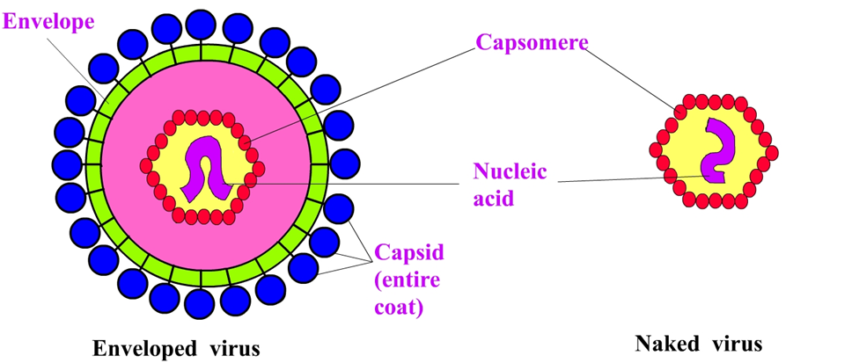

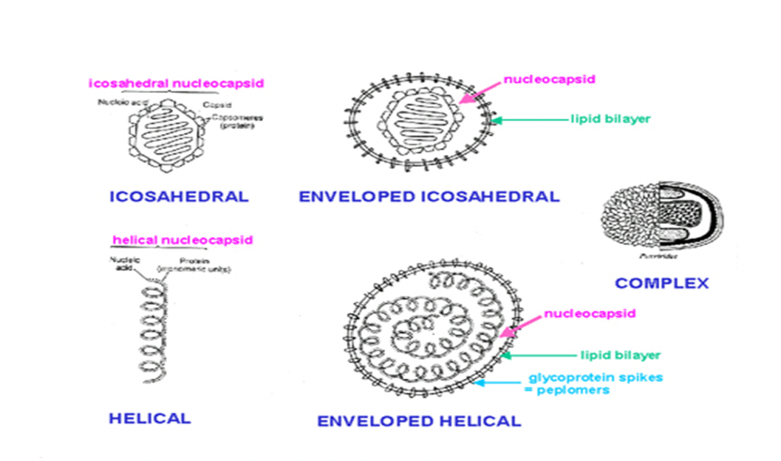
Viral Nucleic Acids
- The genome of some viruses is DNA, whereas the genome of others is RNA. These DNA and RNA genomes can be either single-stranded or double-stranded.
- Some RNA viruses, such as influenza virus and rotavirus, have a segmented genome, i.e., the genome is in several pieces.
- All viruses have one copy of their genome (haploid) except retroviruses, which have two copies (diploid).
Viral Proteins
Viral proteins serve several important functions. .
1. The outer capsid proteins protect the genetic material and mediate the attachment of the virus to specific receptors on the host cell surface. This interaction of the viral proteins with the cell receptor is the major determinant of species and organ specificity.
2. Some of the internal viral proteins are structural (e.g., the capsid proteins of the enveloped viruses), whereas others are enzymes (e.g., the polymerases that synthesize the viral mRNA).
3. Some viruses produce proteins that act as "superantigens" similar in their action to the superantigens produced by bacteria, such as the toxic shock syndrome toxin of Staphylococcus aureus.
4. In addition to the capsid and internal proteins, there are two other types of proteins, both of which are associated with the envelope. The envelope is a lipoprotein membrane composed of lipid derived from the host cell membrane and protein that is virus-specific. Another protein, the matrix protein, mediates the interaction between the capsid proteins and the envelope.
Viral Envelope
- The viral envelope consists of a membrane that contains lipid derived from the host cell and proteins encoded by the virus. Typically, the envelope is acquired as the virus exits from the cell in a process called budding.
- Viruses with an envelope are less stable, i.e., they are more easily inactivated, than naked viruses (those without an envelope). In general, enveloped viruses are transmitted by direct contact via blood and body fluids, whereas naked viruses can survive longer in the environment and can be transmitted by indirect means such as the fecal–oral route.
Properties of naked capsid viruses
• Capsid is resistant to
– Drying
– Heat
– Detergents
– Acids
– Proteases
• Consequences
– Can survive in the gastrointestinal tract
– Retain infectivity on drying
– Survive well on environmental surfaces
– Spread easily via fomites
– Must kill host cells for release of mature virus particles
– Humoral antibody response may be sufficient to neutralize
Infection
Properties of enveloped viruses
• Envelope is sensitive to
– Drying
– Heat
– Detergents
– Acid

• Consequences
– Must stay wet during transmission
– Transmission in large droplets and secretions
– Cannot survive in the gastrointestinal tract
– Do not need to kill cells in order to spread
– May require both a humoral and a cellular immune
response
Atypical Virus-like Agents
There are four exceptions to the typical virus as described above:
- Defective viruses are composed of viral nucleic acid and proteins but cannot replicate without a "helper" virus, which provides the missing function. Defective viruses usually have a mutation or a deletion of part of their genetic material. During the growth of most human viruses, many more defective than infectious virus particles are produced.
- Pseudovirions contain host cell DNA instead of viral DNA within the capsid. They are formed during infection with certain viruses when the host cell DNA is fragmented and pieces of it are incorporated within the capsid protein. Pseudovirions can infect cells, but they do not replicate.
- Viroids consist solely of a single molecule of circular RNA without a protein coat or envelope. There is extensive homology between bases in the viroid RNA, leading to large double-stranded regions. They cause several plant diseases but are not implicated in any human disease.
- Prions are infectious particles that are composed solely of protein, i.e., they contain no detectable nucleic acid. They are implicated as the cause of certain "slow" diseases called transmissible spongiform encephalopathies, which include such diseases as Creutzfeldt-Jakob disease in humans and scrapie in sheep. Prions are much more resistant to inactivation by ultraviolet light and heat than are viruses. They are remarkably resistant to formaldehyde and nucleases.
Table –2 Comparison of Prions and Conventional Viruses

Feature | Prions | Conventional Viruses
Particle contains nucleic acid | No | Yes
Particle contains protein | Yes, encoded by cellular genes | Yes, encoded by viral genes
Inactivated rapidly by UV light or heat | No | Yes
Appearance in electron microscope | Filamentous rods (amyloid-like) | Icosahedral or helical symmetry
Infection induces antibody | No | Yes
Infection induces inflammation | No | Yes

Classification of Medically Important Viruses
The classification of viruses is based on chemical and morphologic criteria. The two major components of the virus used in classification are (1) the nucleic acid (its molecular weight and structure) and (2) the capsid (its size and symmetry and whether it is enveloped). A classification scheme based on these factors is presented in Tables –1 and –2 for DNA and RNA viruses, respectively. This scheme was simplified from the complete classification to emphasize organisms of medical importance. Only the virus families are listed; subfamilies are described in the lectures on the specific virus.
DNA Viruses
The families of DNA viruses are described in Table –1. The four naked (i.e., nonenveloped) icosahedral virus families—the parvoviruses, polyomaviruses, papillomaviruses, and adenoviruses—are presented in order of increasing particle size, as are the three enveloped families. The hepadnavirus family, which includes hepatitis B virus and the herpesviruses, are enveloped icosahedral viruses. The largest viruses, the poxviruses, have a complex internal symmetry.
Polyomaviruses
These are naked icosahedral viruses (45 nm in diameter) with double-stranded circular supercoiled DNA. Two human polyomaviruses are JC virus, isolated from patients with progressive multifocal leukoencephalopathy, and BK virus, isolated from the urine of immunosuppressed kidney transplant patients.
Papillomaviruses
Papillomaviruses are naked icosahedral viruses (55 nm in diameter) with double-stranded supercoiled DNA. The human pathogen in the family is human papilloma virus (HPV). It causes papillomas (warts) of many body sites and certain strains cause carcinoma of the cervix.
Adenoviruses
These are naked icosahedral viruses (75 nm in diameter) with double-stranded linear DNA. They cause pharyngitis, upper and lower respiratory tract disease, and a variety of other less common infections. There are at least 40 antigenic types, some of which cause sarcomas in animals but no tumors in humans.
Herpesviruses
These are enveloped viruses (100 nm in diameter) with an icosahedral nucleocapsid and double-stranded linear DNA. They are noted for causing latent infections. The five important human pathogens are herpes simplex virus types 1 and 2, varicella-zoster virus, cytomegalovirus, and Epstein-Barr virus (the cause of infectious mononucleosis).
Table –1 Classification of DNA Viruses

Virus Family | Envelope Present | Capsid Symmetry | Virion Size (nm) | DNA MW (x10⁶) | DNA Structure¹ | Medically Important Viruses
Parvovirus | No | Icosahedral | 22 | 2 | SS, linear | B19 virus
Polyomavirus | No | Icosahedral | 45 | 3 | DS, circular, supercoiled | JC virus, BK virus
Papillomavirus | No | Icosahedral | 55 | 5 | DS, circular, supercoiled | Human papilloma virus
Adenovirus | No | Icosahedral | 75 | 23 | DS, linear | Adenovirus
Hepadnavirus | Yes | Icosahedral | 42 | 1.5 | DS, incomplete circular | Hepatitis B virus
Herpesvirus | Yes | Icosahedral | 100² | 100–150 | DS, linear | Herpes simplex virus, varicella-zoster virus, cytomegalovirus, Epstein-Barr virus
Poxvirus | Yes | Complex | 250 x 400 | 125–185 | DS, linear | Smallpox virus, molluscum contagiosum virus

¹SS = single-stranded; DS = double-stranded.
²The herpesvirus nucleocapsid is 100 nm, but the envelope varies in size. The entire virus can be as large as 200 nm in diameter.

RNA Viruses
The 14 families of RNA viruses are described in Table 31–2. The three naked icosahedral virus families are listed first and are followed by the three enveloped icosahedral viruses. The remaining eight families are enveloped helical viruses; the first five have single-stranded linear RNA as their genome, whereas the last three have single-stranded circular RNA.
Retroviruses
These are enveloped viruses with an icosahedral capsid and two identical strands (said to be "diploid") of single-stranded, linear, positive-polarity RNA. The term "retro" pertains to the reverse transcription of the RNA genome into DNA. There are two medically important groups: (1) the oncovirus group, which contains the sarcoma and leukemia viruses, e.g., human T-cell leukemia virus (HTLV) and (2) the lentivirus ("slow virus") group, which includes human immunodeficiency virus (HIV) and certain animal pathogens, e.g., visna virus. A third group, spumaviruses,
Orthomyxoviruses
These viruses (myxoviruses) are enveloped, with a helical nucleocapsid and eight segments of linear, single-stranded, negative-polarity RNA. The term "myxo" refers to the affinity of these viruses for mucins, and "ortho" is added to distinguish them from the paramyxoviruses. Influenza virus is the main human pathogen.
Paramyxoviruses
These are enveloped viruses with a helical nucleocapsid and single-stranded, linear, nonsegmented, negative-polarity RNA. The important human pathogens are measles, mumps, parainfluenza, and respiratory syncytial viruses.

Rhabdoviruses
These are bullet-shaped enveloped viruses with a helical nucleocapsid and a single-stranded, linear, nonsegmented, negative-polarity RNA. The term "rhabdo" refers to the bullet shape. Rabies virus is the only important human pathogen.

Coronaviruses
These are enveloped viruses with a helical nucleocapsid and a single-stranded, linear, nonsegmented, positive-polarity RNA. The term "corona" refers to the prominent halo of spikes protruding from the envelope. Coronaviruses cause respiratory tract infections, such as the common cold , SARS (severe acute respiratory syndrome), and covid -19 in humans.

Table –2 Classification of RNA Viruses

Virus Family | Envelope Present | Capsid Symmetry | Particle Size (nm) | RNA MW (x10⁶) | RNA Structure¹ | Medically Important Viruses
Picornavirus | No | Icosahedral | 28 | 2.5 | SS linear, nonsegmented, positive polarity | Poliovirus, rhinovirus, hepatitis A virus
Hepevirus | No | Icosahedral | 30 | 2.5 | SS, linear, non-segmented, positive polarity | Hepatitis E virus
Calicivirus | No | Icosahedral | 38 | 2.7 | SS linear, nonsegmented, positive polarity | Norwalk virus
Reovirus | No | Icosahedral | 75 | 15 | DS linear, 10 or 11 segments | Rotavirus
Flavivirus | Yes | Icosahedral | 45 | 4 | SS linear, nonsegmented, positive polarity | Yellow fever virus, dengue virus, West Nile virus, hepatitis C virus
Togavirus | Yes | Icosahedral | 60 | 4 | SS linear, nonsegmented, positive polarity | Rubella virus
Retrovirus | Yes | Icosahedral | 100 | 7² | SS linear, 2 identical strands (diploid), positive polarity | HIV, human T-cell leukemia virus
Orthomyxovirus | Yes | Helical | 80–120 | 4 | SS linear, 8 segments, negative polarity | Influenza virus
Paramyxovirus | Yes | Helical | 150 | 6 | SS linear, nonsegmented, negative polarity | Measles virus, mumps virus, respiratory syncytial virus
Rhabdovirus | Yes | Helical | 75 x 180 | 4 | SS linear, nonsegmented, negative polarity | Rabies virus
Filovirus | Yes | Helical | 80³ | 4 | SS linear, nonsegmented, negative polarity | Ebola virus, Marburg virus
Coronavirus | Yes | Helical | 100 | 10 | SS linear, nonsegmented, positive polarity | Coronavirus
Arenavirus | Yes | Helical | 80–130 | 5 | SS circular, 2 segments with cohesive ends, negative polarity | Lymphocytic choriomeningitis virus
Bunyavirus | Yes | Helical | 100 | 5 | SS circular, 3 segments with cohesive ends, negative polarity | California encephalitis virus, hantavirus
Deltavirus | Yes | Uncertain⁴ | 37 | 0.5 | SS circular, closed circle, negative polarity | Hepatitis delta virus

¹SS = single-stranded; DS = double-stranded.
²Retrovirus RNA contains 2 identical molecules of MW 3.5 x 10⁶.
³Particles are 80 nm wide but can be thousands of nanometers long.
⁴The nucleocapsid appears spherical but its symmetry is unknown.

Reaction to physical & chemical agents
Temperature
Heat - there is great variability in the heat stability of different viruses but icosahedral viruses tend to be relatively stable, enveloped viruses are heat labile and most pathogenic viruses are inactivated at 55-60oC for 30 min. because their capsid protein is destroyed (an important exception is the hepatitis B virus.

Cold - most viruses can be preserved at sub-freezing temperatures, some can withstand lyophilisation and can be stored in the dry state at 4C or even at room temperature while enveloped viruses tend to lose infectivity after prolonged storage at –90oC.
pH
Most viruses are stable in the pH range 5-9. Enteroviruses that have to pass through the stomach can withstand low pHs. All viruses are destroyed by alkaline conditions.
Radiation
UV produces damaging results on double-stranded DNA that can cause inactivation of the virus
x-ray, gamma rays and beta particles inactivate viruses..
Stabilization by Salts
Magnesium chloride stabilizes polioviruses, magnesium sulphate stabilizes influenza viruses and sodium sulphate stabilizes herpes virus. Important in the preparation of vaccines e.g.. Non-stabilized polio vaccine must be stored at <0oC whereas stabilized vaccine remains potent for weeks at ambient temperature which is an advantage when immunizing in rural areas

- Ether Susceptibility and Lipid Solubility
Enveloped viruses are inactivated by ether whereas non-enveloped ones are not (simple efficient test for the presence of envelopes). Other organic solvents and sodium deoxycholate also destroy the envelope.

- Detergents
Non-ionic detergents solubilize lipid constituents but do not denature the proteins of the capsid. Anionic detergents solubilize the lipid constituents and disrupt the capsids into separated polypeptides
- 50% Glycerol
Many viruses remain alive in 50% glycerol for many years. Vaccinia virus is preserved in 50% glycerol for many years while bacteria are killed.

