**GROWTH **

Growth can be defined as the process by which the fertilized ovum becomes an adult, it includes the following:

1- Formation of tissue, change in the size of the body as a whole or its individual parts

2- Change in the shape, tissue composition and distribution.

3- Enlargement of the head, trunk and limbs, and an increase in the strength of small and large muscles.

4- Formation of new cells and incorporation of more proteins and other materials into the cells already present.

Knowledge of the normal growth and development of children for preventing and detecting diseases by recognizing overt deviations from normal patterns.

***Growth characterized by the following:***

1- It is regular process, self – stabilizing and target seeking except for the hair, skin, and lining of G.I.T.

2-it is governed by genetic orders and powered by energy absorbed from natural environment (complex interaction of genetic, nutritional and hormonal factor).

***Factors affecting growth:***

1- Genetics e.g., identical twins

2- Environmental e.g., nutrition

3- Race and ecological conditions e.g. bone growth in colored > Europeans and sex growth in Europeans> colored.

4- Season: growth is faster in spring; weight is more in autumn.

5- Psychological e.g., maternal deprivation syndrome.

6-Socioeconomic class and number of children in the family affecting the meals regularity, exercise, sleep, general organization and intelligence of the parents.

7- Chronic diseases e.g., D.M, coeliac disease.

8- Secular trend, causes of acceleration of growth are multiple e.g., better nutritional state, high protein and calories.

***Physiology:***

Growth results from complex interaction of genetic, nutritional& hormonal factors (Growth hormone, thyroid hormone, sex hormones& glucocorticoids play a role in this process). Also, psychological factors play a role through the hypothalamic-pituitary GH –IGF axis. These factors play a role in postnatal growth rather than growth in utero. Growth regulation & Growth patterns Growth in utero: influenced by uterine size, nutrition, insulin, IGF &binding proteins.

**Catch-up growth**: during a period of illness or starvation the rate of growth is slowed but after

The incident, the child grows more rapidly (3 folds) than usual, so he catches up towards his

Original growth curve. The degree to which this catch up is successful depends on the length of

Time growth has been slowed.

Compensatory growth: growth of one organ to compensate the function of another e.g. growth of one kidney after removal of the other.

**Growth maturity gradient**: different rates of growth in different systems of the body

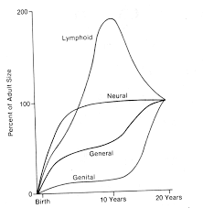

Why we need to know the normal growth?

* Growth monitoring in infancy and childhood has been part of preventive Child heath
* programs for more than century
* Short stature or growth retardation is regarded as a relatively early sign of poor health.
* The primary causes and secondary causes of growth failure have no different prevalence
* In different countries, except for malnutrition which is related to socioeconomic status.
* Recent literatures found the association between zinc deficiency with short stature
* In spite of similarities of the presentation, there are substantial difference in the
* Guidelines of the diagnostic approach to short stature.

**Prenatal growth:**

1- It is crucial in determining the future child.

2- It is fastest during this time.

3- It is most vulnerable to adverse effects of the environments.

**The following factors could affect fetal growth:**

1- Height of the mother

2- Mid pregnancy weight

3- Nutrition

4-Smoking &alcohol

5- Genetic character of the population

6-Sex of the fetus

7- hormones (IGF I, IGF II, IGF 5, IGF BP3, FGF, EGF, TGFα, TGF ß, PDGF)

8- Uterine size.

**Neonatal & infant growth:**

• **At birth** average weight= 3.5kg (2.5-4.5kg), weight drops by 10% in the 1st week due to excretion of the excess extravascular fluid, return to birth weight by the 10th day due to intake of high fat milk & colostrum.

Normally baby doubles its weight by **5 months** (7kg), & triples by **1yr** (10.5kg) & quadruple by **2yrs**

**Weight in infancy= age (months) +9/2**

0-3months 30 gm. /day

3-6months 20 gm. /day

6-9months 15 gm. /day

9-12months 12 gm. /day

**At birth, length of baby=50cm** (45-55cm)

1st yr. =75cm, gain25cm

2nd yr. =85cm, gain 10cm

Then gain =5-6cm/yr.

**At birth, Head circumference = 35 cm**. gains will be:

0-3months →2cm/month

3-6months →1cm/month

6-12months →0.5cm/month. I.e. in the1st yr. gain =12cm

• Ant. Fontanel ↓in size in infancy (2.5cm x 2.5cm) &closes by

9-18months, the post. Closes by 4th month

**Growth (1-3year)**

• The growth rate slows further in the 2nd yr. of life.

• Appetite decreases, activity increases

• Lumbar lordships, abdomen protrudes

• Brain growth continues with myelination

• Weight gain = 8gm/day

• Length gain 1cm/month (10-12cm/yr.)

• Head circumference growth= 0.25cm/month (3cm/yr.)

**Growth (3-6year)**

Weight gain 2kg/year (6gm/day), Height gain 7cm/year

Head circumference growth 1cm/year

**Weight (1-6yr) kg= age (yr.) x2+9**

**Growth in school age (6-12yr)**

• Weight gain 3-3.5kg/year, weight= age (yr.) x7-5 /2

• Height gain (2-12yr) is 6cm/year, height at 12yr= 154cm

**Adolescent growth (12-20yr):**

* It varies with gender and race. In girls it begins 2yrs earlier than boys, but boys have bigger spurt.

* Peak height velocity in girls occurs during stage II & IV of sexual maturity of breast (mean age11.5-12yr) with average of 9 cm/yr.

* Peak height velocity in boys is at stage III & IV of pubic hair growth (mean age 13.5-14yrs) with average of 10.3cm/yr.

This factor combines with a 2yrs of longer pubertal growth time in boys, results in an average of[13 cm] difference in adult height between the two genders

Changes occur during adolescence:

1- ↑ in body size especially height.

2- Change in the shape of the body (in ♂ ↑ muscles while in ♀ ↑ fat).

3- Development of reproductive & sexual characteristics (see below).

4- ↑ bone density & ↓ marrow cavity in size.

5- ↑ total body K & water (more in ♂)

6- ↑ RBS number & Hb (more in ♂)

7- ↑ creatinine excretion/ 24hr (more in ♂)

8- Marked ↑ in heart & lung size.

9- Higher systolic blood pressure & lower resting heart rate

10- ↑ excretion of hydroxy proline.

**Breast development (**♀)

**Stage B1:** Preadolescent: elevation of papilla only.

**Stage B2:** Breast bud stage: elevation of breast and papilla as small mound. Areolar diameter enlarged over stage B1.

**Stage B3:** Breast and areola both enlarged and elevated more than in stage B2, but with no separation of their contours.

**Stage B4:** The areola and papilla form a secondary mound projecting above the contour of the breast.

**Stage B5:** Mature stage: papilla only projects, with the areola recessed to the general contour of the breast.

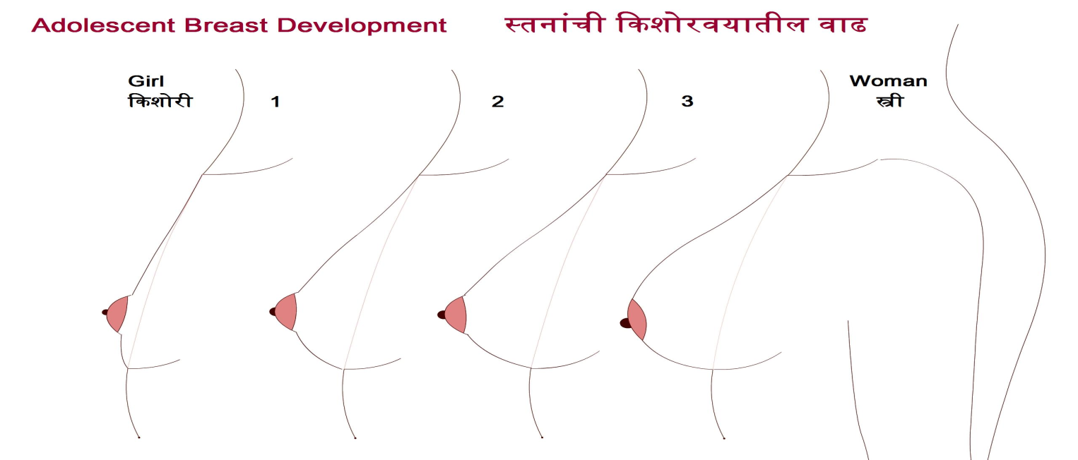



**Genitalia (penis) development stages**

´ **Stage G1:** Preadolescent. Testes,

scrotum and penis are about same

size and shape as in early

Childhood.

´ Stage **G2:** Scrotum slightly

Enlarged, with reddening of the skin

And changes in the texture. Little or

No enlargement of the penis at this

Stage.

´ Stage **G3:** Penis slightly enlarged,

at first mainly in length. Scrotum

further enlarged than in stage G2.

´ **Stage G4:** Penis further enlarged,

with growth in breadth and

development of glans. Further

enlargement of scrotum and

darkening of scrotal skin.

´ Stage **G5:** Genitalia adult in size



**Pubic hair stages for boys and girls**

´ **Stage PH1:** Preadolescent. The vellus over

the pubes is not further developed than that

over the abdominal wall, i.e. no pubic hair.

´ **Stage PH2:** Sparse growth of long, slightly

pigmented downy hair, straight or slightly

curled, chiefly at the base of the penis or

along labia.

´

**Stage PH3:** Considerably darker, coarser and

more curled. The hair spreads sparsely over

the junction of the pubes.

´ **Stage PH4:** Hair now adult in type, but area

covered is still considerably smaller than in

adults. No spread to medial surface of thighs.

´ **Stage PH5:** Adult in quantity and type with

distribution of the horizontal (or classically

‘feminine’) pattern. Spread to medial surface

of thighs, but not up the Linea alba.

´ **Stage PH6:** Spread upwards along the Linea

alba (the typical male escutcheon).

**GroAssessment of Growth**

**Tools**: stadiometer, skin fold caliber, tape measure, weight scale, measuring board &

anthropometer

**Measures:** Ht, Wt, length, sitting ht, triceps &sub scapular skin fold thickness, head &chest

circumferences & BMI (Wt/Ht²) Kg/M²

**Pubertal ratings: Tanner**

• Breasts in girls

• Genitalia in boys

• Pubic and axillary hair in both sexes

**Proportions**

**Arm Span**: less than height in boys up to 10 years of age and in girls up to 11 years of age.

In adults arm span is ~5 cm greater than the height in males & ~1.2 cm in females.

**Upper versus lower segment:** The ratio is 1 .7:1 at birth and decreases by 0.1 for every

year of age. At seven years of age, the ratio becomes 1:1 and remains so.

The target Height of a child: is calculated by measuring parents’ height and plotting them on growth centile for appropriate sex

**MPH ♂ = (father Ht + mother Ht +14) /2 cm**

**MPH ♀ = (father Ht -14)+ mother Ht /2 cm**

**MPH (median pubertal height)**

**Techniques to Measure Growth**

´ For infants and toddlers age <2 yr, weight, length, and head circumference are obtained.

**Head circumference** is measured with a flexible tape measure starting at the supraorbital

ridge around to the occipital prominence in the back of the head, locating the maximal

circumference. **Height** and **weight** measures should be performed with the infant naked,

and ideally, repeated measures will be performed on the same equipment. **Recumbent**

**length** is most accurately measured by two examiners (one to position the child). Hair

ornaments and hairstyles that interfere with measurements and positioning should be

removed. The child's head is positioned against an inflexible measuring board in the

**Frankfurt plane** , in which the outer canthi of the eyes are in line with the external auditory

meatus and are perpendicular to the long axis of the trunk. Legs should be fully extended,

and feet are maintained perpendicular to the plane of the supine infant.

´ For older children (>2 yr) who can stand unassisted, standing heights should be obtained

without shoes, using a stadiometer with the head in the Frankfurt plane, and the back of the head, thoracic spine, buttocks, and heels approximating the vertical axis of one another and the stadiometer.

´ Measurements obtained using alternative means, such as marking examination paper at the foot and head of a supine infant or using a tape measure or wall growth chart with a book or ruler on the head can lead to inaccuracy and render the measurement useless.

´ Measurements for height and weight should be plotted on the age-appropriate growth

curve. Comparing measurements with previous growth trends, repeating measures that are inconsistent, and plotting results longitudinally are essential for monitoring growth.

Calculation of interim linear height velocity, such as centimeters per year (cm/yr), allows

more precise comparison of growth rate to the norm

**Dental Development**

´ Dental development includes [mineralization, eruption, and exfoliation] .

´ Initial mineralization begins as early as the 2nd trimester (mean age for central incisors,

14 wk.) and continues through 3 yr. of age for the primary (deciduous) teeth and 25 yr. of

age for the secondary (permanent) teeth.

´ Eruption begins with the central incisors and progresses laterally. Exfoliation begins at

about 6 yr. of age and continues through 12 yr. Eruption of the permanent teeth may follow exfoliation immediately or may lag by 4-5 mo. The timing of dental development is poorly correlated with other processes of growth and maturation.

´ **Delayed eruption** is usually considered when no teeth have erupted by approximately 13 mo. of age (mean + 3 SD). Common causes include congenital or genetic disorders,

endocrine disorders (e.g., hypothyroidism, hypoparathyroidism), familial conditions, and

(the most common) idiopathic conditions. Individual teeth may fail to erupt because of

mechanical blockage (crowding, gum fibrosis).

´ Causes of **early exfoliation** include hypophosphatasia, histiocytosis X, cyclic neutropenia, leukemia, trauma, and idiopathic factors. Nutritional and metabolic disturbances, prolonged illness, and certain medications (tetracycline) frequently result in discoloration or malformations of the dental enamel. A discrete line of pitting on the enamel suggests a time- limited insult

**Growth Curves**

Types of growth data:

1- Longitudinal study: a small number of children measured on multiple occasions.

2- Cross sectional study: data from large number of children measured on single occasion.

We construct curves whose 50th centile represents the actual growth of a typical individual.

New cross sectional data are represented by 9 centile curves for growth with a constant SD:0.67

between curves giving the following centiles (0.4, 2, 9, 25, 50, 75, 91, 98 & 99.6)th centiles .

The American Academy of Pediatrics (AAP) and the U.S. Centers for Disease Control and

Prevention (CDC) recommend use of the 2006 World Health Organization (WHO) growth curves for children age 0-24 mo. and the 2000 CDC growth curves for children age 2-19 yr.

There are 5 standard gender-specific charts: (1) weight for age, (2) height (length and stature) for age, (3) head circumference for age, (4) weight for height (length and stature) for infants, and (5) body mass index for age

The WHO curves describe growth differently than the CDC curves The WHO curves are **growth standards** that describe how children grow under optimal conditions, whereas the CDC curves are **growth references** that describe how children grew in a specific time and place. The WHO growth curves are based on longitudinal growth studies. In contrast, the CDC curves are based on crosssectional data from different studies during different time points

**Gradient**

**20**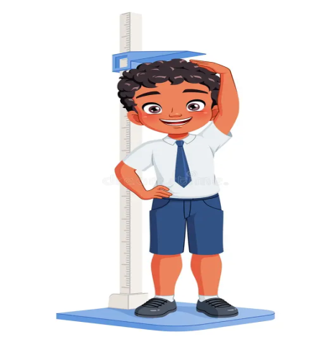

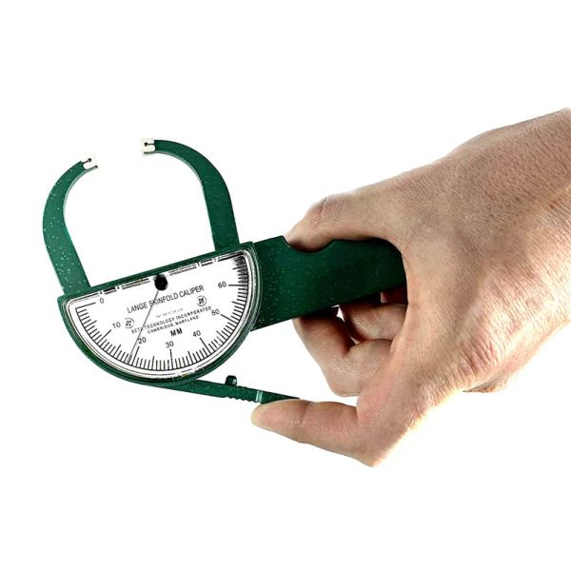

**40**

**60**

**80**

**100**

**120**

**140**

**160**

**180**

**200**

**2 4 6 8 10 12 14 16 18**