**Al Mustansiriyah university college of medicine/pediatric department/Dr. Athraa**

2024-2025

**Tuberculosis**

**TUBECULOSIS**

**Etiology**

There are 5 closely related mycobacteria in the Mycobacterium tuberculosis complex: M. tuberculosis (which is the most important cause of TB disease in human), M. bovis, M. africanum, M. microti, and M. canetti.

**Epidemiology**

WHO estimates that one third of the world's population are infected with M. tuberculosis, and 95% of these cases occur in developing countries due to several reasons e.g. impact of HIV epidemics, increasing poverty, crowded living conditions, and poor access to health services.

**Transmission**

Transmission of M. tuberculosis is person to person, usually by inhalation of airborne mucus droplet nuclei that contain M. tuberculosis as small as 1-5 µm in diameter. Environmental factors e.g. poor air circulation can enhance transmission. Transmission also rarely occurs by direct contact with an infected discharge or contaminated fomite. The most common cause of TB in children is the exposure to high-risk adults; whereas they are rarely infects other children or adults. Airborne transmission of M. bovis & M. africanum can also occur. M.bovis can penetrate the GIT mucosa or invade the lymphatic tissue of the oropharynx when large numbers of organisms are ingested, but it can be killed by pasteurization of milk.

**Pathology**

The lung is the portal of entry in >98% of cases. The tubercle bacilli multiply initially within the alveoli and alveolar ducts. Most of bacilli are killed, but some are survive within the non-activated macrophages, which carry them through lymphatic vessels to the regional lymph nodes The primary complex or **"Gohn complex"** of TB includes local infection at the portal of entry and the regional LNs which drain that area. When primary infection is in the lung, the hilar LNs usually are involved, although an upper lobe focus can drain into paratracheal LNs.

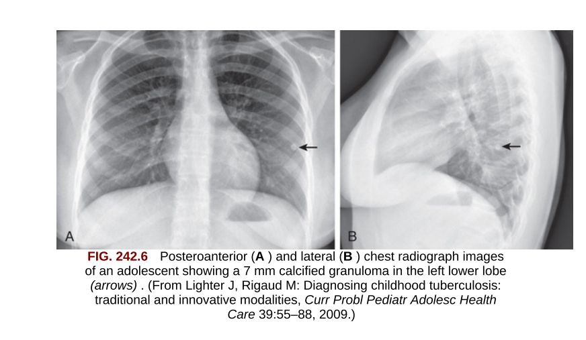

**granuloma**

The tissue reaction in the lung parenchyma and LNs intensifies over the next 2-12 wk as the organisms grow in number and tissue hypersensitivity develops. The parenchymal portion of the primary complex often heals completely by fibrosis or calcification after undergoing caseous necrosis and encapsulation. Occasionally, this portion continues to enlarge, resulting in focal pneumonitis and pleuritis. If caseation is intense, the center of the lesion liquefies and empties into the associated bronchus, leaving a residual cavity. The foci of infection in the regional LNs develop some fibrosis and encapsulation, but healing is usually less complete, thus viable M. tuberculosis can persist within these foci for decades.

**Immunity**

is initially associated with humoral antibody response, which appears to play a little role in host defense because the lipid-rich mycobacterial cell wall resist the bactericidal actions of antibody and complement; in addition to that, sulfatides in the cell wall can inhibit fusion of the macrophage phagosome and lysosomes, allowing the organisms to escape destruction by intracellular enzymes. Therefore, shortly after infection, tubercle bacilli replicate in free alveolar spaces and within inactivated alveolar macrophages.

Cell-mediated immunity develops 2-12 wk after infection, along with tissue hypersensitivity. After bacilli enter macrophages, lymphocytes that recognize mycobacterial antigens proliferate and secrete lymphokines and cytokines e.g. interleukin IL-12, interferon-γ & TNF which attract other lymphocytes and macrophages to the area; also certain lymphokines activate macrophages causing them to develop high concentrations of lytic enzymes which enhance their mycobactericidal capacity. The pathologic events of initial TB infection seem to depend on the balance between mycobacterial antigen load in one hand, and cell mediated immunity (which enhances intracellular killing) & tissue hypersensitivity (which promotes extracellular killing) on the other hand. In immunocompetent persons, the response to the initial infection with M. tuberculosis usually provides protection against reinfection when a new exposure occurs; however, reinfection can occur in the immunocompromised persons (e.g. patients with HIV/AIDS).)

**Tuberculin Skin Testing (TST)**

The development of delayed-type hypersensitivity in most persons infected with the tubercle bacillus makes the TST a useful diagnostic tool. Tuberculin sensitivity develops 3 wk - 3 mo (most often within 48 wk) after inhalation of organisms.

Mantoux TST is the intradermal injection of 0.1 mL purified protein derivative (PPD). The amount of induration should be measured 48-72 hr after administration, although in some patients the induration may be delayed >72 hr.

**False-Negative results** are include: very young age, malnutrition, immunosuppression (by disease or drugs), viral infections (measles, mumps, varicella, influenza), vaccination with live-virus vaccines, overwhelming infection (up to 50% of patients with meningitis or disseminated disease do not react initially with PPD, but most become reactive after several months of anti-TB Rx), poor technique, and misreading of the results, as well as 10% of immunocompetent children with TB disease are do not react with PPD.

**False-Positive results** may be due to cross sensitization to antigens of non-tuberculous mycobacteria (NTM) (although this is usually transient over months to years), or due to previous vaccination with BCG. Immediate hypersensitivity reactions to tuberculin or other constituents of the preparation are short lived (<24 hr) and not considered a positive result.

**The interpretation of TST** is depend on reaction size limits and person's risk factors for infection as follows:

• For children at the highest risk for having infection progress to disease including those with recent contact with infectious persons, clinical illness consistent with TB (especially positive CXR), HIV or other immunosuppression illnesses; a reactive area of ≥5 mm is classified as a positive result.

• For other high-risk groups e.g. children with age <4 yr, chronic medical illnesses, born in or travel to regions with high-prevalence of TB; a reactive area of ≥10 mm is considered positive.

• For children ≥4 yr without risk factors; the cutoff point for a positive reaction is ≥15 mm.

**Interferon-γ Release Assays (IGRAs)**

Two blood tests: T-SPOT.TB & Quanti FERON-TB can detect IFN-γ generated by T lymphocytes in response to specific M. tuberculosis antigens which are not present in M. bovis–BCG or M. avium complex; therefore, it is specific with less false-positive results in vaccinated persons or infection with non tuberculus mycobacteria . However, IGRAs should be interpreted with caution in children <2 yr of age and in immunocompromised patients.

**General Indications of TST or IGRAs**

1.Contacts of people with confirmed or suspected contagious TB disease.

2. Children with radiographic or clinical findings suggesting TB disease.

3. Children immigrating from or have travel histories to countries with endemic TB infection.

4.Children at increased risk for progression of TB infection to disease.

5. Before starting immunosuppressive therapy e.g. prolonged steroid administration, use of TNF-alpha antagonists...etc.

6. Children infected with HIV should have annual TST or IGRA.

**Isolation of TB bacilli**

The tubercle bacilli are obligate aerobic, non–spore-forming, nonmotile, weakly gram-positive curved rods. The hallmark of all mycobacteria is acid fastness, which is the capacity to form stable mycolate complexes with arylmethane dyes Mycobacteria grow slowly from clinical specimens on solid media (e.gLoewenstein-Jensen culture) that usually takes 3-6 wk.

**Clinical manifestations**

There are 3 major clinical stages of tuberculosis: **exposure, infection, and disease**

**Exposure** means a child has had significant contact (shared the air) with an adult or adolescent with infectious tuberculosis but lacks proof of infection. In this stage, both TST &IGRA results are negative, physical exam is normal, chest radiograph is normal.

**Infection** occurs when the individual inhales droplet nuclei containing M. tuberculosis, which survive intracellularly within the lung and associated lymphoid tissue. In this stage, both TST &IGRA results are positive, physical exam is normal, and chest radiograph is normal (or reveals only granuloma or calcifications).

**Disease** occurs when signs or symptoms or radiographic manifestations caused by M. tuberculosis become apparent.

Not all infected individuals have the same risk of developing disease. An immunocompetent adult with untreated TBI has approximately a 5– 10% lifetime risk of developing disease. In contrast, an infected child <1 yr old has a 40% chance of developing TB disease within 9 mo.

❖ **Primary Pulmonary Disease**

About 70% of lung foci are subpleural, thus localized pleurisy is common. The initial parenchymal inflammation is usually not visible on CXR, but a localized, nonspecific infiltrate may be seen before the development of tissue hypersensitivity. All lobar segments of the lung are at equal risk for initial infection. Two or more primary foci are present in 25% of cases.

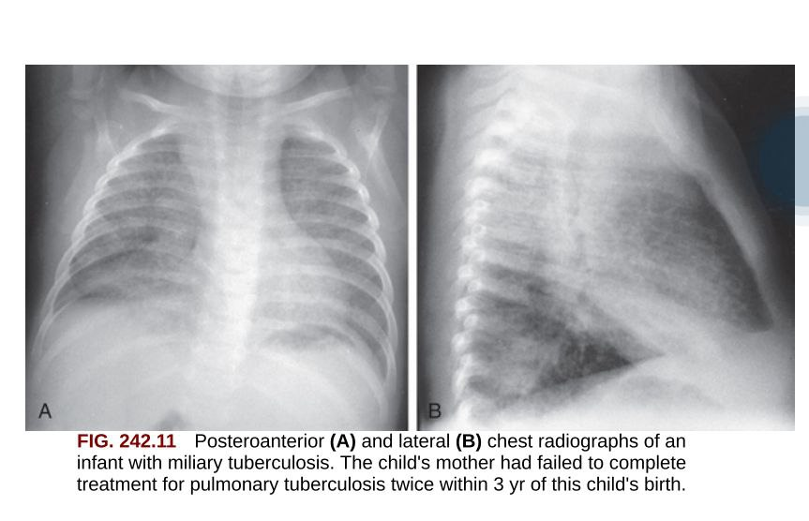

Partial obstruction of the bronchus caused by external compression of the enlarged LNs can cause hyperinflation in the distal lung segment; whereas complete obstruction results in atelectasis. The resulting lesion is a combination of pneumonitis and atelectasis on CXR which is called (Collapse-Consolidation) or (Segmental TB).

**Clinical manifestations**

In children, the symptoms and signs of primary pulmonary TB are, surprisingly, scanty comparing with the degree of radiographic findings, whereas infants are more likely to experience manifestations. History of non productive cough and mild dyspnea. Systemic complaints are less including fever, night sweats, anorexia, and decreased activity . Some infants develop FTT. Examination include: localized wheezing (indicating bronchial obstruction), ↓ breath sounds, and tachypnea, or rarely, respiratory distress.

The most specific confirmation of pulmonary TB is isolation of M. tuberculosis. Sputum specimens should be collected from adolescents and older children who are able to expectorate. Induced sputum with a jet nebulizer and chest percussion followed by nasopharyngeal suctioning is effective in children & infants as young as 1 yr. The traditional culture specimen in young children is the early morning gastric acid obtained before the child has arisen and peristalsis has emptied the stomach of the pooled secretions that have been swallowed overnight. However, even under optimal conditions, 3consecutive morning gastric aspirates yield the organisms in <50% of cases. Sputum induction provides samples for both culture and acid-fast bacilli staining, whereas gastric aspirates are usually cultured only.

Negative cultures never exclude the diagnosis of TB in a child. The presence of positive TST or IGRA, abnormal CXR consistent with TB, and hx of exposure to an adult with infectious TB are adequate proof that the disease is present.

❖ **Progressive Primary Pulmonary Disease**

A rare but serious Cx of TB in a child occurs when the primary focus enlarges steadily and develops a large caseous center. If the primary infection is progressively destructive, liquefaction of the lung parenchyma can → formation of a primary TB cavity. The enlarging focus can slough necrotic debris into the adjacent bronchus → further intrapulmonary dissemination. History of Severe productive cough (thus it is highly contagious), high fever, weight loss, and night sweats.

Examination , Diminished breath sounds, rales, and dullness or egophony (resonance) over the cavity.

❖ **Reactivation of TB**

Pulmonary TB that occurs >1 yr after the primary infection is usually caused by endogenous regrowth of bacilli persisting in partially encapsulated lesions. This reactivation TB is rare in children but is common in adolescents and young adults. The most common pulmonary sites are the original parenchymal focus, lymph nodes, or apical seedings which established during the hematogenous phase of early infection. Apical seedings (**Simon foci**) is the most common form of disease which appear as extensive infiltrate or thick-walled cavity in apex of the upper lobes on CXR.

History of fever, anorexia, malaise, weight loss, night sweats, productive cough (thus it also contagious), hemoptysis, and chest pain. Examination usually minor or absent, even when cavities or large infiltrates are present.

❖ **Pleural Effusion**

Tuberculous pleural effusions is due to discharge of bacilli into the pleural space from a subpleural pulmonary focus or caseated LN. It is uncommon in children <6 yr of age and rare in children <2 yr of age. It can be local or general, usually unilateral but may be bilateral on CXR.

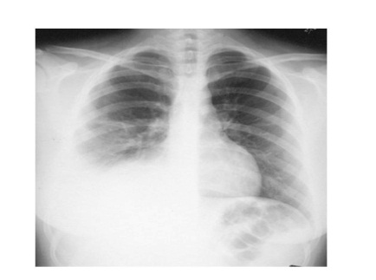

Asymptomatic local pleural effusion is so common in primary TB. Larger and clinically significant effusions occur months to years after the primary infection but it is uncommon in disseminated TB. Clinical onset of tuberculous pleurisy is often sudden, characterized by fever, shortness of breath, chest pain on deep inspiration, and diminished breath sounds. TST is positive in only 70-80% of cases.

Exam of pleural fluid is usually yellow and only occasionally tinged with blood. The specific gravity is usually 1.012-1.025, the protein level is usually 2-4 g/dL, the glucose concentration is low or low-normal range (20-40 mg/dL), and adenosine deaminase (ADA) is high. Typically there are several hundred to several thousand of WBC/μL, with early predominance of PMN followed by a high percentage of lymphocytes. Acid-fast smears of the pleural fluid are rarely positive and cultures of

the fluid are positive in <30% of cases!. However, biopsy of pleural membrane is more likely to yield a positive acid-fast stain or culture, and granuloma formation can be demonstrated

❖ **Pericardial Disease**

It is rare but is the most common form of cardiac TB. Pericarditis usually arises from direct invasion or by lymphatic drainage**. Hx.** nonspecific including low-grade fever, malaise, and weight loss; whereas chest pain is unusual in children. **Ex.** pericardial friction rub, distant heart sounds, and pulsus paradoxus may be present. Inv. The pericardial fluid is typically serofibrinous or hemorrhagic. Acid-fast smear of the fluid rarely reveals the organism, but cultures are positive in 30-70% of cases. The culture yield from pericardial biopsy may be higher, and the presence of granulomas often suggests the diagnosis. **Rx.** In addition to anti-TB medications (see later), partial or complete pericardiectomy may be required when constrictive pericarditis develops

.

**❖ Disseminated (Lymphohematogenous) and Miliary Disease**

In all patients with TB infection, during the development of the primary complex, the tubercle bacilli are often carried to most tissues of the body through the blood and lymphatic vessels. Although seeding of organs of the RES is common, bacterial replication is more likely to occur in organs which favor their growth where oxygen tension and blood flow are great e.g. lung apices, brain, kidneys, and bones Disseminated TB occurs if the number of circulating bacilli is large and the host's cellular immune response is inadequate.



These remote foci usually become encapsulated, but they may be the origin of both extrapulmonary TB or reactivation TB in some persons. The risk for dissemination of M. tuberculosis is very high in HIV-infected persons.

Disseminated and meningeal TB are early manifestations, often occurring within 2-6 mo after acquisition; significant LN or endobronchial TB usually appears within 3-9 mo; lesions of the bones and joints take several years to develop; whereas renal lesions become evident decades after infection.

Although the clinical picture may be acute, more often it is indolent and prolonged, with spiking fever accompanying the release of organisms into the bloodstream. Early pulmonary involvement is surprisingly mild, but diffuse involvement becomes apparent with prolonged infection.

Miliary Disease is the most clinically significant form of disseminated TB. It occurs when massive numbers of tubercle bacilli are released into the bloodstream, it usually occur within 2-6 mo of the initial infection. It is most common in infants and malnourished or immunosuppressed patients . The onset is insidious, with early systemic signs, including anorexia, weight loss, and low-grade fever.

within several more weeks, the lungs can become filled with tubercles on CXR with dyspnea, cough, rales, or wheezing occur. The lesions of pulmonary miliary TB are initially small nodules that distributed evenly in both lungs, then coalesce to form larger lesions and sometimes extensive infiltrates. As the pulmonary disease progresses, an alveolar-air block syndrome develop → frank respiratory distress, hypoxia, and pneumothorax or pneumomediastinum.

Signs or symptoms of meningitis or peritonitis are found in 20-40% of patients with advanced disease. Cutaneous lesions include papulonecrotic tuberculids, nodules, or purpura. Choroid tubercles (detected by ophthalmoscope) occur in ≈ half of patients which are highly specific for diagnosis of miliary TB. Unfortunately, TST is nonreactive in up to 40% of patients with disseminated TB.

**Diagnosis** of disseminated TB can be difficult, and high index of suspicion by clinician is required. Often the patient presents with fever of unknown origin (FUO). Early sputum or gastric aspirate cultures have a low sensitivity, whereas biopsy of liver or BM with appropriate bacteriologic and histologic exam are more often yields an early Dx. However, the most important clue is the hx of recent exposure to an adult with infectious TB.

* **Upper Respiratory Tract Disease**

Children with laryngeal TB have a croup-like cough, sore throat, hoarseness, and dysphagia. Most children with laryngeal TB have extensive upper lobe pulmonary disease, but occasional patients have primary laryngeal disease with a normal CXR. TB of the middle ear results from aspiration of infected pulmonary secretions into the middle ear or from hematogenous dissemination in older children. The most common manifestations are painless unilateral otorrhea, tinnitus, decreased hearing, facial paralysis, and a perforated tympanic membrane. Enlargement of LNs in the preauricular or anterior cervical chains can occur. Diagnosis is difficult because stains and cultures of ear fluid are often negative.

❖ **Lymph Node Disease (Scrofula)**

TB of the superficial LNs is the most common form of extrapulmonary TB in children. Most cases occur within 6-9 mo of initial infection by M. tuberculosis, although some cases appear years later. Any lymphoid tissue can be affected especially tonsillar, anterior cervical, submandibular, and supraclavicular LNs.

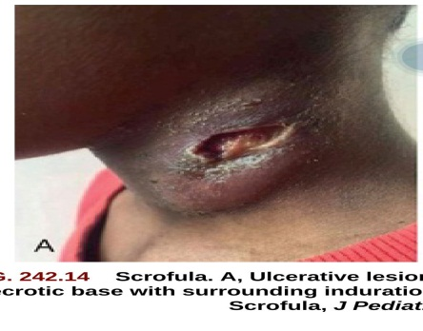

LNs are discrete, non-tender, and firm but not hard. The LNs are often feel fixed to the underlying or overlying tissues. Disease is most often unilateral, but may be bilateral. As infection progresses, multiple nodes are infected, resulting in a mass of matted nodes. Systemic manifestations are usually absent other than a low-grade fever. TST is usually reactive, but CXR is normal in 70% of cases. A definitive Dx usually by fine-needle aspiration for culture, stain, and histology. If fine-needle aspiration is not successful, then excisional biopsy of the involved node is indicated. Culture of LN tissue yields the organism in only ≈ half of cases.

**❖ Cutaneous Disease**

It usually associated with HIV infection, malnutrition, and poor sanitary conditions. All forms are caused by M. tuberculosis, M. bovis (which usually get access to skin by trauma). The initial lesion develops 2-4 wk after introduction of the organism into the damaged tissue. A red-brown papule gradually enlarges to form a shallow, firm, sharply demarcated ulcer.Painless regional LAP may appear several weeks after the development of primary lesion and may be accompanied by lymphangitis, lymphadenitis, or perforation of the skin surface, forming Scrofuloderma. M. tuberculosis or M. bovis can be cultured from the skin lesion and local LNs, but acid-fast staining of histologic sections often does not reveal the organisms, especially in well-controlled infection.

* **Bone and Joint Disease**

It is most likely involve the vertebrae. The classic manifestation of tuberculous spondylitis is progression to Pott disease, in which destruction of the vertebral bodies result in gibbus deformity and kyphosis. Skeletal TB is a late Cx and has become a rare entity but it is more likely to occur in children than adults. Tuberculous bone lesions can resemble pyogenic and fungal infections or bone tumors. Multifocal bone involvement can occur. A bone biopsy is essential to confirm the Dx.

❖ **Gastrointestinal and Abdominal Disease**

The most common lesion is a painless ulcer on the mucosa, palate, or tonsil with enlargement of the regional LNs. Tuberculous Enteritis is caused by hematogenous dissemination or by swallowing tubercle bacilli discharged from the patient's own lungs. The jejunum and ileum near Peyer patches and the appendix are the most common sites of involvement. The typical findings are shallow ulcers. C.M. are nonspecific, mimicking other infections and conditions that cause diarrhea (or occationally constipation) that usually associated with abdominal pain, weight loss, and low-grade fever. The disease should be suspected in any child with chronic GI complaints & positive TST or IGRA. Biopsy, acid-fast stain, and culture of the lesions are usually necessary to confirm the Dx. Mesenteric adenitis usually complicates the infection. The enlarged nodes can cause intestinal obstruction or erode through the omentum to cause generalized peritonitis. TB peritonitis is caused by direct extension from an abdominal LN intestinal focus, or genitourinary TB. Peritonitis also can arise from subclinical or miliary hematogenous dissemination of TB bacilli. Abdominal pain or tenderness, ascites, anorexia, and low-grade fever are typical manifestations. TST is usually reactive. The Dx can be confirmed by paracentesis of the ascitic fluid with appropriate stains and cultures, but this procedure must be performed carefully to avoid entering the bowel that is adherent to the omentum

**❖ Genitourinary Disease**

Tubercle bacilli usually reach the kidney during lymphohematogenous dissemination. Renal TB is most often unilateral and clinically silent in its early stages, marked only by sterile pyuria and microscopic hematuria. Dysuria, flank or abdominal pain, and gross hematuria develop as the disease progresses. Urine cultures for M. tuberculosis are positive in 80-90% of cases, and acid-fast stains of large volumes of urine sediment are positive in 50-70% of cases. The TST is nonreactive in up to 20% of patients. An IV pyelogram or CT scan often reveals mass lesions, dilatation of the proximal ureters, multiple small filling defects, and hydronephrosis if ureteral stricture is present. TB of the genital tract is uncommon before puberty in both boys and girls.

**Anti-Tuberculous Therapy**

**• Isoniazid**, 10-15 mg/kg. SE; mild hepatic enzyme elevation, hepatitis, peripheral neuritis, hypersensitivity. Children are generally tolerate the drug better than adults.

* **Rifampin**, 15-20 mg/kg. SE; orange discoloration of secretions & urine, vomiting, hepatitis, influenza-like reaction, thrombocytopenia, pruritus.

**• Ethambutol**, 20 mg/kg. SE; optic neuritis (usually reversible), GIT upset, hypersensitivity.

**• Pyrazinamide**, 20-40 mg/kg. SE; hepatotoxic effects, hyperuricemia, arthralgias, GIT upset.

Standard therapy of intra-thoracic TB (pulmonary, pleural, or pericardial) is a 6 mo regimen of isoniazid + rifampin, supplemented in the 1st 2 mo by pyrazinamide + ethambutol. 9 month regimen of only isoniazid and rifampin is also effective for drug-susceptible TB.

Therapy for extrapulmonary TB is variable. Tuberculous lymphadenitis, cutaneous, upper RT, GIT, and GUS can be treated as same as intra-thoracic TB (as above), whereas bone & joint, CNS, disseminated (miliary) TB, and probably HIV-infected children should be treated for a longer period, i.e. up to 9-12 mo.

**Corticosteroids**

Corticosteroids are useful in treating some children with TB. They are most beneficial when the host inflammatory reaction contributes significantly to tissue damage or impairment of organ function.

• In tuberculous meningitis, corticosteroids can ↓ mortality rates and long-term neurologic sequelae in some patients by reducing vasculitis, inflammation, and ultimately, intracranial pressure.

• Some children with severe miliary TB have dramatic improvement with corticosteroids therapy if the inflammatory reaction is so severe that alveolo-capillary block is present.

• Short courses are also effective in children with endobronchial TB and pleural or pericardial effusion. The most commonly prescribed regimen is prednisone, 1-2 mg/kg/day orally in 1-2 divided doses for 4-6 wk followed by gradual tapering.

**Supportive Care**

Children receiving treatment should be followed carefully to promote adherence to therapy, to monitor toxic reactions to medications, and to ensure that the TB is being adequately treated. Adequate nutrition is important. Patients should be seen at monthly intervals and should be given just enough medication that last until the next visit.

**Prognosis**

In most tuberculous diseases (except advanced CNS disease), the prognosis is excellent, especially when the patient given early and appropriate therapy, although the resolution is slow in miliary disease.

**Prevention**

All children and adults with symptoms suggestive of TB disease and those in close contact with an adult with suspected infectious pulmonary TB, especially young infants, should be tested for TB infection by TST or IGRA. Most adults no longer transmit the organism within several days to 2 wk after beginning adequate chemotherapy, but however some patients remain infectious for many weeks.

**Bacille Calmette-Guerin (BCG) vaccination**

BCG is a life-attenuated vaccine which is derived from a strain of M bovis (not M. tuberculosis) that given by intradermal injection usually in the left shoulder. BCG vaccines are extremely safe in immunocompetent hosts . Vaccination with BCG characteristically produces a papule after ≈ 2 wk of vaccination. The papule ↑ in size and typically ulcerates within 24 mo, then heals slowly with scarring. Local ulceration and regional suppurative adenitis occur in < 1% of cases. BCG is contraindicated in profoundly immunocompromised patients because they can develop disseminated BCG infection

Unfortunately, BCG vaccine does not give complete protection from TB disease throughout life. It has been suggested that BCG is only 50% effective in preventing pulmonary TB and slightly higher (50-80%) in preventing disseminated and meningeal TB. In addition, BCG vaccination administered during infancy has little effect on the ultimate incidence of TB when become an adult, suggesting waning protection with time.