**Retroviridae &AIDS**

**Retroviruses have many subfamilies in three basic groups.**

1. Oncoretroviruses (cancer-causing retroviruses) include human T-lymphotropic virus (HTLV) causing a type of leukemia in humans
2. Lentiviruses (slow viruses) include HIV-1 and HIV-2, the cause of acquired immune deficiency syndrome (AIDS) in humans.
3. Spumaviruses (foamy viruses) are benign and not linked to any disease in humans or animals

**Human Immunodeficiency Virus**: Human immunodeficiency virus (HIV) 1 is the cause of acquired immunodeficiency syndrome (AIDS).

Both HIV-1 and HIV-2 cause AIDS, but HIV-1 is found worldwide, whereas HIV-2 is found primarily in West Africa. HIV is one of the two important human T-cell lymphotropic retroviruses (human T-cell leukemia virus is the other). HIV preferentially infects and **kills helper (CD4) T lymphocytes,** resulting in the loss of cell-mediated immunity and a high probability that the host will develop **opportunistic infections.** Other cells (e.g., macrophages and monocytes) that have CD4 proteins on their surfaces can be infected also.

HIV belongs to the lentivirus subgroup of retroviruses, which cause "slow" infections with long incubation periods. HIV has a bar-shaped (type D) core surrounded by an envelope containing virus-specific glycoproteins (gp120 and gp41). The genome of HIV consists of two identical molecules of single-stranded, positive-polarity RNA and is said to be **diploid.** The HIV genome is the most complex of the known retroviruses. In addition to the three typical retroviral genes *gag, pol*, and *env*, which encode the structural proteins, the genome RNA has six regulatory genes (Table –1). Two of these regulatory genes, *tat* and *rev*, are required for replication, and the other four, *nef, vif, vpr*, and *vpu*, are not required for replication and are termed "accessory" genes.

|  |
| --- |
|  |

|  |
| --- |
|  |
|  |

|  |  |
| --- | --- |
| |  | | --- | | Table –1 Genes and Proteins of Human Immunodeficiency Virus | |
| | **Gene** | **Proteins Encoded by Gene** | **Function of Proteins** | | --- | --- | --- | | **I. Structural genes found in all retroviruses** | | | | *gag* | p24, p7 | Nucleocapsid | |  | p17 | Matrix | | *pol* | Reverse transcriptase | Transcribes RNA genome into DNA | |  | Protease | Cleaves precursor polypeptides | |  | Integrase | Integrates viral DNA into host cell DNA | | *env* | Gp120 | Attachment to CD4 protein | |  | Gp41 | Fusion with host cell | | **II. Regulatory genes found in human immunodeficiency virus that are required for replication** | | | | *tat* | *Tat* | Activation of transcription of viral genes | | *rev* | *Rev* | Transport of late mRNAs from nucleus to cytoplasm | |
|  |

The *gag* gene encodes the internal "core" proteins, the most important of which is p24, an antigen used in serologic tests. The *pol* gene encodes several proteins, including the virion "reverse transcriptase," which synthesizes DNA by using the genome RNA as a template, an integrase that integrates the viral DNA into the cellular DNA, and a protease that cleaves the various viral precursor proteins. The *env* gene encodes gp160, a precursor glycoprotein that is cleaved to form the two envelope (surface) glycoproteins, gp120 and gp41.

Three enzymes are located within the nucleocapsid of the virion: **reverse transcriptase, integrase,** and **protease**.

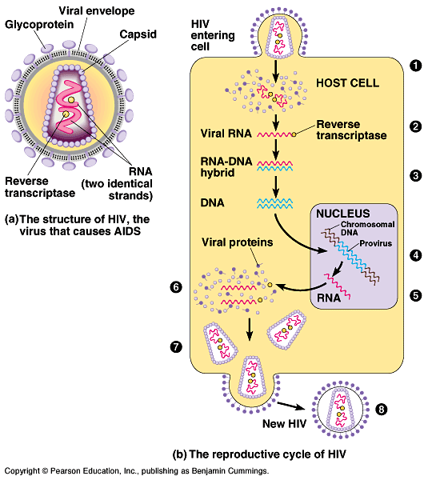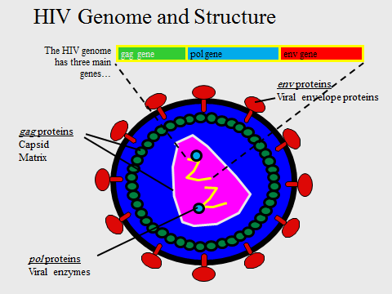

**There are several important antigens of HIV:**

1. gp120 and gp41 are the **type-specific envelope glycoproteins.** gp120 protrudes from the surface and interacts with the CD4 receptor on the cell surface. gp41 is embedded in the envelope and mediates the fusion of the viral envelope with the cell membrane at the time of infection. Antibody against gp120 neutralizes the infectivity of HIV, but the rapid appearance of gp120 variants will make production of an effective vaccine difficult.
2. The group-specific antigen, p24, is located in the core and is not known to vary. Antibodies against p24 do not neutralize HIV infectivity but serve as important serologic markers of infection.

**Summary of Replicative Cycle**

In general, the replication of HIV follows the typical retroviral cycle .The initial step in the entry of HIV into the cell is the binding of the virion gp120 envelope protein to the CD4 protein on the cell surface. The virion gp120 protein then interacts with a second protein on the cell surface, one of the **chemokine receptors.** Chemokine receptors, such as CXCR4 and CCR5 proteins, are required for the entry of HIV into CD4-positive cells. The T cell–tropic strains of HIV bind to CXCR4, whereas the macrophage-tropic strains bind to CCR5.Next, the virion gp41 protein mediates fusion of the viral envelope with the cell membrane, and the virion core containing the nucleocapsid, RNA genome, and reverse transcriptase enters the cytoplasm.

In the cytoplasm, reverse transcriptase transcribes the genome RNA into double-stranded DNA, which ``migrates to the nucleus where it integrates into the host cell DNA. The viral DNA can integrate at different sites in the host cell DNA, and multiple copies of viral DNA can integrate. Integration is mediated by a virus-encoded endonuclease (integrase). Viral mRNA is transcribed from the proviral DNA by host cell RNA polymerase and translated into several large polyproteins. The Gag and Pol polyproteins are cleaved by the viral-encoded protease, whereas the Env polyprotein is cleaved by a cellular protease.

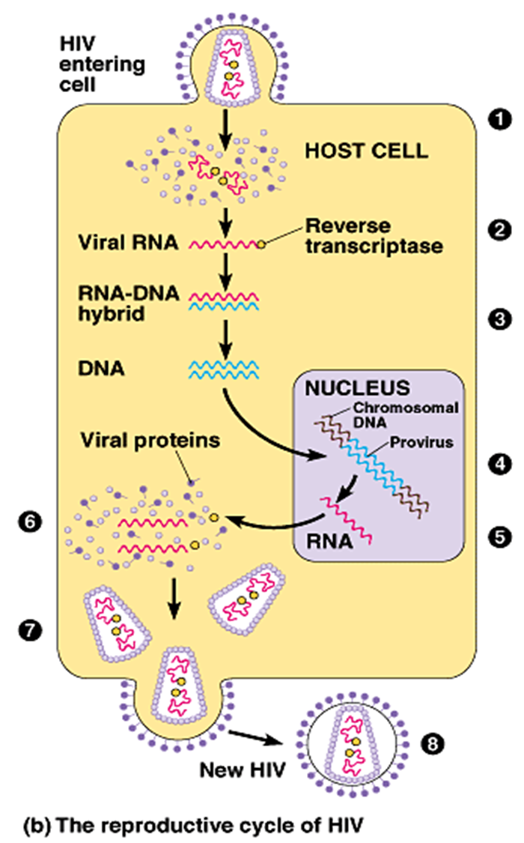

**Pathogenesis & Immunity**

Human immunodeficiency virus primarily infects :

1. CD4 T cells and
2. cells of the myeloid lineage (e.g., monocytes, macrophages, alveolar macrophages of the lung, dendritic cells, and microglial cells of the brain)
3. Cellular adhesion molecule( α-4 β-7 integrin) present on gut-associated lymphoid tissue (GALT),
4. Dendritic cell–specific intercellular adhesion molecule 3-grabbing nonintegrin (DC-SIGN) on dendritic and other cells.

**Viral Entry**

* HIV entry requires the presence of CD4 + one of two co--‐receptors: CCR5 or CXCR4
* CD4 is the major determinant of viral tropism –expressed : T cells,macrophages, monocytes and dendtritic cells
* •CCR5 and CXCR4 are chemokine receptors .CCR5 is found on both CD4+T cells and macrophages.
* CXCR4 is only found on T cells.
* Entry of HIV is initially mediated by the attachment of the viral envelope glycoprotein,gp120, to CD4.

Clinical Features

1. Early stage- infectious mononucleosis like illness.
2. Latent period - this is the period when the patient is completely asymptomatic and may vary from a few months to a more than 10 years. The median incubation period is 8-10 years.
3. ARC “AIDS-related complex “or persistent generalized lymphadenopathy.
4. Late- Full-blown AIDS.

**the course of the disease**

**1. Acute Infection**

* High virus titer•Mild symptoms
* •Fall in CD4+ cells but recovers
* •Rise in CD8+ cells but recovers
* •A high virus titer (up to 10 million viruses per ml blood)
* •Macrophages :infected Macrophages bring HIV into the body if sexually transmitted

**2. A strong immune response**

Virus almost disappears from circulation

* •Good cytoxic T cell response
* •Soluble antibodies appear later against both surface and internal proteins
* •Most virus at this stage comes from recently activated (dividing)and infected CD4+ cells
* •CD4+ cell production compensates for loss due to lysis of cells by virus production and destruction of infected cells by CTLs

**3. A latent state Latency of virus and of symptoms**

* •Virus persists in extra-vascular tissues
* •Lymph node dendritic cells
* •Resting CD4+ memory cells (last a very long time -a very stable population of cells) carry provirus

**4. The beginning of disease**

Massive loss of CD4+ cells

* •CD4+ cells are the targets of the virus
* •Cells that proliferate to respond to the virus are killed by it
* •Dendritic cells present antigen and virus to CD4 cells
* •Epitope variation allows more and more HIV to escape from immune response just as response
* wanes
* •Apoptosis of CD4+ cells
* •HIV patients with high T4 cell counts do not develop AIDS

1. **Advanced disease – AIDS**

* **•**CD4 cell loss means virus and infected cells no longer controlled
* •As CD4+ cells fall below 200 per cu mm virus titer rises rapidly and remaining immune
* response collapses
* •CD8+ cell number collapses
* •Opportunistic infections
* •Death in ~2 years without intervention

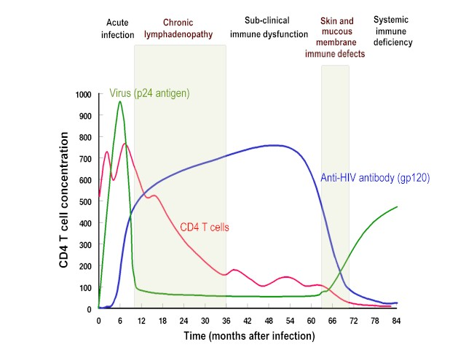

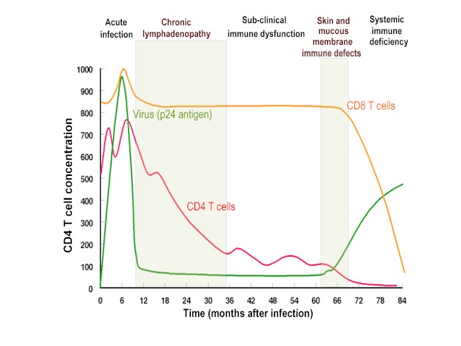

HIV infects helper T cells (CD4-positive cells) and kills them, resulting in **suppression of cell-mediated immunity.** This predisposes the host to various opportunistic infections and certain cancers such as Kaposi's sarcoma and lymphoma. However, HIV does not directly cause these tumors because HIV genes are not found in these cancer cells. The initial infection of the genital tract occurs in dendritic cells that line the mucosa (Langerhans' cells), after which the local CD4-positive helper T cells become infected. HIV is first found in the blood 4 to 11 days after infection.

|  |  |
| --- | --- |
| |  | | --- | | Table –2 Common Opportunistic Infections in AIDS Patients | |
| | **Site of Infection** | **Disease or Symptom** | **Causative Organism** | | --- | --- | --- | | Lung | 1. Pneumonia | *Pneumocystis carinii,* cytomegalovirus | |  | 2. Tuberculosis | *Mycobacterium tuberculosis* | | Mouth | 1. Thrush | Candida albicans | |  | 2. Hairy leukoplakia | Epstein-Barr virus | |  | 3. Ulcerations | Herpes simplex virus-1, *Histoplasma capsulatum* | | Esophagus | 1. Thrush | *Candida albicans* | |  | 2. Esophagitis | Cytomegalovirus, herpes simplex virus-1 | | Intestinal tract | Diarrhea | *Salmonella sp., Shigella sp,* cytomegalovirus, *Cryptosporidium parvum, Giardia lamblia* | | Central nervous system | 1. Meningitis | *Cryptococcus neoformans* | |  | 2. Brain abscess | *Toxoplasma gondii* | |  | 3. Progressive multifocal leukoencephalopathy | JC virus | | Eye | Retinitis | Cytomegalovirus | | Skin | 1. Kaposi's sarcoma | Human herpesvirus 8 | |  | 2. Zoster | Varicella-zoster virus | |  | 3. Subcutaneous nodules | *Cryptococcus neoformans* | | Reticuloendothelial system | Lymphadenopathy or splenomegaly | *Mycobacterium avium* complex, Epstein-Barr virus | |
|  |

The two most characteristic manifestations of AIDS are *Pneumocystis* pneumonia and Kaposi's sarcoma. Many AIDS patients have severe neurologic problems, e.g., dementia and neuropathy, which can be caused by either HIV infection of the brain or by many of these opportunistic organisms.

The most frequent opportunistic tumour, Kaposi's sarcoma, is observed in 20% of patients with AIDS.

•KS is observed mostly in homosexuals and its relative incidence is declining. It is now associated with a human herpes virus 8 (HHV-8).

•Malignant lymphomas are also frequently seen in AIDS patients.

