Dr.Maryam Virology lecture 9

Paramyxoviruses:
The paramyxovirus family contains four important human pathogens: measles virus, mumps virus, respiratory syncytial virus (RSV), and parainfluenza viruses. They differ from orthomyxoviruses in that their genomes are not segmented, they have a larger diameter, and their surface spikes are different Paramyxoviruses are composed of one piece of single-stranded RNA, a helical nucleocapsid, and an outer lipoprotein envelope. The virion contains an RNA-dependent RNA polymerase, which transcribes the negative-polarity genome into mRNA. The genome is therefore not infectious. The envelope is covered with spikes, which contain hemagglutinin, neuraminidase, or a fusion protein that causes cell fusion and, in some cases, hemolysis (Table –1).
Table–1 Envelope Spikes of Paramyxoviruses

Virus | Hemagglutinin | Neuraminidase | Fusion Protein¹
Measles virus | + | – | +
Mumps virus² | + | + | +
Respiratory syncytial virus | – | – | +
Parainfluenza virus² | + | + | +

¹The measles and mumps fusion proteins are hemolysins also.
²In mumps and parainfluenza viruses, the hemagglutinin and neuraminidase are on the same spike and the fusion protein is on a different spike.

Measles Virus
This virus causes measles, a disease characterized by a maculopapular rash. It occurs primarily in childhood. The genome RNA and nucleocapsid of measles virus are those of a typical paramyxovirus (see above). The virion has two types of envelope spikes, one with hemagglutinating activity and the other with cell-fusing and hemolytic activities (Table-1). It has a single serotype, and the hemagglutinin is the antigen against which neutralizing antibody is directed. Humans are the natural host.
Summary of Replicative Cycle
After adsorption to the cell surface via its hemagglutinin, the virus penetrates and uncoats and the virion RNA polymerase transcribes the negative-strand genome into mRNA. Multiple mRNAs are synthesized, each of which is translated into the specific viral proteins; no polyprotein analogous to that synthesized by poliovirus is made. The helical nucleocapsid is assembled, the matrix protein mediates the interaction with the envelope, and the virus is released by budding from the cell membrane.
Transmission & Epidemiology
Measles virus is transmitted via respiratory droplets produced by coughing and sneezing both during the prodromal period and for a few days after the rash appears. Measles occurs worldwide, usually in outbreaks every 2 to 3 years, when the number of susceptible children reaches a high level. The attack rate is one of the highest of viral diseases; most children contract the clinical disease on exposure.
. In malnourished children, especially those in developing countries, measles is a much more serious disease than in well-nourished children. Vitamin A deficiency is especially important in this regard, and supplementation of this vitamin greatly reduces the severity of measles. Patients with deficient cell-mediated immunity, e.g., AIDS patients, have a severe, life-threatening disease when they contract measles.
Pathogenesis & Immunity
After infecting the cells lining the upper respiratory tract, the virus enters the blood and infects reticuloendothelial cells, where it replicates again. It then spreads via the blood to the skin. The rash is caused primarily by cytotoxic T cells attacking the measles virus–infected vascular endothelial cells in the skin. Antibody-mediated vasculitis may also play a role. Shortly after the rash appears, the virus can no longer be recovered and the patient can no longer spread the virus to others. Multinucleated giant cells, which form as a result of the fusion protein in the spikes, are characteristic of the lesions.
Lifelong immunity occurs in individuals who have had the disease. Although IgG antibody may play a role in neutralizing the virus during the viremic stage, cell-mediated immunity is more important.. Maternal antibody passes the placenta, and infants are protected during the first 6 months of life.
Infection with measles virus can transiently depress cell-mediated immunity .The proposed mechanism for this unusual finding is that when measles virus binds to its receptor (called CD46) on the surface of human macrophages, the production of IL-12, which is necessary for cell-mediated immunity to occur, is suppressed.
Clinical Findings
After an incubation period of 10 to 14 days, a prodromal phase characterized by fever, conjunctivitis (causing photophobia), running nose, and coughing occurs. Koplik's spots are bright red lesions with a white, central dot that are located on the buccal mucosa and are virtually diagnostic. A few days later, a maculopapular rash appears on the face and proceeds gradually down the body to the lower extremities, including the palms and soles. The rash develops a brownish hue several days later.
The complications of measles can be quite severe. Encephalitis occurs at a rate of 1 per 1000 cases of measles. The mortality rate of encephalitis is 10%, and there are permanent sequelae, such as deafness and mental retardation, in 40% of cases. In addition, both primary measles (giant cell) pneumonia and secondary bacterial pneumonia occur. Bacterial otitis media is quite common. Subacute sclerosing panencephalitis (SSPE) is a rare, fatal disease of the central nervous system that occurs several years after measles.
Measles in a pregnant woman leads to an increased risk of stillbirth rather than congenital abnormalities. Measles virus infection of the fetus is more severe than rubella virus infection, so the former typically causes fetal death, whereas the latter causes congenital abnormalities.
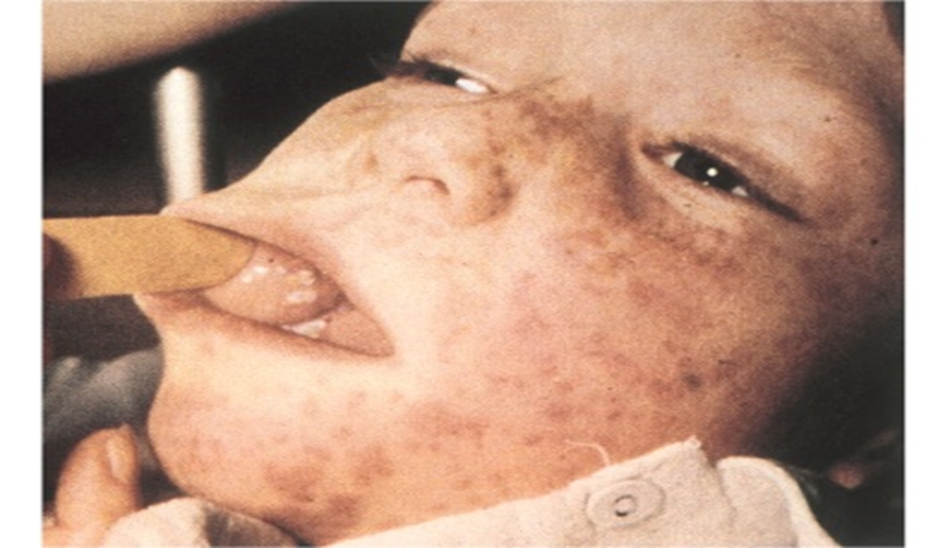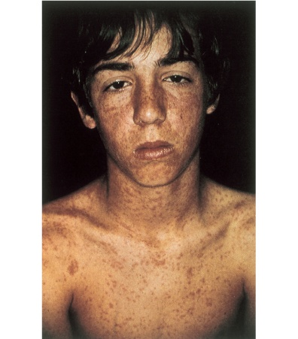
Laboratory Diagnosis
Most diagnoses are made on clinical grounds, but the virus can be isolated in cell culture; a rise in antibody titer of greater than fourfold can be used to diagnose difficult cases.
Treatment: There is no antiviral therapy available.
Prevention
Prevention rests on immunization with the live, attenuated vaccine. The vaccine is effective and causes few side effects. It is given subcutaneously to children at 15 months of age, usually in combination with rubella and mumps vaccines. The vaccine should not be given to children prior to 15 months of age, because maternal antibody in the child can neutralize the virus and reduce the immune response. Because immunity can wane, a booster dose is recommended. The vaccine contains live virus, so it should not be given to immunocompromised persons or pregnant women. However, outbreaks still occur among unimmunized individuals, e.g., children in inner cities and in developing countries.
The killed vaccine should not be used. Immune globulin can be used to modify the disease if given to unimmunized individuals early in the incubation period. This is especially necessary if the unimmunized individuals are immunocompromised.

In Iraq first dose at 9 months(alone),second at 15 month(MMR)

Mumps Virus
This virus causes mumps, a disease characterized by parotid gland swelling. It occurs primarily in childhood.
Important Properties: The genome RNA and nucleocapsid are those of a typical paramyxovirus. The virion has two types of envelope spikes: one with both hemagglutinin and neuraminidase activities and the other with cell-fusing and hemolytic activities (Table -1).
The virus has a single serotype. Neutralizing antibody is directed against the hemagglutinin. The internal nucleocapsid protein is the S (soluble) antigen detected in the complement fixation test used for diagnosis. Humans are the natural host.
Summary of Replicative Cycle: Replication is similar to that of measles virus (see Measles Virus).
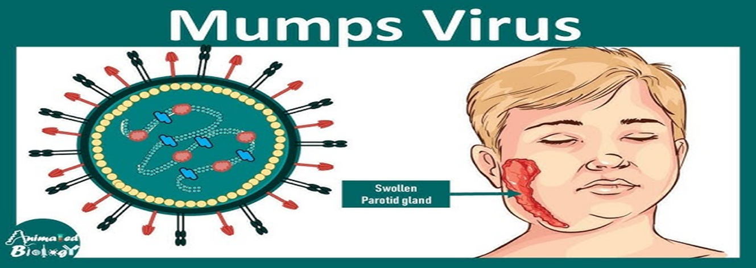
Transmission & Epidemiology; Mumps virus is transmitted via respiratory droplets. Mumps occurs worldwide, with a peak incidence in the winter. About 30% of children have a subclinical (inapparent) infection, which confers immunity. There were only 683 reported cases of mumps in the United States in 1997—a finding attributed to the widespread use of the vaccine. However, in 2006, a resurgence of mumps occurred with 6584 cases being recorded despite a high (87%) coverage rate for the vaccine.
Pathogenesis & Immunity; The virus infects the upper respiratory tract and then spreads through the blood to infect the parotid glands, testes, ovaries, pancreas, and, in some cases, meninges. Alternatively, the virus may ascend from the buccal mucosa up Stensen's duct to the parotid gland.
Lifelong immunity occurs in persons who have had the disease. There is a popular misconception that unilateral mumps can be followed by mumps on the other side. Mumps occurs only once; subsequent cases of parotitis can be caused by other viruses such as parainfluenza viruses, by bacteria, and by duct stones. Maternal antibody passes the placenta and provides protection during the first 6 months of life.
Clinical Findings
After an incubation period of 18 to 21 days, a prodromal stage of fever, malaise, and anorexia is followed by tender swelling of the parotid glands, either unilateral or bilateral. There is a characteristic increase in parotid pain when drinking citrus juices. The disease is typically benign and resolves spontaneously within 1 week.
Two complications are of significance. One is orchitis in postpubertal males, which, if bilateral, can result in sterility. Postpubertal males have a fibrous tunica albuginea, which resists expansion, thereby causing pressure necrosis of the spermatocytes. Unilateral orchitis, although quite painful, does not lead to sterility. The other complication is meningitis, which is usually benign, self-limited, and without sequelae. Mumps virus, Coxsackie virus, and echovirus are the three most frequent causes of viral (aseptic) meningitis. The widespread use of the vaccine in the United States has led to a marked decrease in the incidence of mumps meningitis.

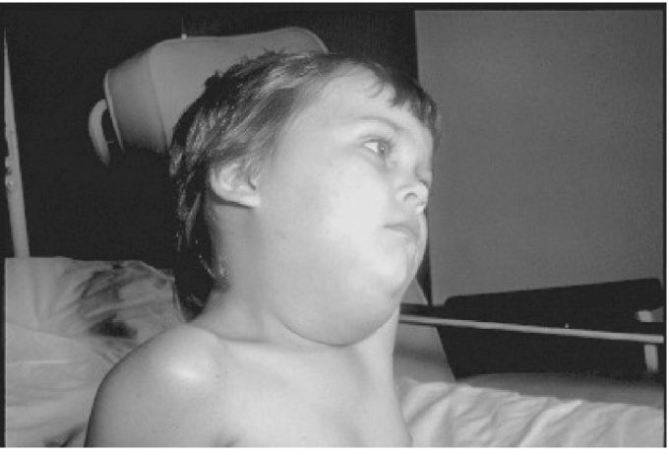

Laboratory Diagnosis
The diagnosis of mumps is usually made clinically, but laboratory tests are available for confirmation. The virus can be isolated in cell culture from saliva, spinal fluid, or urine. In addition, a fourfold rise in antibody titer in either the hemagglutination inhibition or the CF test is diagnostic. A single CF test that assays both the S and the V (viral) antigens can also be used. Because antibody to S antigen appears early and is short-lived, it indicates current infection. If only V antibody is found, the patient has had mumps in the past.
A mumps skin test based on delayed hypersensitivity can be used to detect previous infection, but serologic tests are preferred. The mumps skin test is widely used to determine whether a patient's cell-mediated immunity is competent.
Treatment; There is no antiviral therapy for mumps.
Prevention
Prevention consists of immunization with the live, attenuated vaccine. The vaccine is effective and long-lasting (at least 10 years) and causes few side effects. Two immunizations are recommended, one at 15 months and a booster dose at 4 to 6 years, usually in combination with measles and rubella vaccines. Because it is a live vaccine, it should not be given to immunocompromised persons or pregnant women. Immune globulin is not useful for preventing or mitigating mumps orchitis.
In the late 1980s, outbreaks of mumps occurred in both immunized and unimmunized people. This led to the recommendation in 1989 that a second course of MMR (measles, mumps, and rubella) vaccine be administered. The incidence of mumps fell and outbreaks did not occur until 2006 when 6584 cases occurred, primarily in college-age individuals who, surprisingly, had received two doses of the vaccine. Waning immunity after the second dose and immunization with a different genotype from the genotype that caused the outbreak are suggested explanations.

