**ألجامعة المستنصرية /كلية الطب**

**ألمرحلة الرابعة / طب الأطفال**

**ا.م. د. نبيهة النقيب**

**٢٠٢٤-٢٠٢٥**

**Development**

* It is continuous process &birth is only an event that does not change the course of development.
* Depends primarily on maturity of nervous system.
* Cephalo-caudal direction (starts by head control before walking).
* Sequences is the same in all children (sit before stand)
* Massive generalized response to stimuli change to specific individual movement to same stimuli at later age.
* Involuntary reflexes have to disappear before voluntary movement is anticipated.

**Factors affecting development**

1- Intelligence.

2- Environment.

3- familial

4- Variation of CNS maturity.

5-Personality.

6- prematurity.

7- Physical handicap: deafness → delay in speech,

Blindness → delay in fine movement.

Parental concern regarding delays in fine and gross motor skills, language skills, and social/emotional development are often highly accurate and should always warrant further evaluation.

**Primitive reflexes**

* Primitive reflexesare involuntary motor responses originating in the brainstem present after birth in early child development that facilitate survival.
* These central nervous system motor responses are eventually inhibited by (4 to 6 months of age) as the brain matures and replaces them with voluntary motor activities but may return with the presence of neurological disease
* If an infant is very sleepy, irritable, or satiated after feeds, the primitive reflexes will be diminished and should be reevaluated when the infant is alert between feedings.
* The primitive reflexes should always be symmetrical and are considered abnormal if asymmetrical or absent at birth

1. **Grasp reflex**: if he examiner' s finger is slipped into the baby palm, the baby closes his hand. In full term baby the grasp is so tight that you can lift the baby off the couch. There is a corresponding planter grasp reflex.it begin at 32 weeks and premature baby up to 36wk has weak grasp reflex. grasp reflex disappears at 3-4 months of age persistence of this reflex in spastic cerebral palsy.

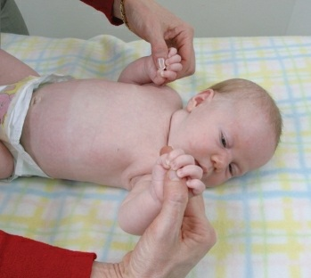

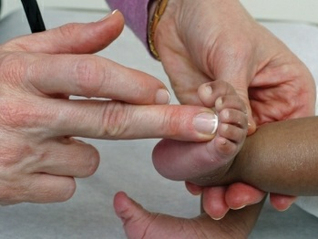

Palmar grasp reflex. Plantar grasp reflex

**2. Moro reflex:** stimuli are given to muscles of neck. It can be elicited in several ways. The head is supported in the palm of the examiner 2 cm above the table, then suddenly released. The reflex consists of abduction & extension of arms, opening of the hands, then adduction & flexion of the arms. The reflex may be accompanied by crying

• Reflex is established by 28 weeks of fetal life

• disappears by 4- 6 months after birth, exaggerated in cerebral palsy, decrease in hypotonia, asymmetrical in Erb's palsy, fracture of clavicle &spastic hemiplegia.

**3- Startle reflex:** sudden noise or tapping the chest. The response is similar to Moro reflex but the hands remain closed &elbow remain flexed.

**4- Limp placement reflex:** the infant held vertically by the trunk, the tibia brought up against the edge of the table, the baby steps up the table. It appears in full term baby, disappear in 6weeks. It is absence in brain damage

**5- Asymmetrical tonic neck reflex**: The baby lying awake at rest in supine

position, the head is turned to one side→ the arm &leg on the same side is

extended & the contralateral knee is flexed. It occurs spontaneously in 7 weeks baby. Disappear in 2-3months Persist in spastic child.

**6- Walking (stepping) reflex:** feet are pressed against the surface of the table with the infant held vertically, the baby makes walking movements.It lasts for 1-2 months ,but more if the neck remain extended( for several months). The reflux is not well developed until 40 weeks of fetal life.

**7- Crossed extension reflex:** child in supine position, stimulation of the sole of one foot with the leg held in extension causes flexion of the opposite hip followed by adduction & extension of the leg.

It is not normally obtained after 1 month of age, found in spastic children.

**8- Rooting reflex:**

elicited by baby ‘s cheek contacting the mother ‘s breast resulting in reflex moving the angle of the mouth towards the stimulus & open the mouth. Disappear by 4-6 mo.

**Development milestones**

***Neonatal period:***

• prone: flexed attitude, turn face from side to side, head sags on ventral suspension

• supine: flexed, a little stiff.

• visual: may fixate on light in line of vision, doll ‘s eye movement of eye on turning the body

• reflexes: (Moro, stepping, walking, grasp) are active.

• social: visual preference for human face.

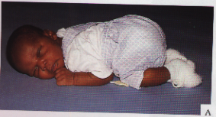

Normal flexion in term infant

***[1month]:***

• prone: legs more extended, hold chin up, turn head, head lifted momentarily to plane of body on ventral suspension.

• supine: tonic neck posture predominates, head lags on pulling to sitting position.

• visual: follow moving objects, watch persons.

• social: begins to smile, body movement in cadence with voice of others in social contact.

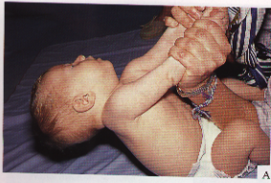

tonic neck posture

Head lag

**2months:**

• prone: raises head slightly further, head sustained in plane of body on ventral suspension.

• supine: tonic neck posture, head lags on pulling to sitting position.

• visual: follow moving objects 180 degrees

• social: smile on social contact, listen to voice& coos.

**(3 months):**

• prone: lifts head & chest, arm extended, head above plane of body on ventral suspension.

• supine: tonic neck posture predominates, reach towards & misses objects, wave at a toy.

• sitting: head lags partially compensated on pull to sitting position, early head control with bobbing, back is rounded

• reflexes: typical Moro reflex disappears, make defensive movement or selective withdrawal reactions

• social: sustained social contact, listen to music, say aah- ngah

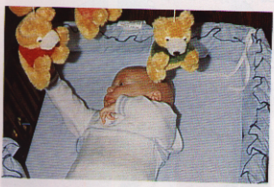

Wave at toy

***(4months) :***

• prone: lifts head on chest, head is approximately in vertical axis, legs are extended.

• supine: symmetric posture predominates, hands in midline, reach & grasp objects & bring them to mouth.

• sitting: no head lag on pull to sitting position, head is steady tipped forwards, enjoy sitting with full trunk support

• standing: when held erect push with feet

• adaptive: see pellet, but makes no move to it.

• social: laugh aloud, displeasure when social contact is broken & excited at sight of food.

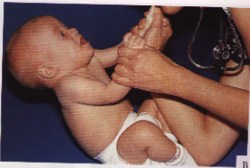

Head control

**7 months:**

• Prone: roll over, crawl or creep.

• Supine: lift head, roll over, squirming movement

• Sitting: sits briefly with support of pelvis, lean forward

• Standing: support most of weight, bounce actively.

• Adaptive: reach out & grasp large object, transfer objects from hand to hand.

• Language: polysyllabic vowel sounds.

• Social: prefer mother, enjoy looking at mirror. Respond to change in social & emotional contact.

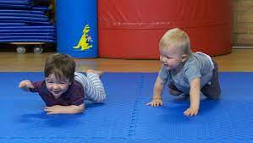 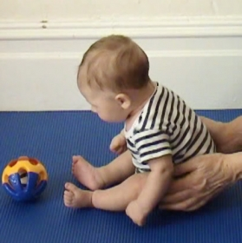

Crawling. Creeping Sitting with pelvic support

***(10 months):***

• sitting: sit alone indefinitely without support.

• standing: pull to standing position, walk holding furniture.

• motor: creep, crawl.

• adaptive: grasp object with thumb & forefinger, pick pellet with assisted pincer movement, attempt to retrieve dropped objects, release object grasped by others uncovers hidden toy.

• social: respond to sound of name play peekaboo, wave bye-bye.

• language: mama, baba (repetitive constant sounds).

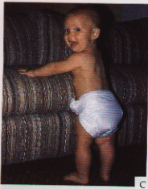 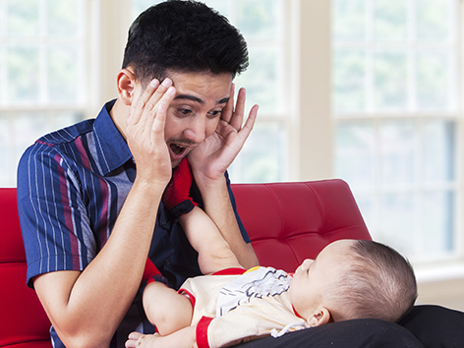

walk holding furniture play peekaboo

***(1 year):***

• motor: walk with one hand held(48wk), rises independently, takes several steps.

• adaptive: pick up pellet with unassisted pincer movement of forefinger &thumb, request to gesture.

• language: few words beside mama, baba.

• social: play simple ball game. Makes postural adjustment to dressing



***At 15 months:***

• motor: walk alone, crawl upstairs.

• adaptive: make tower of 3 cubes, insert pellet in a bottle, make a line.

• language: jargon, follow simple commands, name familiar objects، respond to his name.

• social: indicate some desire or need by pointing hugs parents.

***At 18 months:***

• motor: run stiffly, sit on small chair, walk upstairs with one hand held, explore drawers & waste baskets.

• adaptive: make a tower of 4 cubes, scribble, imitate vertical stroke, dumps pellet from bottle.

• language: 10 words, name pictures, identify one or more parts of the body.

• social: feeds self, seek help when in a trouble, complain when wet or soiled, kisses parents with pucker

***At 24 months:***

• motor: runs well, walk up & downstairs with one step at a time, opens doors, jumps.

• adaptive: tower of 7 cubes, circular scribbling, imitate horizontal stroke, folds paper once imitatively, handle spoon well.

• social: tell immediate experience, help to undress, listen to stories with pictures.

• language: Puts 3 words together (subject, verb, object) ،well, developed, questioning, expressing, sing nursery rhyme

***At 30 months :***

• motor: goes upstairs on alternating feet.

• adaptive: tower of 9 cubes, make vertical & horizontal strokes but generally will not join them to make a cross, imitates circular stroke, forming closed figures.

• language: knows full name, refers to self by pronoun ( I ).

• social: helps put things away, pretends in play.

***At 3 years:***

• motor: rides tricycle, stands momentarily on one foot.

• adaptive: tower of 10 cubes, imitates construction of bridge of 3 cubes , copies a circle, imitates a cross.

• language: knows age & sex, counts 3 objects correctly, repeats 3 numbers or a sentence of 6 syllables, most of speech intelligible to strangers

• social: plays simple games (in parallel with other children), helps in dressing (unbuttons clothing & puts on shoes), washes hands.

***4 years:***

• motor: hops on one foot, throws ball overhand, uses scissors to cut out pictures, climbs well.

• adaptive: copies bridge from model, imitates construction of gate of 5 cubes, copies cross & square, draws a man with 2-4 parts besides head, name longer of 2 lines.

• language: Counts **4** pennies accurately, tells a story

• social: plays with several children with beginning of social interaction & role playing, goes to toilet alone.

***(5 years):***

• motors: skips.

• adaptive: draws triangle from copy, names heavier of 2 weights.

• language: names 4 colors, repeats sentence of 10 syllables, counts 10 pennies correctly.

• social: dresses & undresses, asks questions about meaning of words, domestic role playing.