L.5/ 4-11-2024

د.محمدالموسوي

The shoulder:

The shoulder is made up of two joints, the acromioclavicular joint and the glenohumeral joint. The acromioclavicular joint is where the acromion, part of the shoulder blade (scapula) and the collar bone (clavicle) meet. The glenohumeral joint is where the ball (humeral head) and the socket (the glenoid) meet. The [shoulder joint](https://en.wikipedia.org/wiki/Shoulder_joint) is the main joint of the shoulder. It is a [ball and socket joint](https://en.wikipedia.org/wiki/Ball_and_socket_joint) that allows the arm to rotate in a circular fashion or to hinge out and up away from the body. The [joint capsule](https://en.wikipedia.org/wiki/Joint_capsule) is a soft tissue envelope that encircles the glenohumeral joint and attaches to the [scapula](https://en.wikipedia.org/wiki/Scapula), [humerus](https://en.wikipedia.org/wiki/Humerus), and head of the [biceps](https://en.wikipedia.org/wiki/Biceps) . It is lined by a thin, smooth [synovial membrane](https://en.wikipedia.org/wiki/Synovial_membrane). The [rotator cuff](https://en.wikipedia.org/wiki/Rotator_cuff) is a group of four muscles that surround the shoulder joint and contribute to the shoulder's stability. The muscles of the rotator cuff are [supraspinatus](https://en.wikipedia.org/wiki/Supraspinatus), [subscapularis](https://en.wikipedia.org/wiki/Subscapularis), [infraspinatus](https://en.wikipedia.org/wiki/Infraspinatus), and [teres minor](https://en.wikipedia.org/wiki/Teres_minor) . The cuff adheres to the glenohumeral capsule and attaches to the [humeral head](https://en.wikipedia.org/wiki/Humeral_head). Rotator cuff tendon is sheets of conjoint tendon closely applied over shoulder capsule and inserting into the grater tuberosity of the humerus. It is made up of:

* Subscapularis………………in front.
* Supraspinatus……………...above.
* Infraspinatus…………………behind.
* Teres minor …………………behind.

The rotator muscles have an important function in stabilizing the heat of the humerus by pulling it firmly into the glenoid whenever the deltoid lifts the arm forwards or sideways. Arching over the cuff is a fibro-ossseous canopy –the coraccoacrromial arch-formed by:

* The acromion process postero-superiorrly.
* The coracoids process anteriorly.
* The coracoacromial ligament joining them.

Separating the tendon from the arch & allowing them to glide, is the subacromial bursa. (fig.1)

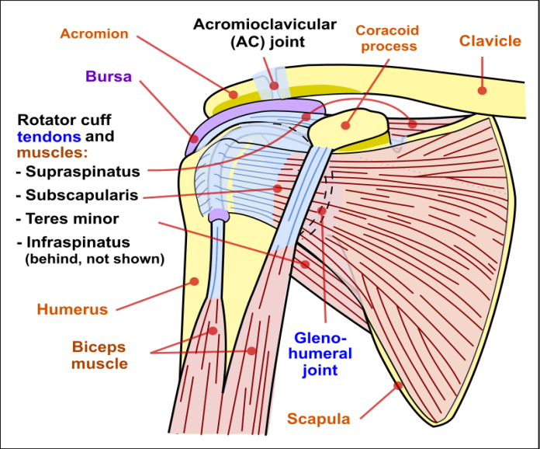

(Fig.1)

**Shoulder Pain without Injury**:

Pains from shoulder joint or its surrounding tendon is felt anterolateral and at the insertion of deltoid and some time it radiate down the arm. There are several conditions that cause discomfort but aren’t caused by a traumatic activity.

***Six Common Causes:***

**1-Rotator cuff tendonitis: (Shoulder impingement syndrome) (painful arc syndrome):**

is a [syndrome](https://en.wikipedia.org/wiki/Syndrome) involving [tendonitis](https://en.wikipedia.org/wiki/Tendonitis) ([inflammation](https://en.wikipedia.org/wiki/Inflammation) of [tendons](https://en.wikipedia.org/wiki/Tendon)) of the [rotator cuff](https://en.wikipedia.org/wiki/Rotator_cuff) muscles as they pass through the [subacromial space](https://en.wikipedia.org/wiki/Subacromial_space), the passage beneath the [acromion](https://en.wikipedia.org/wiki/Acromion). It is particularly associated with tendonitis of the [supraspinatus muscle](https://en.wikipedia.org/wiki/Supraspinatus_muscle). This can result in pain, weakness, and loss of movement at the [shoulder](https://en.wikipedia.org/wiki/Shoulder).

**Causes &Predisposing factor**:

1-, age-related degenerative changes within the tendon predispose the tendon to become damaged with normal daily activities.

2-Bursitis occurs when the bursa that provides a cushion between the bones and the tendons becomes swollen or irritated.

3-Some repetitive activities that can exacerbate rotator cuff tendonitis are tennis, golf, or housework, like painting or carpentry.

**Clinical feature:**

Age of patients usually 40-60y. The Pain in the shoulder and over the deltoid m, worse at night &may be quite sever on attempting certain activities such as putting on a jacket. The shoulder looks normal but is tender just below the anterior edge of acromion. The scapulohumeral rhythm is disturbed and pain is aggravated as the arm traverses an arc (on abduction) between 60& 120 degrees **(the painful arc test). (***fig.2*)

[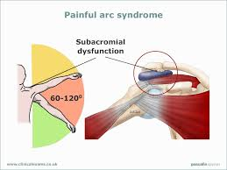](http://www.google.com/url?sa=i&rct=j&q=&esrc=s&source=images&cd=&cad=rja&uact=8&ved=0ahUKEwjMhcKc56DJAhUKvRoKHUusBIoQjRwIBw&url=http://www.clinicalexams.co.uk/painful-arc-syndrome.asp&psig=AFQjCNGqiRfJRvSfvJuCn9mtxwD447JKTQ&ust=1448170918613752)

(Fig.2)

When repeating the movement with arm in full external rotation throughout may be much easier and relatively painless; this is virtually pathognomonic of supraspinatus tendinitis. In long standing cases there is wasting of the muscle & loss of power during movement especially abduction &external rotation, are restricted.

**X- ray:**

1-Calcification just above the grater tuberosity.

2-Late complications are upward subluxation of humeral head & O.A. of the shoulder. Sometime O.A of acromioclavicular J.

**Treatment:**

* Some patient improves with a short course of anti-inflammatory tablets.
* If this fail local injection of methylprednisolone (8omg) or triamcinolone (40mg) &lignocaine (local Anesthesia) is tried. If symptom keeps recurring, operation is advisable (Arthroscopic washout).

**2-Rotator cuff tears:**The same overuse that leads to tendonitis can lead to rotator cuff tears. Eventually the chronic inflammation and degeneration can cause the tendon to wear down and tear. “The pain of a tear is more of an aching or throbbing discomfort that can interrupt sleep.

**We have 2 types of tear:**

**a) Partial tear:** occur with supraspinatus tendinitis.

**b) Complete tear:** may result from a sudden shoulder strain, or it may appear as a complication of tendinitis or partial tear.

* Clinical features: Age 45-75 years (younger in partial& older in complete tear). While lifting a weight or protecting himself from falling, he sprains the shoulder. &Pain is felt immediately & he is unable to lift the arm side way. If tear is ***partial,*** he may gradually recover, although perhaps with persistent painful arc of abduction. If ***complete*** the pain soon subside, but gross weakness of abduction persists. ***Clinically*** ***to distinguish*** ***between partial and complete tears, pain is abolished by injecting local anesthesia, if active abduction is now possible the tear only partial.*** If same weak have elapsed since the injury ,the two types are easily differentiated, with complete tear pain has then subside and the clinical is unmistakable, with complete tear, active abduction is impossible & attempting it produces characteristic shrug; but passive abduction is full &once the arm has been lifted above a right angle the patient can keep it up by using his deltoid (*abduction paradox*) when he lowers it sideway it suddenly drops (*drop arm sign*) .With partial tear abduction slowly recovers(fig3).

**Diagnosis** confirmed by ultrasonography, MRI, or arthroscopy.

[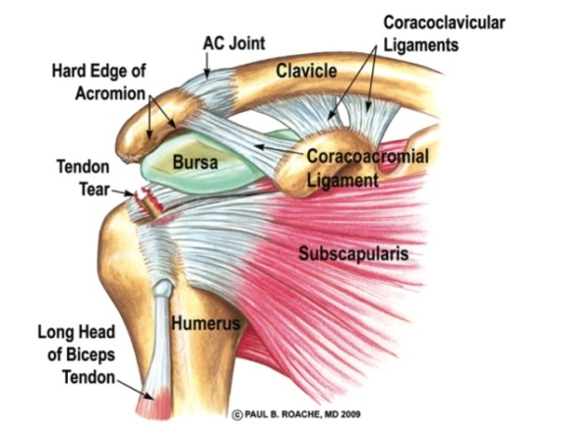](http://www.google.com/url?sa=i&rct=j&q=&esrc=s&source=images&cd=&cad=rja&uact=8&ved=0ahUKEwj-ye3omZ7JAhWJ1RQKHUToCfIQjRwIBw&url=http://imgarcade.com/1/rotator-cuff-tendons/&psig=AFQjCNHS4Bz_eETDg_J3wgkdPTZnL2ubIg&ust=1448081419188597)

(Fig.3)

**Treatment:** Acute: conservative &consists of heat, exercise &one or two injections of local anesthesia into the tender area. **After 3 weeks,** it’s usually possible to assess the extent of the rupture. ***Complete tear*** in younger, active individuals, should be repaired (surgery), operation is contraindicated in old or sedentary individuals, & in long standing cases that are painless. ***Partial tear*** doesn’t require operation unless they cause persistent pain.

**3- Frozen shoulder:** *A*lso known as ***adhesive capsulitis***, frozen shoulder happens when there’s inflammation in the lining of the capsule of the ball socket joint. The shoulder capsule thickens and tightens, which creates the discomfort. There is no known cause of frozen shoulder, which presents as progressive pain with motion and stiffness. It’s more common in women,

Treating frozen shoulder usually involves performing exercises to expand range of motion. Sometimes, doctors use medications and local corticosteroids. If conservative treatment failed, surgery (arthroscopic capsulotomy) to loosen the joint capsule, allowing it to better move. It’s unusual for frozen shoulder to happen again in the same shoulder where it first occurred, but people can develop this condition again in the opposite shoulder (fig.4).

[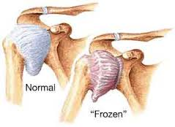](http://www.google.com/url?sa=i&rct=j&q=&esrc=s&source=images&cd=&cad=rja&uact=8&ved=0ahUKEwjGs7CLpZ7JAhVIsxQKHd_JATcQjRwIBw&url=http://www.myerssportsmedicine.com/frozen-shoulder/&psig=AFQjCNF27zEH_LCVfmCMnZyJTwGCJdc03g&ust=1448084413592007)

**(Fig. 4)**

4- **Calcific tendonitis:**Like frozen shoulder, there’s no identifiable cause for calcific tendonitis, but it can be quite painful, calcific tendonitis as a condition where calcium deposits (up to 1 to 2 centimeters in diameter) build up in the muscles or tendons. They can be seen on an X-ray and are typically more common in people who are over the age of 30 but can occur at any age. Calcific tendonitis can usually be treated by anti-inflammatories or injections. Many cases resolve over time without treatment. In rare cases, surgery is required (fig.5).

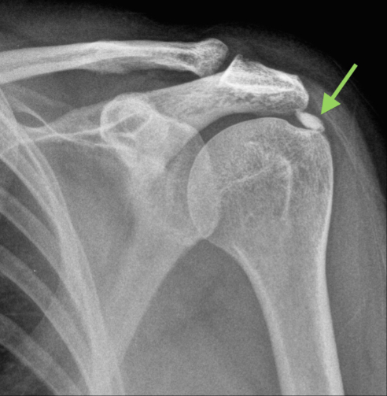

(Fig.5) ***Calcific tendinitis***

5- **Arthritis:**Patients can experience intense shoulder pain as results of arthritis; many people have never had a documented injury or trauma to their shoulder area. It’s important to look at the patient’s history to determine if there were any injuries—or injuries that may have gone undiagnosed (i.e. causes of arthritis). Otherwise, a fair amount of people can experience shoulder pain due to arthritis without any prior injury.

**6-Spinal pathology:**  Your shoulder may hurt, but it may not be the result of a shoulder problem in the first place. Sometimes it’s hard to determine where pain originates, but cervical spine and disc issues can be the root cause of shoulder pain.

**Lesion of biceps tendon:**

**1) Bicipital tendinitis: usually** occurs together with rotator cuff impingement, rarely, it presents as an isolated problem in young people after unaccustomed strain. Tenderness is sharply localized to the bicipital groove. Treatment by (Rest, local heat ) usually bring relief; if recovery is delayed, a corticosteroid injection will help.

**2)Tear of long head of biceps**  are similar to those of supraspinatus tendon & are preceded by degeneration &. Age over 50years. While lifting, he feel something snap, the shoulder, which previously felt normal aches for time & arm may look bruised (fig.6). Soon the ache disappears &good function returns, but when the elbow is flexed actively the belly of the muscle contracts into a prominent lump (fig.6). Function is so little disturbed that treatment is unnecessary but sometimes surgery needed by anchoring the origin of the long head of biceps to its origin in supraglenoid tubercle).

[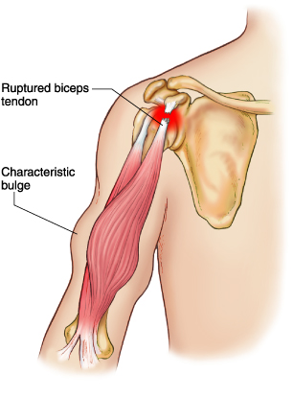](http://www.google.com/url?sa=i&rct=j&q=&esrc=s&source=images&cd=&cad=rja&uact=8&ved=0ahUKEwji2Kbpp57JAhWD8RQKHbpnBlgQjRwIBw&url=http://www.mdguidelines.com/ruptured-biceps-tendon-traumatic-and-nontraumatic&psig=AFQjCNHi0MHGlunOi44x1z3gw8Q8Wi9CHg&ust=1448085164542897) [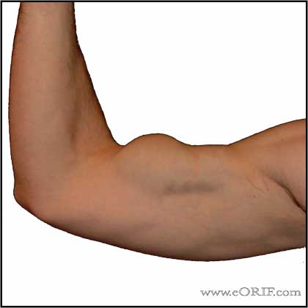](http://www.google.com/url?sa=i&rct=j&q=&esrc=s&source=images&cd=&cad=rja&uact=8&ved=0ahUKEwjE7ZG7qJ7JAhUC0RQKHRMhCtgQjRwIBw&url=http://eorif.com/biceps-tendon-rupture-proximal-m66829-72762&psig=AFQjCNHi0MHGlunOi44x1z3gw8Q8Wi9CHg&ust=1448085164542897)

(Fig.6)

**Tears of the distal biceps tendon** are rare. Follow anacute flexion strain of the elbow; the tendon is not degenerate but tears cleanly or is avulsed from the radial tuberosity (fig.7). Nonoperative treatment typically results in loss of flexion & supination strength so early anatomic re-attachment is the goal.

[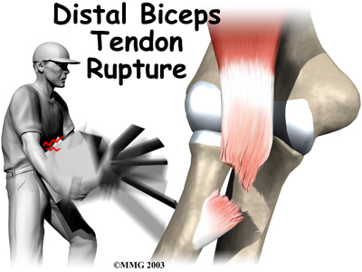](http://www.google.com/url?sa=i&rct=j&q=&esrc=s&source=images&cd=&cad=rja&uact=8&ved=0ahUKEwi847Wgq57JAhWIOhoKHdQ_A6YQjRwIBw&url=http://www.houstonmethodist.org/orthopedics/where-does-it-hurt/elbow/distal-biceps-rupture/&psig=AFQjCNHi0MHGlunOi44x1z3gw8Q8Wi9CHg&ust=1448085164542897) [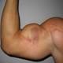](https://www.google.com/imgres?imgurl=https://s-media-cache-ak0.pinimg.com/236x/98/d0/51/98d051936aa6052a6e386df7112fbf58.jpg&imgrefurl=https://www.pinterest.com/mightymouze/men-s-power-powerlifting-beast/&docid=8yD83aqtDfappM&tbnid=8IYiQydu0KgkAM:&w=236&h=236&ved=0ahUKEwi7wqO7qJ7JAhXDbhQKHb4oCr8QxiAIBzAF&iact=c&ictx=1)

(Fig.7)