Neuromuscular disorders: affect the nerves that control voluntary muscles and the nerves that communicate sensory information back to the brain. Nerve cells (neurons) send and receive electrical messages to and from the body to help control voluntary muscles.
These include:
1-Cerebral palsy
2-Neural tube defects
3-Poliomylitis
4-Peripheral neuropathy
5-Muscular dystrophy
6- Compressive lesion of the spinal cord.
Clinical assessment: cerebral palsy & neural tube defects present during infancy. Poliomyelitis usually occurs in childhood.Spinanal cord lesions &peripheral neuropathies are more common in aduls.However the residual effects of neurological disease may present throughout the life.
-Examination: should include complete neurological assessment & examination of the back.
These include:

1- Gait:
Steps of gait: typical pattern of gait can be recognized:
Heel strike--- midstance phase---swing phase---toe off.
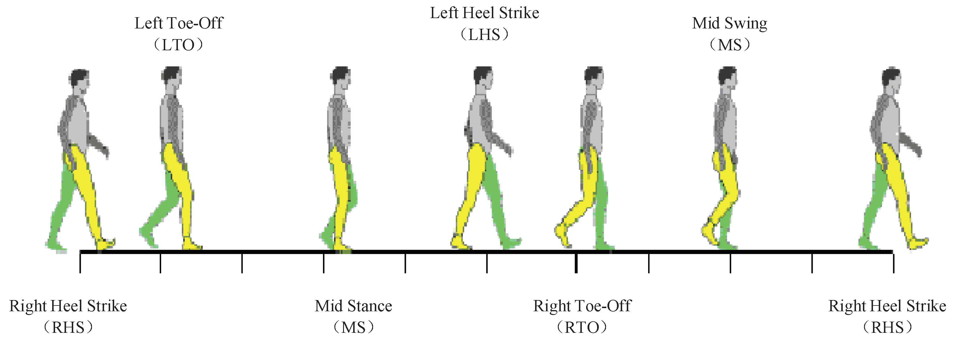

Types of gait:
1-spastic Gait: The patient stands with spastic weakness on the affected side, arm flexed, adducted and internally rotated. ...
2-Neuropathic Gait. ...
3-Myopathic Gait.(waddling gait) ...
4-Choreiform Gait. ...
5-Ataxic Gait. ...
5-Parkinsonian Gait.
6-High stepping Gait.

2-Deformity: when all muscle groups are equally weak ( balanced paralysis ), the joint simply assumes the position imposed on it by gravity , it’s unstable & the limb feels floppy or flial , deformity occurs when one group of muscles is too weak to balance the pull of antagonists (unbalanced paralysis ), in children paralysis may affect the bone growth.

3-Muscle weakness: this may be due to upper motor neuron lesion (spastic type) ,lower motor neuron lesion (flaccid type ) or muscle disorders.

Score | Description
0 | No contraction
1 | Flicker or trace of contraction
2 | Active movement, with gravity eliminated
3 | Active movement against gravity
4 | Active movement against gravity and resistance
5 | Normal power
Grades of muscle power
4-Sensory changes: numbness & parasthesia may be the main complaints .It’s important to establish their exact distribution as this will help to localize the lesion.
5- Investigation:
a- imaging: brain x-ray of the skull or the spinal cord is routine for all disorders of CNS. CT scan & MRI of the brain or the spinal cord may be necessary to reveal degenerative or space occupying lesion.
b- EMG& NCS helpful to establishing:
1- Weather weakness due to nerve or muscle disorders.
2-weather & when a peripheral nerve is compressed or damage.

c- Muscle biopsy: may yield valuable diagnostic information.

Cerebral palsy: (CP) is a group of disorders that affect a person's ability to move and maintain balance and posture. CP is the most common motor disability in childhood. Cerebral means having to do with the brain. Palsy means weakness or problems with using the muscles.
-Causative factors: Cerebral palsy is caused by a brain injury or problem that occurs during pregnancy (prenatal) or birth (perinatal) or within the first 2 to 3 years of a child's life (postnatal). It can be caused by: Problems from being born too early (premature birth). Not getting enough blood, oxygen, or other nutrients before or during birth.

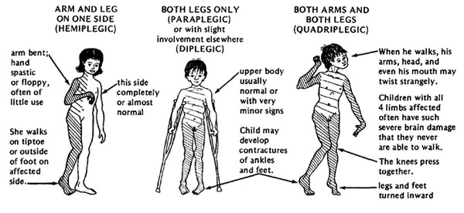
-Diagnosis: The signs of cerebral palsy usually appear in the first few months of life, but many children are not diagnosed until age 2 or later. In general, early signs of cerebral palsy include:
1- Developmental delays. The child is slow to reach milestones such as rolling over, sitting, crawling, and walking. Developmental delays are the main clues that a child might have cerebral palsy.
2-Abnormal muscle tone. Body parts are floppy or too stiff.
3-Abnormal posture. The child might also use one side of the body more than the other when reaching, crawling, or moving.

-Types: Spastic CP is the most common. Kids with spastic CP have stiff muscles. These may be in the upper part of the body, the lower part, or both. They can be on one or both sides of the body. Other types of cerebral palsy can lead to writhing movements (dyskinetic CP) or problems with balance and walking (ataxic CP).

In summary, there are four main types of CP:
1-Spastic Cerebral Palsy. ...
2-Dyskinetic Cerebral Palsy (also includes athetoid, choreoathetoid, and dystonic cerebral palsies)
3-Ataxic Cerebral Palsy. ...
4-Mixed Cerebral Palsy. .

-Treatment: Common types of treatment for cerebral palsy include:
1- Physical therapy and rehabilitation. A child with cerebral palsy usually starts these therapies in the first few years of life or soon after being diagnosed
2- Orthotic devices. Braces, splints, and casts can be placed on the affected limbs and can improve movement and balance.
3-Medication. Certain medications (muscle relaxants) can relax stiff or overactive muscles and reduce abnormal movement.
4- Surgery. A child may need surgery if symptoms are severe. For instance, surgery can lengthen stiff, tightly contracted muscle.

Spina Bifida:
Is a birth defect that occurs when the spine and spinal cord don't form properly. It's a type of neural tube defect. The neural tube is the structure in a developing embryo that eventually becomes the baby's brain, spinal cord and the tissues that enclose them. 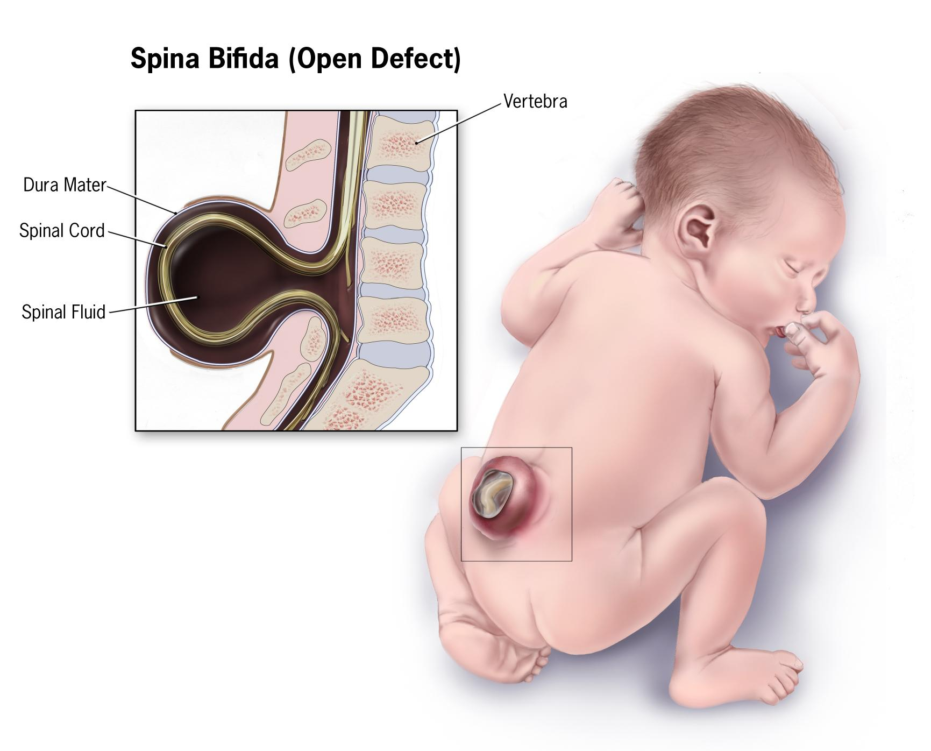

Types:
1- Myelomeningocele. This is the most common and serious type of spina bifida. It involves a sac outside the opening in the baby’s back somewhere on the spine. This sac contains parts of the spinal cord and nerves. The spinal cord and nerves in the sack will be damaged.
2-Meningocele. This type of spina bifida also involves a sack of fluid outside an opening in the baby's back. This type of spina bifida also the sac does not contain any part of the spinal cord
3-Spina bifida occulta: This is a mild type of spina bifida. It may also go by the term “hidden” spina bifida. It does not cause any disabilities and may go unnoticed until later in life. There is usually no opening in the baby’s back, but only a gap in the spine. In this type, there is no damage to the spinal cord or the nerve

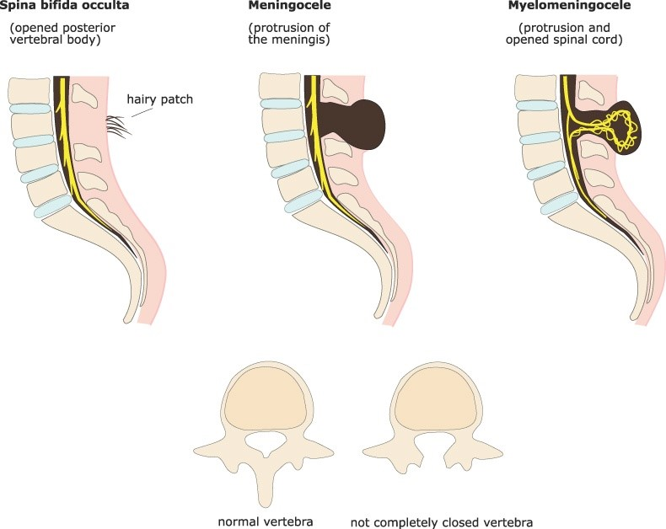

Hydrocephalus: is a condition in which an accumulation of cerebrospinal fluid (CSF) occurs within the brain. This typically causes increased pressure inside the skull, ventricle dilatation& skull enlarged by separation of skull sutures. Older people may have headaches, double vision, poor balance, urinary incontinence, personality changes, or mental impairment.
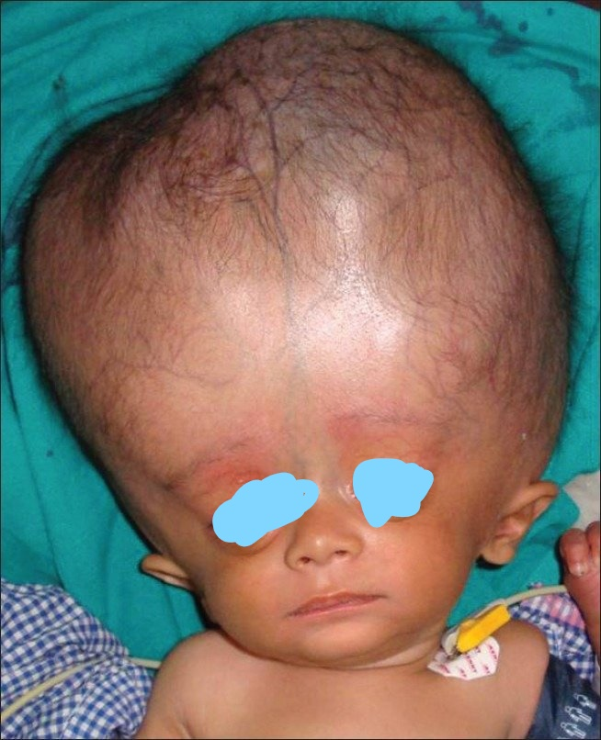

-Treatment:
Depending on the severity of spina bifida and the complications, treatment options may include:
1-Walking and mobility aids.
2-Bowel and bladder management.
3-Surgery for hydrocephalus.
4-Treatment and management of other complications.

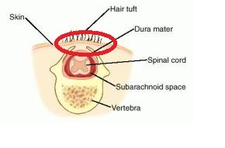

Poliomyelitis:
Poliomyelitis (polio) is a highly infectious viral disease that largely affects children under 5 years of age. The virus is transmitted by person-to-person spread mainly through the faecal-oral route or, less frequently, by a common vehicle (e.g. contaminated water or food) and multiplies in the intestine, from where it can invade the nervous system and cause paralysis There are three wild types of poliovirus (WPV) – type 1, type 2, and type 3. People need to be protected against all three types of the virus in order to prevent polio disease and the polio vaccination is the best protection.

Clinical features: Sufferers of polio have the following symptoms:
1-In mild cases — headache, slight fever, nausea and vomiting for up to three days
2-In moderate cases — moderate fever, muscle pain, a stiff neck and back, fatigue
3-In most severe cases — fever, muscle pain or spasms, muscle weakness, stiffness, constipation, tremors and difficulty with swallowing.
Paralytic polio can cause severe physical disabilities due to muscle paralysis and deformities of the hips, ankles and feet, but the sensation is intact. Polio can also cause serious complications to other organs such as the lungs, intestines, kidneys and heart.

Treatment:
1- Symptoms of fever, headache, back, and neck and muscle pain are relieved by using pain relievers and muscle relaxant medications. Usually NSAIDs like Ibuprofen, Diclofenac and Acetaminofen are preferred

2- Physical therapy plays an important role in rehabilitation for patients with poliomyelitis. Patients with muscle paralysis benefit from frequent passive range of motion (PROM) and splinting of joints to prevent contracture and joint ankylosis

Lower or upper limb paralysis may persist as weakness or paralysis that leads to disability for life need permanent splintage of the limb in flail joint (balanced paralysis of all muscles around the joint) or tendon transfer in (unbalanced paralysis in which only one group of muscle affected) , also polio can lead to arrest the growth of the limb & this lead to shortening of limb usually need treatment by lengthening of short limb or shortening of normal limb.

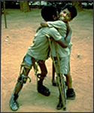

lesion of spinal cord: usually caused by
1-Acute injury
2- Infection (eg :T.B)
3-Intervertibral disc prolapse
4-Vertebral bone disease (metastasis)
5-Spinal cord tumours
6-Interinsic cord lesions
Clinical features:
Patients complaing of muscle weakness or loss of balance,bladder or bowel may be affected (impaired control ) & importance
Diagnosis :
Histoy ,examination and imaging study (X-ray,CTscan & MRI) ,blood & CSF examination .
Treatment:
Treatment of cause & compressve lesions, require urgent diagnosis & treatment,motor & sensory signs may improve after decompression but bladder control become irreversible after 24 hours from treatment.

