
Al-Mustansiriyah University
Dr. Mohammed Suhail Al-salam
College of Medicine - Department of surgery
Ophthalmology

Introduction into Ophthalmology

Learning objectives:

- Recognize the general principles of Ophthalmology
- Identify the basic anatomical and physiological basis of the eye.

Anatomy

The Eyeball is nearly an inch in diameter lies suspended in the fat that largely fills the orbit.
The Eye ball is separated by a few millimeters from the four converging bony walls of the orbit, it is unprotected only on its anterior surface where the cornea lies.
The ocular movements are achieved by six extra-ocular muscles, 4 recti and 2 oblique.
The ocular movements are controlled by 3 cranial nerves :
3rd cranial nerve ( oculomotor nerve )
4th cranial nerve (trochlear nerve )
6th cranial nerve (abducent nerve )

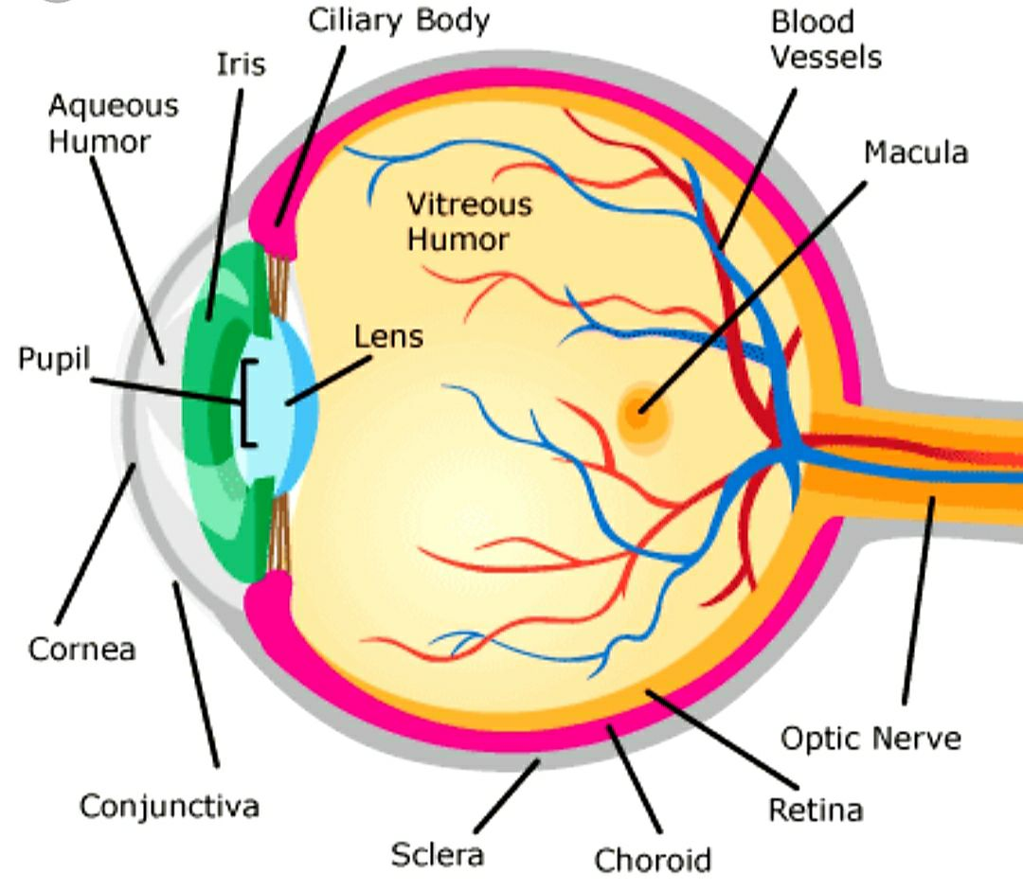
Anatomy of the eye

The eyeball consists of three concentric layers
Outer layer; Cornea-Scleral layer,
Sclera: outer fibrous layer, offers protection
Cornea: Transparent anterior 1/6 of the outer layer
With diameter 12mm, and thickness of central part 0.5 mm
Main refractive element in the eye (43 diopter)
Cornea-Scleral junction called the limbus

Middle layer; Uveal tract , is vascular layer
consists of iris, ciliary body, and choroid.
Central aperture in the iris called the pupil

Inner layer; Retina, light sensitive layer, contains photoreceptors; Rods and Cones.
Within the Retia , we have :

Macula: is an oval area in the posterior pole of the eye, about 5mm in diameter, corresponding to the central 15º of vision.
Fovea: central 1.5 depression in the macula correspond to the
Central 5º of vision.

Retinal photoreceptors are of two types :
Rods; are responsible for night vision, maximum concentration at mid-
periphery of the retina
Cones; are responsible for daylight and color vision, maximum concentration at the fovea

- Crystalline lens, is transparent, avascular structure, located between the iris and the vitreous, suspended in place by a series of fibers (zonules) extend from the ciliary processes in the ciliary body to the equator of the lens.
The crystalline Lens is the second refractive element of the eye (15 diopter).
Decrease in transparency of the lens called cataract.

The anterior segment: lies between the cornea and the lens, filled
by the aqueous humors and divided by the iris into anterior and
posterior chambers.

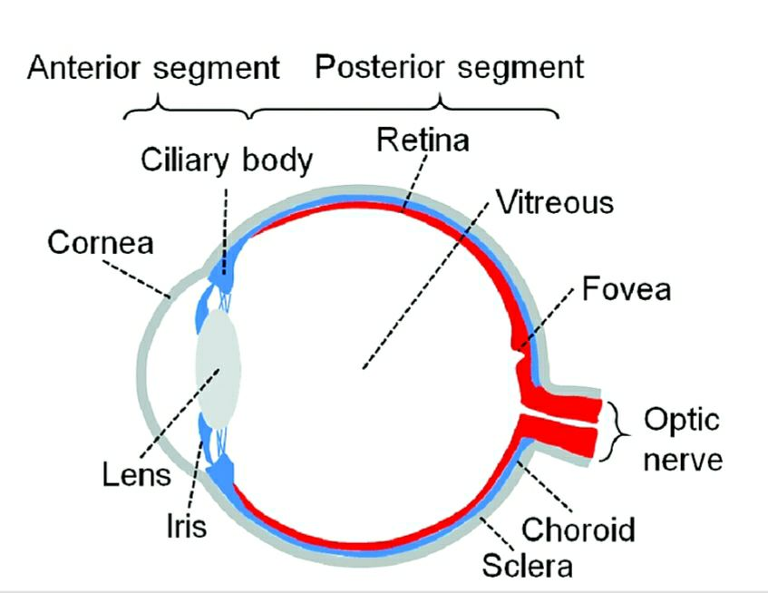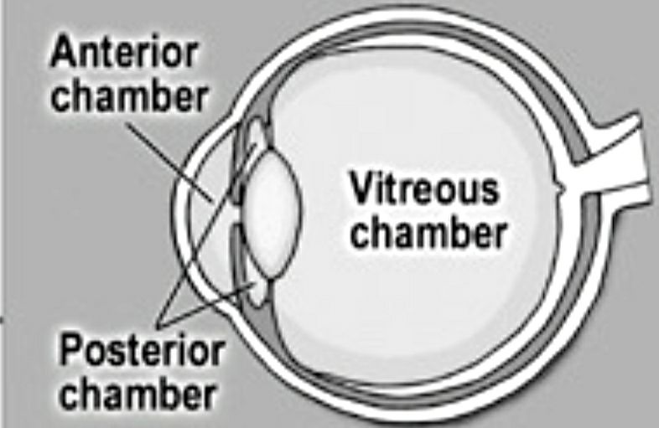

The posterior segment: lies between the lens and the retina , filled by the vitreous.
The vitreous is a transparent jelly, volume about 4ml, lies between the lens and the retina

Aqueous humour; is a clear fluid that fills anterior and posterior chambers.
Pathway of aqueous humour: secreted by the ciliary process in the ciliary body to the posterior chamber, pass through the pupil to the anterior chamber. It is eliminated from the eye though the trabeculum meshwork to canal of Schlemn located circumferentially deep in the limbus, and leave the eye to the deep scleral venous plexus.
Obstruction in the drainage pathway cause increase in the intraocular pressure ( normal 10-21mmHg), this is called Glaucoma.

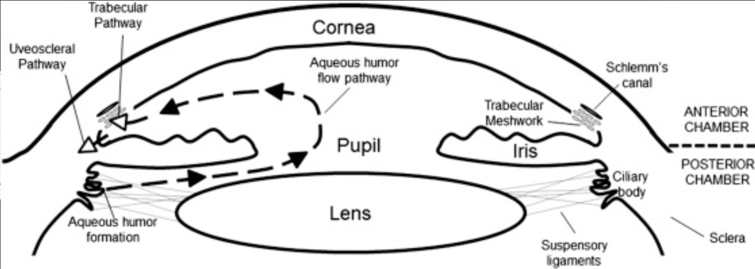

Ocular examination

Visual Acuity ( V.A.) is measurement of the resolving power of the eye.
The standard test is the Snellen chart, which consists of rows of letters of decreasing size. Each row is numbered with the distance in meters at which each letter subtends 5 minutes of arc at the nodal point of the eye.
V.A. is recorded with two numbers,
The numerator represents the distance in Meters between the person and the chart (e.g. 6 meters).
The denominator represents the smallest row number seen by the person.

If the vision of a patient is poor and he cannot see the largest letter from the distance of one Meter then the vision is recorded as;
Counting fingers,
Hand movements,
Light perception

In young children V. A. determine by matching pictures and letters of varying size.

Slit Lamp
Slit Lamp is a biomicroscope with a strong source of light that can be made as slit to obtain an optical cross section of the transparent parts of the eye (cornea and the lens).
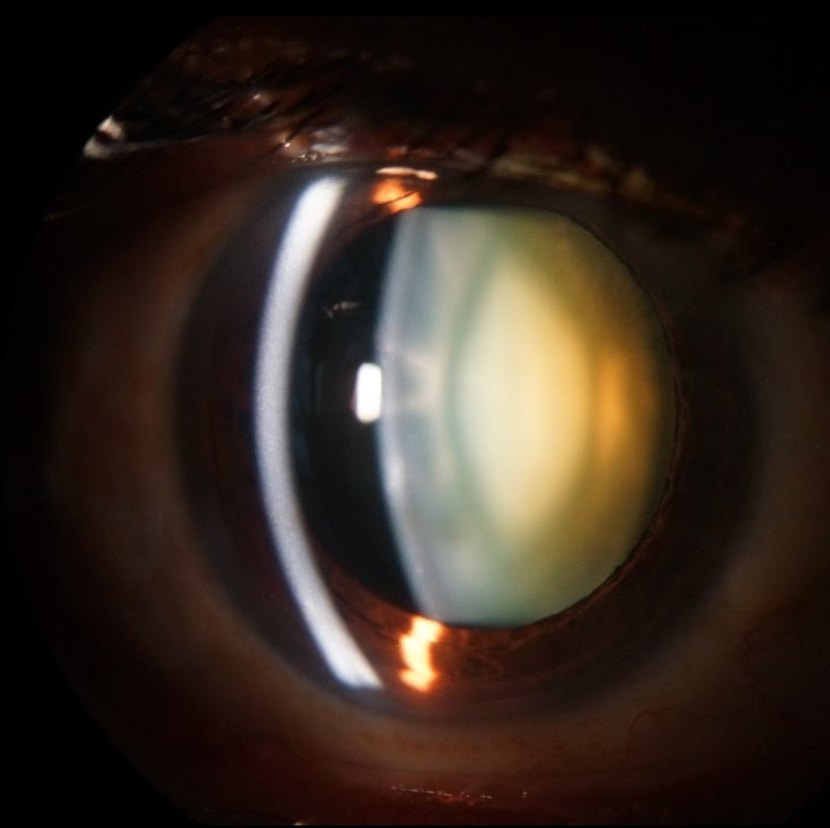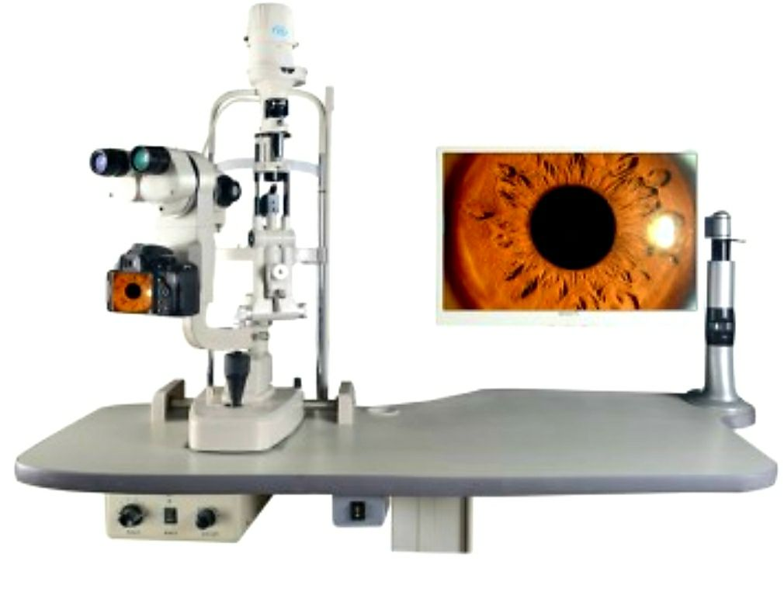

Direct and Indirect ophthalmoscope for examination of the posterior segment of the eye
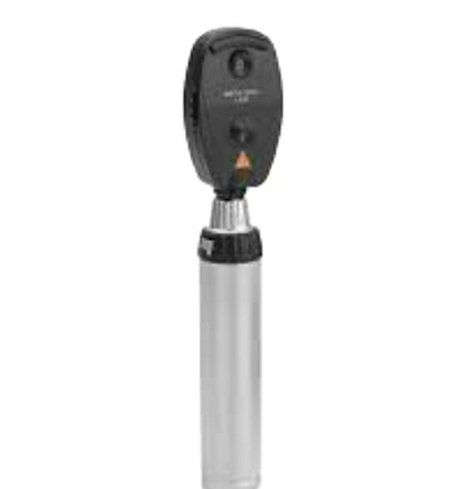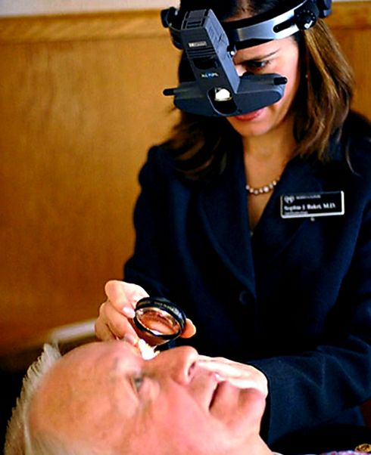

Visual Field: Map the area of surrounding that can be seen at one time.
Different points of the retina have different sensitivities. The peak of vision is at the fovea, peak of the hill, decreasing at the periphery.
On the temporal of the field is the blind spot, which corresponds to the optic nerve where there is absence of photoreceptors.
Central visual field corresponds to the central 30º .
Peripheral visual field corresponds to;
Temporally 90º
Nasally 60º
Superiorly 50º
Inferiorly 70º

Assessment of visual field is by perimeters e.g.
Goldman perimetry for assessment central and peripheral visual field
Tangent screen for assessment central visual field
Computerized perimetry for assessment central and peripheral visual field
Visual field defects in one eye (uni-ocular) indicate a disorder in the retina or optic nerve.
Visual field defects in both eyes (binocular) indicate disorders in the optic chiasma or behind the chiasma (optic tract, lateral geniculate body, optic radiation, occipital cortex).

Intra-ocular pressure(IOP); normal range between 10-21mmHg.
IOP measured by tonometry, e.g. Goldman tonometry which can be incorporated with Slit Lamp.
Increase IOP may cause optic nerve head damage with specific changes in the visual field, this is called Glaucoma.
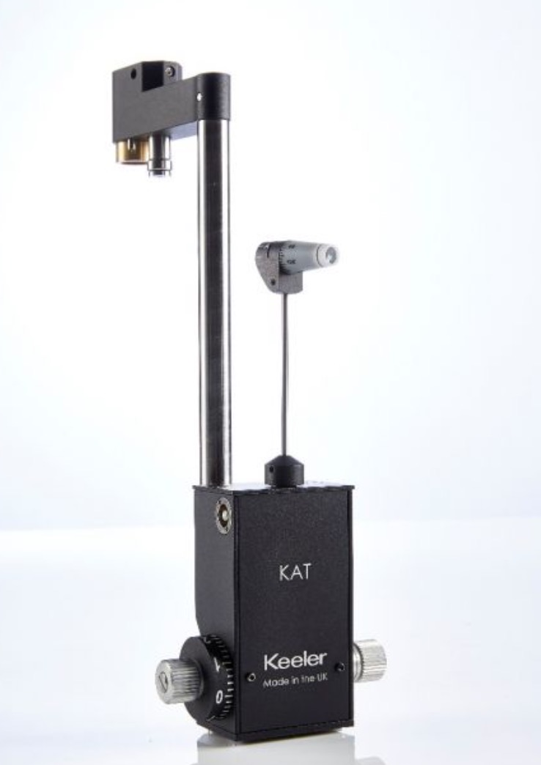
References:
- Kanski clinical ophthalmology
- Oxford handbook of ophthalmology
- American academy of ophthalmology

