
Al-Mustansiriyah University
By Mohammed Suhail Al-salam
College of Medicine - Department of surgery
Ophthalmology

The Crystalline lens

Learning objectives:

- To understand the anatomy of the crystalline lens
- To identify important clinical disorders related to the crystalline lens
- To recognize Cataract as one of the most common causes of visual loss in the world .

Anatomy of the lens
The crystalline lens is a biconvex, avascular transparent structure enclosed by a capsule.
The lens consists of:
1- Nucleus: the central compacted core, which represents the older lens fibers formed during intrauterine life and early years of life.
2- Cortex: represents the newly formed epithelial cells, which elongate to form new lens fibers (which are softer than that of nucleus) surrounding the old fibers (nucleus). These new lens fibers are continuously laid down sub-capsularly throughout life, resulting in that the older layers acquire progressively deeper localizations within the lens.
3- The capsule: which is the thickest basement membrane in the body and responsible for moulding the lens substance during accommodation.

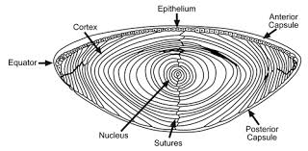

A ring of zonular fibers, which insert in the equatorial region, suspends the lens from the ciliary body. As the zonule keeps the lens attached to the ciliary body, it can mould and change the shape of the lens during accommodation. Contraction of the ciliary muscle causes decrease in the tension of the zonule on the lens capsule which causes change in the lens shape to more spherical by its elasticity and thus increasing the power of lens. This is called "Accommodation"
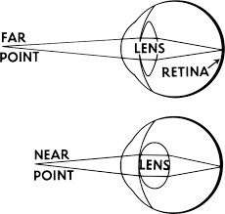
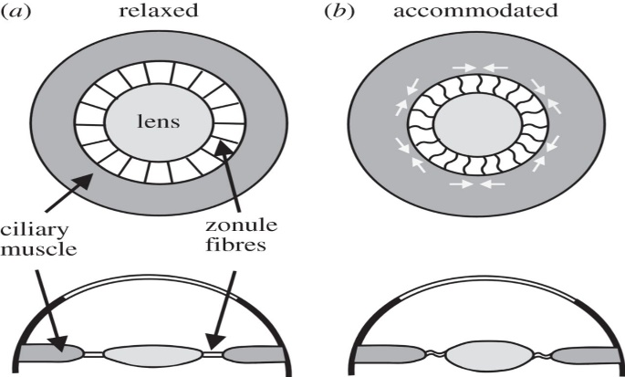

The lens grows in both anteroposterior and equatorial dimensions throughout life (this explains why angle- closure glaucoma occurs in old aged people, as the increasing volume of the lens may cause blockage or closure of the angle and impair drainage of fluid from anterior chamber to trabecular meshwork).
Disorders of the crystalline lens
Cataract
- The normal lens is transparent, any congenital or acquired opacity in the lens or its capsule, irrespective to the effect on vision, is a cataract.
Types of cataract:
1- According to its site within the lens:
a- Posterior subcapsular: just anterior to the posterior capsule. b- Anterior subcapsular: just posterior to the anterior capsule. c- Cortical: cataract involving the cortex. d- Nuclear: cataract involving the nucleus.
2- According to maturation:
- Immature: if there is involvement of part of lens (any part), and other parts are transparent.
- Mature: complete opacification of the entire lens.
- Hypermature Cataract: which is a mature cataract liquefaction, leakage of fluids from the lens towards aqueous humor, shrinkage and folding of capsule.
- Morgagnian Cataract : a hypermature cataract in which liquefaction of the cortex allows the nucleus to sink inferiorly
3- According to its onset: either acquired or congenital.
Acquired cataract
Causes:
1- Age-related cataract: due to biochemical changes that occur with advancing age in the proteinaceous matter of the lens converting soluble into insoluble protein causing opacification, usually develops after the age of 60.
2- Pre-senile cataract: develops before the age of 60 in the following conditions:
a- Diabetes Mellitus:
High level of glucose in the aqueous humor so it diffuses into the lens, where glucose is metabolized into sorbitol by aldose reductase, then accumulation of sorbitol causes secondary osmotic overhydration leading to refractive changes (Myopia), then cataract.
b- Myotonic dystrophy: 90% of patients develop cataract in the third decade.
c- Atopic dermatitis: 10% of patients with severe atopic dermatitis develop cataract in the 2nd-4th decades of life.
d- Neurofibromatosis type 2.

3- Traumatic cataract: trauma is the most common cause of unilateral cataract in young individuals:
a- Direct penetrating injury to the lens. b- Concussion.
c- Electrical shock is a rare cause. d- Ionizing radiation.
e- Infrared radiation; as in glassblowers.
4- Drug-induced cataract:
a- Steroids: both systemic and topical steroids are cataractogenic.
b- Chlorpromazine: both corneal and lenticular deposits are dose related and usually irreversible, high dose (>2400 mg daily) may cause retinotoxicity.
c- Amiodarone (anti-arrhythmic): lens deposits occur in 50% of patients.
d- Gold: lens deposits occur in 50% of patients on treatment for longer than 3 years.
e- Allopurinol: used in hyperuricaemia and chronic gout.
5- Secondary cataract: is a complicated (secondary) cataract develops as a result of some other primary ocular disease:
- Chronic anterior uveitis: it is the most common cause of secondary cataract.
- Acute congestive angle-closure glaucoma.
c- High (pathological) myopia.
- Hereditary fundus dystrophies, such as retinitis pigmentosa.

Treatment of catract
SURGERY● there is NO effective medical treatment
Indications of surgery:
1- Visual improvement: is the most common indication, whether it is mature or immature. If the patient feels that his vision is not enough to perform daily requirements surgery is indicated.
2- Medical indications: e.g., Intumescent Cataract (phacomorphic cataract) which might lead to intumescent glaucoma. Other example is dense cataract impaired visualization of retina in diabetic patients.
Anesthesia used is general, local, topical and intracameral (injection of local anesthesia inside the AC). Choices one of them is according to method of surgery, general health of the patient and surgeon preference.
Types of cataract surgery:
1- Intracapsular cataract extraction (ICCE) ± AC IOL (anterior chamber, intraocular lens): →
Need large circumferential, 10-12mm, about 160° limbal or corneal incision. Removal of catractous opacified lens totally by insertion a cryoprobe (its temperature is -80°) and freeze the lens capsule and moving it to destruct all zonules and taken the lens out. Finally, we implant artificial intraocular lens (IOL) in the anterior chamber in front of iris and suturing the incision. This operation has disadvantages of prolonged period of rehabilitation; the stitches may stretch the cornea causing Astigmatism and high incidence of vitreous loss.
2- Extracapsular cataract extraction (ECCE) ± PC IOL (posterior chamber intraocular lens): →
We do a smaller incision 8-10mm. about 120°-140°. The anterior capsule is cut near to its periphery and removes it (Capsulotomy). Then we fluctuate the nucleus to extract it out, and the retained lens material is taken out by irrigation and aspiration. Therefore, what will remain are the posterior capsule and the peripheral part of anterior capsule. Finally, we bring the IOL and implant it in the bag between the posterior capsule and the peripheral part of anterior capsule (in the position of previous cataractous lens). This operation characterized by having less length incision, rapider rehabilitation, less astigmatism and less incidence of vitreous loss because the posterior capsule is still intact.
3- Phacoemulsification:
Most recent method, 3.2 mm incision + foldable or injectable IOL, sutureless because the incision is so small.
Like ECCE, also we cut the anterior capsule but the nucleus is not delivered as a one piece but it emulsified and fragmented into small pieces. So there is no need to do a large incision like in ICCE or ECCE. Finally, we either inject a lens or implant a foldable lens manufactured of soft material. This operation does not need suture and patient can leave hospital at the day of surgery and resume his life after few days. Astigmatism is either minor degree or nil because the incision is so small.

Aphakia
Congenital or acquired absence of the lens from the eye, or its absence from the pupillary area (luxated).
An aphakic eye is usually strongly hypermetropic where parallel rays of light are brought to a focus behind the retina.
Treatment:
1- High powered convex lenses in spectacles: High power spectacles lens causing magnification of the images on the retina (about 30% magnification), which will produce anisoconia (different sizes of image on the retina coming from the 2 eyes). Normal eye sending normal size image while aphakic eye with high power spectacle producing large image (30%). The cerebral cortex cannot fuse those 2 images with such high difference in their sizes. Other disadvantages of high power spectacles are including, limitation of visual field and heavy weight.
* Cerebral cortex cannot fuse images different in more than 5%. Therefore any difference which is more than 5% will cause diplopia.
2- Contact lens (1% magnification). This is can be used without diplopia in aphakic eye if the other eye is phakic or pseudophakic.
3- IOL (intraocular lens): is the best way of correction as there is no magnification at all.
Congenital cataract
Occurs in about 3:10.000 live birth, 2/3rd of cases are bilateral.
Causes:
1- Isolated hereditary cataracts:
Account for about 25% of cases, mode of inheritance is most frequently AD (Autosomal dominant), yet AR (Autosomal Recessive) and X-linked inheritance can occur.

2- Metabolic cataract:
a- galactosaemia (Galactose -1-phosphate uridyl transferase "GPUT").
b- Lowe's (oculocerebral) syndrome: rare inborn error of amino acid metabolism which predominantly affects boys (X-linked).
3- Prenatal infections:
a- Congenital Rubella: cataract presents in 15% of cases.
b- Others: Cytomegalovirus, Herpes simplex and Varicella.
4- Chromosomal abnormalities:
a- Down syndrome (Triosomy 21).
b- Other: Patau syndrome , Edward syndrome

Treatment:
We assess the density of cataract through visualization of retina. If the cataract is so dense, visualization of retina is difficult or impossible then surgery is indicated.
Surgery is by lensectomy (removal of the entire cataractous lens) + anterior vitrectomy (removal of anterior surface of the vitreous just posterior to the lens) should be done with it as opacification of anterior vitreous face occur in 100% of childs after surgery. Lensectomy and anterior vitrectomy done by special machine called vitrectomy machine.

Correction of aphakia in congenital cataract:
1- Unilateral aphakia: either IOL or contact lens (NO role for glasses)
2- Bilateral aphakia: in addition to IOL and contact lens, it can be corrected by spectacles.

Ectopia lentis
Is refers to a displacement of the lens from its normal position. The lens may be completely dislocated "Luxated" (complete destruction or cut of zonules) or partially dislocated "Subluxated".
Causes:
1- Acquired:
- Trauma.
- Large eye {high myopia, buphthalmus (congenital glaucoma)} , due to stretching of zonules that causes their destruction.
- Anterior uveal tumour, as it pushes the lens away from the ciliary body leading to destruction of zonules.
2- Congenital:
a- Without systemic association: AD, AR or associated with aniridia (congenital absence of iris).
b-With systemic association: e.g., Marfan's syndrome, Weill-Marchesani syndrome, homocystinuria, Ehlers-Danlos syndrome.
Complications of ectopia lentis:
1- Refractive errors: myopia (as the lens moves forward) and astigmatism (as the lens is tilted).
2- Glaucoma: due to pupillary block that raises the pressure inside the posterior chamber that pushes and bows the iris anteriorly "Iris bombé" and causes obstruction of the angle of the anterior chamber ending with glaucoma.
3- Endothelial touch: damage to the endothelium of cornea.
4- Lens induced uveitis: rare, occurs due leakage of lens matter to the intraocular cavities where it is regarded as foreign body, so there will be inflammatory reaction causing uveitis.
Indications of treatment:
1- Refractive error: treated by spectacles and surgery if not corrected by spectacles.
2- Glaucoma: - If the lens is clear, so we do YAG PI (Yttrium-Aluminum-Garnet Peripheral Iridotomy, where we create a fistula between anterior and posterior chamber through a hole at the periphery of iris).
- If there is cataract, we do lens extraction.
3- Endothelial touch → removal of lens.
4- Lens induced uveitis (which is chronic) → removal of lens.

