
Al-Mustansiriyah University
Dr. Mohammed Suhail Al-salam
College of Medicine - Department of surgery
Ophthalmology

Neurophthalmology

Learning objectives:

- Identify the probable location of visual pathway lesion based on visual field pattern
- Recognize the possible presentations for optic N. lesions
- Identify the pupillary pathways with possible lesions effecting them

Visual Pathway
Consists:
Optic nerve, Optic chiasm , Optic tract, Lateral geniculate body, Optic radiation and Visual cortex.

Optic Nerve
The second cranial nerve. It contains the axons of the ganglion cells of the retina ( about one million axons). Optic nerve considered as part of the central nervous system and has no neurolemma and no ability to regenerate after damage due to trauma or inflammation.
Optic nerve has 4 parts:
Optic nerve head; anterior 1mm including intraocular part.
Intra-orbital 3 cm,
Intra-canlicular 0.6 cm
Intracranial 1cm

Blood supplies of the optic nerve head is mainly by short posterior Ciliary arteries, while blood supplies of the rest of the optic nerve is mainly by ophthalmic artery .
The optic disc; anterior end of the optic nerve. It is 1.5 mm in diameter and lies 3 mm nasal to the post pole of the eye. At the margin of the optic disc, the choroid and all the retinal layers stop except axons of the ganglion cells of the retina which pass through the lamina cribrosa of the sclera and emerge from the eye ball as the optic nerve. Optic cup is a central depression in the disc that dose not contain nerve fibers.
Optic nerve pass through optic canal to the middle cranial fossa, where it lies over the cavernous sinus. It converges with the optic nerve of the opposite side to form the optic chiasm where nasal fibers decussate to the opposite optic tract.

Optic Nerve Disorders

Optic Neuritis: optic nerve inflammation

Causes;
1-Demyelinating (MS): most common cause (70%), typically affects young adults, and women are affected more than men
2- Para-infectious. Viral infection or immunization. Children are affected much
more common
3- Infectious, sinus related, syphilis, cat-scratch
4- Non infectious [ Sarcodosis ]

Clinical features
Symptoms: Sudden onset of Monocular visual loss (sometimes bilateral especially in young children) and Discomfort in or around the eye exacerbated by ocular movement

Signs:
Reduction in the visual acuity
Impairment of color vision
Diminished pupillary light reactions
Diminished light brightness sensitivity
Visual field defects, central scotoma, centrocaecal scotoma and others

Clinical classification: [ ophthalmological classification ]

Papillitis: 1/3 of cases, inflammation of the optic nerve head.
Ophthalmoscopic findings: hyperemic, edematous disc.
Retrobulbar neuritis: 2/3 of cases, inflammation behind the optic nerve head. Ophthalmoscopic findings: normal optic disc.
Neuro-retinitis: inflammation of the optic nerve head and the retina. Least common is usually associated with viral infection
Ophthalmoscopic findings: Papillitis with macular star composed of hard exudates

Investigations to confirm the diagnosis of MS;
Visual Evoked Potential (VEP) reduced amplitude with delayed response acuity
MRI: peri-ventricular plaques

Papilloedema
Definition:
Bilateral optic disc swelling secondary to increase intracranial pressure.
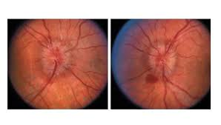Causes:
1- Space occupying lesions,( e.g. intracranial tumor).
2- Blockage of the ventricular system
3- Obstruction of CSF absorption,(e.g. damage to the arachoid villi post meningitis).
4- Benign intra-cranial hypertension.
5- Diffuse cerebral edema, (e.g. head trauma).
6- Malignant hypertension

Clinical features:

1. Early papilloedema;
Visual acuity normal
Mild optic disc swelling
Hyperemic disc with Indistinct margins

2.Established papilloedema;
Transient visual obstruction lasting few seconds
Severe hyperemic disc swelling with flame shaped hemorrhage
Blurring of optic disc margins
Engorged retinal veins with Hard exudates and cotton wool spots

3.Atrophic papilloedema;
Visual acuity impaired
Secondary optic disc atrophy Pale disc, slightly elevated, indistinct margins.

Optic Disc Atrophy
Permanent damage to the neural tissue of the optic nerve

Primary optic atrophy; is caused by lesions affecting the visual pathways from behind the optic nerve head to the lateral geniculate body.
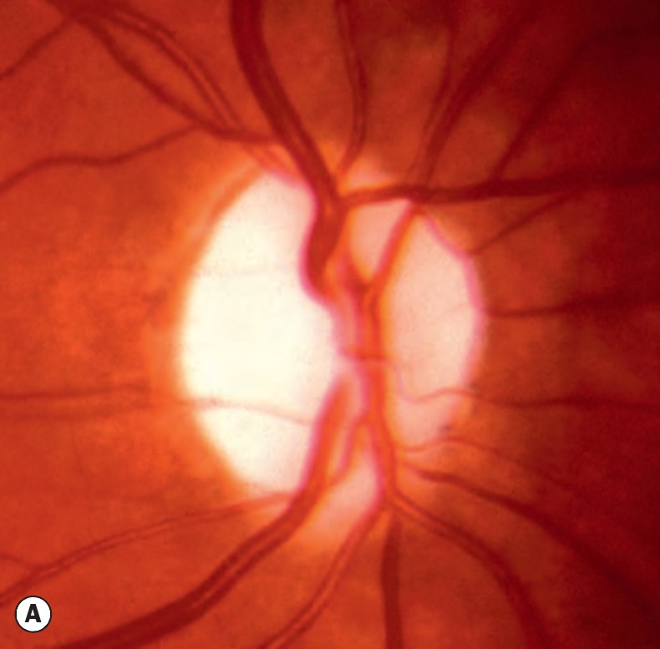
Causes:
Hereditary optic neuropathy
Compressive lesions on the optic nerve
Post retro-bulbar optic neuritis

Clinical appearance:
Pale, white and flat disc
Clear delineated margins
Attenuated blood vessels

Secondary optic atrophy; secondary to optic nerve head disease.

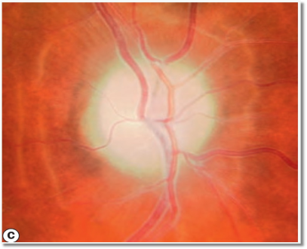

Causes:
Papillitis
Papilloedema
Anterior ischemic optic neuropathy

Clinical appearance:
Pale, grey and slightly elevated disc
Poorly delineated margins
Attenuated blood vessels

Anterior ischemic optic neuropathy

Infarction of the optic nerve head caused by occlusion of the short posterior ciliary arteries

Two types :
Arteritic : associated with Giant cell arteritis
Non- Arteritic : idiopathic, usually occurs in hypertensive patients between 40-60 years old.
Sudden monocular visual loss
Disc appears, pale and edematous

Pupil

Pupil: the central aperture in the iris.
Pupillary constriction (Miosis) is achieved by sphincter pupillae muscle.
Pupillary dilatation ( Mydriasis) is achieved by dilator pupillae muscle.

Pupillary Reaction
A- Constriction of the pupil Induced by Para-sympathetic innervations to the sphincter pupillae muscle of the iris

Light reflex; Constriction of the pupil when light is projected toward the eye. Direct Light reflex; Constriction of the ipsilateral pupil
Consensual Light reflex; Constriction of the contra-lateral pupil (due to crossing of fibers at the optic chiasm, and mid-brain)

Light reflex;
Consists of 4 neurones:
1- from the retina to the pre-tectal nucleus in the mid-brain
2- from pre-tectal nucleus to Edinger-Westphal nucleus
3- from Edinger-Westphal nucleus to the ciliary ganglion with III n.
4- from ciliary ganglion to sphincter pupillae and ciliary muscles with ciliary n.

Near reflex; constriction of the pupil on looking to a near object
Consist of :
1- Increased Accommodation
2- Constriction of the pupil (Miosis)
3- Convergence of the visual axis

B- Dilatation of the pupil
Induced by sympathetic innervations to the dilator muscle of the iris

Consists of 3 neurones :
1- Starts from hypothalamus to ciliospinal center of Budge between C8 and T2
2- from ciliospinal center of Budge to the superior cervical ganglion in the neck 3- from the superior cervical ganglion pass along the internal carotid artery then through the nasociliary nerve and long ciliary nerve to the dilator muscle of the iris
Abnormalities of Pupil
Amaurotic pupil; is caused by complete optic nerve damage.

Characterized by:
The involved eye is completely blind
Both pupils are equal in size
When the affected eye is stimulated neither pupil reacts, but When the normal eye is stimulated both pupils react.

Marcus Gunn pupil (Relative afferent pupillary conductive defects, RAPD) Caused by incomplete optic nerve lesion or severe retinal disease.

Characterized by:
Both pupils are equal in size
When the affected eye is stimulated both pupils react.
Swinging light test; in which each pupil is stimulated in rapid succession by a flash light. When the affected eye is stimulated the pupil dilates instead of constriction.
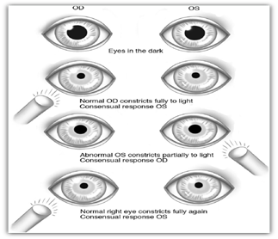

Argyll Robertson pupil Caused by neuro-syphilis
Involvement is usually bilateral but asymmetrical , the Pupil is small and irregular The light reflex is absent, but near reflex is normal (light-near dissociation).

Adie pupil : Caused by denervation of the post ciliary ganglionic nerve supply to the eye (sphincter pupillae and ciliary muscles), which may follow viral infection.
Unilateral 80%
It typically affect young adult.
Affected pupil is large and regular
Light reflex is absent or very slow
Accommodation is slow ( tonic )
Diagnosis is confirmed with Pilocarpine 0.125%

Horner Syndrome effect the sympathetic nerve supply to the eye (dilator pupillae muscle, and Muller muscle of the lid).

Causes:
Central; Brain stem, spinal cord diseases (tumor, vascular, demyelination) Preganglionic; Pancoast tumor
Post ganglionic; Internal carotid aneurysm.

Clinical feature
Mild ptosis
Miosis + Anhidrosis
Normal papillary reaction to light and near

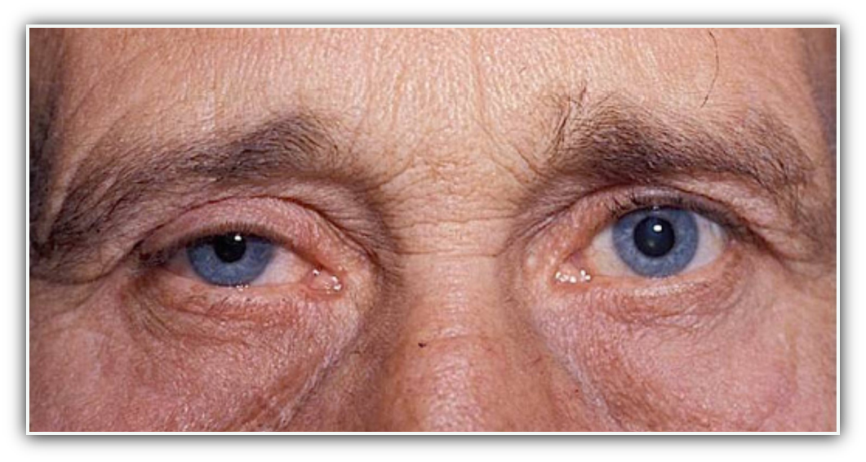

Disorders of the Chiasma

Pituitary adenoma, Craniopharyingioma, Meningioma
Visual field defects; Bitemporal hemianopia
Optic atrophy 50% of cases
General clinical features
Sings and symptoms of raised intracranial pressure (headache, vomiting, papilloedema)
Pituitary gland dysfunctions; hypopituitarism, acromegaly, Cushing disease

Disorders of Retro-Chiasma Visual pathways and Visual Cortex
Tumors, Vascular
Visual field defects; contralateral Homonymous hemianopia

