Organic Chemistry
Functional Group Identification
Many organic compounds contain an atom or group of atoms that substitute for hydrogen or carbon in a basic hydrocarbon. The atom or group of atoms is commonly referred to as functional group. Each imparts characteristic chemical properties to the substituted hydrocarbon.
The aim of this experiment is to study the chemical properties of several functional groups: Alcohols, phenols, aldehydes, ketones and carboxylic acids.

I.Alcohols:
They are hydrocarbons in which an -OH replaces a hydrogen atom.
Alcohols are classified as primary (ethanol), secondary.(Isopropanol) and tertiary (tertiary butanol).

- Lucas test: (68g ZnCl₂ in 42ml of conc. HCl).
Is employed to differentiate between the three classes of alcohols.
ZnCl₂
R-OH + HCl R-Cl +H₂O

Since the alkyl halide that is formed is soluble in water, the solution will become cloudy and may separate into two layers when the hydroxyl is replaced by halogen. Primary, secondary and tertiary alcohols differ in speed of this reaction.

Procedure:
- In 3 test tubes place 0.5 ml. of propanol (primary alcohol), 0.5 ml of isopropanol (secondary alcohol) and 0.5 ml. of butyl alcohol (tertiary alcohol) in each tube.
- Add 1 ml. of Lucas reagent to each test tube, close the tubes, shake and allow to stand.
- Observe the mixture during 5 minutes. The following result may be obtained.

- Primary alcohol, lower than 6 carbon atoms, dissolve, there may be some darkening but the solution remains clear. Primary alcohols with 6 or more carbon atoms do not dissolve appreciably, the aqueous phase remains clear.
- Secondary alcohol, the clear solution becomes cloudy owing to the separation of finely-divided drops of the chloride.
- Tertiary alcohol: two phases separate almost immediately owing to the formation of the tertiary chloride.

- Oxidation:
All alcohols (except tertiary alcohols) are oxidized by potassium permanganate (KMno4) and potassium dichromate (K₂Cr₂O₇) to give aldehydes or ketones.

Procedure:
- Oxidation by KMnO₄
- Place 0.5 ml. of Propanol, isopropanol and butyl alcohol in 3 separate test tubes.
- Add 1.5 ml. of 2% KMnO₄ to each tube and heat and notice.
- In case of primary alcohol a brown precipitate will be formed. Primary alcohol will be oxidized to aldehyde then further into carboxylic acid.
- Secondary alcohol will be oxidized to ketone and a brown precipitate will be formed (MnO2).
- No reaction with the tertiary alcohol.

- Oxidation by K₂Cr₂O₇ (2-3 g of K₂Cr₂O₇ is dissolve in few mls of water then complete the volume to 500 ml. with conc. H₂S0₄ with cooling.
- Place 0.5 ml. of propanol, isopropanol and butyl alcohol.
H₂SO₄
RCH₂OH + K₂Cr₂O₇ RCHO + CrO₃ + K₂S0₄

- Add 1.5 ml. of K₂Cr₂0₇ solution, notice that:
- Primary alcohol: a green precipitate will be formed.
- Secondary alcohol: a green precipitate will be formed.
- Tertiary alcohol: No reaction.

II. Phenols:
Are aromatic hydrocarbons consist of a benzene ring attached to OH-group. They are more reactive than alkanes but less reactive than alkenes and alkynes..They are soluble in 5% sodium hydroxide, but insoluble in 3% NaHCO3.They react with a solution of bromine in carbon tetrachloride by substitution and-an equivalent quantity of hydrogen bromide is evolve.They yield intense coloration (blue, green, red, or purple) when treated with a solution of ferric-chloride.

- Bromine test: (2 m1 of bromine solution in l00 ml.of CCl₄).
- To small. quantity of phenol add 2 ml. of CCl₄ then add drop
by drop Br₂/CCl₄ solution.
- A positive test in indicated when 1- 4 drops disappear.
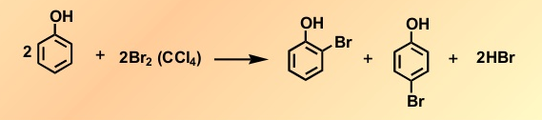

- Ferric chloride test:
- To small quantity of phenol add 2,ml. ethanol then one drop of FeCl₃.
- Complex coloration will be formed according to the type of phenol used.

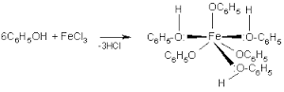

III. Carboxviic acid:
Organic acids are prepard by the oxidation of primary alcohols or aldehydes with strong oxidizing agent eg. KMnO₄. Carboxylic acids are soluble in 5% sodium hydroxide and 5% of NaHCO₃ (The latter reaction is accompanied by the evolution of Co₂).
Carboxylic acids are non-reactive towards a solution of bromine in CCl₄. They give positive test with FeCl₃ solution.
.

1. Bromine test:
- To small quantity of carboxylic acid add 2 ml. of CCl₄ then add Br₂/CCL₄ dropwise until the bromine color persists for 1 minute.
- This means a negative test.

- Ferric chloride test:
- To small quantity of carboxylic acid add 2 ml. ethanol then one drop of FeCl₃.
- Observe the color change.
IV. Aldehydes and Ketones:
Both aldehydes and Ketones contain the carbonyl group, hence a general test for carbonyl compounds will immediately characterize both classes of compounds. The preferred reagent is 2,4-dinitro phenyl hydrazine which give insoluble phenyl hydrazone with carbonyl copounds.

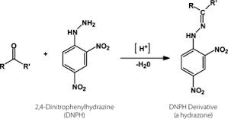

Test for carbonyl group:
- To 1 drop of the sample, add 1 ml. of 2,4-dinitrophenyl hydrazine, wait for 10 minutes.
- Orange precipitate will be formed.

Reagent: (2,4 dinitrophenyl hydrazine)
Dissolve 0.25 g of 2,4-dinitrophenyl hydrazine in 42 ml. of conc. HCl and 50 ml. of water, heat in water bath and complete the volume to 250 ml.
Aldehydes can be oxidized to carboxylic acids using oxidizing agents such as Tolleni's and Fehling’s reagents.

Tollen's reagent: (freshly prepared)
- Few drops AgNO₃ (10%) is added to one drop of 10% NaOH. a brown precipitate will be formed (Ag₂O).
- Then add drop by drop dilute NH₄OH (30% V/V) till all Ag₂O get dissolved.

Procedure:
- Add 2 drops of aldehyde sample to Tollen‘s reagent.
- Warm in‘hot Water bath for about 1 min.
- A silver mirror is deposited on the walls of the tube.
CH3CHO + 2[Ag(NH₃)₂]OH CH₃CO₂H + 2Ag + 4NH₃ + H₂0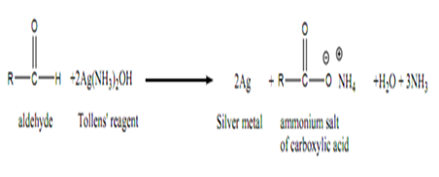

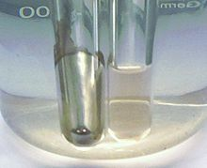

Fehling 's test: (Freshly prepared)
- Dissolve 34.64g of CuSO4 in water containing few drops of H₂SO₄, complete the volume to 500 ml. with D.W( Disstilled water ).
- Dissolve 6og of NaOH and I73g of sodium potassium tartartate in water, filter if necessary (volume 500 ml), mix exactly equal volumes of(1) and (2) immediately before use

Procedure:
- Place 2 ml. of freshly prepared Fehling's solution in a test tube.
- Add 2-3 drops of aldehyde sample and boil for 3-4 minutes.
- A bright red precipitate of Cu₂O is formed.
CH3CHO+ 2CuO CH₃CO₂H + Cu₂O

Iodoform Test:
The formation of iodoform is an example of the haloform reaction , which is characteristic of methyl ketones , CH₃- CO-R , and of secondary alcohols of the type , CH₃-CHOH-R. Only one aldehyde ( CH₃CHO ) and only one primary alcohol ( CH₃CH₂OH ) give a positive haloform test .The reaction involves formation of a trihalomethyl carbonyl compound., X₃C- CO-R , which is cleaved by sodium hydroxide to form X₃C- H and R-CO₂Na . A few methyl ketones fail to give a positive reaction.

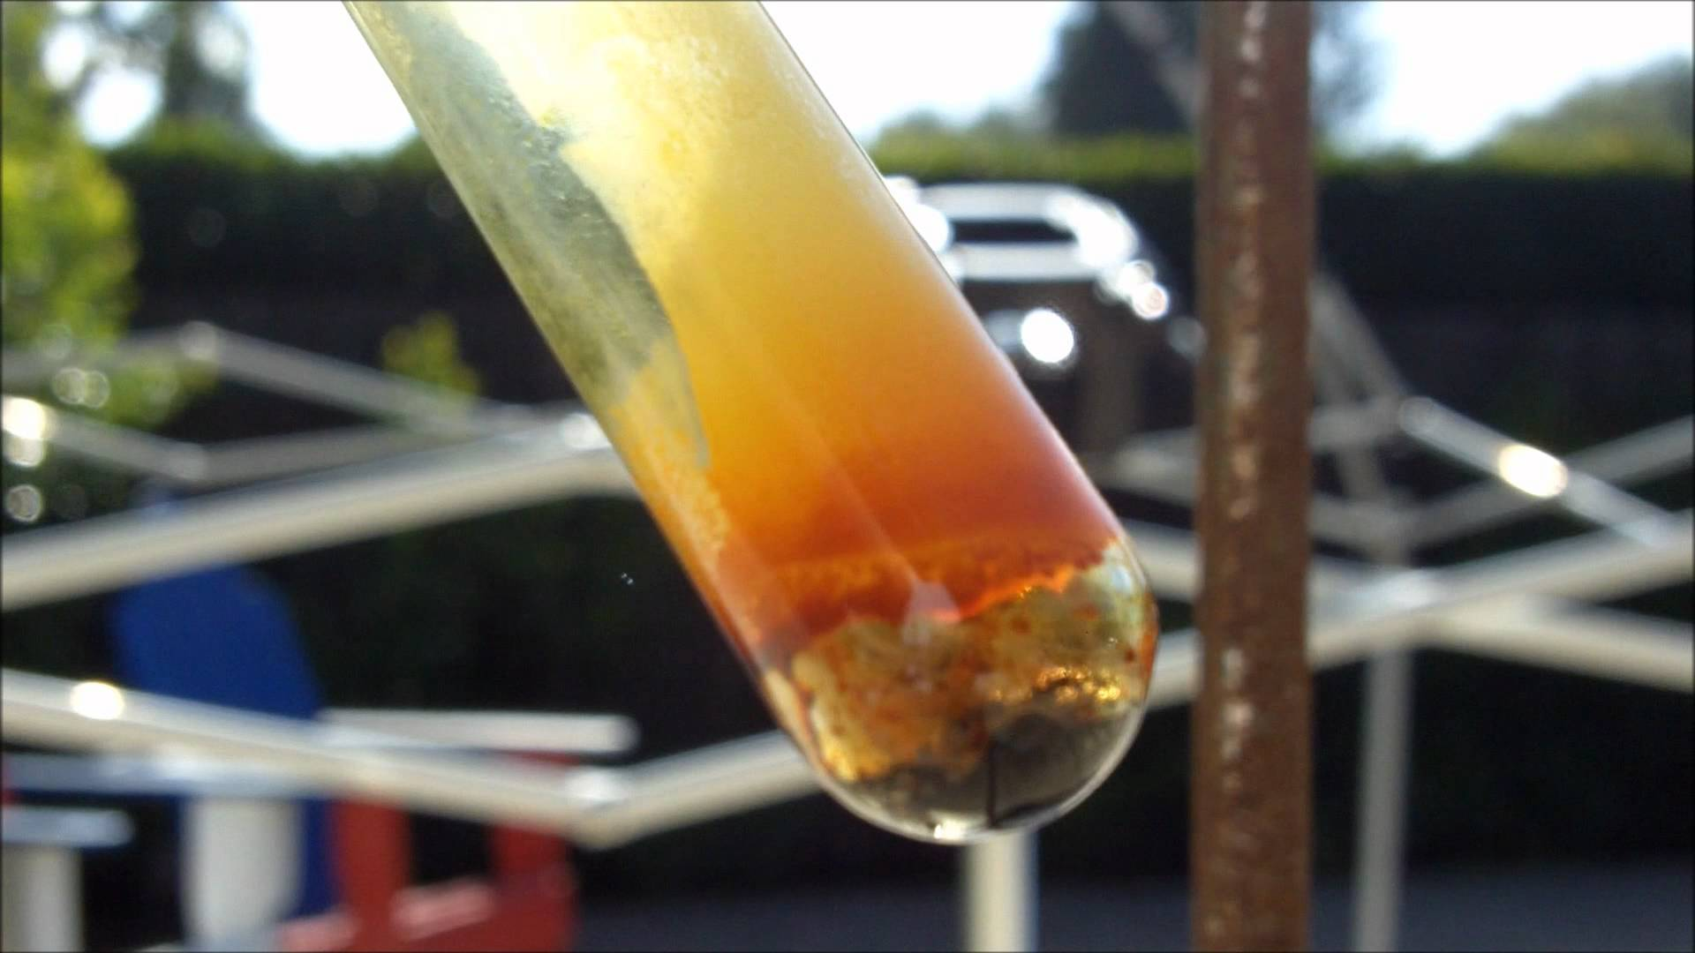
In a small Erlenmeyer flask (or large test tube) dissolve 0.5 ml . (0.4 gm ) of the compound in 5 ml. of water and add 5 ml. of 10 % sodium hydroxide solution . Add dropwise with shaking , a 10 % solution of iodine in potassium iodide until a definite brown color persists ( indicating an excess of iodine ) . If a precipitate of iodoform does not appear after five minutes , warm the solution to 60° in a water bath . If the brown color is discharged add more of the iodine solution until the brown color persists for two minutes. Add a few drops of sodium hydroxide solution to remove the excess iodine , dilute the mixture with water , and allow it to stand for ten minutes. . Iodoform precipitates in yellow hexagonal crystals having a characteristic odor . It is prudent to confirm the identity of the crystals by collecting them with suction , drying and taking the melting point( 119 º)
Perform the test with acetone and with n-butyraldehyde . For compounds that are not appreciably soluble in water , the sample may be dissolved in dioxane or pure methanol instead. of water , before adding the sodium hydroxide and iodine solutions. Before using a solvent it should be tested to see if iodoform - producing impurities are present.

