Color tests for Proteins and Amino Acids
Proteins are polymers or macromolecules, the building units or monomers of which are the alpha Amino acids. An Amino acid contains both a carboxyl group and an amino group, both of which are attached to the alpha carbon atom of the acid .

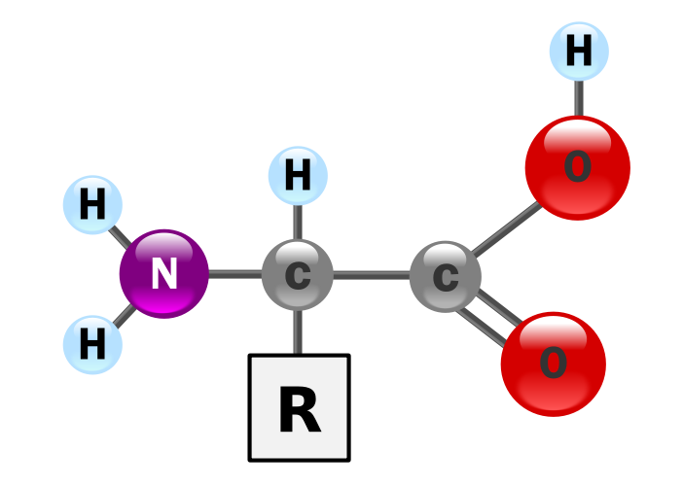

Beta –amino acids and gamma-amino acids occur in nature but not as components of proteins. With the exception of glycine, all α- amino acids are asymmetric , ie, four different groups are bonded to α-carbon atom , so are optically active. Also an α-amino acid can be L-isomer or D-isomer. In natural proteins of higher organisms, only the L-isomer of one or more of approximately 20 amino acids are present.

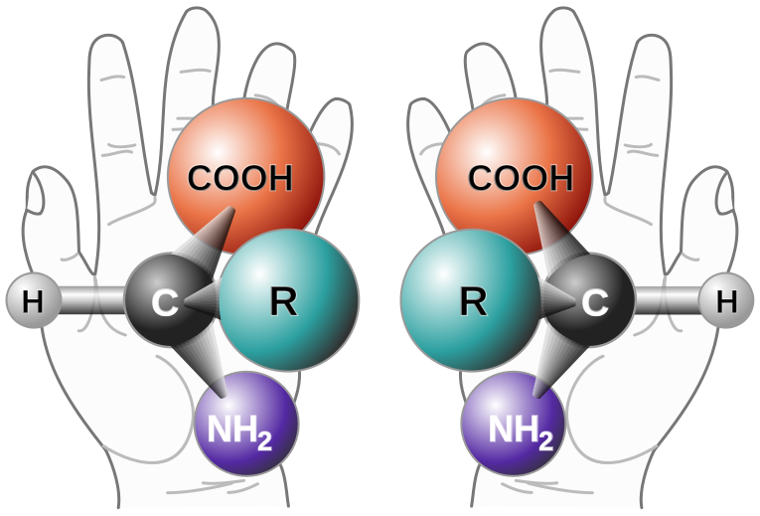

When an amino group and a carboxyl group of two amino acids combine the bond is called the peptide bond causing the release of a molecule of water (H₂O), hence the process is a dehydration synthesis reaction (also known as a condensation reaction) and constituent amino acids are termed amino acid residues.

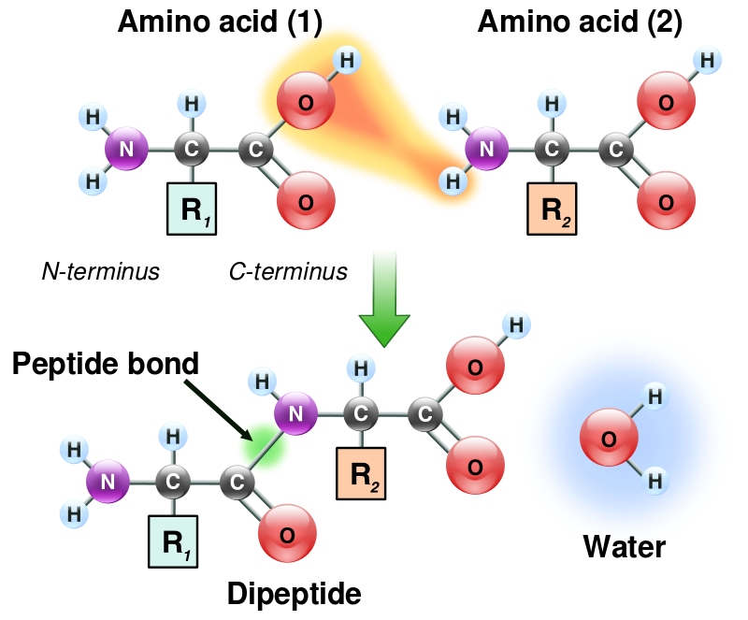

A peptide consists of two or more amino acid residues linked by peptide bonds. Peptides of more than ten amino acid residues are termed polypeptides. With the increase in molecular weight the proteins will form. Peptides are distinguished from proteins on the basis of size, and as an arbitrary benchmark can be understood to contain approximately 50 or fewer amino acids. Proteins consist of one or more polypeptides arranged in a biologically functional way.
Proteins and amino acids can be analysed qualitatively and quantitatively. Different proteins and amino acids may be separated by chromatography or electrophoresis before individual testing.

Principles of the color test:

- Biuret test:
The biuret test is a chemical test used for detecting the presence of peptide bonds. In the presence of peptides, a copper(II) ion forms purple(pink to violet) colored coordination complexe in an alkaline solution. When peptide bonds are present in this alkaline solution, the Cu²⁺ions will form a coordination complex with 4 nitrogen atoms from peptide bonds.At least two peptide bonds (tri-peptide) are required for a positive test.
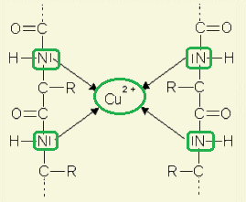
This color change is dependent on the number of peptide bonds in the solution, so the more protein, the more intense the change.

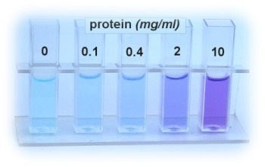

Despite its name, the reagent does not in fact contain biuret (H₂N-CO-)₂ NH). The test is so named because it also gives a positive reaction to the peptide-like bonds in the biuret molecule.

2 CO(NH₂)₂ → H₂N-CO-NH-CO-NH₂ + NH₃

2-Ninhydrin test:
Ninhydrin is a powerful oxidizing agent which causes oxidative decarboxylation of alpha-amino acids.Ninhydrin degrades amino acids into aldehydes, ammonia, and CO₂ through a series of reactions; the net result is ninhydrin in a partially reduced form hydrindantin:
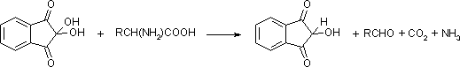
Ninhydrin then condenses with ammonia and hydrindantin to produce an intensely blue or purple pigment, sometimes called Ruhemann's purple:
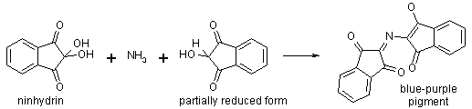
The color varies slightly from acid to acid, probably because unreacted acids complex with the pigment.The reaction depends on presence of free amino group ,so proline and hydroxyproline which lack a free amino group give a yellow color with ninhydrin. Peptides and proteins owing to their free terminal amino groups yield a positive test .

3- Xanthoproteic acid test:

This test is carried out by adding concentrated nitric acid and then heating the mixture. If proteins are present that contains amino acids with aromatic rings, the mixture turns yellow. These color changes are caused by nitrated aromatic rings in the protein. The xanthoproteic test is specific for aromatic amino acids such as tyrosine, tryptophan and phenyalanine. Upon adding a strong base such as liquid ammonia, the color turns orange.

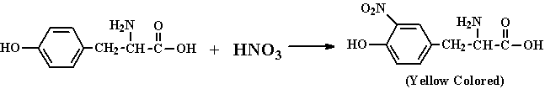

4-Hopkins-cole test:
also known as the glyoxylic acid reaction, is a chemical test used for detecting the presence of tryptophane in proteins. A protein solution is mixed with Hopkins Cole reagent, which consists of glyoxylic acid. Concentrated sulfuric acid is slowly added to form two layers. A purple ring appears between the two layers if the test is positive for tryptophan. Tryptophane due to its indole ring condenses with the aldehyde glyoxylic acid (OCH-CO₂H) in presence of concentrated H₂SO₄ to produce a purple ring.
5-Sakaguchi test:
Sakaguchi test is specific for arginine,used for detecting the presence of arginine in proteins ,which is the only amino acid containing the quinidine group, Sakaguchi reagent consists of alpha-Naphthol and a drop of sodium hypobromite. The guanidine group in arginine reacts with Sakaguchi reagent to form a red-coloured complex.

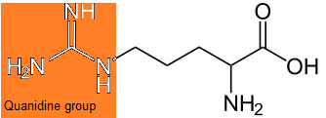

Arginine amino acid

Procedures:

1-Biuret test:
Samples; Albumin , Gelatin , Alanine.
Mix 1 ml. of each sample with 1 ml. of 10% NaOH and 0.5 ml. of 1% CuSO₄. Observe the color produced.

2-Ninhydrine test:
Samples: Albumin , Gelatin , Tryptophane , Proline
- Mix 1 ml. of each sample with 1 ml. of 0.1% aqueous ninhydrin.
- Heat the tubes in boiling water for 3-4 minutes and observe the color after standing for few minutes.

3- Xanthoproteic acid test:
Samples; Albumin , Gelatin , Tryptophane.
- Mix 1 ml. of each sample with 1 ml. with concentrated HNO₃.
- Heat for 1-2 minutes in boiling water bath, observe any change in color.

4-Hopkins-Cole test:
Samples; Albumin , Gelatin , Tryptophane , alanine.
- Mix 1 ml. of each sample with 1 ml. of Hopkins-Cole reagent mix thoroughly.
- Carefully add 1 ml. of concentrated H₂SO₄ along the side of the tube so that the two liquids form separate layers.
- Notice the ring at the junction.

5- sakaguchi test:
Samples; Arginine , Alanine , Albumin , Gelatin.
- Mix 2 ml. of each sample with 0.5 ml. of 10% NaOH and 0.5 ml. of α-naphthol solution.
- After 3 minutes add 2-4 drops of NaOBr and observe the color change.

Materials and reagents:

- 1% solutions of Alanine , Arginin , Tryptophane , Albumin , Gelatin.
- Sakaguchi reagent; 10% NaOH , 0.02% α-naphthol. Sodium hypobromite (2 gm Br₂ in 100 ml. of 5% NaOH)
- Hopkins-Cole reagent; 10 gm of powdered magnesium are covered with shaking by some distilled water. 250 ml of saturated oxalic acid are added slowly with cooling under tap water. Filterate to remove the insoluble magnesium oxalate. Acidify the filterate with acetic acid to prevent partial precipitation of the magnesium on long standing and make up to a liter with distilled water. This solution contains only the magnesium salt of glyoxylic acid.

