**Dentistry College Medical Physics**

**Electricity Within The Body**

Physical phenomena involving electricity and magnetism have been observed since ancient times. Electricity plays an important role in medicine. There are two aspects of electricity and magnetism in medicine: -

1. Electrical and magnetic effects generated inside the body.

2- Applications of electricity and magnetism to the surface of the body.

The electricity generated inside the body serves for the control and operation of nerves, muscles, and organs.

The nervous system plays a fundamental role in nearly every body function. Basically, a central computer (the brain) receives internal and external signals and (usually) makes the proper response.

**The nervous system and the neuron**

*The nervous system can be divided into two parts: -*

1-The central nervous system.

2-The autonomic nervous system.

The central nervous system consists of the brain, the spinal cord, and the peripheral nerves-nerve fibers (neurons) that transmit sensory information to the brain or spinal cord (*afferent nerves*) and nerve fibers (neurons) that transmit information from the brain or spinal cord to the appropriate muscles and glands (*efferent nerves*).

The autonomic nervous system controls varies internal organs such as the heart, intestines, and glands. The control of the autonomic nervous system is essentially involuntary.

|  |  |
| --- | --- |
| The basic structural unit of the nervous system is the neuron; a nerve cell specialized for reception, interpretation, and transmission of electrical massages. There are many types of neurons. Basically, a neuron consists of a cell body that receives electrical messages from other neurons through contacts called synapses located on the dendrites or on the cell body. |  |

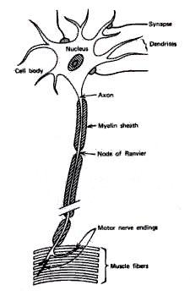

The dendrites are the parts of the neuron specialized for receiving information from stimuli or from other cells. If the stimulus is strong enough, the neuron transmits an electrical signal outward along a fiber called an axon. The axon, or nerve fiber, which may be as long as 1m, carries the electrical signal to muscles, glands, or other neurons.

**Electrical potentials of nerves**

Across the surface or membrane of every neuron is an electrical potential (voltage) difference due to the presence of more negative ions on the inside of the membrane than on the outside. The neuron is said to be polarized. The inside of the cell is typically 60 to 90 mV more negative than the outside. This potential difference is called the resting potential of the neuron. When the neuron is stimulated, a large momentary change in the resting potential occurs at the point of stimulation. This potential change, called the action potential, propagates along the axon. The action potential is the major method of transmission of signals within the body.

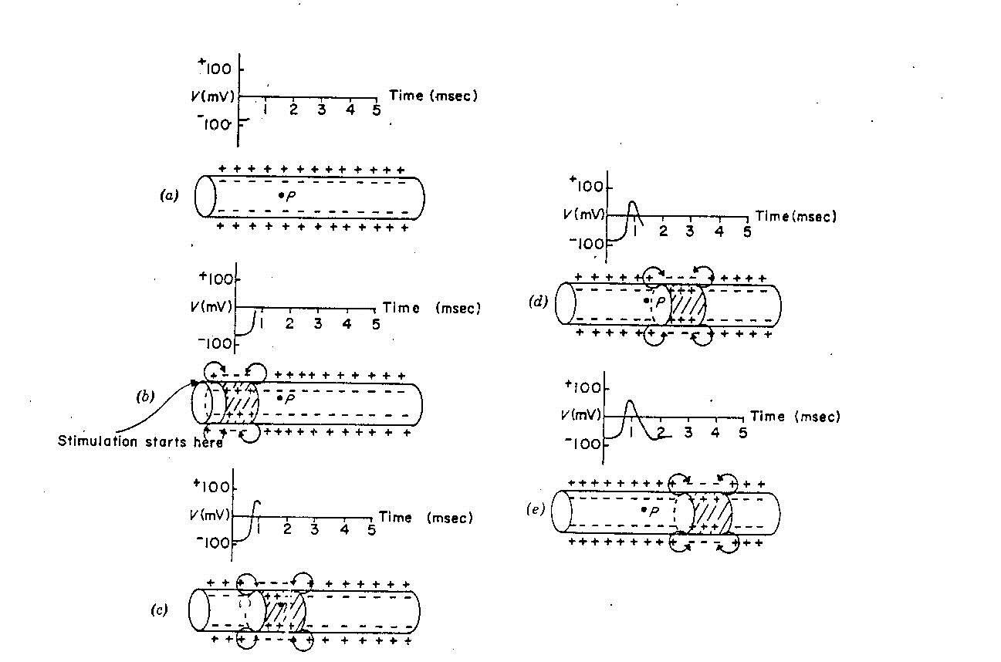

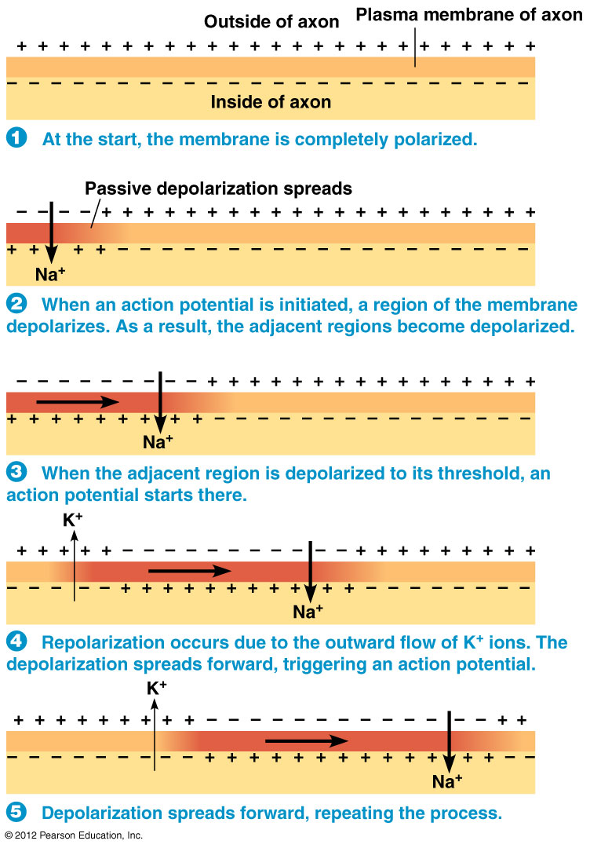

An axon can transmit in either direction. However, the synapse that connects it to another neuron only permits the action potential to move along the axon away from its own cell body.Examination of the axons of various neurons with an electron microscope indicates that there are two different types of nerve fibers: -

1-The membranes of some axons are covered with a fatty insulating layer called myelin that has small uninsulated gaps called nodes of Ranvier every few millimeters; these nerves are referred to as myelinated nerves.

2-The axons of other nerves have no myelin sleeve (sheath), and these nerves are called unmyelinated nerves.

Myelinated axons conduct differently than the unmyelinated axon. The myelin sleeve is a very good insulator, and the myelinated segment of an axon has very low electrical capacitance. The action potential decreases in amplitude as it travels through the myelinated segment just as an electrical signal is attenuated when it passes through a length of cable. The reduced signal then acts like a stimulus at the next node of Ranvier (gap) to restore the action potential to its original size and shape. This process repeats along the axon; the action potential seems to jump from one node to the next, that is, it travels by *saltatory conduction*.

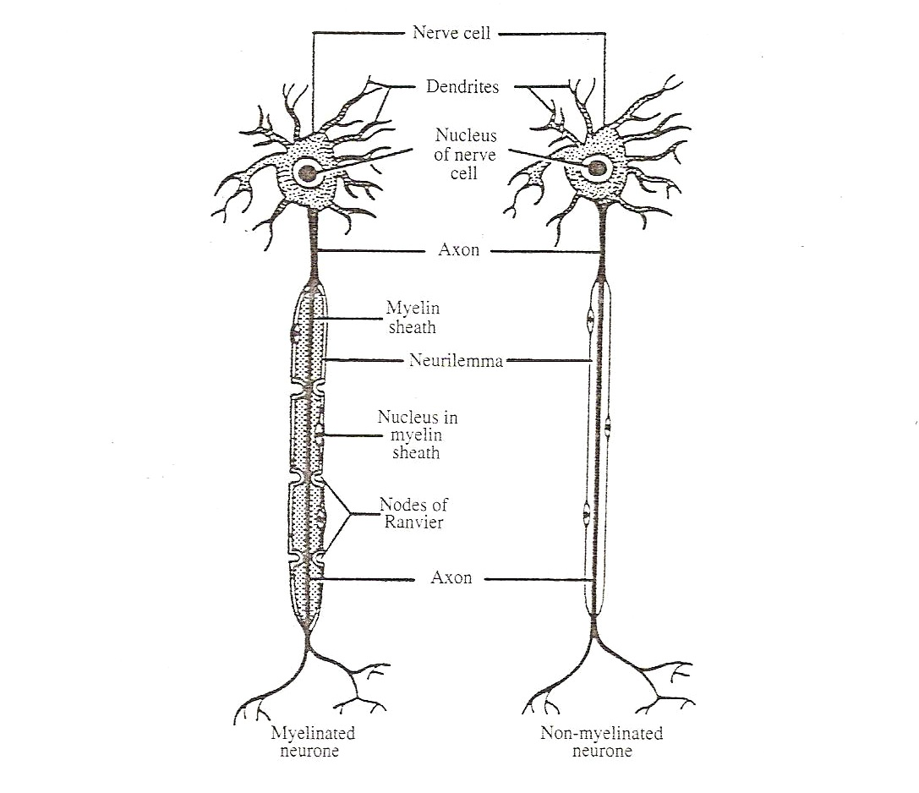

***Two primary factors affect the speed of propagation of the action potential: -***

1. The resistance within the core of the membrane.
2. The capacitance (or the charge stored) across the membrane.

A decrease in either will increase the propagation velocity. The internal resistance of an axon decreases as the diameter increases, so an axon with a large diameter will have a higher velocity of propagation than an axon with a small diameter. The greater the stored charge on a membrane, the longer it takes to depolarize it, and thus the slower the propagation speed. Because of the low capacitance, the charge stored in a myelinated section of a nerve fiber is very small compared to that on an unmyelinated fiber of the same diameter and length. Hence the conduction speed in the myelinated fiber is many times faster.

**Electrical signals from muscles**

The record of the potentials from muscles during movement is called the **electromyogram**, or **EMG**.

A muscle is made up of many motor units. A motor unit consists of a single branching neuron from the brain stem or spinal cord and the 25 to 2000 muscle fibers (cells) it connects to via motor end plates. The resting potential across the membrane of a muscle fiber is similar to the resting potential across a nerve fiber. Muscle action is initiated by an action potential that travels along an axon and is transmitted across the motor end plates into the muscle fibers, causing them to contract.

Single muscle cells are usually not monitored in an EMG examination because it is difficult to isolate a single fiber. Instead, EMG electrodes usually record the electrical activity from several fibers.

1. Either a surface electrode attached to the skin measures the electrical signals from many motor units.

2. Or a concentric needle electrode inserted under the skin measures single motor unit activity by means of insulated wires connected to its point.

|  |  |
| --- | --- |
| C:\Users\Win\Desktop\physics\Picture 009.jpg |  |

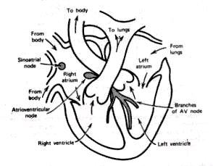The action potential appears in the EMG after a **latency period** (the time between stimulation and the beginning of the response). Sometimes the EMGs from symmetrical muscles of the body are compared to each other or to those of normal individuals to determine whether the action potentials and latency periods are similar.

**Electrical signals from the heart**

|  |  |
| --- | --- |
| The rhythmical action of the heart is controlled by an electrical signal initiated by spontaneous stimulation of special muscle cells located in the right atrium. These cells make up the *sinoatrial (SA) node, or the pacemaker.* |  |

The SA node fires at regular intervals about 72 times per minute. The electrical signal from the SA node initiates the depolarization of the nerves and muscles of atria, causing the atria to contract and pump blood into the ventricles. Repolarization of the atria follows. The electrical signals then passes into the atrioventricular (AV) node, which initiates the depolarization of the right and left ventricles, causing them to contract and force blood into the pulmonary and general circulations. The ventricle nerves and muscles then repolarize and the sequence begins again.

Obviously it is not practical to make direct electrical measurements on the heart; diagnostic information is obtained by measuring at various places on the surface of the body the electrical potentials generated by the heart. The record of the heart's potentials on the skin is called the electrocardiogram or ECG.

*The major electrical events of the normal heart cycle are: -*

|  |  |
| --- | --- |
| 1. The atrial depolarization, which produces the P wave.  2. The atrial repolarization, which is rarely seen and is unlabeled.  3. The ventricular depolarization, which produces the QRS complex.  4. The ventricular repolarization, which produces the T wave. | 15 |

**Patient monitoring**

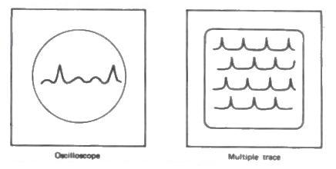The convenient approach is to use the **ECG** oscilloscope to continually monitor a patient. It shows one to two cycles of the **ECG**, which is enough for a doctor or nurse to assess the patient's condition. Modern monitors use a microcomputer to store the **ECG** information and use it to continually refresh the trace. The trace slowly moves across the screen. In many **intensive care units** (**ICUs**) several patients are monitored by the use of multiple traces on a single large oscilloscope. Several times a day, a short section is taken on a pen recorder and placed in each patient's medical record.

It is very difficult to maintain vigilance while watching ECG tracings on a scope. In order to free the nurse from this monotonous task and allow her or him to perform other tasks, automatic alarm devices (cardiotachometer) have been developed. Electronic devices measure the time between successive R waves. The inverse of this R-R interval is the heart rate, and this rate is indicated on a meter.

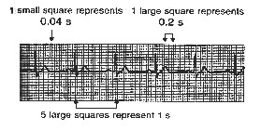**The heart rate (beats/min) = 1/(R-R interval in min)**

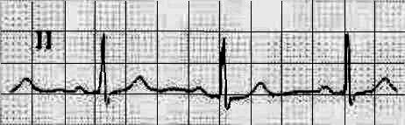**\* Calculate the heart rate from this ECG: -**



**Defibrillators**

The reason for continuously monitoring the **ECG** is that should problems arise; prompt therapeutic action can be taken to save the patient's life. Many heart attack patients undergo sudden changes in rhythm. The orderly heart muscle contractions associated with normal heart pumping change to the uncoordinated twitching of ventricular fibrillation, which halts the heart pumping action. Death follows within minutes unless the heart can be defibrillated.

**Defibrillation** is accomplished as shown in the figure below. The line voltage is stepped up to several thousand volts by a transformer. A diode rectifies the alternating current into direct current to charge up the capacitor. When the switch is thrown, the capacitor discharges through the paddles and the heart.

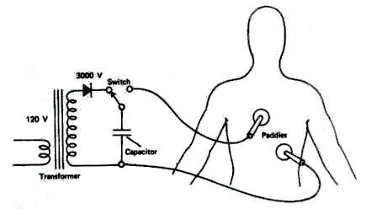

The paddles are metal electrodes **7.5cm** in diameter that are coated with conductive paste and placed **above** and **below** the heart. The paddle handles are made of plastic and are electrically insulated to prevent accidental shock to the operator.

When the switch is thrown, a current of about **20A** flows through the heart for about **5msec**. This current contracts every muscle fiber in the heart at the same time. All the muscle fibers then recover at about the same time, and the heart can initiate normal rhythm again.

**Pacemakers**

The atria of the heart are separated from the ventricles by a **fatty layer** that does not conduct electricity or propagate nerve impulses. At a single location, the **atrioventricular node**, impulses from the atria are conducted to the ventricles, which perform the heart's pumping action. If this node is damaged, the ventricles receive no signals from the atria. However, the ventricles do not stop pumping; there are natural pacing centers in the ventricles that provide a pulse if none has been received from the atria for **2sec**. The resulting heart rate, **30 beats/min**, will sustain life, but the patient may have to live a life of semi-invalidism.

To improve the quality of life for patients with faulty **atrioventricular nodes**, artificial **pacemakers** have been developed. The **pacemaker** contains a pulse generator that puts out **72 pulses/min**. When the **pacemaker** is put in place, the patient is given local anesthetic and a flap of skin just below the right collarbone is lifted. The pacing wire is fed through a slit in

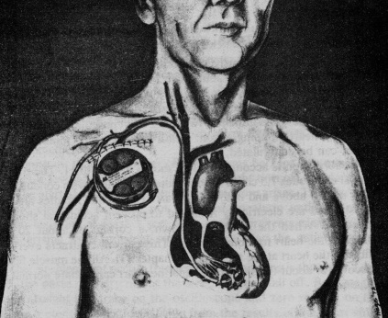

the shoulder vein and advanced under fluoroscopic control until the tip is imbedded in the wall of the right ventricle.

Then the **pacemaker** is placed in the pocket under the skin, and the flap is replaced. The **pacemaker** runs on batteries that last about **2 years**. It is made of materials that are impervious to body fluids and do not cause tissue reaction.

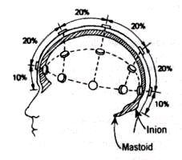**Electrical signals from the brain**

|  |  |
| --- | --- |
| If you place electrodes on the scalp and measure the electrical activity, you will obtain some very weak complex electrical signals. These signals are due primarily to the electrical activity of the neurons in the cortex of the brain. |  |

The recording of the signals from the brain is called the **electroencephalogram** or **EEG**. Electrodes for recording the signals are attached to the head at locations that depend upon the part of the brain to be studied. The reference electrode is usually attached to the ear (A1 or A2).

Since asymmetrical activity is often an indication of brain disease, the right side signals are often compared to the left side signals.

The amplitude of the EEG signals is low (about 50μV), and interference from external electrical signals often causes serious problems in EEG signal processing. Even if the external noise is controlled, the potentials of muscle activity such as eye movement can cause artifacts in the record.

The frequencies of the EEG signals seem to be dependent upon the mental activity of the subject.

For Example: -

1. A relaxed person usually has an EEG signal composed primarily of frequencies from 8 to 13 Hz, or alpha waves (α).
2. When a person is more alert a higher frequency range, the beta wave (β) or fast range (above 13Hz).
3. Delta (δ) or slow (0.5 to 3.5 Hz).
4. Theta (θ) or intermediate slow (4 to 7 Hz).

As a person becomes drowsy, particularly with his eyes closed, the frequencies from 8 to 13 Hz (alpha wave) dominate the EEG. The amplitude increases and the frequency decreases as a person moves from light sleep to deeper sleep. Occasionally an EEG taken during sleep shows a high frequency pattern called paradoxical sleep or rapid eye movement (REM) sleep because the eyes move during this period. Paradoxical sleep appears to be associated with dreaming.

Besides recording the spontaneous activity of the brain, we can measure the signals that result when the brain receives external stimuli such as flashing lights or pulses of sound. Signals of this type are called evoked responses. The EEGs show responses to the first few pulses and the last two pulses. The lack of responses in between is called habituation.

**Electrical signals from the eye**

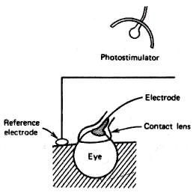The recording of potential changes produced by the eye when the retina is exposed to a flash of light called the **electroretinogram**or **ERG**.

One electrode is located in a contact lens that fits over the cornea and

the other electrode is attached to the ear or forehead to approximate

the potential at the back of the eye

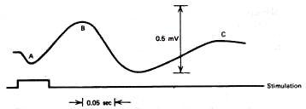The B wave is the most interesting clinically since

it arises in the retina. The B wave is absent in the

ERG of a patient with inflammation of the retina.

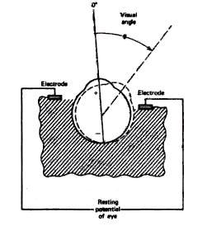

The **electrooculogram**or **EOG** is the recording of

potential changes due to eye movement. For this

measurement, a pair of electrodes is attached near the eye.

Electrooculograms provide information on the orientation of the eye, its angular velocity, and its angular acceleration.

**Magnetic signals from the heart and brain**

Since a flow of electrical charge produces a magnetic field, a magnetic field is produced by the current in the heart during depolarization and repolarization. The recording of the heart's magnetic field is the **magnetocardiogram** or **MCG**. The magnetic field around the heart is about 5x10-11 tesla (T), or about one-millionth of the earth's magnetic field.

To measure fields of this size it is necessary to use magnetically shielded rooms and very sensitive magnetic field detectors (magnetometers). One such detector, called a SQUID (Superconducting Quantum Interference Device).

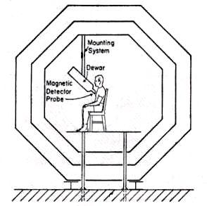

The SQUID magnetometer has also been used to record the magnetic field surrounding the brain. The recording of this field is called the **magnetoencephalogram** or **MEG**. During the alpha rhythm, the magnetic field from the brain is about 1x10-13 tesla (T). This is almost one-billionth of the earth's magnetic field.