Rest and rest seat preparation
Rest: Is a rigid extension of partial denture which rest on; occlusal, incisal and lingual surface of a tooth, and it is a rigid stabilizing extension of P.D which contact remaining tooth or teeth to dissipate vertical or horizontal forces.
Rest seat: It is that portion of the tooth that have been selected and prepared to receive a rest.
The primary purpose of the rest is to provide vertical support for the partial denture.
In doing so, it also does the following:
- Maintained components in their planned positions.
- Maintained established occlusal relation ships by preventing settling or sinking of the denture.
- Prevents impingement of soft tissue.
- Direct and distributes occlusal loads to abutment teeth.
Requirements of a rest:
- It should have sufficient thickness of metal to prevent breakage especially over the marginal ridge.
- It should fit the rest seat accurately with beveled margins, properly contoured, thus preventing food stagnation or impaction.
- It must be at less than right angle to the long axis of the tooth.
- It should be extended to the center of the tooth as possible.
- It may rest in a natural depression on the occlusal surface, or it may occupy a rest seat prepared in the enamel or in an inlay (which is called an in-set occlusal rest) or may rest on a cast crown or may rest on amalgam filling keeping in mined that the amalgam is a brittle material and may fracture or may flow under pressure (creep) so it need an examination during follow up visits.

The thickness of the rest depends on:
- The type of alloy used.
- The heaviness of the occlusion or the bite.
- Whether the rest is opposed by natural or artificial teeth.

Classification of rests:
Rest can be classified as following:
- Based on relation of rest to the direct retainer.
- Based on the location of the rest.
Based on relation of rest to the direct retainer:
- Primary rests: Rest placed along with clasp assembly.(direct retention)
- Secondary or auxiliary rest: Rest placed away from the clasp. (indirect retention)

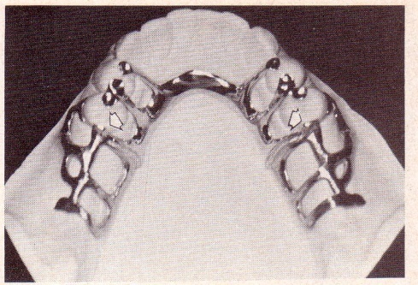
Based on the location of the rest:
- Occlusal rest: Placed on the occlusal surface of the posterior tooth.
- Cingulum or Lingual rest: Placed on the lingual surface of a tooth, especially in maxillary canine.
- Incisal rest: Placed on the incisal edge of a tooth usually in a mandibular canine and incisors.

Occlusal rest and rest seat:
A rigid extension of a partial denture which contact the occlusal surface of the tooth.
Form of the Occlusal rest and rest seat:
- The outline form of the occlusal rest seat should be a rounded triangular shape with the apex toward the center of the occlusal surface.
- The size should be;
- One – half the buccolingual width between the cusp tips.
- One-third to one -half the mesiodistal width of the tooth.
- Deapth 1.5mm reduction from the marginal ridge.
- The floor of the occlusal rest seat should be apical to the marginal ridge and should be spoon with out any sharp edge or line angle in preparation.
- The angle formed by the occlusal rest and the vertical minor connector from which it originated should be less than 90º, only this way can the occlusal forces directed along the long axis of the abutment tooth. An angle greater than 90º forces applied to an inclined plane and end with orthodontic movement of abutment tooth.
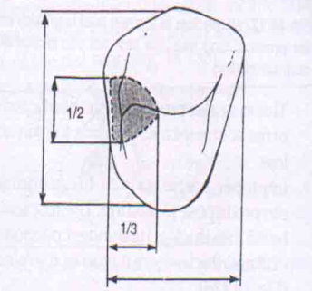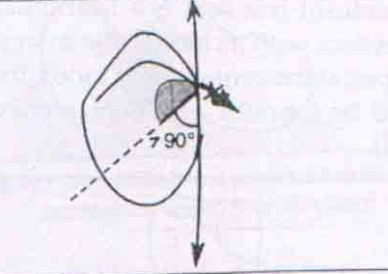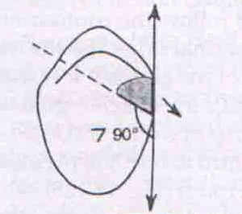

Cingulum or Lingual rest and rest seat:
Indicate the rests that are prepared on the lingual surface or above the cingulum of the anterior teeth and canine.
Characteristics:
- An occlusal rest placed on the mesial fossa of a premolar is better and more preferred than a lingual rest on the anteriors.
- They are usually fabricated on maxillary canines.
- Cannot be prepared on mandibular canines due to in adequate thickness of enamel.
- Canines are more preferable than incisors and when canine is not present, multiple rests spread over several incisors teeth are preferable to use.
- Lingual rests are nearer to the center of rotation of the tooth. Hence, they help to avoid tipping of the tooth.
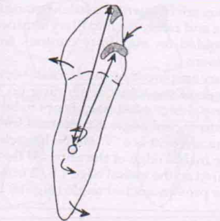
Form of the lingual rest and rest seat:
- The out line is half- moon-shaped, extended as a smooth curve from one marginal ridge to the other.
- The rest seat is V shaped notch.
- 2.5-3mm mesio distal length.
- 1.5mm deep.
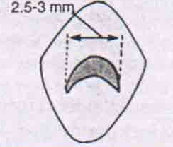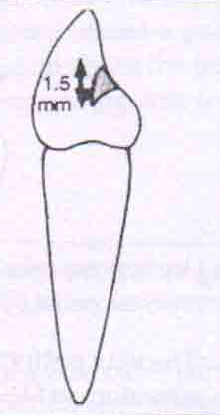
Incisal rest and rest seat:
Characteristics:
- A lingual rest placed on the maxillary anterior teeth is better and more preferred than an Incisal rest placed on the mandibular anterior teeth.
- Prepared on sound mandibular canines.
- If canines are not present, multiple rests spread over several incisors teeth are preferable to use.
- Incisal rests are used as indirect retainers (auxiliary rests).
Disadvantages:
Incisal rests are less desirable than lingual rests, because:
- Esthetically less accepted.
- Tipping movement of the teeth.

Form of the incisal rest and rest seat:
- The rest seat is prepared in the form of a rounded notch located on the incisal edge of anterior teeth.
- 2.5mm the mesiodistal width of the tooth.
- 1.5mm deep.
- The rest seat should extend into the facial surface to act as a locking device.

