Pressure and Blood Pressure
Pressure: Is the force exerted per unit area (F/A).
Standard Units of Pressure: N/m² = Pascal.
Blood Pressure: Is the force exerted by the blood against any unit area of the vessel wall.
The classical method of measuring pressure is to determine the height of a column of liquid that produces a pressure equal to the pressure being measured.
For Example: -
When one says that the pressure in a vessel is 50 mmHg, one means that the force exerted is sufficient to push a column of mercury up to a level of 50 mm high. If the pressure is 100 mmHg, it will push the column of mercury up to 100 millimeters.
Standard Units of Blood Pressure
Blood pressure is almost always measured in millimeters of mercury (mmHg) because the mercury manometer has been used since antiquity as the standard reference for measuring blood pressure.
Occasionally, pressure is measured in centimeters of water (cmH₂O). A pressure of 10 cmH₂O means a pressure sufficient to raise a column of water to a height of 10 centimeters.
1 mmHg = 1.36 cmH₂O
Systolic and Diastolic Pressure
Turbulence is used to make common blood pressure measurements The cardiac cycle consists of a period of relaxation called "Diastole", during which the heart fills with blood, followed by a period of contraction called "Systole"", during which the heart empty from blood.

Systolic Pressure is measured by noting the cuff pressure when flow first resumes as the pressure in the cuff is lowered. The first flow is turbulent.

The cuff pressure is then reduced until there is flow during all parts of the cycle. Flow remains turbulent because the artery is partially constricted. The turbulent sounds made by blood flow in the partially constricted artery (in blood pressure measurement) are called "Korotkoff Sounds".

The pressure at which flow occurs during all parts of the cycle but remains turbulent is called the Diastolic Pressure and is normally recorded.

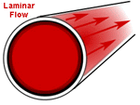 | 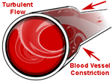

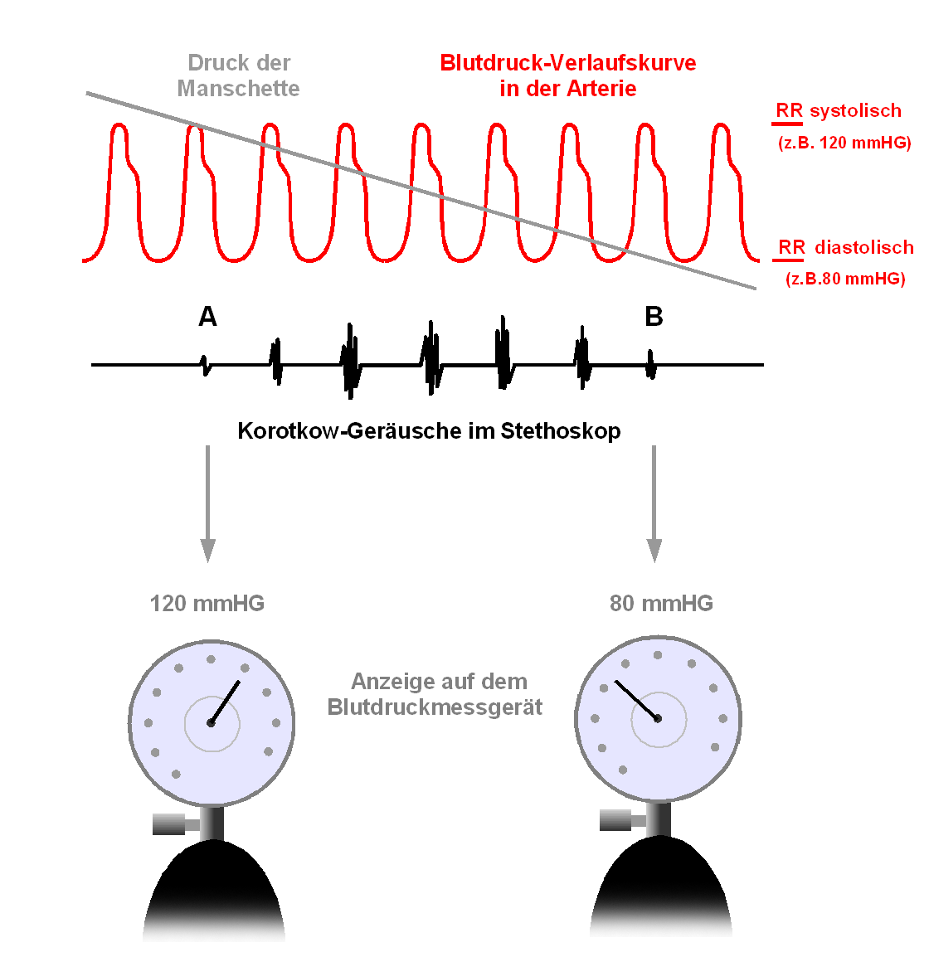

( Korotkoff Sounds)

Clinical Method for Measuring Systolic and Diastolic Pressures
There are two methods for measurements:-
1-Direct method(invasive method):
Arterial blood pressure is most accurately measured invasively through an arterial line.
Invasive arterial pressure measurement with intravascular cannula involves direct measurement of arterial pressure by placing a cannula needle in an artery (usually radial, femoral, dorsalis pedis or brachial). The cannula is connected to an electronic pressure transducer, which convert the pressure to signals display on screen. this method use in an intensive care unit (ICU) or operation room.

2- Indirect method :the instrument that commonly used is called sphygmomanometer.

The Needs for Measuring the Blood Pressure by Indirect Method
To measure the blood pressure by indirect method we need: -
- Stethoscope.
- Sphygmomanometer
Stethoscope:
It is made by R. T. H. Laennec. It is consists of chest-piece with two functions and convertible axis, latex tubes, binaural head frame and ear plugs. It is used for auscultating various sounds of heart, lung and other organs in human body.

Sphygmomanometer
It is one of the most common clinical instruments used in measuring blood pressure. The first known experimental measurement of blood pressure was made in 1733 by the Rev. Stephen Hales in Great Britain.
Sphygmomanometer found in several types: -
a- Manual:
A stethoscope is generally required for auscultation .Manual meters are used by trained practitioners, and, while it is possible to obtain a basic reading through palpation alone, this only yields the systolic pressure.
- Mercury sphygmomanometers are considered the gold standard. They show blood pressure by affecting the height of a column of mercury, which does not require recalibration. It consists of:-
1-Inflated Cuff (rubber bag enclosed in a cloth cuff with a cloth tail).
2-Rubber Tubes.
3-Inflated Rubber Bulb with valves .
4-Mercury Reservoir.
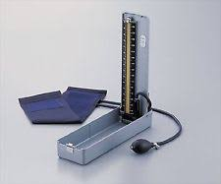
5-Graduated Cylinder.

- Aneroid sphygmomanometers (mechanical types with a dial) are in common use; they may require calibration checks, unlike mercury manometers.
In this type the pressure changes the shape of a sealed flexible container, which causes a needle to move on a dial. It consists of: -
- Inflated Cuff (rubber bag enclosed in a cloth cuff with a cloth tail).
- Rubber Tubes.
- Inflated Rubber Bulb with valves.
- Sealed Flexible Container.
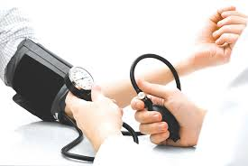
- Dial with Needle.

b-Digital
Digital meters employ oscillometric measurements and electronic calculations rather than auscultation. It easy to operate without training, and can be used in noisy environments .They measure systolic and diastolic pressures by oscillometric detection, employing either deformable membranes that are measured using differential capacitance, or differential piezoresistance, and they include a microprocessor. They accurately measure mean blood pressure and pulse rate, while systolic and diastolic pressures are obtained less accurately than with manual meters, and calibration is also a concern.

In this method used automatic Cuffs, Automatic blood pressure cuffs run on either electricity or battery power and have a digital screen that displays the blood pressure reading. Automatic cuffs work on a the same principle as the manual cuffs .

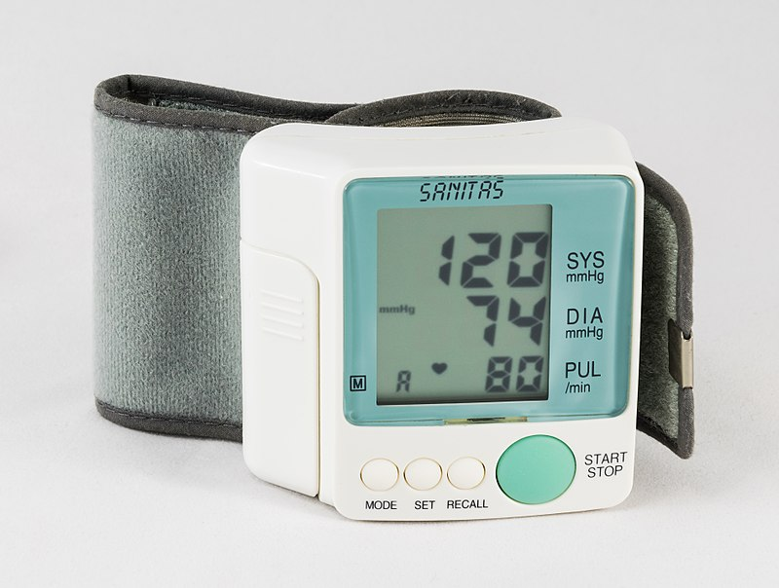

Recently, a group of researchers at Michigan State University developed a smartphone based device that uses oscillometry to estimate blood pressure. The oscillometric method of detection used gives blood pressure readings that differ from those determined by auscultation, and vary according to many factors, such as pulse pressure, heart rate and arterial stiffness.

Measuring the Blood Pressure by Indirect Methods
a-(Auscultatory Method)
In determining blood pressure by the auscultatory method, the pressure in the cuff is first elevated well above arterial systolic pressure. As long as this pressure is higher than systolic pressure, the brachial artery remains collapsed and no blood jets into the lower artery during any part of the pressure cycle.
Therefore, no korotkoff sounds are heard in the lower artery. But then the cuff pressure is gradually reduced. Just as soon as the pressure in the cuff falls below systolic pressure, blood slips though the artery beneath the cuff during the peak of systolic pressure, and one being to hear tapping sounds in the antecubital artery in synchrony with the heartbeat. As soon as these sounds are heard, the pressure level indicated by the manometer connected to the cuff is about equal to the systolic pressure.
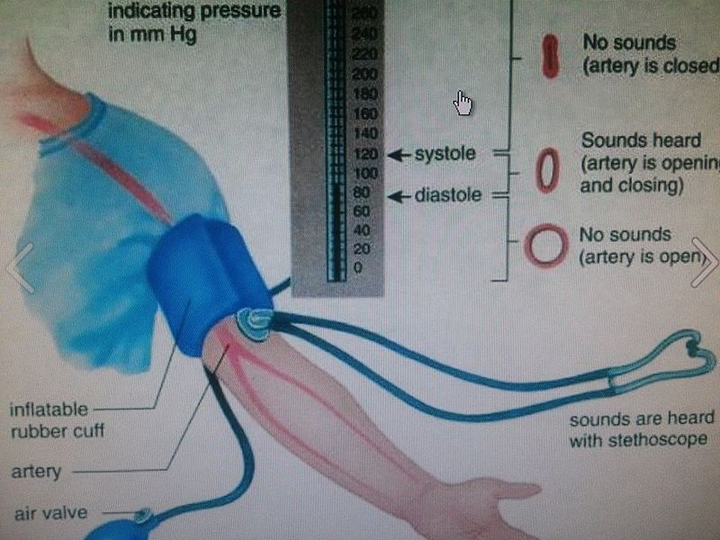
As the pressure in the cuff is lowered still more, the korotkoff sounds change in quality, having less of the tapping quality and more of a rhythmical. Then, finally, when the pressure in the cuff falls to equal diastolic pressure, the artery no longer closes during diastolic, which means that the basic factor causing the sounds (the jetting of blood through a squeezed artery) is no longer present. Therefore, the sounds suddenly change to a muffled quality and then usually disappear entirely after another 5 to 10 millimeter drop in cuff pressure. One notes the manometer pressure when the korotkoff sounds change to the muffled quality, and this pressure is about equal to the diastolic pressure.

b-(Palpatory Method)
In palpatory method feel the radial pulse by putting the three middle fingers of the right hand along the course of the radial artery at the wrist with the index finger towards the subject, and then follow the same steps of auscultatory method.
A blood pressure cuff is inflated around the upper arm by raising the blood pressure above the normal limit until the palpation from the radial artery cannot be felt then the cuff pressure is reduced slowly until we can feel a pulse under our fingers that we put on the radial artery this pulse will indicate the systolic pressure.
In this method as we mentioned previously we can get the systolic pressure without the diastolic pressure.

Precaution Taken During Measurement of Blood Pressure
1-Before taking your blood pressure, plan to relax and rest for at least 15 minutes. This will reduce the error due to physical activity.
2-Whether sitting or lying, be sure that your arm rests at the same level as your heart to obtain a pressure that is uninfluenced by gravity.
3-Do not let tight clothes around the arm or the cuff is inflated for some time, the discomfort may cause reflex vasoconstriction, raising the blood pressure.
4-Leaving the cuff partially inflated too long will fill the venous system and make sound difficult to hear.

Blood pressure column | Systolic column | Diastolic column
Normal level | Less than 120 | Less than 80
Pre-pathological level | 120-129 | Less than 80
First stage of hypertension (moderate intensity) | 130-139 | 80-89
Second stage of hypertension (severe) | More than 140 | More than 90

