MANAGEMENT
OF ROOT FRUCTURES
Management of Root Fractures

It is defined as fractures involving dentin, cementum and pulp, they are relatively uncommon. The mechanism of root fractures is usually a frontal impact, which creates compression zones labially and lingually. The resulting shearing stress zone then dictates the plane of fracture.

Notes:

1) Root fracture of primary teeth is relatively uncommon because the more pliable alveolar bone allows for displacement of the tooth. When root fracture does occur, it should be treated in the same manner as recommended for permanent teeth; however, the prognosis is less favorable.
2) The pulp in a permanent tooth with a fractured root has a better chance to recover, since the fracture allows immediate decompression and circulation is more likely to be maintained.
3) The prognosis is poor for any tooth with a fracture that extends below the gingiva1 margin and involves the pulp in an immature tooth.
4) Root fractures occur in the apical half of the tooth are more likely to undergo repair. Fractures in the apical third are often repaired
without treatment. In fact, many apparently are undetected until evidence of a calcified repair is seen radiographically sometime after the injury.

Clinical features:
1) Root fractures involving the permanent dentition predominantly affect the maxillary central incisor region.
2) Coronal fragments are displaced lingually or slightly extruded.
3) Temporary loss of sensitivity.

Radiographic demonstration of root fractures is facilitated by the fact that the fracture line is most often oblique and at an optimal angle for radiographic disclosure. In this context it should be remembered that a root fracture would normally be visible only if the central beam is directed within a maximum range of 15 to 20° of fracture plane.

Classification of Root fractures:
Based on direction of fracture line with long axis of tooth:
- Horizontal (transverse root fracture. intralveolar root fractures): Fracture perpendicular to long axis of tooth.
- Oblique. Fracture is at an angle to long axis.
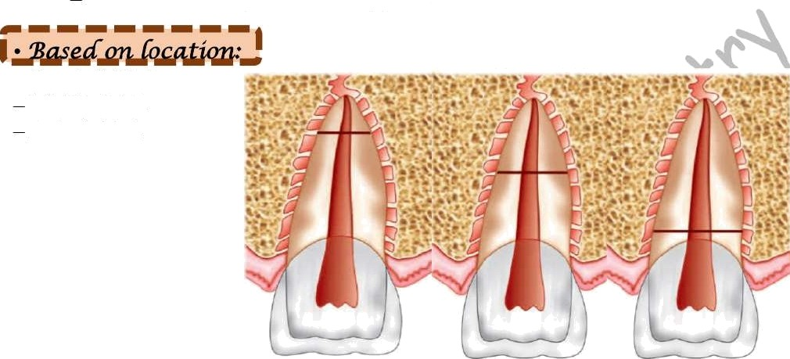
Vertical: Fracture parallel to long axis.

— Cervical third. Middle third. Apical third.

Apical third middle third cervical third

The position of the fracture line is an important facture in determining the treatment outcome
Fractures, which occur in the apical third of the root, have an excellent prognosis if the coronal and apical segments can be maintained in close proximity. A tooth with a middle third fracture has fair prognosis for repair and requires endodontic therapy. If the root fracture is in the coronal third, approximation and stabilization of fractured segments is almost impossible. The tooth has to be extracted.

Tissue reactions after root fracture:
Four types of tissue reactions had been described after root fracture.
(1) Healing with calcified tissue, which is characterized by a uniting callus of hard tissue that may consist of dentin, osteodentin, or cementum.
- Healing with interposition of connective tissue, in which the fractured root surfaces are covered by cementum with connective tissue fibers joining the two fragments.

- Healing with interposition of bone and connective tissue, in which a bony bridge and connective tissue are positioned between the fragments.
(4) Interposition of granulation tissue. It is the least favorable form of attempted repair, and the fracture will not heal spontaneously. The teeth usually present unfavorable symptom that may be accompanied by fistulas resulting from necrosis of the coronal portion and also sometimes the apical portion of the pulp. These teeth require follow-up endodontic treatment or extraction. Gross separation of the root fragments invariably causes inflammation in the area and subsequent resorption of the approximating fractured surfaces. For repair to take place, the fragments must be maintained in apposition. Therefore splinting is usually necessary, particularly if the coronal fragment is mobile.
Previously, a longer stabilization period (3 months) seemed necessary to encourage a more favorable type of healing of calcified tissue; however, it had been found no significant difference in the frequency of healing when short periods (under 60 days) and long periods (60 to 90 days) of splinting were compared.
It had been found that hard-tissue healing also took place in teeth that were not even splinted. A comparison between non-splinted and splinted teeth showed no difference in frequency of healing. So that optimal positioning of dislocated fragments significantly increases the frequency of healing, particularly in mature teeth. However, in immature teeth, healing took place even after suboptimal repositioning of dislocated coronal fragments and persistent distance between the fragments after splinting. Teeth With no or slight loosening of the fragment may not require splinting. In addition, there is general agreement that splints for root fractures should be more rigid than the splints used for stabilization after other types of displacement injuries. Application of a more rigid splint is also believed to enhance the opportunity for calcified tissue repair Therefore, the use of heavier wires is recommended (0.032 to 0.016 inch) when one is stabilizing teeth with fractured roots.
The occlusion should be adjusted so that the injured tooth is not further traumatized during normal masticatory function. Follow-up radiographs should be obtained and pulp tests performed at frequent intervals during the first 6 months after the injury.

Treatment:

*• The principle of treatment of permanent teeth is reduction of displaced coronal fragments and firm immobilization.
*• Immobilization of teeth with root fractures is achieved with rigid fixation with an acid etch splint.
*• Following treatment modalities are recommended based on the fracture line:

- If the remaining root is long enough, coronal portion can be removed, endodontic treatment completed on the apical fragment and restored with post and core. Then cement it and take an impression overall to make acrylic crown.
- If the remaining root is short, do extraction.
If the fracture line located subgingivally, removal of the coronal fragment supplemented by gingivectomy and\or osteotomy, in order to convert the subgingival fracture surface to supragingival in situations where esthetics permit, thereafter, restoration (e.g. with a post- retained crown).

Fracture of middle third:
1) If there is slight mobility: This fracture is treated by performing root canal treatment involving both the coronal and the apical fragments in which obturation with silver cone (that also acts as a splint) is done and later on, callus formation will occur. Sometime mostly the apical part, the tooth stay vital so inject Ca (OH)2 to interrupt the fracture line. New calcific body will be formed by Ca (OH)2 in fracture line.
2) If there is high mobility: The tooth should be extracted.

Fracture of the apical third:
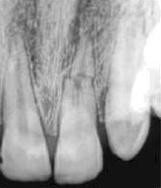
High apical fractures usually require no treatment. The prognosis will depend on height of fracture — the more apical the better the prognosis. Calcific repair will be formed without treatment. Just observe the child in future and do devitalization of the pulp. Sometimes the fracture part become reattached with the root. X -Ray is important.
If there is vertical root fracture:
- It is also called as cracked tooth syndrome.
- It runs lengthwise from crown towards the apex.
- It is mostly found in posterior teeth and its etiology is mostly iatrogenic like insertion of screws, after pulp therapy or due to traumatic occlusion.

Clinical Features:
- Persistent dull pain of long-standing origin.
- Pain is elicited by applying pressure.

Radiographic features:
- If the central beam lies in the line of fracture it is visible as radiolucent line.
- Thickening of PDL is also seen.
- Occlusal pressure test: When asked to bite/chew on a cotton applicator or a rubber polishing wheel patient gets sharp pain.

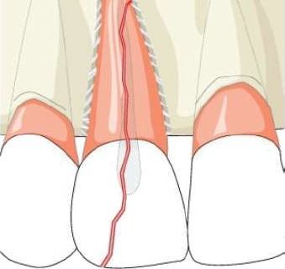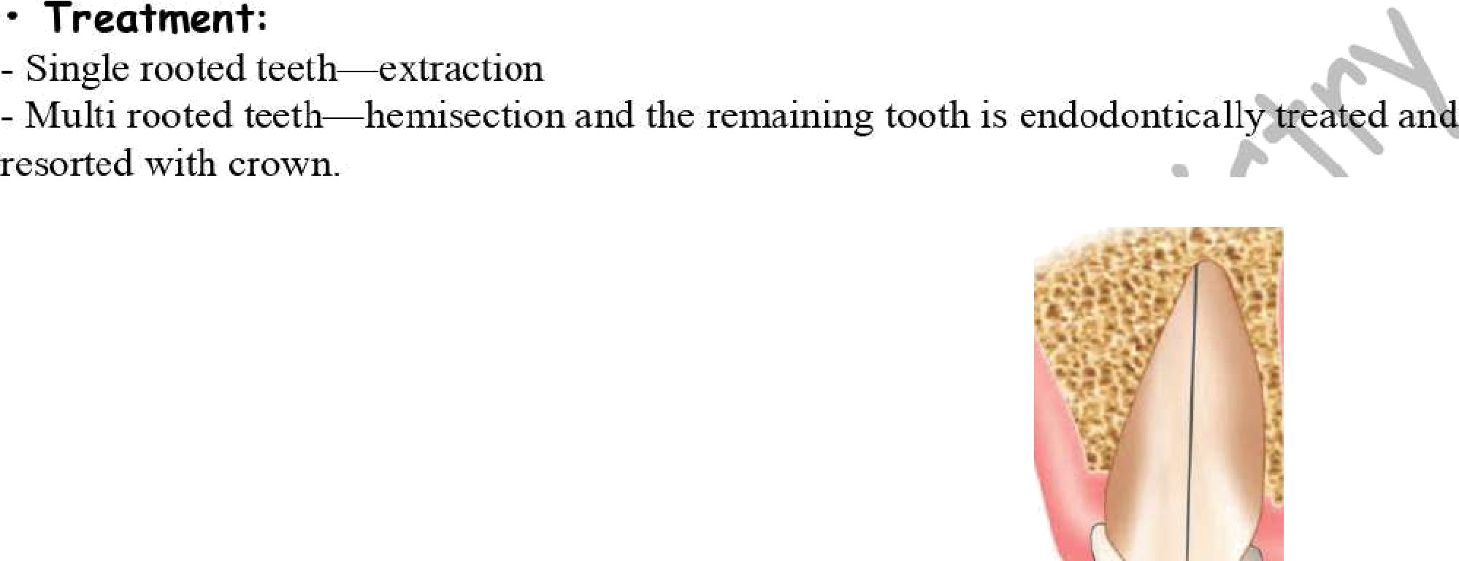

Teeth subjected to less severe luxation injuries may also benefit from stabilization with a bonded resin and wire splint during the recovery period. The severity of the injury will help determine the length of time the splint should remain in place. Splinting times may vary from:
* 1 to 2 weeks, for teeth that have been discernibly loosened (subluxation),
*4 to 6 weeks. For teeth that have been laterally displaced. Fracturing the alveolar process.
As with all tooth injuries, frequent periodic evaluation is required for at least the first 6 months to afford the dentist the opportunity for early intervention if adverse sequelae develop; after this, evaluation at regular recall appointments should continue.
Displaced teeth with closed apices and many with open apices will require follow up endodontic therapy. .As with many of the other injuries, calcium hydroxide paste is the currently recommended material for initial canal filling, and the canal should be recleaned

and refilled with calcium hydroxide periodically if signs or symptoms warrant retreatment. Placement of a permanent gutta-percha filling should be delayed for at least 1 year (arbitrarily determined), and the calcium hydroxide should be replaced at least once (again, arbitrarily determined) during this time. If the injured tooth had an open apex when endodontic therapy was initiated, the calcium hydroxide filling material should be used until the apexification process is complete or at least 1 year has elapsed, whichever is longer.

Note:
Types of fracture:
By Ellis and Davey (1960):
Class I: Enamel fracture;
Class II: Enamel and dentin fracture;
Class III: Enamel and dentin fracture exposing dental pulp; Class IV: The traumatized tooth that becomes non vital; Class V: Avulsion;
Class VI: Fracture of the root;
Class VII: Displacement of tooth;
Class VIII: Fracture of crown en masse; Class IX: Traumatic injuries of primary teeth.

Note:

(For both closed and open apex teeth)

Closed apex, tooth replanted prior to †he patient’s arrival a† †he dental office
Treatment
  - Leave the tooth in place.
  - Clean the area with water spray, saline, or chlorhexidine.
  - Suture gingival lacerations if present.
  - Verify normal position of the replanted tooth both clinically and radiograplilcally.
  - Apply a flexible splint for up to 2 weeks.
- 1. Open apex. tooth rep1anted prior to the patient's arrival at the dental office or clinic
Treatment
- Leave the tooth in place.
- Clean the area with water spray, saline, or chlorhexidine..
- Suture gingival laceration if present.
- Verify normal position of the replanted tooth both clinically and radiogi’ap1iically.
- Apply a flexible splint for up to 1-2 weeks.

- Administer systemic antibiotics. Tetracyc1ine is the first choice (doxycycline twice a day for 7 days at appropriate dose for patient age and weight). The risk of discoloration of permanent teeth must be considered before systemic administration of tetracyc1ine in young patients. (In many countries, tetracyc1ine is not recommended for patients under 12 years of age ) hi young patients, phenoxymetlylpenicillin
(Pen V) or amoxicillin, at an appropriate dose for age and weight, is an alternative to tetracyc1ine.
- If ‘the avulsed tooth has been in contact with soil and if tetanus coverage is uncertain, refer to physician for a tetanus booster.
- Initiate root canal treatment 7—10 days after rep1antation and before splint rernoval Patient instructions
- Avoid participation in contact sports.
- Eat only soft food for up to 2 weeks.
- Brush teeth with a soft toothbrush after each meal.
- Use a chlorhexidine (0.1%) mouth rinse twice a day for I week.
Follow-up
  - Splint removal and clinical and radiographic control after’ 2 weeks
  - Root canal treatment 7-10 days after replantation
  - Clinical and radiographic control after 4 weeks, 3 months, 6 months, 1 year, and then yearly thereafter.
- Closed apex, extra oral dry time less than 60 minutes:
The tooth has been kept in physiologic storage
media or osmolality-balanced media (milk, saline, saliva, or Hanks’ Balanced Salt Solution) and/or stored dry for less than 60 minutes
Treatment
- Clean the area with water spray, saline, or
chlorhexidine.
- Replant the tooth in the socket.
- Suture gingival lacerations if present.
- Verify normal position of the replanted tooth both clinically and radiographically.

- Administer systemic antibiotics (see previous
comments)
- If the avulsed tooth has been in contact with soil and if tetanus coverage is uncertain, refer to physician for a tetanus booster.
- The goal for replanting still-developing (iniinature) teeth in c1ii1di’en is to allow for possible revascularization of tlic tooth pulp. If that does not occur, root canal treatment is i’ecoiiunended.

Open apex, extra oral dry time less
than 60 minutes.
The tooth has been kept in physiologic storage media or osmolality-balanced media (milk, saline, saliva, or Hanks’ Balanced Salt Solution) and/or stored dry for less than 60 minutes
Treatment
- Clean the root surface and apical foramen with a
stream of saline.
- Topical application of antibiotics has been shown to enhance chances for revascularization of the pulp and can be considered if available (minocycline or doxycycline 1 mg per 20 mL saline for 5-minute soak).
7

  - Apply a flexible splint for up to 2 weeks.
  - Administer systemic antibiotics (see previous
comments).
  - If the avulsed tooth has been in contact with soil and if tetanus coverage is uncertain, refer to physician for a tetanus booster.
  - Initiate root canal treatment 7-10 days after replantation and before splint removal.
Patient instructions (see previous comments) Follow-up (see previous comments)

- Closed apex. Extra oral dry time greater than 60 minutes, suggesting non- viable cells:
Delayed replantation has a poor long-term
prognosis. The periodontal ligament will be necrotic and cannot be expected to heal. The goal at delayed replantation is, in addition to restoring the tooth for aesthetic, functional, and psychological reasons, to maintain alveolar bone contour’. However, the expected eventual outcome is ankylosis and resorption of the root and the tooth will be lost eventually.
Treatment
- Clean the area with water spray, saline. or
chlorhexidine.
- Re-implant the tooth in the socket.
  - Apply a flexible splint for up to 2 weeks.
  - Administer local anesthesia
  - Examine the alveolar socket. If there is a fracture of the socket wall, reposition it with a suitable instrument.
  - Irrigate the socket with saline.
  - Replant the tooth slowly with slight digital pressure.
  - Suture gingival lacerations, especially in the cervical area.
  - Verify normal position of the replanted tooth
Clinically and radioghraphically.
  - Apply a flexible splint for up to 2 weeks.
» Administer systemic antibiotics (see previous
comments).
  - If the avulsed tooth has been in contact with soil and if tetanus coverage is uncertain, refer to physician for a tetanus booster.
  - Patient instructions (see previous comments)
  - Follow-up (see previous comments)
  - The goal for replanting still-developing (immature) teeth in children is to allow for possible revascularization of the pulp space. The risk of infection-related root resorption should be weighed against the chances of revascularization. Such resorption is very rapid in children. If revascularization does not occur, root canal treatment may be recommended.
3. Open apex. Extra oral dry time greater than 60 minutes, suggesting non-viable cells
Delayed replantation has a poor long-term prognosis. The periodontal ligament will be necrotic and is not expected to meal. The goal in delayed replantation is to restore the tooth to the dentition for aesthetic, functional, and psychological reasons and to maintain alveolar contour. The eventual outcome will be ankylosis and resorption of the root.
Treatment
- Remove attached non-viable soft tissue with gauze.
- Root canal treatment can be carried out prior to
replantation or later.
- Administer local anesthesia.

8

- Suture gingival 1acerations if present. • Irrigate the socket with saline.
+ Verify normal position of the replanted tooth both • Examine the alveolar socket. If there is a
Clinically and radiographically. fracture of the socket wall, reposition it with a
- Apply a flexible splint for up to 2 weeks. suitable instrument.
- Administer systemic antibiotics (see above). • Replant the tooth slowly with slight digital
- If the avulsed tooth has been in contact with soil and pressure
if tetanus coverage is uncertain refer to physician for • Suture gingival lacerations if present. Verify
a tetanus booster. normal position of the replanted tooth clinically
- Initiate root canal treatment 7-10 days after and radiographically. Stabilize the tooth for 4 replantation and before splint removal. weeks using a flexible splint.
- To slow osseous replacement of the tooth, treatment ° Administer systemic antibiotics (see previous
of the root surface with fluoride prior to replantation comments).
has been suggested (2% sodium fluoride solution for • If the avulsed tooth has been in contact with soil 20 minutes). or if tetanus coverage is uncertain, refer to
Patient instructions (see previous comments) physician for evaluation of the need for a tetanus Follow-up (see previous comments) booster. To slow osseous replacement of the Ankylosis is unavoidable after delayed replantation and tooth, treatment of the root surface with fluoride must be taken into consideration. In children and prior to replantation has been suggested (2% adolescents, arkylosis is frequently associated with sodium fluoride solution for 20 minutes). infraposition. Careful follow-up is required and good Patient instructions (see previous comments) communication is necessary to assure the patient and Follow-up (see previous comments) Ankylosis guardian of this likely outcome. after delayed replantation (see previous Decoronation may be necessary when infraposition (Al comments)
mm) is seen
Reference: Adapted from The Dental Trauma Guide: Avulsion-First Aid for Avulsed Teeth, Iutaztationa1 Association of
Dental Traumatology, 1ihJ:. .’»z rlentals a\unamiic!e.of

Because of secondary wound healing and scar contracture, burns involving the perioral and intraoral tissues can cause various degrees of microstomia. A common cause of oral burns is electrical trauma. The most frequently encountered electrical injury to children is the electrical burns of the mouth. These burns occur most often in children between 6 months and 3 years of age and are equally common among boys and girls.
TREATMENT
Assessing the general physical status of a patient who has sustained an electrical burn to the mouth is the first priority. Subsequently, the extent of the burns is carefully evaluated and local measures are initiated, such as control of minor hemorrhage or conservative debridement of none viable tissue. The immunization status of the patient must be ascertained, and tetanus toxoid or depot triple antigen (diphtheria-pertussis-tetanus vaccine) administered when appropriate. Many physicians prescribe a broad-spectrum antibiotic as prophylaxis. However, it may not be necessary or prudent to prescribe antibiotics in the absence of infection.

9

