***Dental Radiology***

**Lec: 1 ا. د. امل رؤوف**

**Physics of Radiation**

**Radiology:** is the science that deals with diagnosis, therapeutic and researches application of high energy radiation. •

**Dental radiography:** is a process of image production for an object through the use of x – radiation. •

**Radiologic examination:** is an integral component of the diagnostic procedure.

Dentists often make radiographic images of patients to obtain additional information beyond that available from a clinical examination or their patient's history. Information from these images is combined with the clinical examination and history to make a diagnosis and formulate an appropriate treatment plan.

**Nature of Radiation**

**Radiation :** a form of energy carried by waves or stream of particles .Also it is the transmission of energy through space and matter . It may occur in two forms :

1. **Particulate radiation**

Consists of atomic nuclei or subatomic particles moving at high velocity .Alpha particles , beta particles and cathode rays are examples of particulate radiation .

1. **Electromagnetic radiation**

Is the movement of energy through space as a combination of electric and magnetic fields . Gamma rays , x- ray , ultraviolet rays , visible light , microwaves , and radio waves are all examples of electromagnetic.

• X – Ray was discovered by (Roentgen) in 1895,it travels in a form of pure energy and the basic unit is x – ray **photon**

• X – Ray photons travel with a wave motion called **(sine – wave)** and the distance between the crests of these waves called **(wave – length)** which measured by **Angstrom** units .

**A = 1\ 100 000000 cm**

X- ray wave length used in diagnostic radiation range **(0.1 – 0.5)A.**

The photon carries energy and the amount of energy carried by a photon is called **(photon energy)** which depend on the **frequency** and **wave length** of the radiation .

**Photon energy = Frequency X Wave length**

**Short W. L === High Frequency === more energy**

**Long W. L === Low Frequency === less energy**

**Comparison between x – ray and light**

1. Both belong to the same electro – magnetic radiation family.

2. Both travel in straight lines at the same speed which is 186,000 miles per seconds.

3. Both affected the photographic films and made them black.

4. Both not affected by magnetic fields

5. X-ray and light cast the shadows of the objects in the same manner

6. X-ray has the ability to penetrate objects that the light cannot pass through

7. X-ray has the ability to ionize atoms

8. X-ray has the ability to produce light (blue light) when it hits some objects and this phenomena called (fluorescence).

9. X-ray is invisible

**X- Ray machine :**

a dental x- ray machine is used to generate x- ray , this machine is composed of:

1. **The component parts *:***consists of

* 1. **The control panel :** contain ;

1. on – off switch ,and indicator light
2. exposure button , and indicator light
3. control devices ( time , kilovoltage , and milliamperage selectors )

**B-The extension arm :**allows for the movement and

positioning of the tube head

**C- Tube head:** is tightly sealed ,and the component part of it:

**1-Metal housing** : surrounds the x- ray tube head and transformers , it filled with oil ,it protect the x- ray tube and grounds the high – voltage components .

**2-Insulating oil** : it prevents overheating by absorbing the heat created by the production of x- rays .

**3- Transformer** :is a device that used to either increase or decrease the voltage in the electrical circuit.

**4-Aluminum filter** :disks or sheets of 0.5 mm placed in the path of the x- ray beam , they filter out the non – penetrating , long wave length x- rays

**5-Lead collimator** :or lead plate with a central hole , it restricts the size and the shape of the x- ray beam .

Diagram of tube head 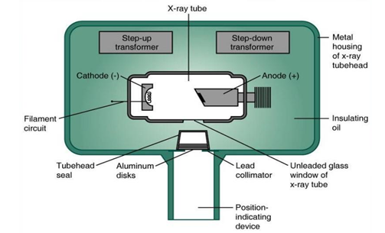

**2-X-ray tube :**

is the heart of the x- ray generating system . The x-ray tube is evacuated to prevent collision of the fast-moving electrons with gas molecules, which would significantly reduce their speed. The vacuum also prevents oxidation, or “burnout,” of the filament.

**The component parts of the X –ray tube include :**

**A-leaded – glass housing** : .The glass of the tube is leaded to **prevent (the generated X – ray) from escaping in all directions.** While the window is of unleaded glass so that X – ray exist out through this window.

**B- a cathode ( - ve )** : The cathode consists of a filament and a focusing cup. The filament is the source of electrons within the x-ray tube. It is a coil of **tungsten** wire approximately 2 mm in diameter and 1 cm or less in length, and typically contains approximately 1% thorium, which greatly increases the release of electrons from the heated wire.

The filament is heated by a low-voltage source and **emits electrons** at a rate proportional to the temperature of the filament.

The filament lies in a **focusing cup**, a negatively charged concave molybdenum bowl. The electrons emitted by the filament directed at a small rectangular area on the anode called the **focal spot**.

**C- anode ( + ve )** : in an x-ray tube consists of a tungsten target embedded in a copper stem .**The purpose of the target in an x-ray tube is to convert the kinetic energy of the colliding electrons into x-ray photons**. The conversion of the kinetic energy of the electrons into x-ray photons is an inefficient process, with more than 99% of the electron kinetic energy converted to heat.

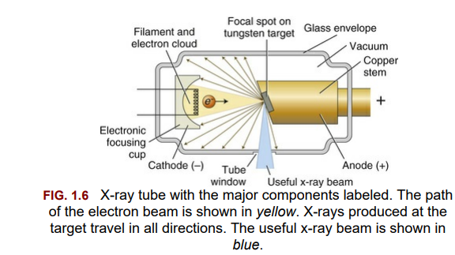

**Selection of target material :**

The ideal target material should have the following properties :

1. **High atomic number** (74), allows for efficient x-ray production.

2. **High melting point** (3422°C), to withstand heat produced during x-ray production.

3. **High thermal conductivity** (173 W m−1 K−1), to dissipate the heat produced away from the target.

4. **Low vapor pressure** at the working temperatures of an x-ray tube, to help maintain vacuum in the tube at high operating temperatures

**The tungsten target** is typically embedded in a large block of copper which functions as a thermal conductor to remove heat from the tungsten, reducing the risk of the target melting

**Focal Spot :** it ,s an area on the tungsten target (anode) from which x- ray photons are emerged

The smaller the focal spot , the sharper the radiographic image , so the sharpness of the radiograph is inversely proportional with the size of the focal spot.

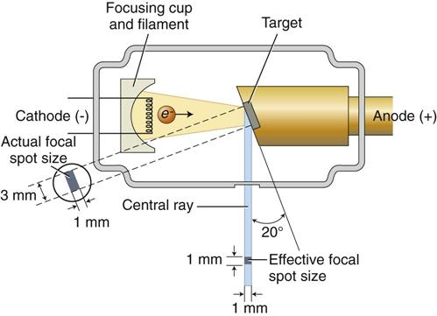

**Types of radiation**

1. **Central ray**: is X– ray photons that traveling in very center of the cone of radiation (radiation beam), and it’s commonly used to fix and locate the position of X – ray beam.

2. **Bremsstrahlung radiation**: radiation produced when projectile electron is slowed by the electric field of target atom nucleus.

3. **Characteristic radiation**: radiation produced when an outer shell electron fills, an inner shell void (empty orbital).

4. **Primary radiation**: Radiation emerging from the X – ray machine in form of collimated useful X – ray beam

5. **Secondary radiation**: Radiation result from interaction of primary beam with matter

6. **Leakage radiation**: x-ray that escape through the protective housing and result in unnecessary exposure of the patient and radiologic technologist and have no value in diagnostic radiology

**Definition of terms used in x- ray interaction :**

**Ionization :**removal of an electron from neutral atom

**Absorption :**deposition of energy , or removal of energy from the beam .

**Scattering :**change in direction of photon with or without a loss of energy .

**Attenuation :**reduction in the intensity of x- ray beam caused by absorption and scattering .

**X-ray interaction with matter**  **(Absorption of X – ray)**

x – Ray absorbed by any form of matter (solid, liquid, and gas) when photons reach an atom, different types of interaction may occur depends on photon energy:

1. X – Ray photons can pass through the atom without any change occurred to both of them.

2. **Coherent scattering** sometimes called classical scattering or Thompson scattering occur by interaction of low energy x-ray photon and atom. there is no loss of photon energy only changes in direction (photon of **scattered radiation**) . 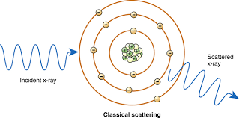

3. **Compton Effect**: occur between moderate energy x-ray photon and free or loosely bound outer shell electron of atom. It result in ionization of atom (ejection of Compton recoil electron) , reduction of photon energy (there is some absorption of photon energy by ejected electron which undergoes further ionization interaction within the tissue) , and change in x-ray direction **(scattered radiation ).**

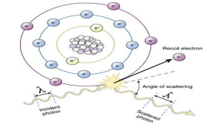

4. **Photoelectric effect**: occur by X – Ray photon interaction with inner – shell electron of the tissue atom (ex. From k shell) , the X – ray photon disappears and deposits all its energy this process is **pure absorption.**

Now the inner – shell electron is ejected with considerable energy (now called a photo – electron) in to the tissue for further interaction with other electrons of other tissue atoms. So this high – energy ejected photo electron behaves like the original high energy X – ray photons interact and eject other electrons as it passes through the tissues, **these ejected electrons are responsible for the majority of ionization interactions within the tissue and the possible resulting damage attributable to the X – rays.**

When k electron removed out of its orbital, an electron from L shell falls in to k shell and release energy in the form of x-ray photon. This photon has definite

wavelength of a particular element, this phenomena is used to identify elements

and the radiation is called **characteristic radiation**.

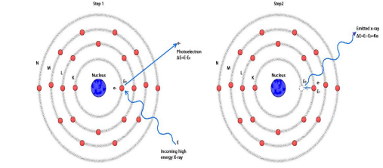

There are two other types of interaction **Pair production** ( between high energy x-ray photon and nuclear force field ) and **photodisintegration** (between high energy photon and nucleus) but both of them not occur in diagnostic radiology.

**Filtration**

X – ray used in dentistry must be able to penetrate dental hard tissues (teeth and bone). The longer wave length X – ray **(soft X – ray)** are not useful in diagnostic radiology thus removal of these long wave length photons from the beam by passing the beam through a filter made from **Aluminum** which absorb most of long wave length photons (soft X – ray), the resulting X – ray beam will consist mainly of X – ray photons with short wave length, high energy photons and high penetrating power that’s why they named **(hard X – ray beam).**

**Types of filtration**:

**1. Inherent filtration:** done by filter built-in to the X – ray machine by manufacturer (as glass wall, the insulating oil and the metal housing of the tube). The inherent filtration tends to increase with age because some of tungsten metal of both target and filament is vaporized and deposited on the inside of the tube window.

**2. Added filtration :** done by using aluminum sheet as extra filter.

total filtration = inherent filtration + added filtration.

**Collimation**

Is a process used to control the size and shape of X – ray beam. In diagnostic radiography its essential to get the diameter of circular X – ray beam at patients skin surface is not great than 2.75 inches, while for Rectangular X – ray beam the dimensions at the skin should be approximately 1½ × 2 inches.

Types of collimators:

1. diaphragms (round or rectangular shape).

2. metal cylinders, cones and rectangular tubes.

**Diaphragm** Consists of a metal plate or disk made from lead with a hole in the center of the disk which allow the beam to pass through it only. The shape of X – ray beam determine by the shape of the diaphragm **hole** such diaphragm is placed over the opening in the head of X – ray machine.

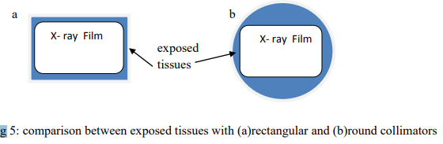

**Half – value layer:**

It’s a method of monitoring the penetration quality of the X – ray beam. Determination of half – value layer is done by placing thin filtering material such as aluminum filter in front of the beam so we continue increase the thickness of filtering material until we have a thickness that reduce the number of X – ray photons in the beam passing through it to **(one half)** this will representing a half – value layer for such beam of radiation. High half value layer the high penetrating ability of the beam. In oral diagnosis the acceptable value is approximately **2 mm of aluminum**

**X-ray measuring units:**

**1. Traditional Units**

•Roentgen ( R) is the basic unit of radiation exposure for the amount of X-radiation or gamma radiation which will produced in one cc of air ions carrying one electrostatic unit of either sign.

• rad ( roentgens absorbed dose ) is a measure of the amount of energy absorbed by an organ or tissue.

• rem ( roentgens equivalent man ) is a measure of the degree of damage caused to different organs or tissues.

•Curie (Ci) : is the unit of quantity of radioactive material and not the radiation emitted by that material.

•RBE: is a relative biological effectiveness dose.

**2. International system of units**

•Coulomb per kilogram (C\kg) : 1 C\kg = 3876 R

•Gray (Gy) : 1 Gy = 100 rad

•Sievert (Sv) : 1 Sv = 100 rem •Becquerel (Bq) : 1 Bq=2.7 x 10*11 Ci