Parasitology
Lab. 3

Protozoology

Kingdom: - Protista
Phylum: - Protozoa
Super class: - 1- Sarcodina
2 -Mastigophora (flagellata)
3- Sporozoa
4- Ciliophora

1- Super class: - Sarcodina (Includes Amoeba).

- Amoeba that parasitise the human can be divided into:-

- Amoeba lives in the digestive tract and able to infect tissue. Ex. :- Entamoeba histolytica

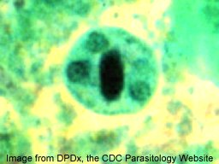
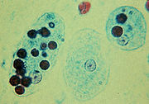

Entamoeba histolytica torphozoite Entamoeba histolytica cyst

b-Amoeba lives in the digestive tract and oral cavity. Ex.1 :- Entamoeba gingivalis Ex.2 Entamoeba coli

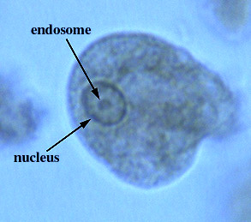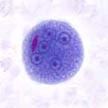

Entamoeba coli trophozaite Entamoeba coli cyst

c-Free living Amoeba may be infecting man. Ex. :- Naegleria Spp .
 | E.histolytica | E. coli | E. gingivalis
1)Trophozoite  - Cytoplasm  - Location  - Inclusion  - Nucleus  - Karyosom  - Nuclear membrane | Clearly defined into ectoplasm and endoplasm  The end of small  Intestine and the large intestine (cecum and sigmoido-rectal) and sometimes tissues (liver, lung, spleen, brain).  Red blood cells  Present. No bacteria  Small, central  Delicate with fine chromatin dots. | Differentiation into ectoplasm and endoplasm indistinct.  Large intestine  Bacteria. No blood cells  Large, eccentric  Thick, with coarse chromatin granules | Clearly defined into ectoplasm and endoplasm  Gingival tissue  White blood cells, bacteria and epithelial cells  Central  Thick with coarse chromatin granules

 | E .hitolytica | E .coli | E. gingivalis
2) Cyst  Nuclei in mature cyst  Glycogen mass in the precyst  Chromatoid bars  3) Disease  4)Diagnosis | Infective stage  4  Seen in uninucleate stage  1 – 4 with rounded ends .  Amoebiasis.  1-primary amoebiasis in the large intestine  2-secondary amoebiasis in the liver and tissues.  - Microscopic examination of stool specimens contain trophozoite and cyst stages.  - Serology is the method of choice for diagnosis of amoebie liver disease. | Infective stage  8  Seen up to quadrinucleate stage  Splinter-like with angular ends.  Non pathogenic  Microscopic examination of stool specimens contain trophozoite and cyst stages. | No cyst  Non pathogenic  Microscopic examination of gingival swab contains trophozoite stage.
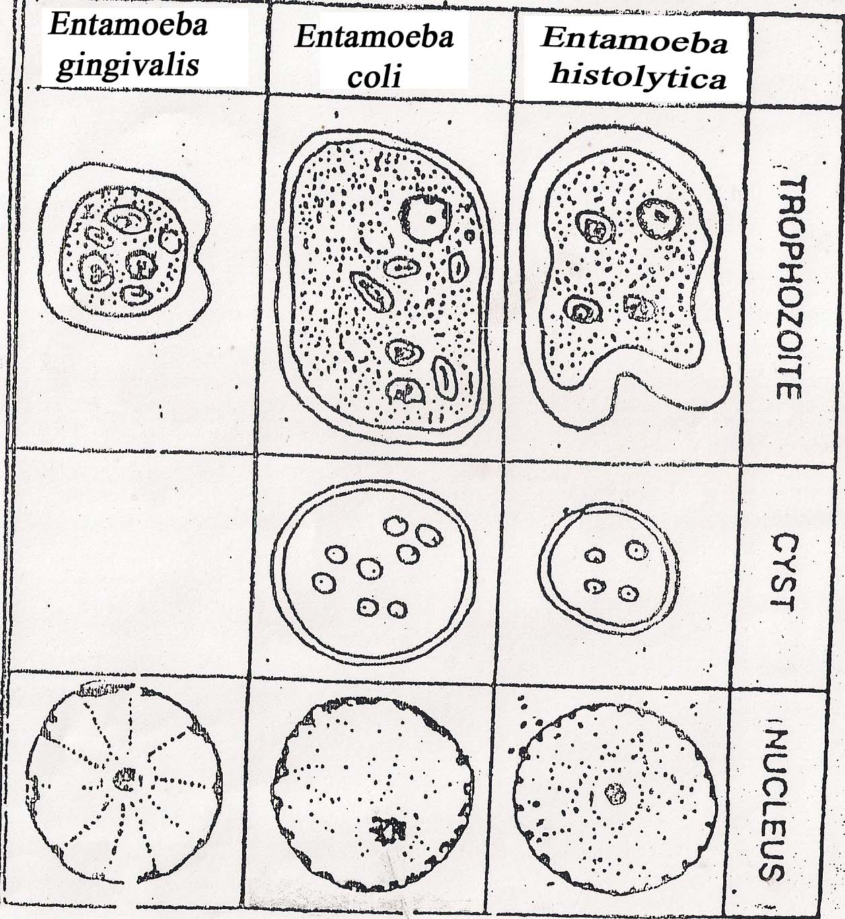

Comparative morphology of amoebae infecting man , showing trophozoite and cystic stage , as well as enlarged representation of their nuclear structure "

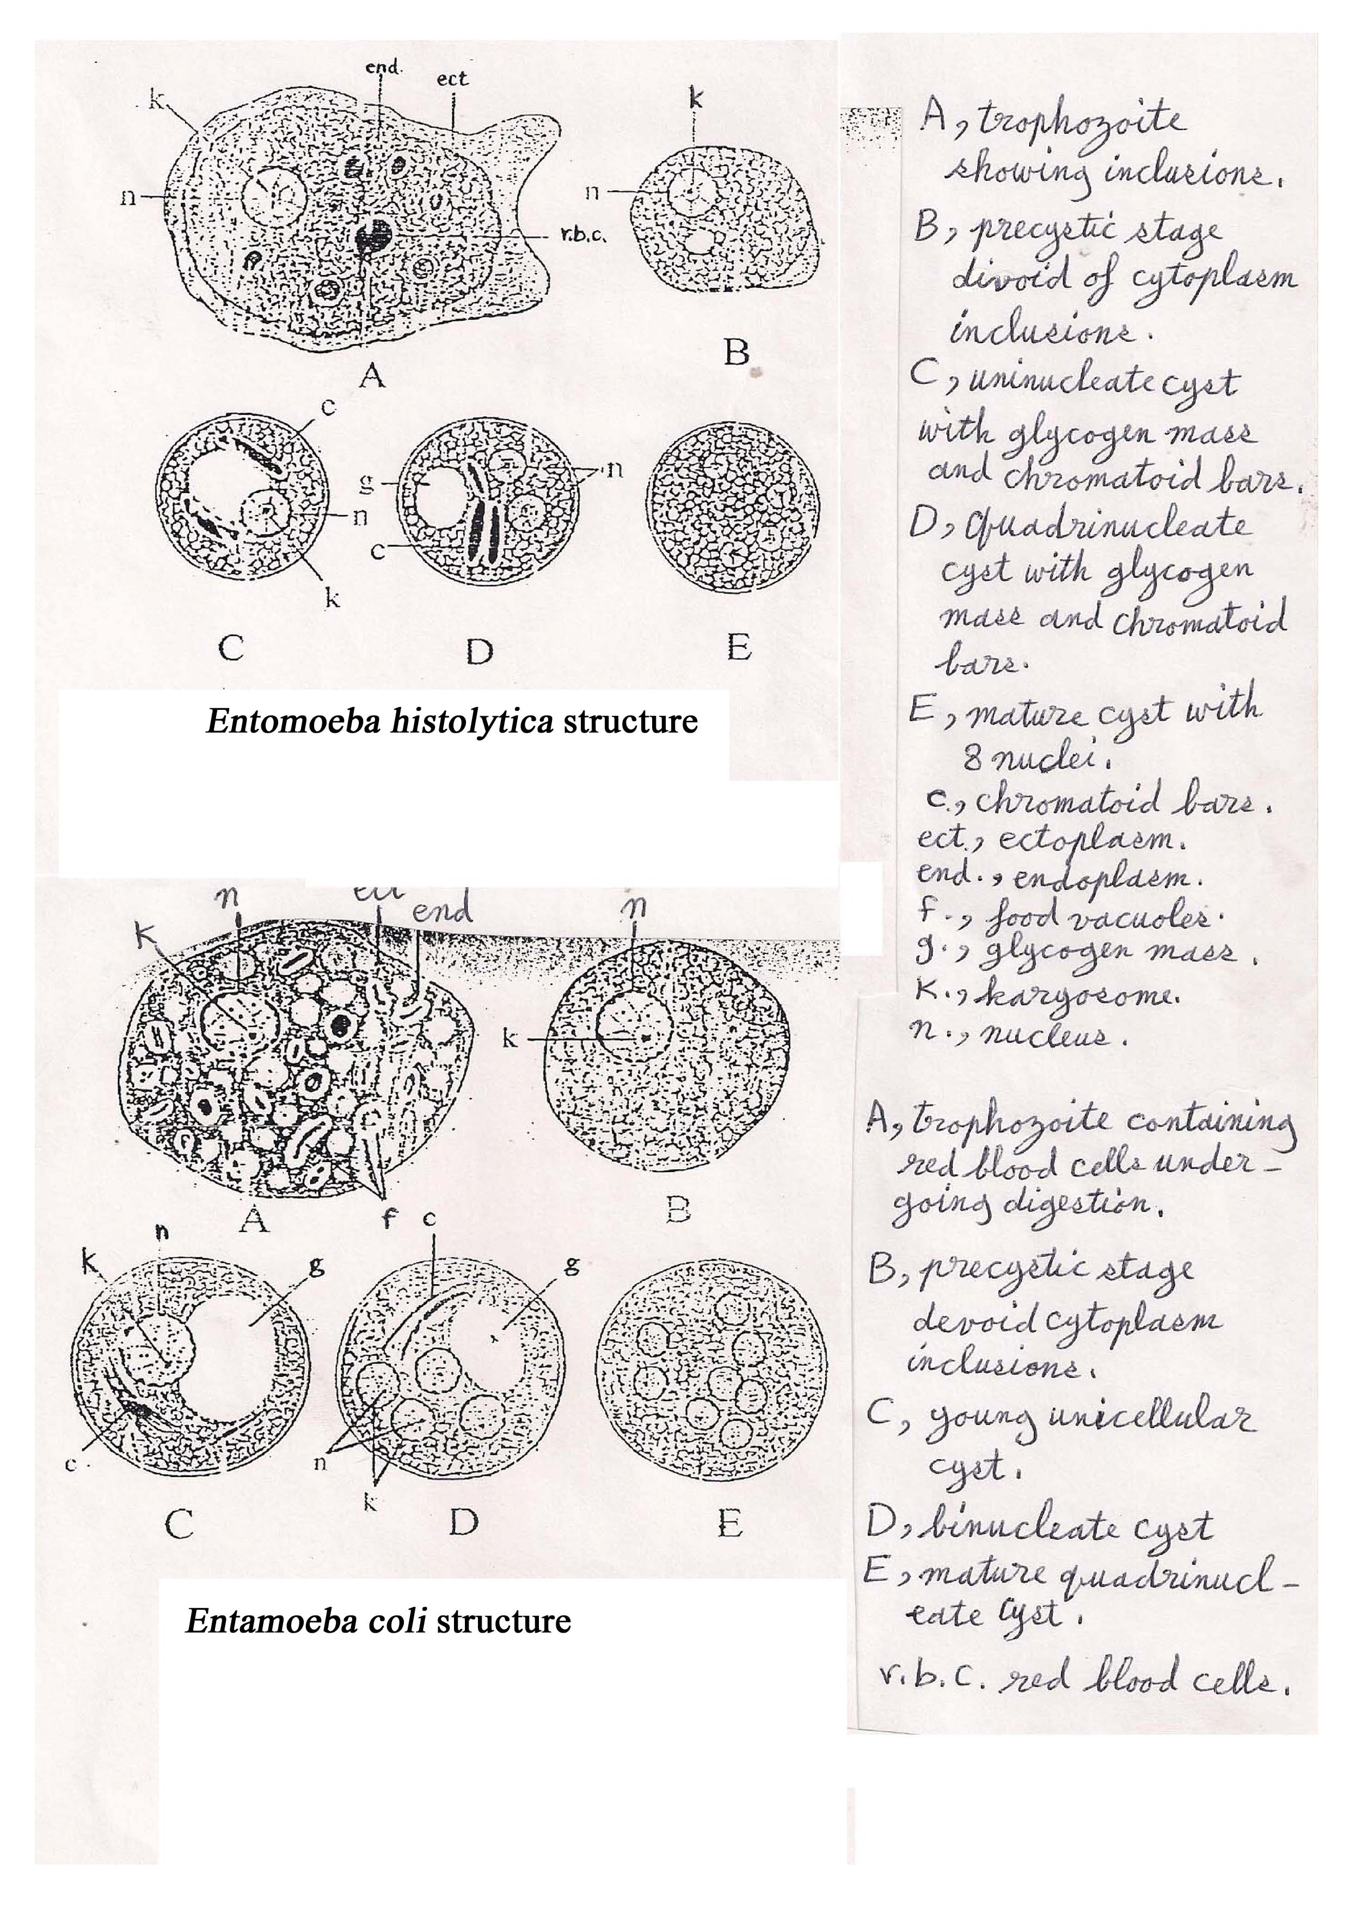

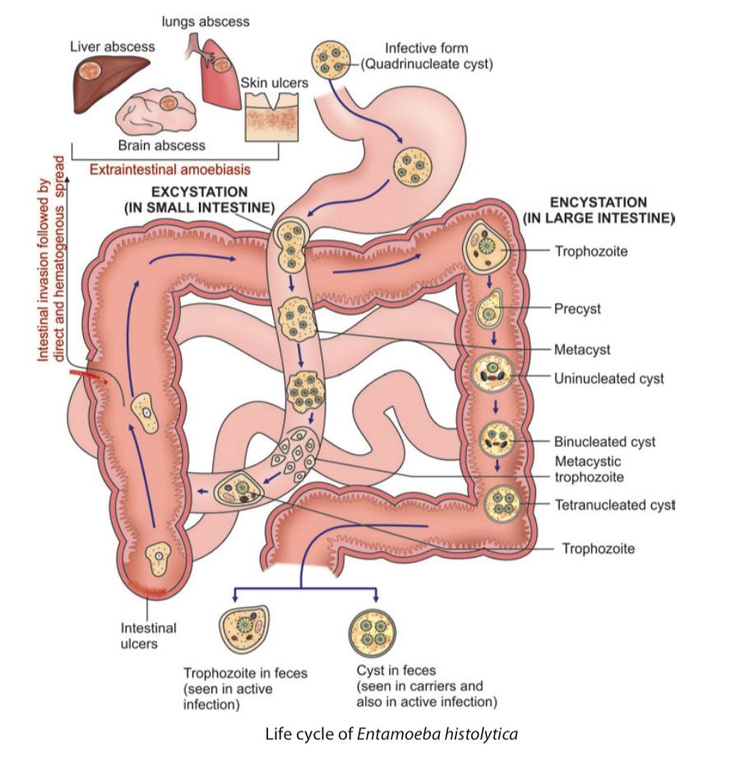

Appendix

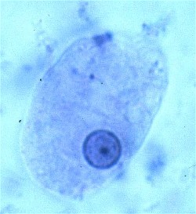 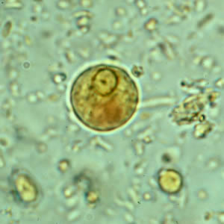 Entamoeba histolytica Entamoeba histolytica
trophozoite cyst

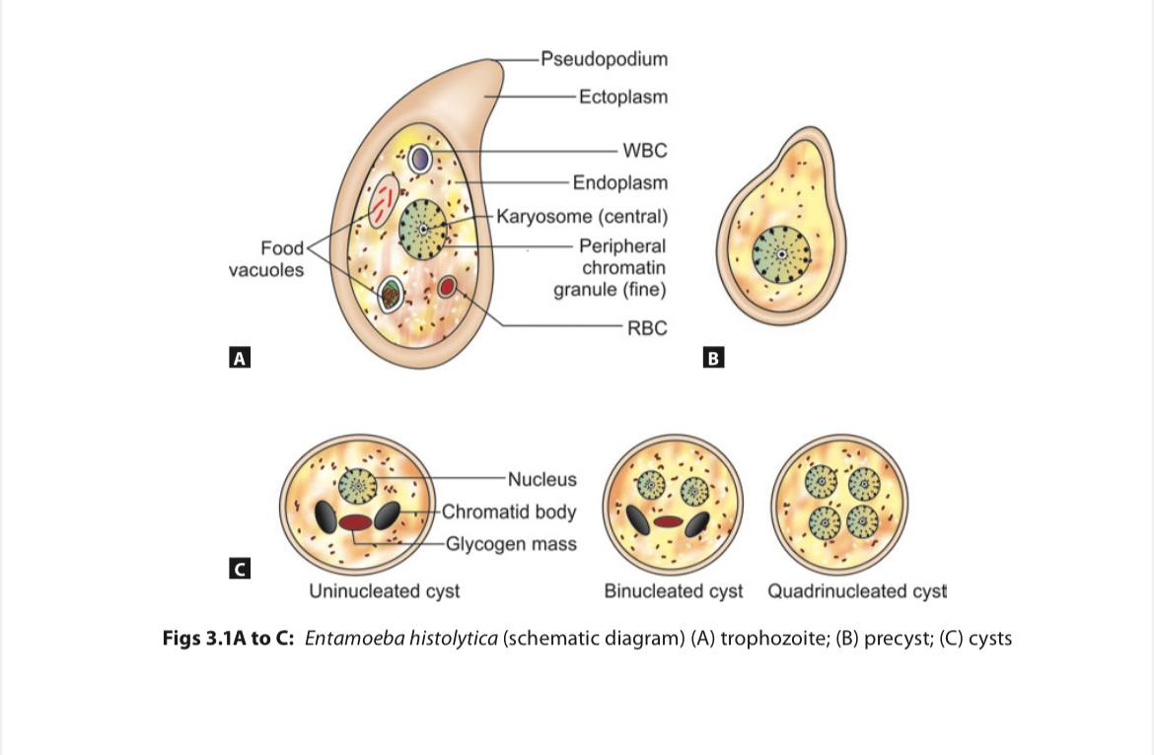

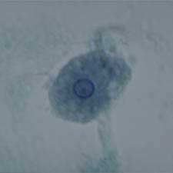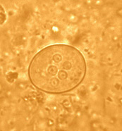

Entamoeba coli Entamoeba coli
trophozoite cyst

