Lab 7

Helminthology

- Phylum :- Platyhelminthes
- Phylum :- Aschehelminthes
- Phylum :- Annelida

- Phylum :- Platyhelminthes
Class: - a- Trematoda
b- Cestoidea

a- Class: - Trematoda

General characteristics :-
  - Flattened dorso-ventrally worms ( schistosomes are exception )
  - Attach to their host by means of suckers (oral and ventral suckers )
  - No body cavity.
  - Need to two hosts to complete the life cycle (intermediate host in snail and the final host in the man).
  - Hermaphroditic (schistosomes are exception).
  - Classified into 4 groups according to their sites of living :-
*Liver flukes
*Intestinal flukes
*Lung flukes
*Blood flukes

*Liver flukes: - Ex: - Fasciola hepatica
  - Common name: - The sheep liver flukes.
  - Disease :- Fascioliasis
  - Habitat: - Adult worm lives in the biliary tract of herbivores (sheep, goat and cattle) and man for about 5 – 10 years.
  - Intermediated host: - Snail from genus Lymnaea.

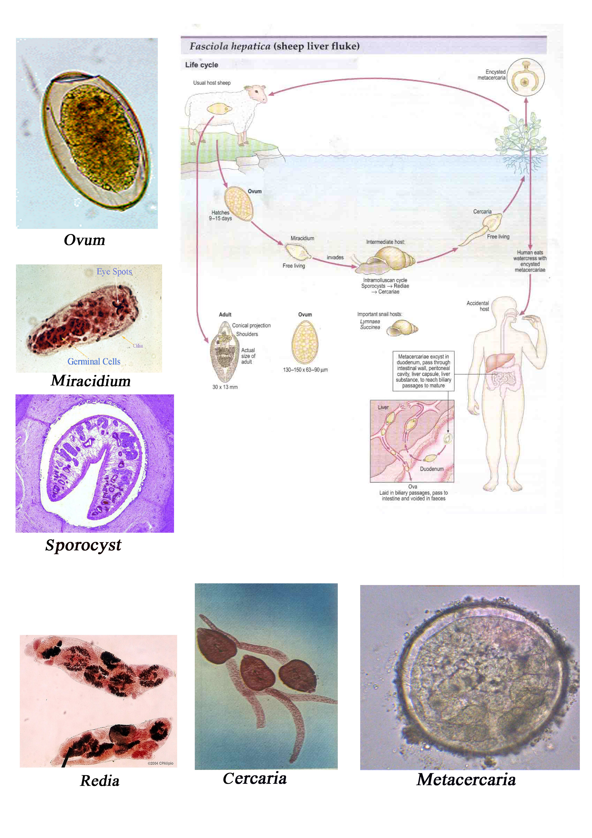
Life cycle of Fasciola hepatica

General characteristics:-
  - Adult worm is large, flattened dorso-ventrally.

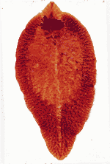

Fasciola hepatica adult

  - It has conical projection interiorly and rounded posteriorly.
  - It has 2 suckers' ventral and oral suckers.

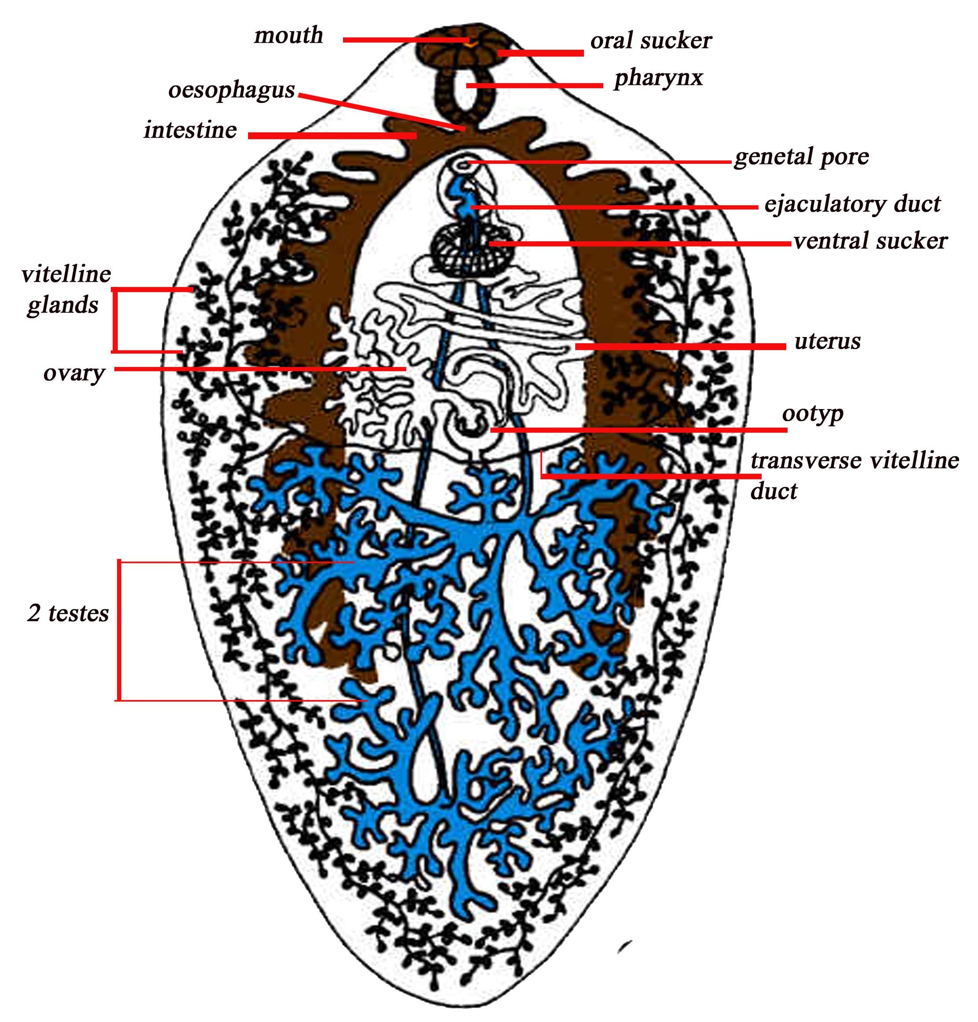
Fasciola hepatica adult structure

  - Digestive system consists of: - mouth → pharynx → esophagus → branched intestine (two intestinal caeci) with many lateral branches.
  - The male reproductive system consists of two greatly branched testes one behind the other in posterior half of the worm.
  - The female reproductive system consists of a fan shaped
ovary → oviduct → ootype → uterus → genital pore.
  - The egg is large oval, operculated, brownish yellow in color.
  - Infective stage is the metacercaria stage.

  - Laboratory diagnosis :-
Ova are found in feaces (microscopic examination of stool specimens).

*Blood flukes: - Ex: - Schistosoma Spp.
General characteristics :-
- Cylindrical, diecious worms, have oral and ventral suckers.

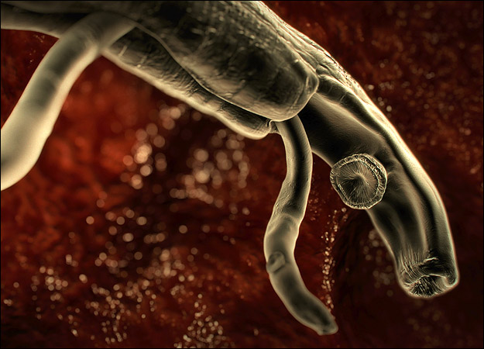
Schistosama Spp. adult suckers

- The male is shorter than the female and has gynecophoric canal in which the female is hold.

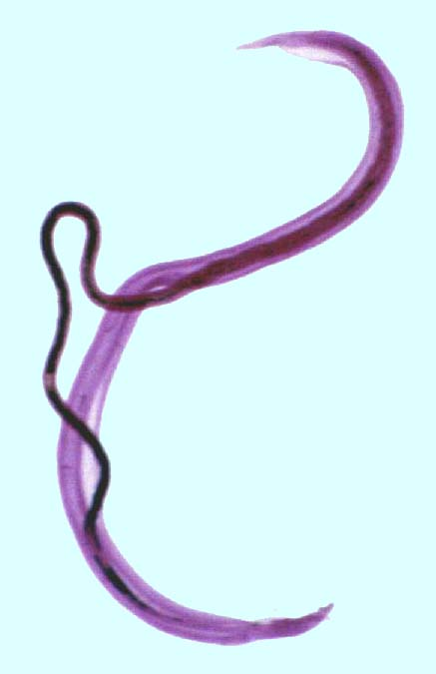
Schistosama Spp. copulation (male and female )

- The cercaria has forked-tail (infective stage).

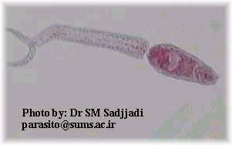

Schistosama Spp.cercaria (forked – tail cercria)

- They have not redia stage.
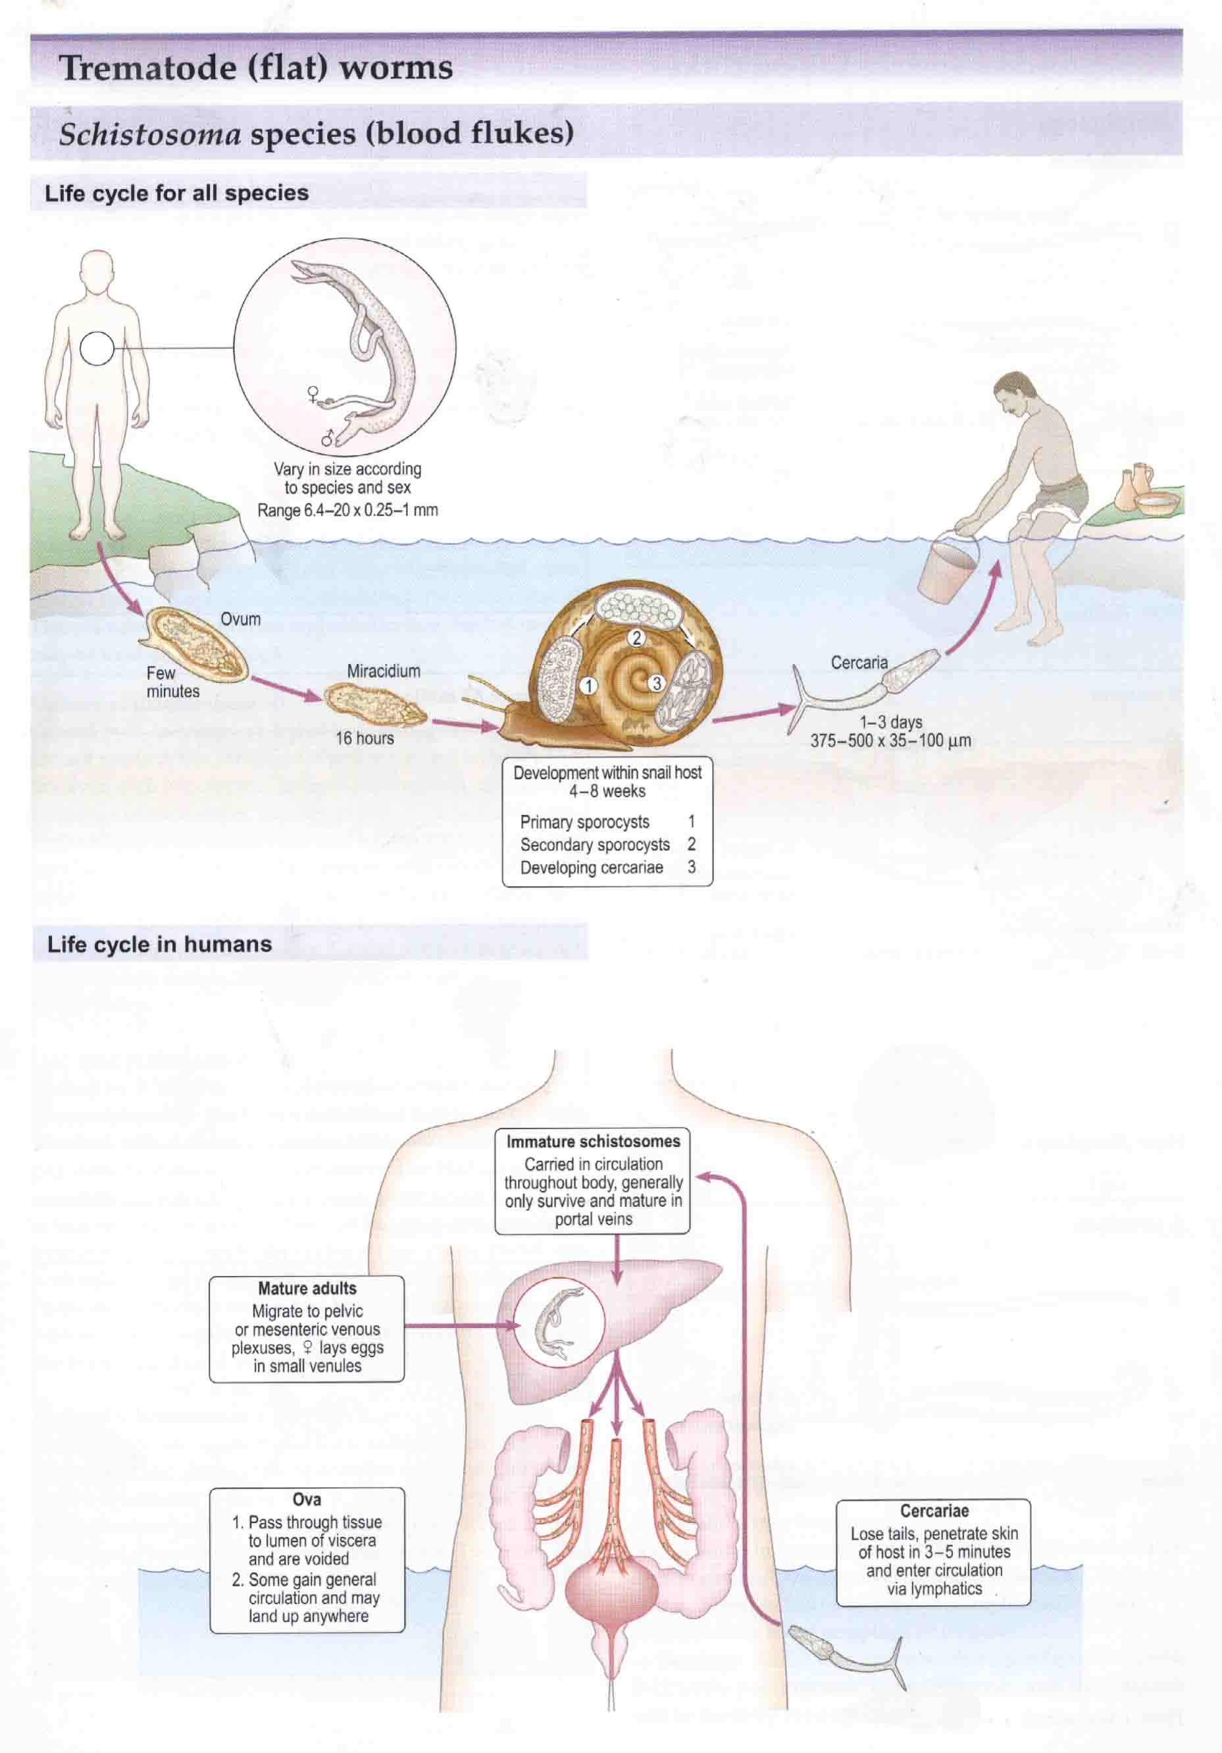
Life cycle of Schistosoma Spp.

- The eggs have spine.
- There are three species of schistosomes :-
Ex.1:-Schistosoma haematobium
Ex.2:-Schistosoma mansoni
Ex.3:-Schistosoma japonicum
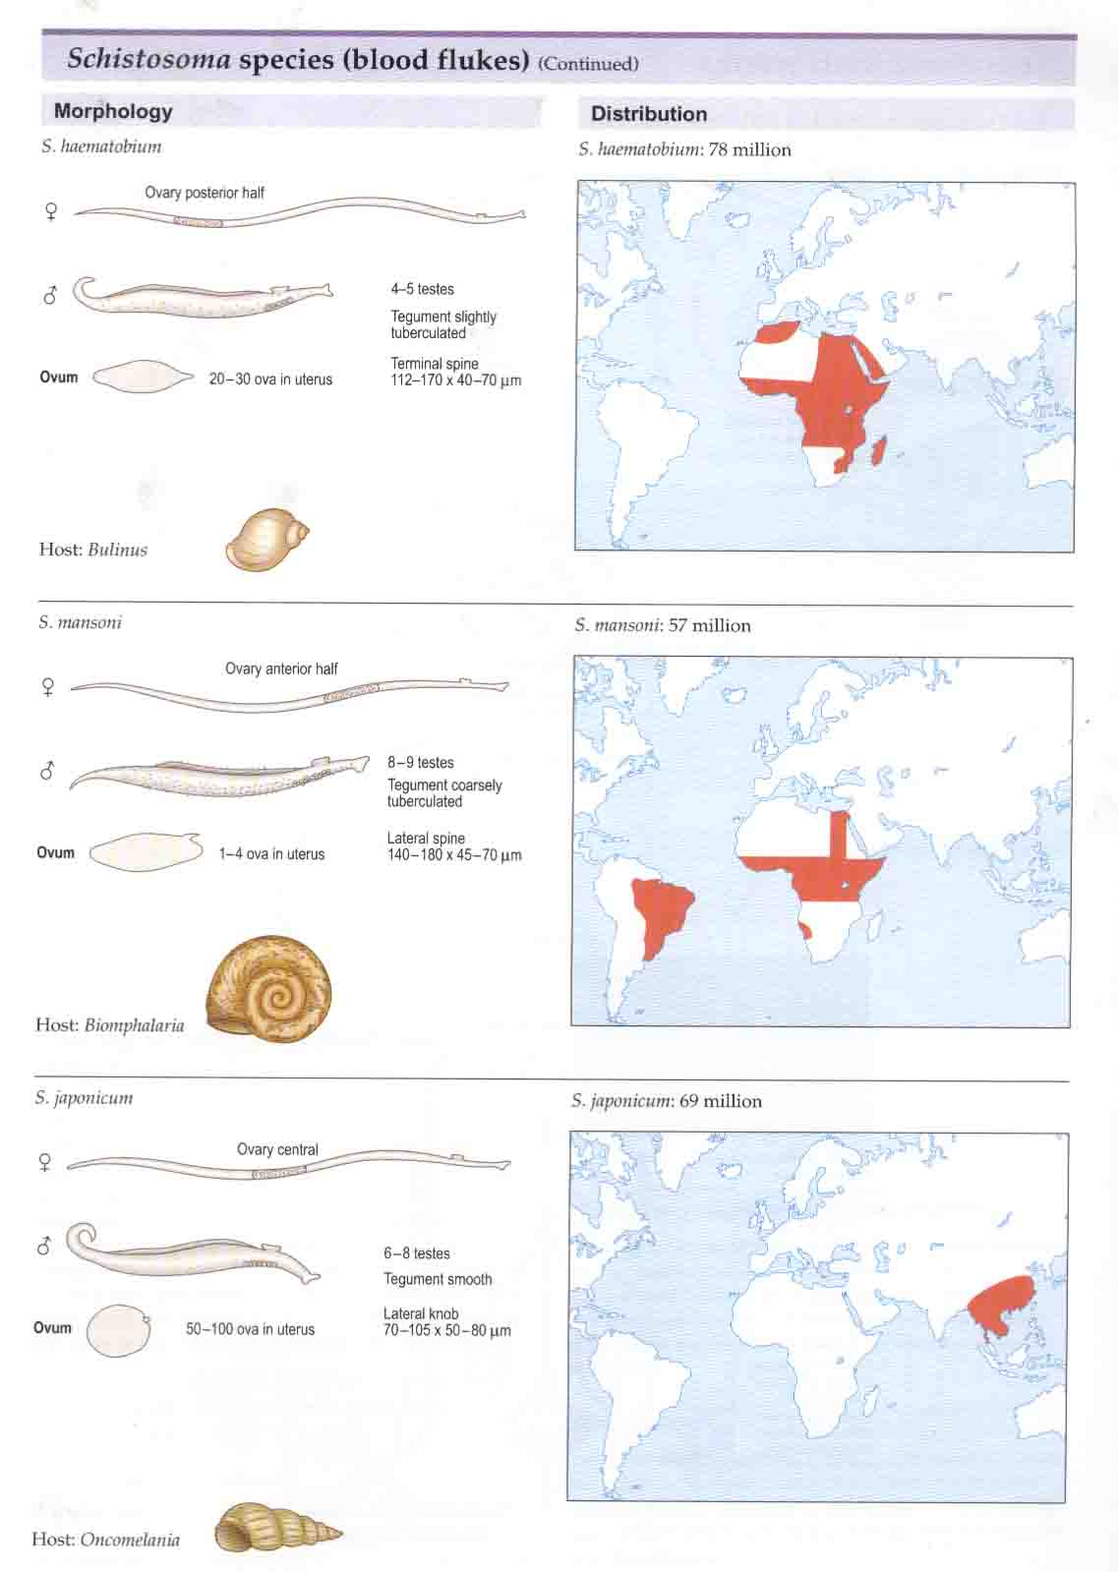

Comparison between the three types of Schistosoma Spp.(a)

Table(1):-Comparison between the three types of Schistosoma Spp.(b)

 | S. haematobium | S. mansoni | S. japonicum
- Final host | Man. | Man. | Man.
2-Intermediate  host | Snail Bulinus Spp. | Snail Biomphalaria Spp. | Snail Oncomelania Spp.
3-Egg | Has terminal spine pass in urine.  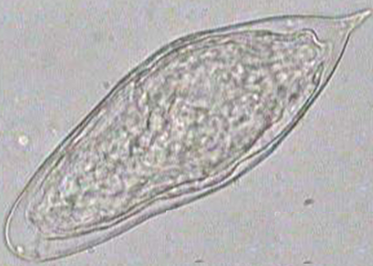  Schistosoma haematobium ovum | Has big lateral spine pass in feces.  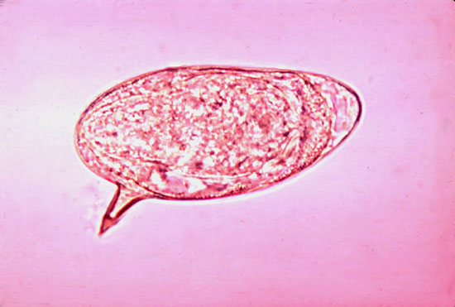  Schistosoma mansoni ovum | Has small lateral spine pass in feces.  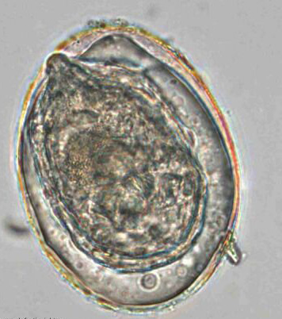  Schistosoma japonicum ovum
4-Adult male:  - Tegument  - Testes  - Intestine | Slightly tuberculated.  4 – 5.  Reunite in the centre. | Coarsely  tuberculated.  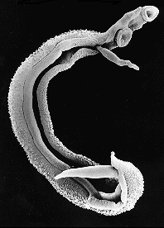  Schistosoma mansoni male tegume  8 – 9.  Reunite in the anterior half. | Smooth.  6 - 8 .  Reunite in the posterior half.
5-Adult female:  - Ovary  - Uterus | In the posterior half.  Has 20 – 30 ova. | In the anterior half.  Has 1 – 4 ova. | Ovary central.  Has 50 – 100 ova.
6- location | Pelvic venous plexuses | Mesenteric venous plexuses | Mesenteric venous plexuses
7- Disease | Bilharziasis | Bilharziasis   | Bilharziasis
8- Diagnosis | Microscopic examination of urine specimens contain ova. | Microscopic examination of stool specimens contain ova | Microscopic examination of stool specimens contain ova.

Appendix

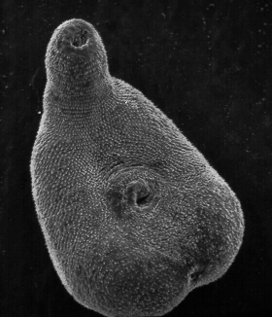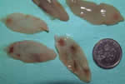
Fasciola hepatica adult Fasciola hepatica adult
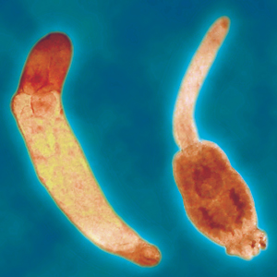
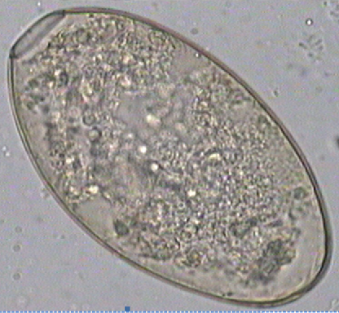
fasciola hepatica ovum
Fasciola hepatecia cercaria

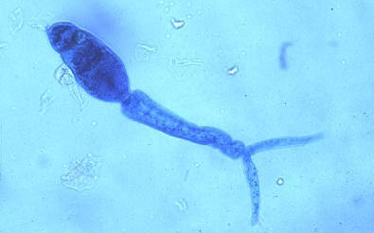

Schistosoma Spp.forked tail cercaria
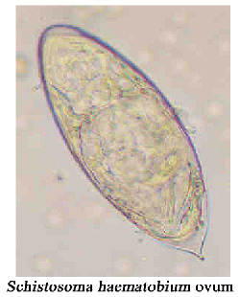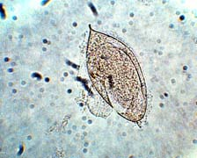
Schistosoma haematobuim ovum

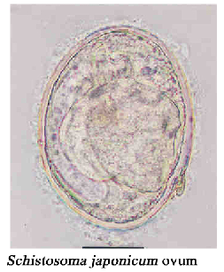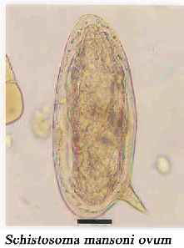

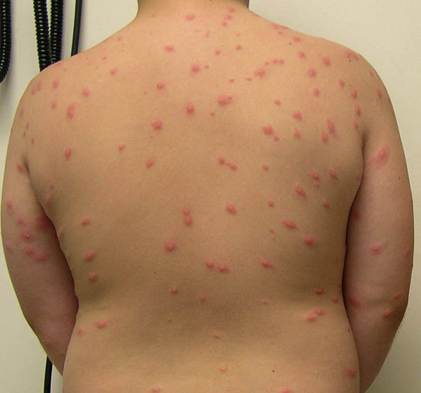

Swimmer's itch

