:

Phylum: - platyhelminthes

2- Class: - cestoidea
Subclass: - cestoda (tape worms)

- General characteristics :-
- Segmented tape-like worms , of several meters in length
- Adult worm consists of three parts: - the head (scolex), neck and trunk (strobila).
- The head carries cup like suckers ( organs of attachment )
- The neck, immediately behind the head is the region of growth and segment formation.
- The trunk (strobila) is composed of a chain of segments, the segments near the neck are the young immature segments, behind them are the mature segments and at the hind end are the gravid segments.
- The reproductive system is well developed; the mature segment
contains both male and female sex organs (hermaphroditic).

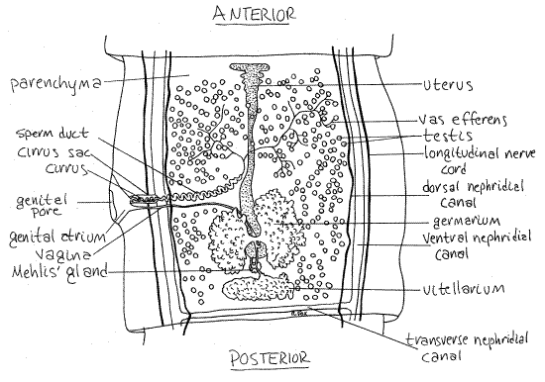
Tape worms mature segment structure

- The gravid segments are completly occupied by the uterus filled with eggs.
- The embryo inside the egg is called oncosphere provided with three pairs of hooklets and called hexacanth embryo.
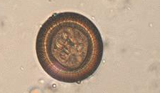

The ovum of tape worms

- the tape worms of medical importance belong to the order : Cyclophyllidea which includes :-
Ex.1:-Taenia solium
Ex.2:-Taenia saginata
Ex.3:-Echinococcus granulosus

Table(1):-Comparison between the three types of tape worms
 | Taenia solium | Taenia saginata | Echinococcus granulosus
- Length of adult worm. | 2 – 4 meters .  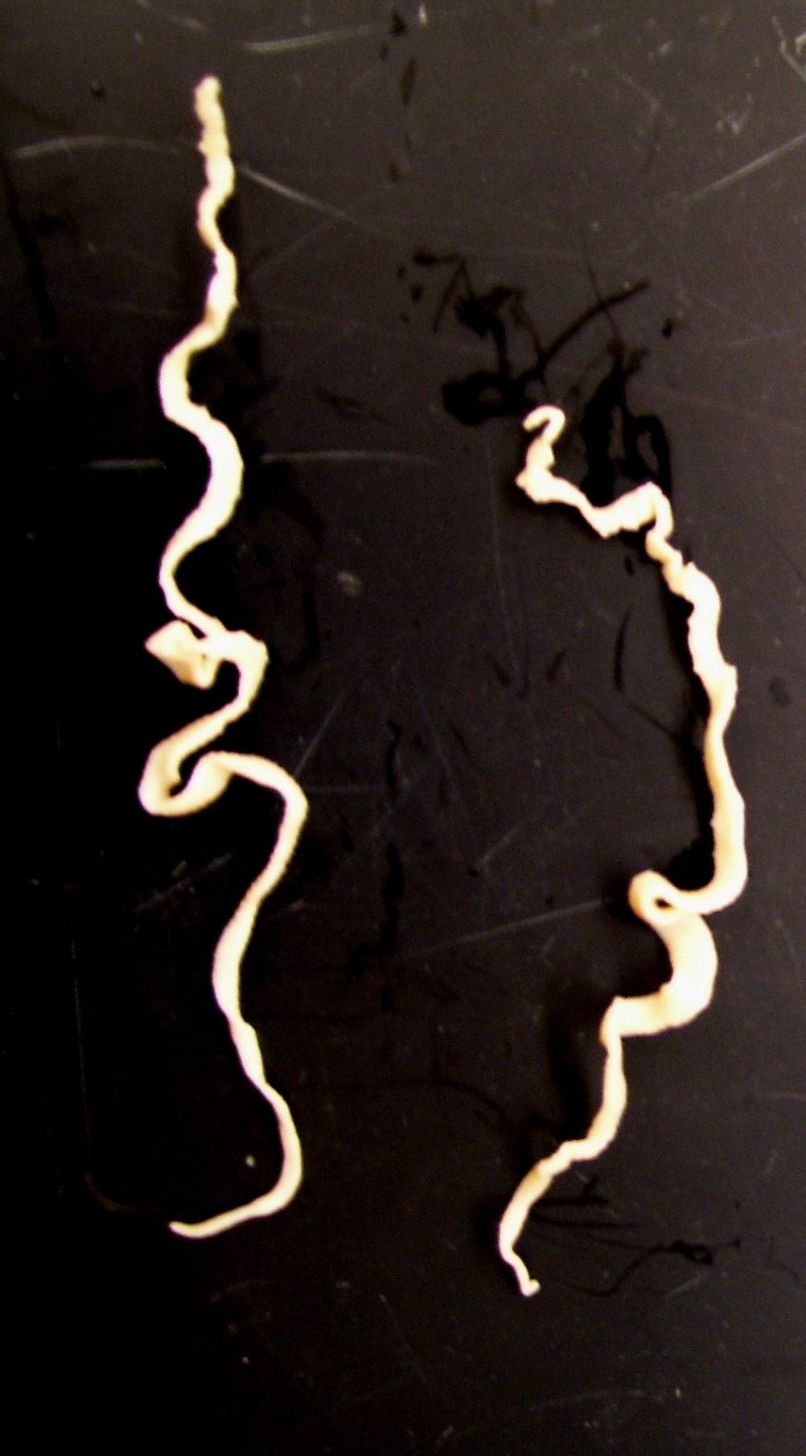  Taenia solium adult worm | 5 – 25 meters.  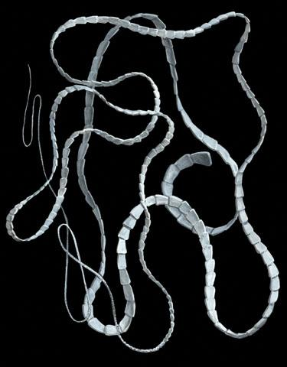  Taenia saginata adult worm | 3 – 8 mm.  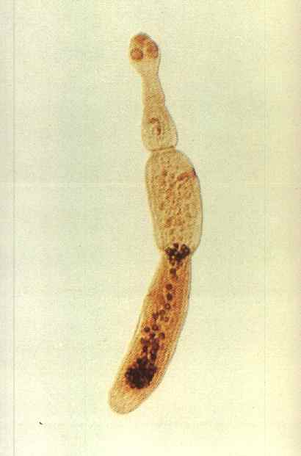  Echinococcus granulosus adult worm
2-Scolex suckers. | 4 | 4 | 4
3-Hooks. | 2 circles | Non. | 2 circles
4-Rostellum | Present.  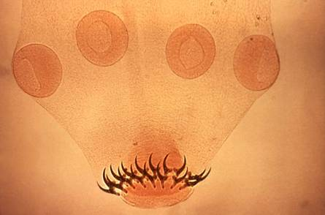  Taenia solium scolex | Non.  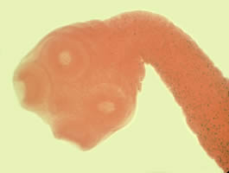  Taenia saginata scolex | Present.  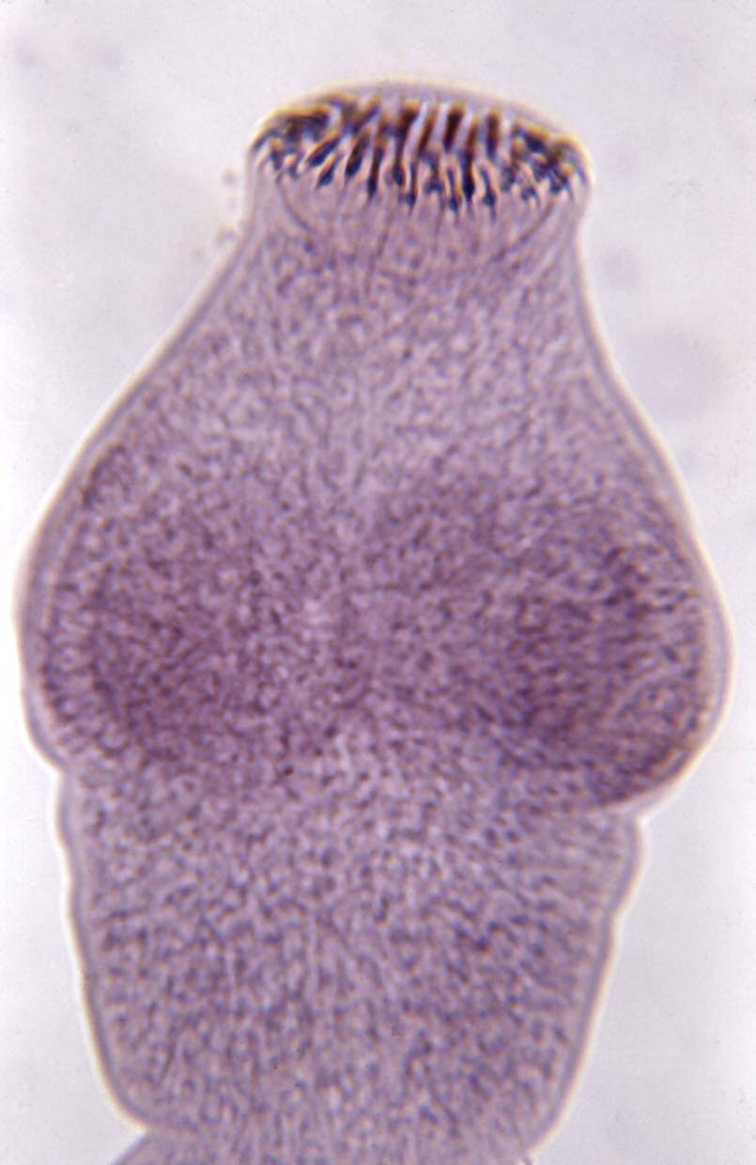  Echinococcus granulosus  scolex
5- Number of segments. | 800-1000 | 1000-2000 | 3
6-Mature segment | Nearly square . | Broader | elongated .
7- Uterus of gravid segment. | 7 – 15 lateral branches.  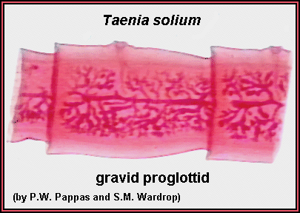  Teania solium gravid segment | 15 – 30 lateral branches.  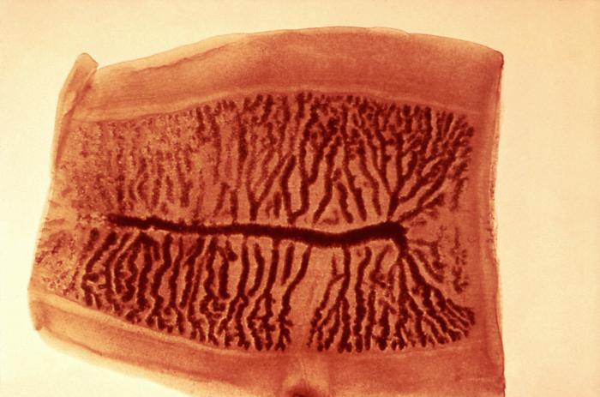  Teania saginata gravid segment | 12 – 15 lateral branches.
8- genital pore | Lateral alternate. | Lateral alternate. | Lateral alternate.
9- Infective larval form. | Cysticercus cellulosae.  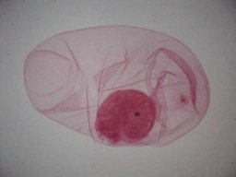  Cysticercus cellulosae | Cysticercus bovis. | Hydatid cyst.  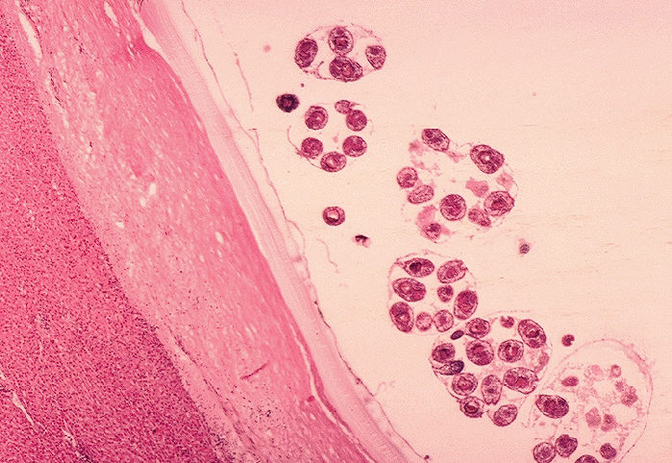  Section in hydatid cyst  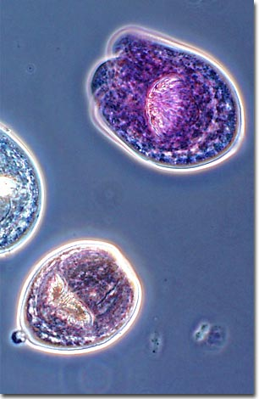  protoscolices
10- ovum. | Redially striated embryophore. | Redially striated embryophore. | Redially striated embryophore.
11- stage in man | Adult, Larval | Adult | Larval
12- Intermediate host | Pork, man | Cattle. | Man, herbivorous.
13-Final host. | Man . | Man. | Dog.
14-common name | The pork tape worm.  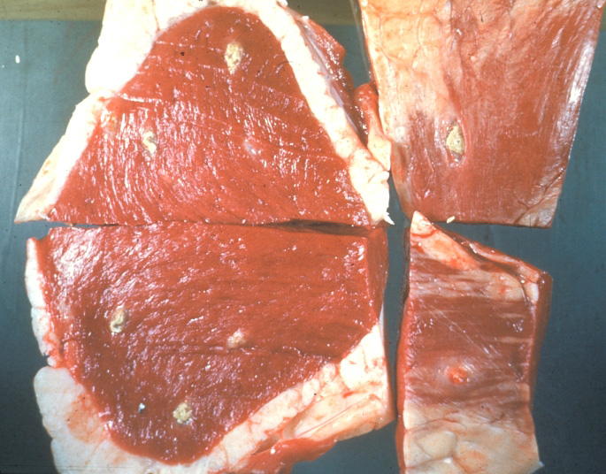  Cysticercus cellulosae in pork | The beef tape worm. | The dog tape worm.
15-habitat | The adult worm lives in human small intestine (jejunum). | The adult worm lives in human small intestine (jejunum). | *The adult worm lives in small intestine of dog.  *The larval form found in man and herbivores.
16- disease | Taeniasis solium. | Taeniasis saginata. | Hydatidosis.  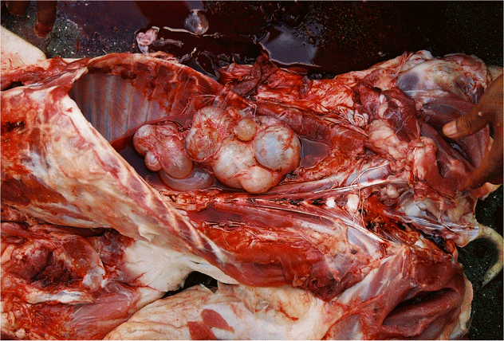  Hydatidosis
17- Diagnosis. | - Microscopic examination of stool specimens contain ova and gravid segments.  - Histological examination of biopsy material. | Microscopic examination of stool specimens contain ova and gravid segments. | x-ray , MRI , ELISA , ultrasonography
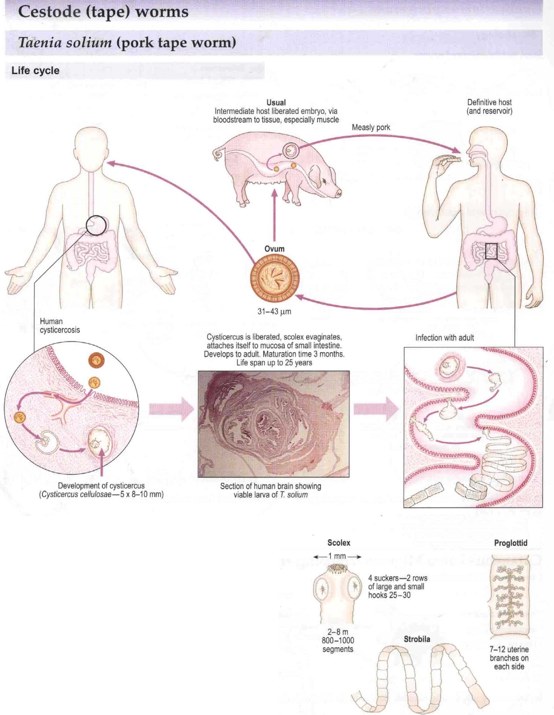
Live cycle of Taenia soluim

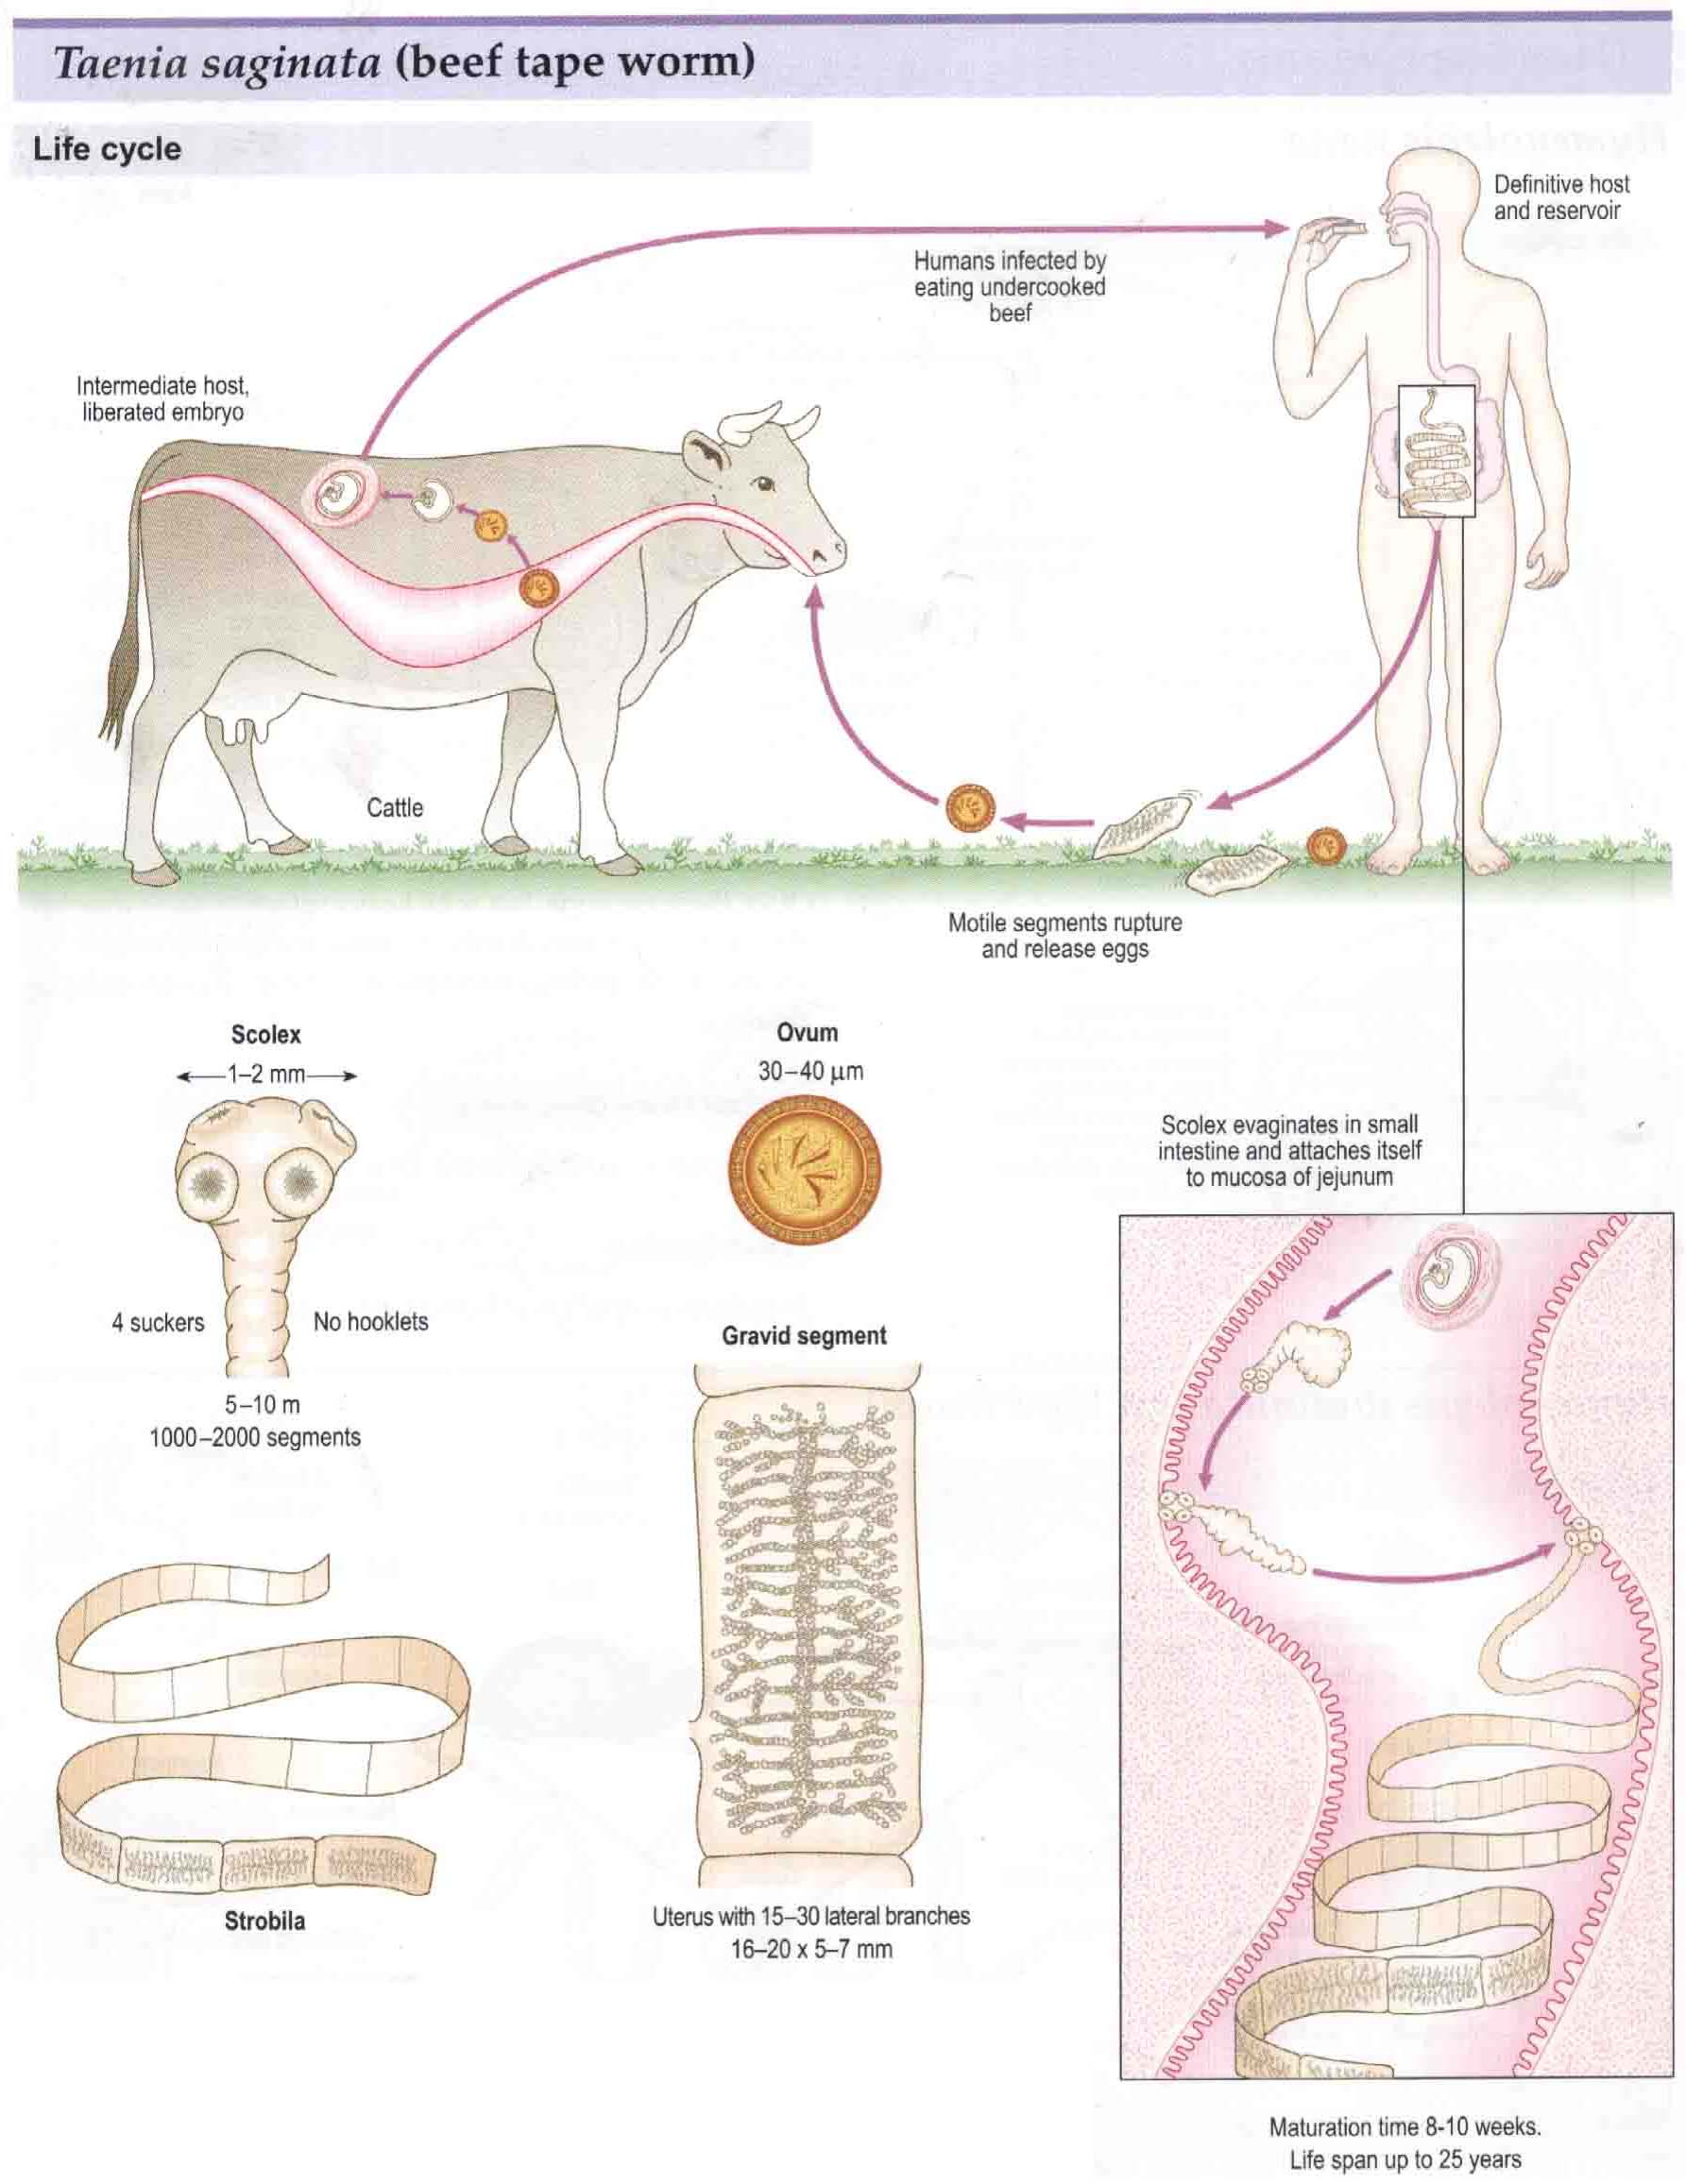
Live cycle of Taenia saginata

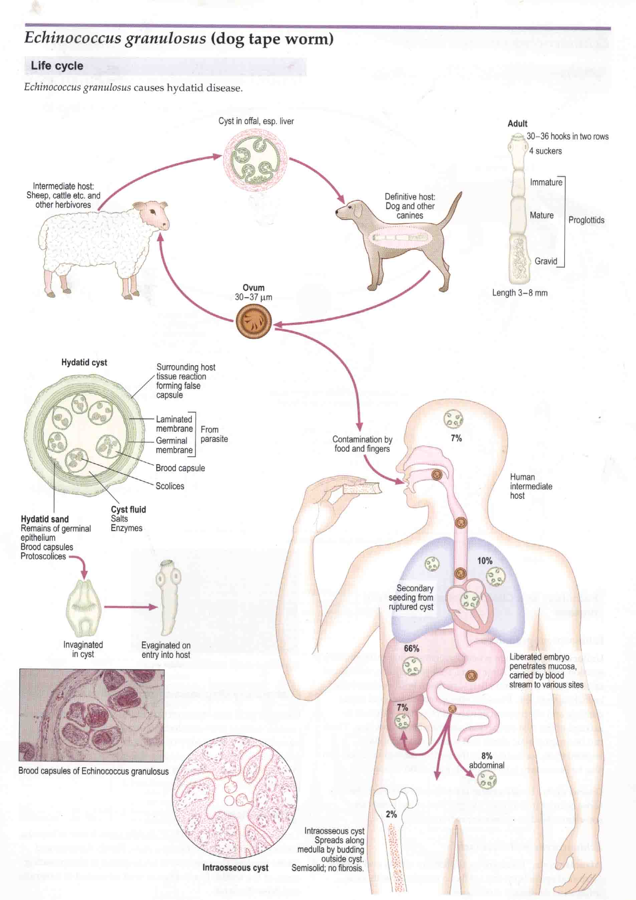

Life cycle of Echinococcus granulosus
2-Phylum:- Nemathelminthes

Class: Nematoda

General characteristics :-

- Non-segmented worms, generally cylindrical in shape, tapering at both ends.
- The body is covered by a tough protective covering (cuticle).
- The sexes are separated (diecious); generally, males are much smaller than females and have curled posterior ends.

- The life cycle consists of four larval stages and the adult form.
- Many species of nematodes infect man :
Ascaris lumbricoides , Ancylostoma duodenale ,
and Enterobius vermicularis

Ex.1:- Enterobius vermicularis
Common name: pin worm or seat worm.

Disease: Enterobiasis

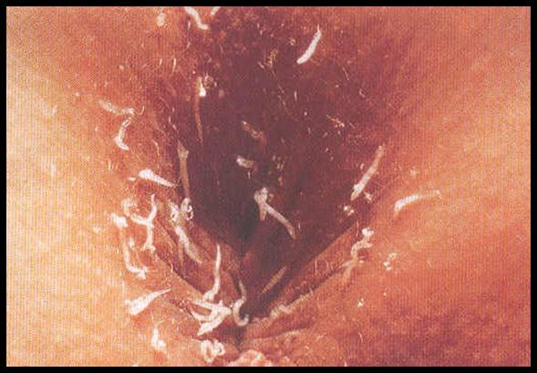

Enterobiasis
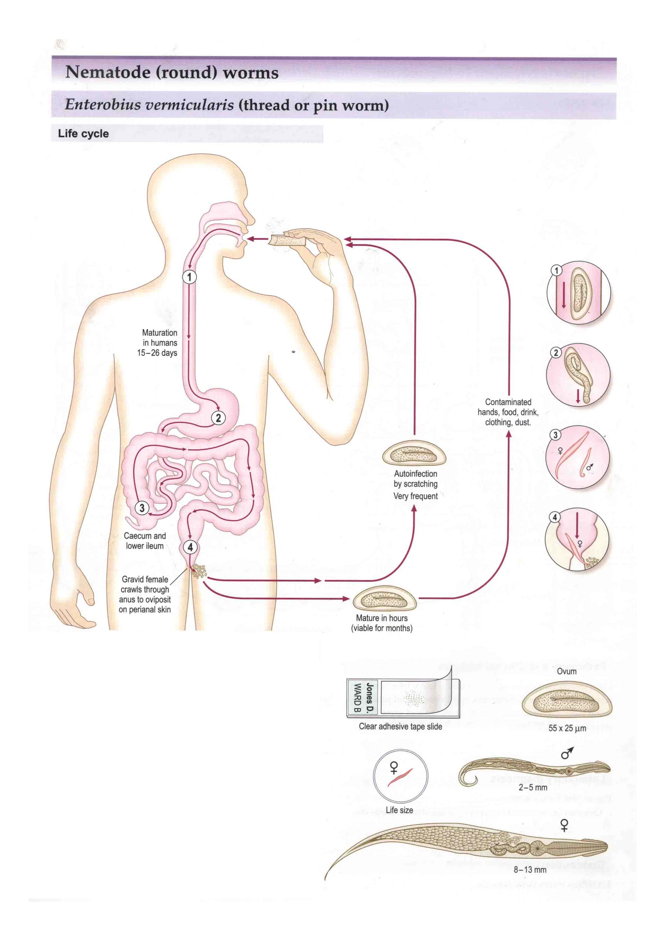
Life cycle Enterobius vermicularis

Habitat: the adult worm lives in the caecum, appendix and the ascending colon.

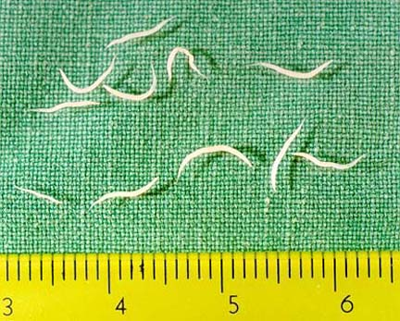

Enterobuis vermicularis adult worm

General characteristics :
- The adult worms are short, white, fusiform, worms
with pointed ends.

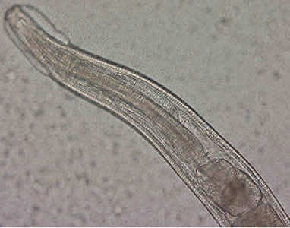
Enterobius vermicularis anterior end of adult

2- The mouth is surrounded by three cervical alae.
3- The esophagus is dilated posteriorly into a prominent bulb.
4- The female has pointed pin like tail.
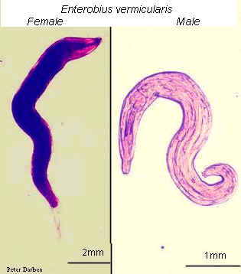

Enterobius vermicularis adult (male and female)

5- the ovum is the infective stage and it is a plonoconvex
ovum (D-shaped).
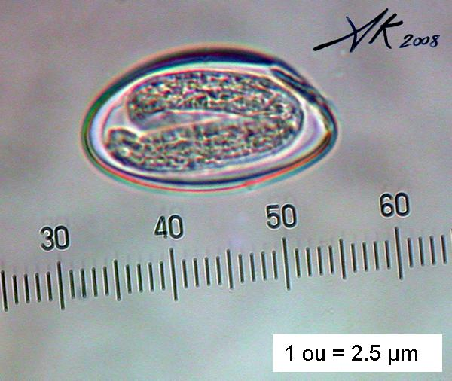
Enterobius vermicularis ovum

Laboratory diagnosis:
1-microscopic examination of stool specimens contain ova
(after centrifugation).
2-ova can be recovered from the perianal area using clear adhesive tape or a cotton swab moistened with saline.
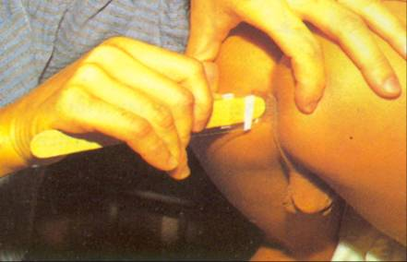

Adhesive tape method

Appendix

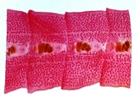
Tap worms mature segments

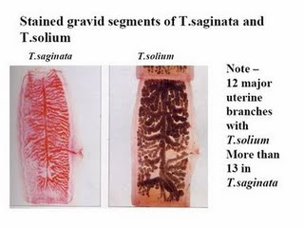
Comparison between gravid segments of
Taenia solium and Taenia saginata

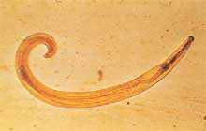
Enterobius vermicularis male

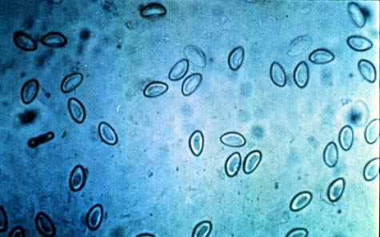
Enterobius vermicularis ova collected by
clear adhesive tape

