Isolation and Identification of Neisseria
General characteristics
- Gram negative diplococci (kidney shape)
- Pyogenic bacteria
- Ferment carbohydrates
- They are found inside polymorph nuclear (PMNs) pus cell (intracellular), they may be found extracellular in chronic cases.
- They grow poorly on simple media. They require enriched media such as chocolate agar with 5-10 % CO₂
- There are two important types.
- Pathogenic Neisseria
- Neisseria meningitides (meningococci): cause meningitis with or without septicemia. These organisms are normal inhabitant in oropharyngeal or nasopharyngeal mucous membrane of human but human carriers of this organism without symptoms is common (asymptomatic).
- Neisseria gonorrhea (gonococci) (sexual transmitted disease): result in gonorrhoeae in genital tract such as urethritis in male or cervicitis in female but rarely found in throat cause pharyngitis, conjunctivitis and rectal infection. May be found in mucous membrane of genital tract at the time of infection.
- Non pathogenic commensal Neisseia include
- N. catarrhalis: this organism is normal flora of the upper respiratory tract but rarely cause respiratory infection (pneumonia, sinusitis and otitis media) or it is usually as opportunistic pathogen)
- N. subflava c- N. sicca d- N.mucosa e- N.lactamica
All non pathogenic are normal flora of the upper respiratory tract

Lab dignosis
Specimens:
  - CSF in meningitis.
  - Urethral discharge swab.
  - Pus or secretion from throat,conjuctivita and rectum in cases of pharyngitis, conjunctivitis and rectal infections.
  - Blood in a systematic infections.
Staining:
Gram negative, dipolcocci arranged in pairs with aflatten or concave opposing edges( kidny shape) intracellular inside polymorphneuclear leukocytes.
In male if the smear is positive (no need culturing ) but in female we need smear for stainig and culturing. The diagnosis must be confirmed with culture because the vaginal flora that composed from gram negative coccobacilli which resemble Neisseia spp.
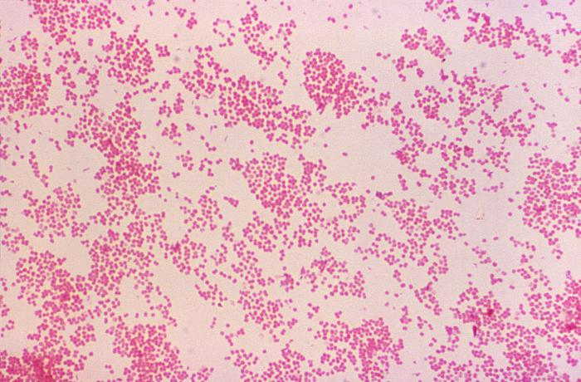 non- pathogenic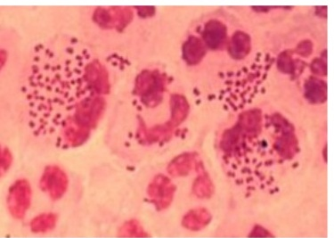intracellular pathogenic
Fig.1: Pathogenic Neisseria ( inside PMN ) and non pathogenic.

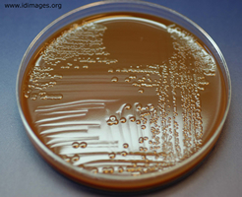
Culture:
Choclate agar: most of pathogenic Neisseria grow on this media
Nutreint agar: most of non- pathogenic Neisseria grow on this media
Neisseia meningitidis grow on blood sheep 5% and choclate agar with 5- 10% CO₂
All incubated in 35- 37 C⁰ for 72 hrs
Selective media for pathogenic Neisseia
Fig.2: Neisseria meningitidis colonies on chocolate agar plate.
Thayer martin agar consist of choclate agar and enriched supplements (isovitalex), and antimicrobial agents added like polymyxin to inhibit G- and vancomycin to inhibit G+ and nystatin or amphortericin B inhibit yeast

Biochemical test
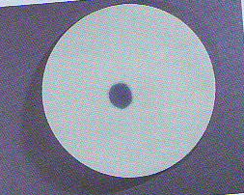
-Oxidase Oxidase enzymes have an important role in the electron transport system during aerobic respiration . This test is used in the differentiation between the oxidase positive bacteria (Neisseria, Pseudomonas and Vibrio) and the other gram negative bacteria:
Positive for all Neisseria spp , filterpaper impregnated with oxidase reagents if give purple colour that means positive result while is stay in pink colour that means negative

Fig.3: Positive Oxidase test
Sugar fermentation: Table (2) sugar fermentation
Neisseria spp. | Acid formed from:
 | Glucose | Maltose | Sucrose
N. gonorrhoeae (gonococcus) | + | - | -
N. meningitides (meningococcus) | + | + | -
N. sicca | + | + | +
N. catarrhalis | - | - | -
Other tests: There are other tests for examples immunological tests

Family: Mycobacteriaceae

Genus: Mycobacterium
Spp.: a- M. tuberculosis (cause Humans Pulmonary and disseminated tuberculosis).
  - M. leprae (cause Humans Leprosy).
  - M. bovis (cause Humans, cattle Tuberculosis-like disease).

General characteristics:
- The mycobacteria are rod-shaped, aerobic bacteria. Although they do not stain readily, once stained they resist decolorization by acid or alcohol and are therefore called "acid-fast" bacilli. All Mycobacterium species share a characteristic cell wall, thicker than in many other bacteria, which is hydrophobic waxy, and rich in mycolic acids/mycolates.

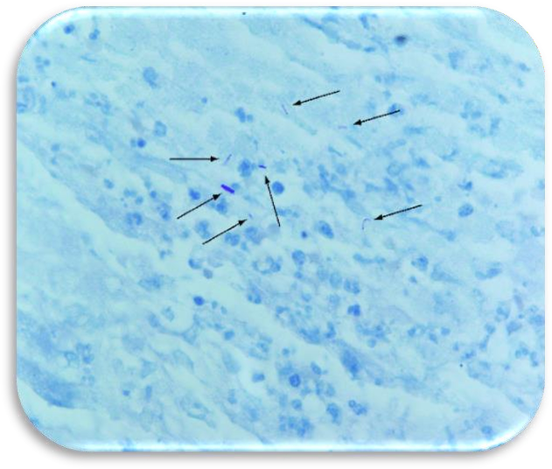
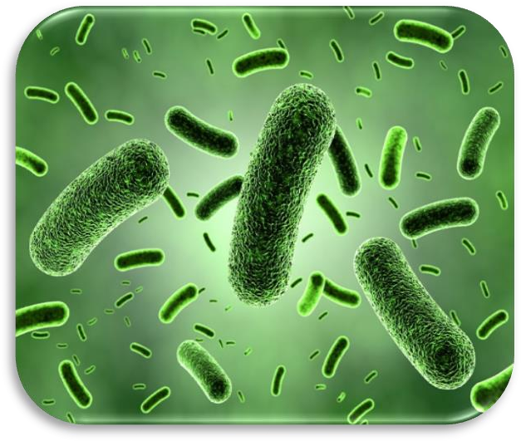
Mycobacteria cannot be classified as either positive or gram – negative. True tubercle bacilli are characterized by acid-fastness, i.e., 95% ethyl alcohol containing 3 % hydrochloric acid (acid-alcohol) quickly decolorizes all bacteria except the mycobacteria because it’s have waxy envelop (mycolic acid).
The Ziehl-Neelsen stain is employed for identification of acid fast bacteria (the single M. tuberculosis appeared red against a faint blue background).

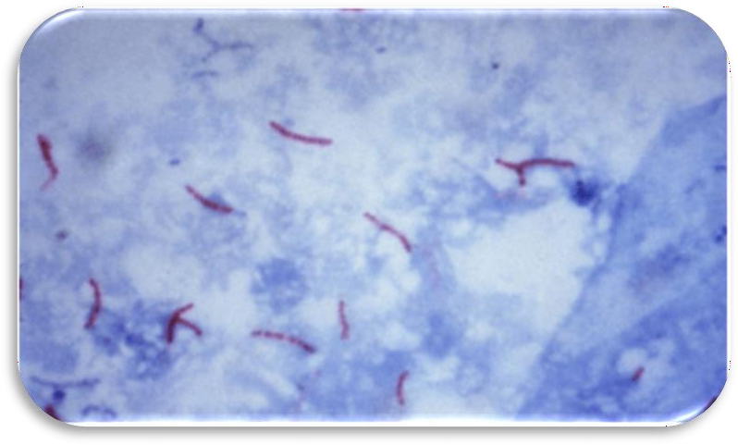
In smears of sputum or sections of tissue, mycobacteria can be demonstrated by yellow-orange fluorescence after staining with fluorochrome stains (e.g., auramine, rhodamine).
Types of media that used to grow Mycobacterium:
1-Lowenstein-Jensen media: contain salts, glycerol, and complex organic substances (e.g., fresh eggs or egg yolks potato flour). Malachite green is included to inhibit other bacteria. Small inoculum in specimens from patients will grow on these media in 3-6 weeks

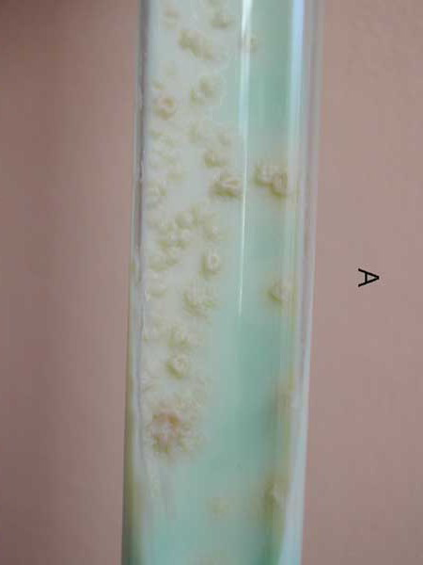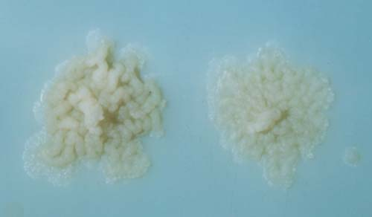

2-Broth Media: this support the proliferation of small inoculum. Ordinarily, mycobacteria grow in clumps or masses because of the hydrophobic character of the cell surface.

Specimens:
- Fresh sputum.
- Gastric washings.
- Urine.
- Pleural fluid.
- Cerebrospinal fluid.
- Joint fluid.
- Biopsy material.
Blood or other suspected material.

Lab diagnostic tests:
Smears: Sputum, exudates, or other material is examined for acid - fast bacilli by Ziehl - Neelsen staining.
Culture: specimens from non-sterile sites (decontaminated with NaOH, kills many other bacteria and fungi) neutralized with buffer, and concentrated by centrifugation, Lowenstein-Jensen inoculated and incubation is 35 - 37 °C in 5 - 10 % CO2 for up to 8 weeks ,
DNA Detection: The polymerase chain reaction holds great promise for the rapid and direct detection of M. tuberculosis in clinical specimens.

