**pharmacognosy**

**Lec. 1 &2 2016-2017 Assistant Lecturer**

**2nd stage 2nd semester Zahraa A.E. Al-Naqqash**

**Introduction to Pharmacognosy**

**Pharmacognosy**: is the study of medicinal products in their crude or unprepared form. The word derived from ‘*pharmakon*’ meaning drug and ‘*gnosis*’ meaning knowledge (Greek word).

**Pharmacognosy** is a subject identify or authenticate the plant parts using macroscopical, anatomical and phytochemical characters; and it includes the study of the physical, chemical, biochemical and biological properties of drugs, drug substances or potential drugs or drug substances of natural origin as well as the search for new drugs from natural sources.

Although **pharmacognosy** is principally concerned with plant materials there are some animal products which are traditionally encompassed within the subject such as beeswax, gelatine, wool fat, vitamins etc. In addition to that the antibiotics, hormones and others may also be involved; marine organisms (plants and animals) which have special potent pharmacological actions are now paid high attention in the search for new drugs. Also there are other materials that have natural associations with the subject are (poisonous & hallucinogenic plants, allergens herbicides, insecticides & molluscicides).

**Pharmacognosy science concerned with studying the following subjects:**

1. Taxonomy of plants and the natural sources of drugs.
2. Distribution of natural products in the world.
3. Description of plants such as tree (salix), shrub (catharanthus), perennial (peppermint).
4. The active constituents from natural sources (active groups) such as Glycosides, Alkaloids, Volatile oils, Tannins etc.
5. The biosynthesis and storage places of the active constituents in organisms (plants, animals etc.).
6. The part used from the natural sources in medicine and pharmacy as leaf (Mint, Digitalis), roots (Liquorice), seeds (Coffee bean), bark (Cinnamon).
7. Storage and collection of the used part.
8. Physical, chemical and biological properties of active constituent.
9. The correct prescription of natural drug in the treatment of the disease.

**Botanical Nomenclature**

In the 18th century, Latin was universal language of scientists. Carlos Linnaeus (1707-1778) was a botanist and compulsive organizer. He was the founder of the botanical nomenclature system. Nomenclature system may include plants place of origin, leaf, bud, branch of flower description, special characteristics or even named after a person.

The botanical nomenclature system is still worldwide used till now with many new plants discovered and many changes. His ideas in classification have influenced generations of biologists during and after his own life time. In his nomenclature the first Latin word spelled with capital letter indicated the genus. The second name not capitalized pinpoints the species. Then plant family with capital letter.

E.g. Belladonna ست الحسن

Botanical name: *Atropa belladonna* (family: Solanaceae).

**Definitions and Basic Principles**

**Pharmacopoeia:** is a book containing directions for the identification of samples and the preparation of compound medicines and published by the authority of a government or medical or pharmaceutical society.

**Drug:** is a naturalor synthetic substance used in the treatment, cure, prevention or diagnosis of disease or used to otherwise enhance physical or mental well-being. Drugs maybe prescribed for a limited duration or on a regular basis for chronic disorders; the drug should be included in the official pharmacopoeia.

**Crude drug:** natural products which are not pure compounds i.e. plants or parts of plants, extracts or exudes; or an un refined or raw drug that is in its natural form such as a drug which is taken directly from plant source.

**Extract:** is a substance made by extracting a part of a raw material often by using solvent such as **ethanol** or **water**. Extracts may be solid as tinctures or in powder form. The aromatic principles of many spices, nuts, herbs, fruits etc., and some flowers are marketed as extracts. Among the best known true extracts are almond, cinnamon, ginger, lemon, peppermint, vanilla, pistachio and rose.

**Extractives (derivatives):** this term deals with the principle constituents that found in natural substances which give natural drug its pharmaceutical activities by many methods like extraction, distillation etc.; they found whether a single or mixture constituents. E.g. the plant Mint is a natural substance, its leaf also natural substance after drying (dried leaf) is considered crude when expressed to drying process is still as found in nature (there are no changes have been made to their molecular structure). Dried leaves are considered as crude drug when they used for the treatment of diseases like stomach inflation pain.

**Types of plant-derived drugs**

***Natural products’:*** single molecules;pure compounds

***Botanicals:*** herbal medicines; whole or partially purified extracts

***Biologicals:*** molecules produced in plants after genetic manipulation

**What is the difference between them?**

***Natural products:*** highly potent drugs, single entity natural products which can be given in very accurate doses e.g. anticancer drugs. Usually very toxic – some have little traditional medical use or it may be unrelated to ‘new’ use – found by bioassay-led isolation. Can often be made synthetically on a commercial scale.

***Botanicals:*** single plant extractsor traditional formulae (e.g. TCM); may be used simply (e.g. to make a ‘tea’) or made into other dosage forms (e.g. tablets). Low toxicity, complex mixtures, most with a history of traditional use: ‘new’ use usually related to ‘old’ use. Cannot be made synthetically but must be grown.

***Biologicals:*** molecules produced in either whole plants or in plant cell culture as a result of genetic manipulation. Chemical structure need not be related to the ‘normal’ constituents of the plant (e.g. vaccines).

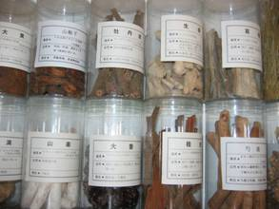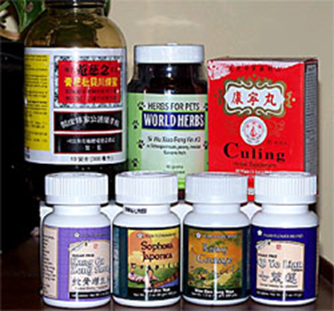

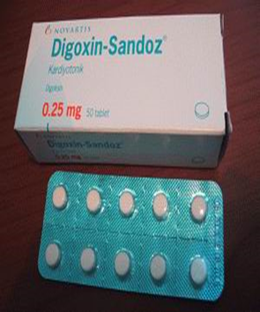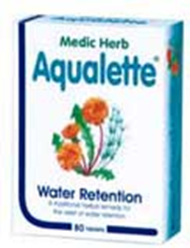

**Natural products**

Natural products/compounds are small or medium molecular weight organic compounds of natural origin: plants, microbes (fungi and bacteria), marine organisms and even frog skins and insects.

In pharmacognosy, natural products were studied for their biological origin, extraction, pharmacology, clinical use and role in drug discovery (may be modified chemically).

**Botanical Drugs**

Dried parts of entire plants, plant organs, or parts of plant organs used as medicines, aromatics, spices or additives.

Products directly obtained from plants which no longer have an organ structure, such as essential and fatty oils, balsams etc.

**Herbal (phyto) medicines**

Obtained from either whole plant (herbs) or specific organs (leaves, fruits, seeds, bark, etc.); may be used as fresh or dried plant material, sold as such, or as a liquid or solid extract (may be made into tablets etc.)

Most of these products are on the GSL (General Sales List), some are P only (Pharmacy Only) or POM (Prescription Only Medicines), others are unlicensed

Phytomedicines are made up of complex mixtures of natural products, some of these are the active compounds, others are considered to be of little of no pharmacological relevance (This is an essential difference to other pharmaceuticals).

**Who (still) uses herbal medicines?**

The use of herbal extracts is common to all forms of indigenous systems of medicine and most of the world’s population still relies on plants for the majority of their healthcare requirements.

In the United States, an estimate showed that 24% of the general population regularly take herbal products also U.K. and Singapore with different percentages.

**Parts of plants used medicinally**

1. Leaf (*folia*): e.g. foxglove, belladonna, coca, tea, ginkgo
2. Flower (*flos, flores*): e.g. chamomile, marigold, arnica, hops
3. Herb (all aerial parts, *herba*): e.g. peppermint, sage
4. Fruit (*fructus*): e.g. star anise, fennel, saw palmetto, bilberry
5. Seed (*semen*): e.g. horse chestnut, mustard, ispaghula
6. Bark (*cortex*): e.g. cinnamon, cascara, cinchona, willow
7. Root (*radix*): e.g. devil’s claw, ginseng, Echinacea
8. Rhizome (*rhizoma*): e.g. ginger, turmeric, liquorice
9. Bulb (*bulbus*): e.g. garlic, squill
10. Wood (uncommon -*lignum*): e.g. sandalwood, quassia
11. ‘Unorganised drugs’ latex (e.g. opium) resins, gums and balsams (e.g. acacia, tragacanth, benzoin, asafoetida, myrrh); juices (e.g. Echinacea); aloe vera; essential oils (pressed or distilled): e.g. peppermint, orange, geranium and lavender.

**What do we need to know about a medicinal plant?**

1. Botanical origin (species and family)
2. Plant part which provides the drug
3. Type of product used:   
   a- Ground plant material  
   b- Uncharacterised extract   
   c- Standardised extract

d- Isolated constituent  
 e- Processed (special) extract

1. Active constituents (if an extract, and if identified).
2. Pharmacological effects and clinical effectiveness, side effects and interactions with other drugs.

**An example of a ‘botanical drug’:**

**Turmeric**

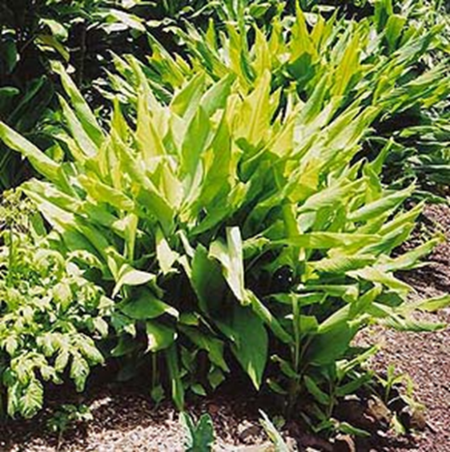

Botanical name: ***Curcuma domestica***Val. [syn. *C. Longa* L. (Zingiberaceae)]

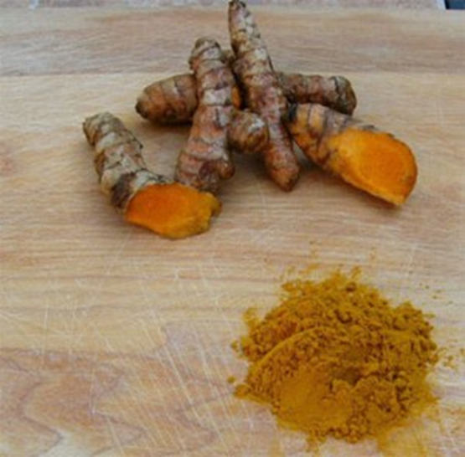

*Curcumae domesticae* rhizoma

Full botanical name: *Curcuma domestica* Val.

Genus: *Curcuma*

Species: *domestica* (domestic)

Family: Zingiberaceae (the ginger family)

Botanical authority: Is short for the botanist who last described and named it

Botanical synonym: *C. longa* L. (only abbreviated if the genus name (*C*.) is the same and has already been stated)

Common names: turmeric

Related species: *Zingiber officinalis* (Ginger)

**What needs to be known about a botanical drug?**

**Turmeric**

* The plant: *Curcuma domestica* Val. (Zingiberaceae).
* Part of plant: rhizome (underground stem) ⇒ dried and ground ⇒ dark yellow powder.
* Food use: spice and colouring agent.
* Medicinal use: anti-inflammatory agent used in arthritis, psoriasis, for dyspepsia, ulcers and other gastrointestinal problems and for liver disease.
* Constituents: types of phytochemical present.
* Toxicity: is it safe? Yes, used widely as a food.
* State of current research and clinical evidence:for turmeric,much interest, lots of on-going work but needs more clinical evidence…….

**Turmeric Constituents**:

* Curcuminoids; the mixture is known as ‘curcumin’, consisting of several phenolic diarylheptanoids, including curcumin itself with various derivatives (demethoxy etc) – the major ‘actives’.



* Essential oil (about 3-5%), containing sesquiterpene ketones (‘turmerones’) including arturmerone, alpha-atlantone, zingiberene, plus borneol, eugenol and others - may contribute to activity.
* Polysaccharides: glycans, ukonans A-D (starch).

**Turmeric Pharmacology and Clinical Efficacy**

* Anti-inflammatory
* Protects against stomach ulcers in rats
* Antispasmodic effect
* Hypoglycaemic (*in vivo*, in animals)
* Hypocholesterolaemic (both in animal and human clinical studies)
* Immuno stimulant activity (*in vivo and* *in vitro)*
* Anti-mutagenic and anticarcinogenic (*in vitro)*
* Antibacterial and antiprotozoal (*in vitro*)

**Pure Natural Products (isolated compounds) as drugs:**

**Galantamine - for Alzheimer’s disease**

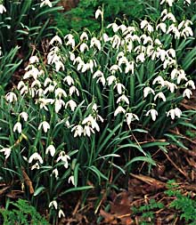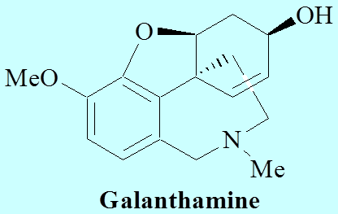

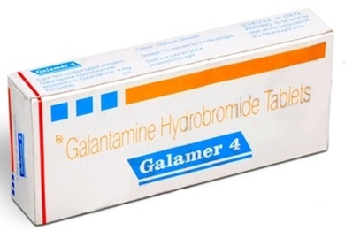 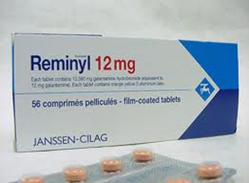

* Galantamine (galanthamine) an alkaloid extracted from snowdrop, *Galanthus nivalis* and other species of the Amaryllidaceae (e.g. *Narcissus pseudonarcissus*) recently been introduced into clinical practice.
* Historically used in Eastern Europe in the symptomatic treatment of polio – not for memory loss!
* Produced semi-synthetically and also isolated.
* Competitive cholinesterase inhibitor → raises levels of acetylcholine in brain areas lacking cholinergic neurons
* Not curative, but slows down progression of illness.

**The Opium poppy (*Papaver somniferum***)

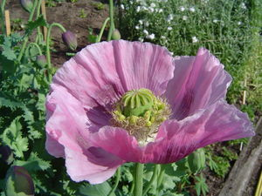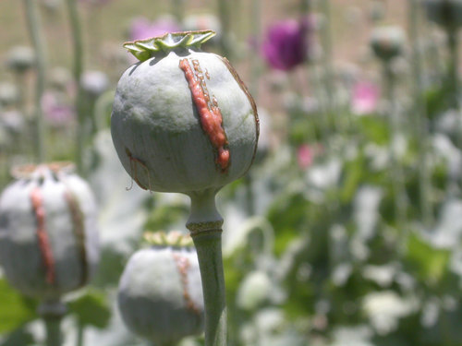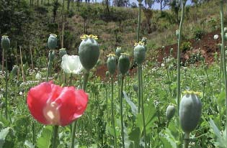

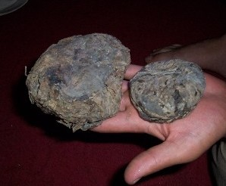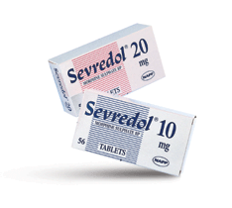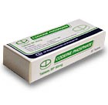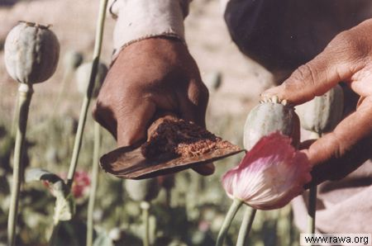

* Genus: *Papaver* (= poppy)
* Species: *somniferum* (= causes sleep)
* Family: Papaveraceae
* Botanical authority: the ‘L’ is for Linnaeus, the famous botanist who first described it and gave it the name.
* Used plant part: **opium**, the dried latex from the unripe capsule (fruit); seeds used in cooking as oil.
* Medicinal usage: analgesic (pain killer).
* Plant Constituents: alkaloids: morphine, codeine etc.
* Toxicity: depends - seeds and oil are safe, alkaloids not!
* State of current research and clinical evidence: very well-known and researched.

**Isolated compounds (alkaloids) from *Papaver somniferum***

In 1805 morphine was discovered, and named after Morpheus, the god of dreams, by F.W. Sertürner. Its structure elucidated in 1925 and first synthesised in 1952; still obtained from *P. somniferum* (poppy straw, dried capsules (not by scraping off latex).

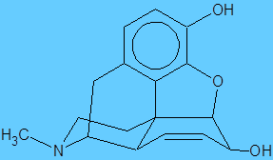

Opium also contains: codeine, papaverine and others.

**Types of herbal extract**

1. Infusions (teas) : ‘home made’ by patient
2. Decoctions : water extract as above, but boiled
3. Liquid/fluid extracts and tinctures: made with ethanol and water as above, often prepared by herbalist or commercially
4. Solid extracts: made by evaporating fluid extracts to dryness or semi-dryness; can be used to make tablets, tinctures, ointments etc.

**Infusions**

* A tea or ‘tisane’: an extraction made with hot water - usually use 500ml (or 1 pint) water to 30g (1oz) dried herb. Stand for about 30mins then filter, decant or strain. Amount of liquid taken can be related to the amount of herb extracted.
* Cold water extracts used less often (and only if actives are heat labile)
* Can be made at home, and sweetened and combined with other herbs if required.
* Use only on day of preparation " not preservative"
* Good for leaves, herbs, some seeds and unorganized drugs which do not contain much messy starch, oil, fat or protein etc. - e.g. tea..

**Decoctions**

* A decoction involves pouring cold water onto the powdered drug, bringing to the boil and simmering, then filtering and allowing to cool
* Quantities as for infusions - but will need topping up during boiling
* Not preserved, use on day of production
* For woody or hard materials, e.g. barks, roots, some seeds and fruits which need softening so the active compounds can be extracted. Should again not contain much starch, oil, fat or protein etc. (unless these are wanted) e.g. some types of coffee.

**Liquid (fluid) extracts**

* A more permanent and convenient way of preserving the constituents of medicinal herb.

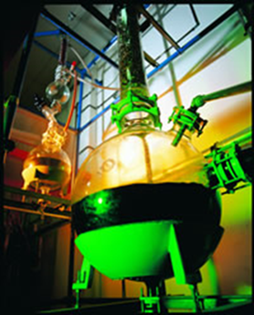

* Made by *percolation* (passing boiling solvent through) or *maceration* (soaking or steeping in hot or cold solvent). May take several days
* Solvent is usually water and/or ethanol
* After filtration, mixture can be evaporated or diluted to a suitable volume, so a unit of volume represents a unit weight of dried herb: e.g. 1mL extract ≡ 1 G dried herb; represented as a 1:1 (or 1:5 etc.) extract.

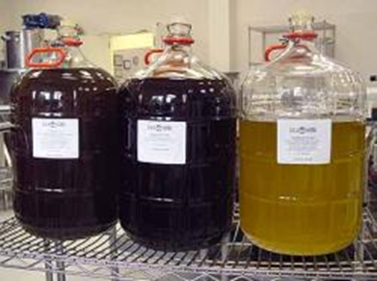

**Dry extracts and tinctures**

* Liquid extracts may be evaporated to different degrees of dryness
* If an ethanol/water extract is evaporated so that the alcohol is removed but not all of the water, a soft extract is obtained (like tar)
* If all the solvent of removed, a dry (hard) extract is formed which can be stored longer
* Both can then be diluted with water to make a tea, or alcohol to make a tincture which is a more preserved and concentrated form (e.g. 5:1 tincture).

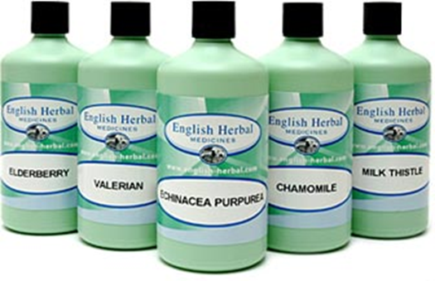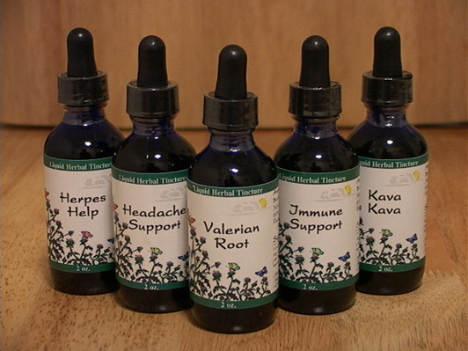

**Other dosage forms**

* Solid extracts can be powdered, granulated, and compressed to make tablets e.g. Senna leaves.

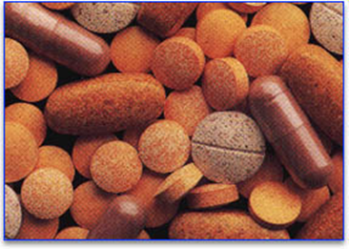

* These, plus fluid extracts and tinctures, can also be added to creams, ointments, suppositories, and liquid medicines (cough mixtures etc.).

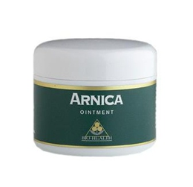 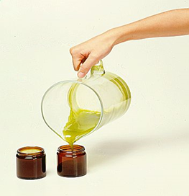

* Powdered herbal drugs can be put into tea bags…….etc.

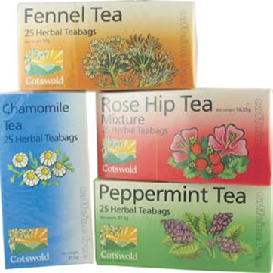

**Types of Standardized Extract**

1. **Type A**: (truly) standardized to active constituents e.g. Senna, standardized to anthraquinones 5.5-8.0%; belladonna, standardized to alkaloids (as hyoscyamine) 0.95-1.05%.
2. **Type B**: ‘quantified’ – standardized to constituents that contribute to activity

St John’s wort, standardized to hypericin 0.1-0.4%; *Ginkgo biloba*, standardized to both flavonoids 16-26% and terpene lactones (ginkgolides)5-7%.

1. **Type C**: standardized to lead compounds of unknown pharmacologicalrelevance, which serve as quality marker e.g. Valerian, standardized to 0.8- 1% valerenic acid.