University of Al-Mustansiriyah Biochemistry
College of Pharmacy Dr. Basma Talib Jasim
Department of Clinical Laboratory Sciences 3^{ed} Stage
--------------------------------------------------------------------------------------------------------
Amino acid
Amino acids are organic compounds containing amine (-NH2) and carboxyl (-COOH) functional groups, along with a side chain (R group) specific to each amino acid (figure 1). The key elements of an amino acid are carbon, hydrogen, oxygen, and nitrogen, although other elements are found in the side chains of certain amino acids. About 500 amino acids are known (though only 20 appear in the genetic code) and can be classified in many ways.
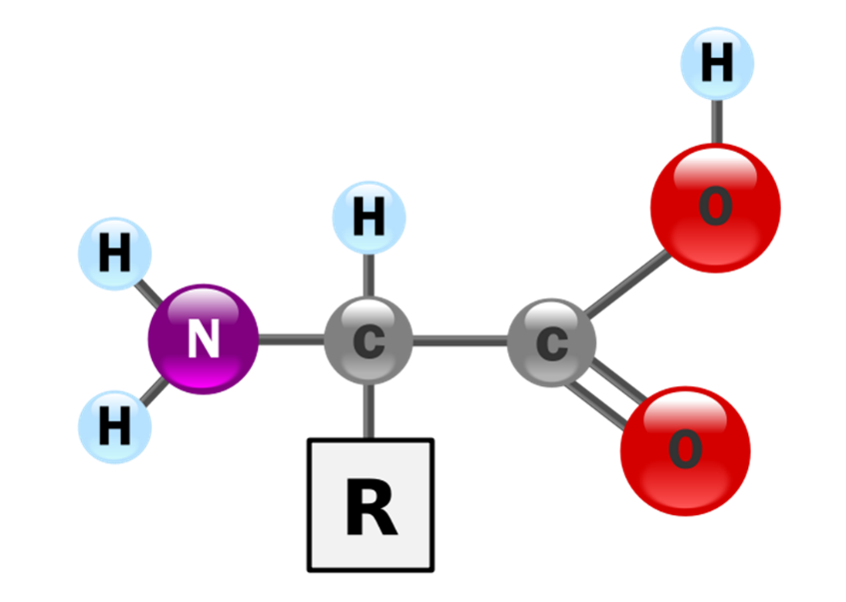
Figure 1: The structure of an alpha amino acid in its un-ionized form.

The first few amino acids were discovered in the early 19th century. In 1806, French chemists Louis-Nicolas Vauquelin and Pierre Jean Robiquet isolated a compound in asparagus that was subsequently named asparagine, the first amino acid to be discovered. Cystine was discovered in 1810, although its monomer, cysteine, remained undiscovered until 1884. Glycine and leucine were discovered in 1820. The last of the 20 common amino acids to be discovered was Threonine in 1935 by William Cumming Rose, who also determined the essential amino acids and established the minimum daily requirements of all amino acids for optimal growth.
Proteins were found to yield amino acids after enzymatic digestion or acid hydrolysis. In 1902, Emil Fischer and Franz Hofmeister proposed that proteins are the result of the formation of bonds between the amino group of one amino acid with the carboxyl group of another, in a linear structure that Fischer termed "peptide".
They can be classified the amino acids according to the core structural functional groups' locations as alpha- (α-), beta- (β-), gamma- (γ-) or delta- (δ-) amino acids; other categories relate to polarity, pH level, and side chain group type (aliphatic, acyclic, aromatic, containing hydroxyl or sulfur, etc.). In the form of proteins, amino acid residues form the second-largest component (water is the largest) of human muscles and other tissues. Beyond their role as residues in proteins, amino acids participate in a number of processes such as neurotransmitter transport and biosynthesis.
In biochemistry, amino acids having both the amine and the carboxylic acid groups attached to the first (alpha-) carbon atom have particular importance. They are known as 2-, alpha-, or α-amino acids (generic formula H2NCHRCOOH in most cases, where R is an organic substituent known as a "side chain"); often the term "amino acid" is used to refer specifically to these. They include the 22 proteinogenic ("protein-building") amino acids, which combine into peptide chains ("polypeptides") to form the building-blocks of a vast array of proteins. These are all L-stereoisomers ("left-handed" isomers), although a few D-amino acids ("right-handed") occur in bacterial envelopes, as a neuromodulator (D-serine), and in some antibiotics.
Twenty of the proteinogenic amino acids are encoded directly by triplet codons in the genetic code and are known as "standard" amino acids. The other two ("non-standard" or "non-canonical") are selenocysteine (present in many prokaryotes as well as most eukaryotes, but not coded directly by DNA), and pyrrolysine (found only in some archea and one bacterium). Pyrrolysine and selenocysteine are encoded via variant codons; for example, selenocysteine is encoded by stop codon and SECIS element (selenocysteine insertion sequence). N-formylmethionine (which is often the initial amino acid of proteins in bacteria, mitochondria, and chloroplasts) is generally considered as a form of methionine rather than as a separate proteinogenic amino acid. Codon–tRNA combinations not found in nature can also be used to "expand" the genetic code and form novel proteins known as alloproteins incorporating non-proteinogenic amino acids.
Many important proteinogenic and non-proteinogenic amino acids have biological functions. For example, in the human brain, glutamate (standard glutamic acid) and gamma-amino-butyric acid ("GABA", non-standard gamma-amino acid) are, respectively, the main excitatory and inhibitory neurotransmitters. Hydroxyproline, a major component of the connective tissue collagen, is synthesised from proline. Glycine is a biosynthetic precursor to porphyrins used in red blood cells. Carnitine is used in lipid transport.
Nine proteinogenic amino acids are called "essential" for humans because they cannot be produced from other compounds by the human body and so must be taken in as food. Others may be conditionally essential for certain ages or medical conditions. Essential amino acids may also differ between species.
Because of their biological significance, amino acids are important in nutrition and are commonly used in nutritional supplements, fertilizers, and food technology. Industrial uses include the production of drugs, biodegradable plastics, and chiral catalysts.

General structure
In the structure as shown in figure 1, R represents a side chain specific to each amino acid. The carbon atom next to the carboxyl group (which is therefore numbered 2 in the carbon chain starting from that functional group) is called the α–carbon. Amino acids containing an amino group bonded directly to the alpha carbon are referred to as alpha amino acids. These include amino acids such as proline which contain secondary amines, which used to be often referred to as "amino acids".

Table 1: Standard amino acid abbreviations and properties
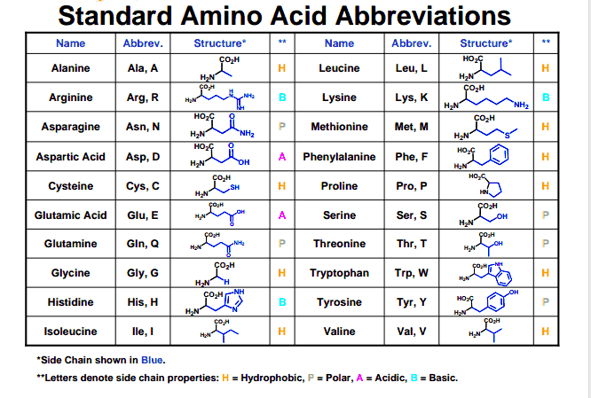

Side chains
In amino acids that have a carbon chain attached to the α–carbon (such as Lysine as shown in figure 2) the carbons are labeled in order as α, β, γ, δ, and so on. In some amino acids, the amine group is attached to the β or γ-carbon, and these are therefore referred to as beta or gamma amino acids.

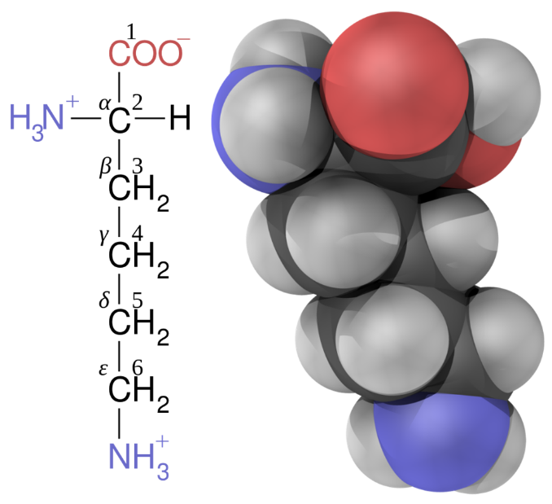
Figure 2: Lysine with carbon atoms labeled by position.

Amino acids are usually classified by the properties of their side chain into four groups (figure 3). The side chain can make an amino acid a weak acid or a weak base, and a hydrophile if the side chain is polar or a hydrophobe if it is nonpolar. The phrase "branched-chain amino acids" or BCAA refers to the amino acids having aliphatic side chains that are non-linear; these are leucine, isoleucine, and valine. Proline is the only proteinogenic amino acid whose side-group links to the α-amino group and, thus, is also the only proteinogenic amino acid containing a secondary amine at this position. In chemical terms, proline is, therefore, an amino acid, since it lacks a primary amino group, although it is still classed as an amino acid in the current biochemical nomenclature, and may also be called an "N-alkylated alpha-amino acid".
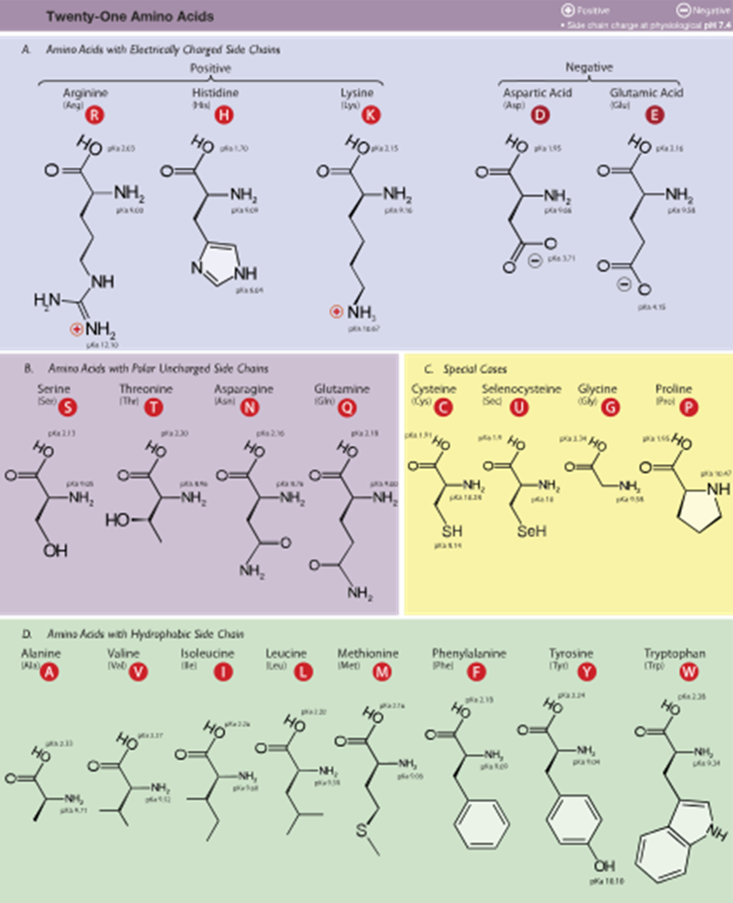
Figure 3: The 21 proteinogenic α-amino acids found in eukaryotes, grouped according to their side chains'.

Classifications of Amino Acids
Experts classify amino acids based on a variety of features, including whether people can acquire them through diet. Accordingly, scientists recognize three amino acid types:
1. Nonessential
2. Essential
3. Conditionally essential

However, the classification as essential or nonessential does not actually reflect their importance, as all 20 amino acids are necessary for human health.
Eight of these amino acids are essential (or indispensable) and cannot be produced by the body. They are:
• Leucine
• Isoleucine
• Lysine
• Threonine
• Methionine
• Phenylalanine
• Valine
• Tryptophan

Histidine is an amino acid that is categorized as semi-essential since the human body doesn't always need it to properly function; therefore, dietary sources of it are not always essential. Meanwhile, conditionally essential amino acids aren't usually required in the human diet, but do become essential under certain circumstances.

Finally, nonessential amino acids are produced by the human body either from essential amino acids or from normal protein breakdowns. Nonessential amino acids include:
• Asparagine
• Alanine
• Arginine
• Aspartic acid
• Cysteine
• Glutamic acid
• Glutamine
• Proline
• Glycine
• Tyrosine
• Serine

An additional amino acids' classification depends upon the side chain structure, and experts recognize these five as:
• Cysteine and Methionine (amino acids containing sulfur)
• Asparagine, Serine, Threonine, and Glutamine (neutral amino acids)
• Glutamic acid and Aspartic acid (acidic); and Arginine and Lysine (basic)
• Leucine, Isoleucine, Glycine, Valine, and Alanine (aliphatic amino acids)
• Phenylalanine, Tryptophan, and Tyrosine (aromatic amino acids)

One final amino acid classification is categorized by the side chain structure that divides the list of 20 amino acids into four groups - two of which are the main groups and two that are subgroups. They are:
1. Non-polar
2. Polar
3. Acidic and polar
4. Basic and polar
For example, side chains having pure hydrocarbon alkyl or aromatic groups are considered non-polar, and these amino acids are comprised of Phenylalanine, Glycine, Valine, Leucine, Alanine, Isoleucine, Proline, Methionine, and Tryptophan. Meanwhile, if the side chain contains different polar groups like amides, acids, and alcohols, they are classified as polar. Their list includes Tyrosine, Serine, Asparagine, Threonine, Glutamine, and Cysteine. If the side chain contains a carboxylic acid, the amino acids in the acidic-polar classification are Aspartic Acid and Glutamic Acid. Furthermore, if the side chain consists of a carboxylic acid and basic-polar, these amino acids are Lysine, Arginine, and Histidine.

Physicochemical properties of amino acids
The 20 amino acids encoded directly by the genetic code can be divided into several groups based on their properties. Important factors are charge, hydrophilicity or hydrophobicity, size, and functional groups. These properties are important for protein structure and protein–protein interactions. The water-soluble proteins tend to have their hydrophobic residues (Leu, Ile, Val, Phe, and Trp) buried in the middle of the protein, whereas hydrophilic side chains are exposed to the aqueous solvent. The integral membrane proteins tend to have outer rings of exposed hydrophobic amino acids that anchor them into the lipid bilayer. In the case part-way between these two extremes, some peripheral membrane proteins have a patch of hydrophobic amino acids on their surface that locks onto the membrane. In similar fashion, proteins that have to bind to positively charged molecules have surfaces rich with negatively charged amino acids like glutamate and aspartate, while proteins binding to negatively charged molecules have surfaces rich with positively charged chains like lysine and arginine. There are different hydrophobicity scales of amino acid residues.

Some amino acids have special properties such as cysteine, that can form covalent disulfide bonds to other cysteine residues, proline that forms a cycle to the polypeptide backbone, and glycine that is more flexible than other amino acids.

Many proteins undergo a range of posttranslational modifications, when additional chemical groups are attached to the amino acids in proteins. Some modifications can produce hydrophobic lipoproteins, or hydrophilic glycoproteins. These types of modification allow the reversible targeting of a protein to a membrane. For example, the addition and removal of the fatty acid palmitic acid to cysteine residues in some signaling proteins causes the proteins to attach and then detach from cell membranes.

Isomerism
The alpha amino acids are the most common form found in nature, but only when occurring in the L-isomer. The alpha carbon is a chiral carbon atom, with the exception of glycine which has two indistinguishable hydrogen atoms on the alpha carbon.

Therefore, all alpha amino acids but glycine can exist in either of two enantiomers, called L or D amino acids, which are mirror images of each other (figure 4).

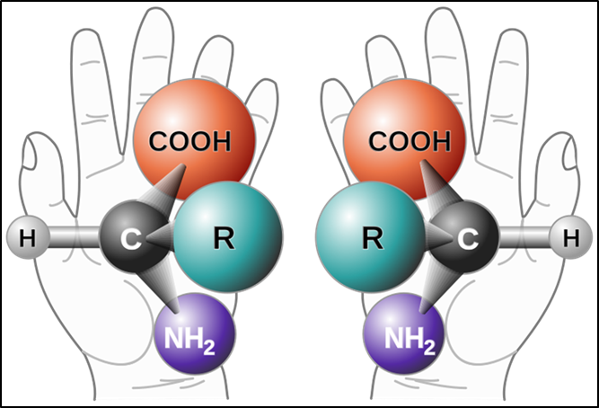
Figure 4: Two enantiomers of a generic amino acid that is chiral.

While L-amino acids represent all of the amino acids found in proteins during translation in the ribosome, D-amino acids are found in some proteins produced by enzyme posttranslational modifications after translation and translocation to the endoplasmic reticulum, as in exotic sea-dwelling organisms such as cone snails. They are also abundant components of the peptidoglycan cell walls of bacteria, and D-serine may act as a neurotransmitter in the brain. D-amino acids are used in racemic crystallography to create centrosymmetric crystals, which (depending on the protein) may allow for easier and more robust protein structure determination. The L and D convention for amino acid configuration refers not to the optical activity of the amino acid itself but rather to the optical activity of the isomer of glyceraldehyde from which that amino acid can, in theory, be synthesized (D-glyceraldehyde is dextrorotatory; L-glyceraldehyde is levorotatory). In alternative fashion, the (S) and (R) designators are used to indicate the absolute stereochemistry. Almost all of the amino acids in proteins are (S) at the α carbon, with cysteine being (R) and glycine non-chiral. Cysteine has its side chain in the same geometric position as the other amino acids, but the R/S terminology is reversed because of the higher atomic number of sulfur compared to the carboxyl oxygen gives the side chain a higher priority, whereas the atoms in most other side chains give them lower priority.

20 Amino Acids and their Functions
- Non-polar, aliphatic residues

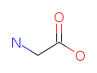 Glycine (G/Gly). Slices DNA in order to produce different amino acids. One of the three most important glycogenic amino acids.
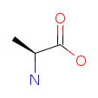 Alanine (A/Ala). Important source of energy for muscle. One of the three most important glycogenic amino acids. The primary amino acid in sugar metabolism. Boosts immune system by producing antibodies.

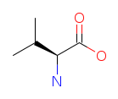 Valine (V/Val). Essential for muscle development.

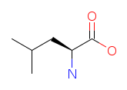 Leucine (L/Leu). Beneficial for skin, bone and tissue wound healing.

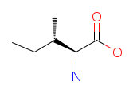 Isoleucine (I/Ile). Necessary for the synthesis of hemoglobin.

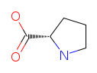 Proline (P/Pro). Critical component of cartilage; aids in joint health, tendons and ligaments. Keeps heart muscle strong.

- Aromatic residues

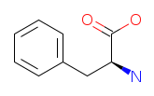 Phenylalanine (F/Phe). Beneficial for healthy nervous system. It boosts memory and learning.

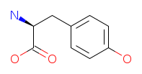 Tyrosine (Y/Tyr). Precursor of dopamine, norepinephrine and adrenaline. Increases energy, improves mental clarity and concentration, can treat some depressions.

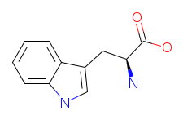 Tryptophan (W/Trp). Necessary for neurotransmitter serotonin (synthesis). Effective sleep aid, due to conversion to serotonin. Reduces anxiety and some forms of depression. Treats migraine headaches. Stimulates growth hormone.

- Polar, non-charged residues

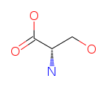 Serine (S/Ser). One of the three most important glycogenic amino acids, the others being alanine and glycine. Maintains blood sugar levels, and boosts immune system. Myelin sheaths contain serine.

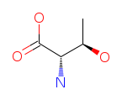 Threonine (T/Thr). Required for formation of collagen. Helps prevent fatty deposits in liver. Aids in antibodies' production.

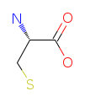 Cysteine (C/Cys). Protective against radiation, pollution, and ultra-violet light. Detoxifier; necessary for growth and repair of skin.

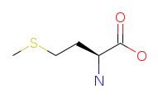 Methionine (M/Met). An antioxidant. Helps in breakdown of fats and aids in reducing muscle degeneration.

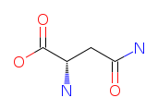 Asparagine (N/Asn). One of the two main excitatory neurotransmitters.

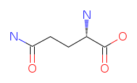 Glutamine (Q/Gln). Essential for helping to maintain normal and steady blood sugar levels. Helps muscle strength and endurance. Gastrointestinal function; provides energy to small intestines.

- Positively charged residues

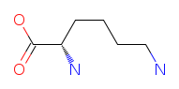 Lysine (L/Lys). Component of muscle protein, and is needed in the synthesis of enzymes and hormones. It is also a precursor for L-carathine, which is essential for healthy nervous system function.

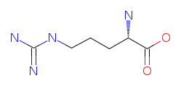 Arginine (R/Arg). One of the two main excitatory neurotransmitters. May increase endurance and decrease fatigue. Detoxifies harmful chemicals. Involved in DNA synthesis.

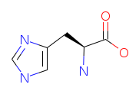 Histidine (H/His). Found in high concentrations in hemoglobin. Treats anemia; has been used to treat rheumatoid arthritis.

- Negatively charged residues

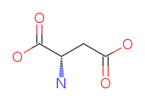 Aspartate (D/Asp). Increases stamina and helps protect the liver; DNA and RNA metabolism; immune system function.

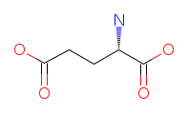 Glutamate (E/Glu). Neurotransmitter that is involved in DNA synthesis.

