***Patient Data sheet***

Patient Name Age: Sex: date of admission

Weight: Height: BMI :

* Chief Compliant (CC):

* History Of Present Illness (HOPI):
* Past Medical History(PMH):
* Past Surgical History(PSH):
* Medication history:
* Drug Allergy:
* Review of other system
* CNS
* CVS
* GIS
* RS
* GUT
* Vital Signs: BP(blood pressure) PR(pulse rate)

RR(respiratory rate) Temp.(temprture)

* Investigation:
* -Lab. Data :
* U/S(ultrasound):
* Morning Tour Treatment
* Night Tour Treatment

***Pre-operative care***

**Pre-operative assessment in the elective patient**

* The aim of pre-operative assessment is to maximize patient safety and minimize the complications of surgery by identifying potential problems and optimizing patients before surgery.
* The extent of pre-operative preparation depends on several factors, mainly:
* the timing of surgery (i.e. how urgent it is);
* the nature of surgery (i.e. minor or major procedure);
* the patient’s past medical history and current status.

**History and examination**

* All patients should have a thorough history taken. Many units now have specially designed forms to ensure all areas are adequately explored. It is important to remember that the junior doctor who undertakes the pre-operative assessment may be the only person to take a detailed history and will often uncover important factors regarding the patient’s peri-operative care.
* It is important that if such a critical factor is identified or an abnormal result is found, it is communicated to the consultants' team before surgery, as this may avoid preventable complications or cancellation of the operation.
* For example, identification that a patient is on clopidogrel, which must be stopped before elective surgery to reduce the risk of hemorrhage, or identification of undiagnosed aortic stenosis.
* Pre-operative assessment is therefore a very responsible role.
* A detailed, systematic history covering all areas is required.

**Past medical history**

* In particular focusing on cardiovascular disease (including hypertension), respiratory disease, renal disease, diabetes and significant obesity.
* If a disease is identified, it should be optimally managed pre-operatively, so it is not enough to simply document ‘hypertension’.
* The level of control should be checked and if sub-optimal, steps taken to improve it. This may necessitate liaison with the GP or hospital specialist responsible for the care of this illness and delaying the planned surgery by contacting the consultant’s team.

**Drug history**

* Particular care is needed to ensure this is accurate with correct drug names, doses and administration times. If necessary, contact the GP for verification.
* Certain drugs should be flagged up to the consultant’s team, as they may have a significant impact on the surgery. These include:
* anticoagulants (see Section 1.3.6);
* steroids (see Section 1.3.9);
* anti-diabetic medication (see Section 1.3.10);
* chemotherapeutic agents: blood counts need to be carefully monitored;
* ACE-inhibitors (e.g. ramipril) and angiotensin II receptor antagonists (e.g. losartan), which should be omitted on the morning of surgery.
* The following medications should **not** be stopped prior to surgery:
* antihypertensive, especially beta-blockers (e.g. atenolol);
* other cardiac medications (e.g. digoxin);
* inhalers, especially steroid inhalers (e.g. beclomethasone);
* analgesics;
* Proton pump inhibitors (PPIs) (e.g. omeprazole).

**Allergies**

* These should be documented and described in terms of severity.
* In latex allergy the surgical team should be informed, as these patients should be first on the operating list and may require special equipment.

**Social history**

* Important issues include:
* Jehovah’s Witnesses who refuse blood products;
* patients who have inadequate support on discharge where timely input from social services may ensure smooth discharge planning;
* Smoking and illicit substance abuse.

**Family history**

* A family history of cardiovascular disease or hyperlipidemia may trigger more detailed assessments.

**Previous anesthetic problems**

* Previous reactions, airway problems or post-operative nausea or vomiting should be noted.

**Examination**

* A full physical examination is required for all patients.

**Relevant investigations**

* Not all investigations are necessary for all patients. Assess the age and comorbidities of the patient, as well as the type of procedure planned.

|  |  |
| --- | --- |
| **Pre-operative test** | **Indications for use in elective patients** |
| Full blood count (FBC) | All patients undergoing major surgery.  All patients with cardiovascular or renal disease.  Consider in all patients with ASA grade 2 or more. |
| Urea and electrolytes (U&E) | All patients undergoing major surgery.  All patients with renal or cardiovascular disease.  All patients over 60 years with ASA grade 2 or more. |
| Liver function tests  (LFTs) | All patients with a history of liver disease, jaundice, alcohol excess, intravenous drug use.  All patients with abnormal nutritional state or metabolic disease.  All patients taking hepatotoxic drugs. |
| Blood glucose | All diabetic patients undergoing surgery.  All patients with renal disease or if glycosuria or ketonuria are present on urinalysis.  Consider in all patients aged over 60 years or the obese. |
| Clotting screen | All patients with a past medical history or family history of bleeding or clotting disorders and those with known liver disease.  All patients taking anticoagulants.  All patients undergoing major surgery. |

|  |  |
| --- | --- |
| **Pre-operative test** | **Indications for use in elective patients** |
| Group and save cross-match | All patients undergoing intermediate, major, major-plus or laparoscopic surgery should be grouped and saved.  In procedures where there is significant anticipated blood loss, e.g. abdominal aortic aneurysm (AAA) repair, patients should be cross-matched.  All patients with coagulopathies or anaemia. |
| 12-Lead  electrocardiography  (ECG) | All patients with cardiovascular disease or diabetes.  Consider in all patients over 40 years of age, especially if there are cardiovascular risk factors (e.g. smoking, hypertension) or when undergoing major surgery. |
| Chest x-ray (CXR) | All patients over 60 years of age should have had a  CXR within the preceding 12 months.  All patients with cardiorespiratory disease, malignancy, thyroid goitre or those undergoing thoracic surgery. |

**Specific investigations**

* The following are not routinely required but may be required in certain patients.

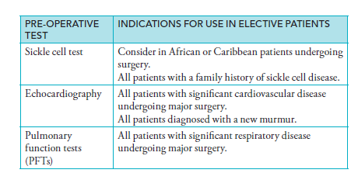

**Pre-operative assessment in the emergency surgical patient**

* In the emergency setting, preparation for theatre is about optimization to give the patient the best possible chance of a good surgical outcome.
* In patients with severe comorbidity, NCEPOD recommends:
* communication between surgeon and anesthetist pre-operatively;
* adequate pre-operative investigation;
* appropriate grade of surgeon (minimizing operating time and blood loss);
* adequate resuscitation;
* availability of critical care bed.
* It should not be forgotten that emergency admissions may require urgent surgery, and so a thorough history and examination should be performed by the admitting doctor.

**Pre-operative investigations in emergency patients**

* All emergency general surgical patients should have an appropriate set of blood test results available prior to surgery, including FBC, U&E, LFTs, glucose, clotting screen, group and save or cross-match depending on the type of surgery, their comorbid conditions and the underlying acute illness.
* All sexually active women of child-bearing age should have a pregnancy test.
* Patients admitted with an acute abdomen, where perforation of a viscous is part of the differential diagnosis, should have an erect chest x-ray.
* Any patients with tachycardia and all adults aged 40 over years should have a baseline ECG, as should anyone with a cardiac, hypertensive or respiratory history.
* All patients should have a simple urinalysis.
* An ABG may be relevant in patients with significant respiratory disease and those with acute sepsis, pancreatitis or suspected intestinal ischaemia where a metabolic acidosis may develop.

**How to manage conditions of special relevance:**

**Recent myocardial infarction (MI)**

* Avoid elective surgery [unless urgent or coronary artery bypass grafting (CABG)] for >6 months as risk of re-infarction is elevated.
* Specific relevant investigations:
* Up-to-date ECG and echocardiogram.
* Continue all normal cardiovascular medications.
* Consider stopping anti-platelets 10 days prior to surgery.

**Aortic stenosis (AS)**

* Patients with severe AS should not undergo elective surgery without prior consideration of valvular replacement.
* Specific relevant investigations:
* Echo to assess the pressure gradient across the valve and its area—the normal gradient is only a few mmHg.
* Prophylactic antibiotics may be required, although the indications for this have recently been substantially reduced.
* Patients may be on anticoagulants.
* Avoid tachycardia and hypotension as patients are at risk of MI.
* Diastolic filling is reduced due to left ventricular hypertrophy.

**Atrial fibrillation (AF)**

* Can precipitate cardiac failure if inadequately rate-controlled peri-operatively.
* May be on warfarin.
* Specific relevant investigations:
* ECG to assess rate and rhythm (if paroxysmal);
* INR if on warfarin.

**Cardiac failure**

* Postpone surgery until stable and optimized on medication.
* Important to carefully control fluid balance to avoid overload.
* Specific relevant investigations:
* U&Es as diuretics and ACE-inhibitors can cause renal impairment.
* CXR to assess for disease severity and fluid overload.
* ECG and echocardiogram to assess LV function.

**Patients taking anticoagulants**

* If on warfarin, it is important to weigh the risk of stopping the medication against the risk of bleeding intra-operatively, and this risk varies with the indication for therapy.
* Patients on warfarin for AF, for example, are not at great risk if they stop taking it and so may simply omit the drug for 5–7 days pre-operatively.
* Patients on warfarin for metallic heart valves, however, are at high risk of thromboembolism if the INR is normalized and so should have cover with low molecular weight heparin (LMWH) or IV heparin.
* In the emergency setting, reversal of warfarin may be required quickly and so drugs such as vitamin K, fresh frozen plasma (FFP) or prothrombin complex concentrate may be used.
* Anti-platelet medications should be omitted pre-operatively.
* Stop clopidogrel 7–10 days pre-operatively.
* Stop dipyridamole 7 days pre-operatively.
* Omit aspirin on the day of surgery.

**Recent cerebrovascular accident (CVA)**

* Avoid elective surgery (unless urgent or carotid endarterectomy) for >6 weeks.
* This is because auto regulation of cerebral blood pressure is disrupted following a CVA, and normal ability to cope with fluctuations of cerebral blood pressure caused by anesthetic agents is impaired. This increases the risk of a further peri-operative CVA.

**Hyperthyroidism**

* Patients with hyperthyroidism are at risk of thyrotoxic crisis, AF and bleeding.
* Efforts should be made to make the patient euthyroid prior to surgery.
* Specific relevant investigations:
* Thyroid function tests (TFTs), ECG, CXR.
* AF may resolve on treating the underlying thyroid disease, but patients may require rate control with beta-blockers, digoxin, verapamil or amiodarone.
* Anti-thyroid drugs may increase bleeding in thyroid surgery, and are often stopped 10–14 days prior to surgery.

**Immunosuppression**

* Surgical patients on long-term steroid therapy are at risk of Addisonian crisis.
* These should be continued throughout surgery, as their use results in adrenal suppression leading to an impaired stress response.
* Patients unable to take their oral steroids will require IV hydrocortisone.
* If patients are taking <10 mg of prednisolone daily (or equivalent dose of other steroid), they need no additional steroid cover.
* If taking >10 mg daily, patients will need 25 mg IV hydrocortisone at induction of anaesthesia and additional cover post-op dependent on the type of surgery.

**Diabetes mellitus**

* Diabetic patients who undergo surgery are at risk of multiple complications.
* Ensure the patient is first on the operating list to optimize glycaemic control.
* Specific relevant investigations:
* U&E, blood glucose, ECG.
* Adjust medication according to the timing and extent of surgery and in consultation with the anesthetist.
* Patients may require a variable rate insulin infusion (VRII), particularly if starved for a substantial period or if they have decompensated diabetes (e.g. in the presence of sepsis).
* BMs should be monitored regularly to ensure good control.

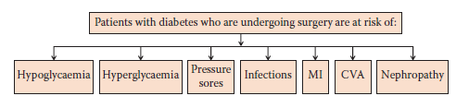

|  |  |  |
| --- | --- | --- |
| **Drug** | **Patient for a.m. surgery** | **Patient for p.m. surgery** |
| Insulin OD | No change to dose. | No change to dose. |
| Insulin BD | . ½a.m. dose, normal p.m dose. | . ½a.m. dose, normal p.m dose. |
| Insulin BD separate  short and intermediate agents | ½total a.m. dose as intermediate-acting insulin, normal p.m. dose. | ½total a.m. dose as intermediate-acting insulin, normal p.m. dose. |
| Insulin 3, 4 or 5  injections daily | Basal bolus regimens:  Omit a.m. and lunchtime short-acting insulin keeping basal dose normal.  Premixed a.m. regimens:  ½ a.m. dose and omit lunchtime dose. | Normal a.m. dose, omit lunchtime dose. |
| Acarbose or meglitinide (e.g.  repalinide) | Omit a.m. dose if NBM. | Give a.m. dose if eating. |
| Sulphonylurea (e.g.  gliclazide) | Omit a.m. dose. | Omit a.m. dose if OD, omit a.m. and p.m. dose if BD. |
| Pioglitazone or  metformin | Normal dosing. | Normal dosing. |
| DPP IV inhibitor  (e.g. sitagliptin) or  GLP-analogue (e.g.  exenatide) | Omit on day of surgery. | Omit on day of surgery. |

**Morbid obesity**

* Operations are made more complicated due to:
* Harder to manually handle larger patients.
* Special equipment may be required, such as larger operating tables, beds and special hoists. Not every hospital will have these.
* Increased prevalence of comorbidities, e.g. IHD, DM, gallstones, etc.
* Poor airway for anesthetic intubation.
* Obesity may predispose to multiple complications.
* Specific relevant investigations:
* ECG, blood glucose, respiratory function tests, including spirometry, ABG and CXR.

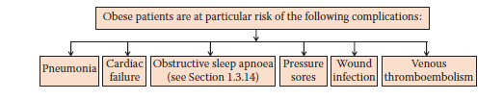

**Renal failure**

* Manage all renal failure patients jointly with a nephrologist.
* Mild chronic renal failure is common in the elderly surgical patient.
* Delay elective surgery to allow optimization and stabilization of the condition.
* Avoid nephrotoxic drugs, e.g. gentamicin.
* Make sure hydration is maintained pre-operatively.
* Severe renal failure.
* Risk of fluid overload, electrolyte imbalances, metabolic acidosis and anaemia of renal failure.
* Uraemia is immunosuppressant so ensure prophylactic antibiotics.
* Monitor urine output, plasma electrolytes, creatinine, urea and bicarbonate.
* Check potassium regularly, as having a general anesthetic (GA) increases the risk of hyperkalaemia.
* Hemodialysis patients should have dialysis more than 24 hours pre-operatively to allow the effects of heparin to wear off.
* Patients using peritoneal dialysis having abdominal surgery may need to be converted to hemodialysis pre- and post-operatively.

**Asthma and COPD**

* Lung function decreases with the use of GA, so alternatives, such as regional anaesthesia, may be considered.
* Optimize medical therapy with nebulizers, oxygen and steroids as required.
* Advise smoking cessation 4–8 weeks prior to surgery.
* Use of chest physiotherapy at least twice a day:
* passive, e.g. breathing exercises;
* active, e.g. postural drainage.
* May need to book a bed on HDU for post-operative non-invasive ventilation.
* Specific relevant investigations:
* Assess lung function using spirometry, ABG and CXR.

**Liver disease**

Patients with liver disease are at risk of several complications.

* Patients with liver disease may be classified using the Child–Pugh criteria.

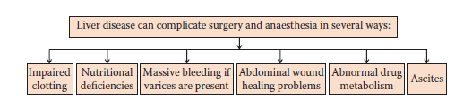

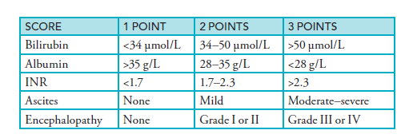

* Surgical risks vary with the score, and in those with a high score all but the most critical, life-saving surgery are contraindicated.
* Specific relevant investigations:
* FBC, clotting screen, U&E, LFT and bone profile.
* Patients should have close monitoring of blood sugar, as they have defective glycolysis and gluconeogenesis.
* Patients with deranged clotting may need vitamin K pre-operatively for several days or require fresh frozen plasma (FFP) peri-operatively.
* Prophylactic antibiotics are indicated.

**Hormonal therapy**

* Patients taking oral contraceptives have an increased risk of postoperative venous thromboembolism because of the combined effects of hormones and the hypercoagulable state, which accompanies surgical stress and postoperative immobility.

The patient should switch to alternative contraceptive methods 4-6 weeks prior to surgery and then restart OCPs after the first menes occurs at least 2 weeks after regaining full mobility following surgery.

Thus the patient is faced with a choice of continuing combined OCPS and receiving thromboprophylaxis in the perioperative period (i.e., SC LMWH and graduated elastic compression stockings) or stopping the pill 4-6 weeks prior to surgery and using another form of contraception (e.g., a progesterone- only pill).

* Hormone replacement therapy in postmenopausal women may increase the risk of postoperative venous thromboembolism so perioperative thromboprophylaxis is prudent, rather than subjecting the patient to the risk of provoking postmenopausal symptoms by stopping HRT.

**Infection**

Surgical antibiotic prophylaxis is the appropriate use of preoperative and postoperative antibiotics to decrease the incidence of postoperative wound infections.

**Treatment Goals**

Surgical Antibiotic Prophylaxis aims to:

* Decrease the incidence of postoperative wound infections.
* Decrease the incidence of adverse drug effects in patients undergoing surgery.
* Decrease the cost of care for surgical patients.
* Minimize the adverse effects of prophylactic antibiotics on the microflora of the patient and the overall bacterial resistance patterns in a particular institution.

**Pathophysiology**

Surgical wound infection does not necessarily follow bacterial contamination. The predominant organisms involved are the endogenous microflora at the surgical site. The development of a surgical wound infection is dependent on a complex interaction between the patient's host-defense response, intrinsic bacterial factors, and local tissue factors. Factors which increase the risk of surgical wound infection are as follows:

* Host-Defense Response Factors: Patients with an underlying host-defense deficit are at increased risk of surgical wound infection (extremes of age, malnutrition, diabetes, corticosteroid therapy, other immunologic deficiency)
* Bacterial Factors:
  + - Degree of wound contamination
    - Bacterial virulence
    - Microbial resistance to prophylactic antibiotics
* Local Tissue Factors:
  + - Blood supply and tissue hypoxia
    - Presence of necrotic material
    - Presence of hematoma
    - Presence of a foreign body

Infectious complications may arise in the surgical wound itself or in other organ systems. They may be initiated by changes in the physiologic state of the respiratory, genitourinary, or immune systems associated with surgery.

**Antimicrobial Spectrum**

The antimicrobial agent chosen for an individual patient should have activity against the most common pathogens which cause surgical wound infections.The agent does not need to possess antibacterial activity against all of the endogenous microbial flora at the surgical site; the use of agents with an excessively broad spectrum of activity increases the risk of microbial resistance and superinfection without an improvement in effectiveness. Third- generation cephalosporins exemplify this point. Despite their increased antimicrobial activity, these agents have not proven superior to first-generation cephalosporins in any operative procedure.

**Timing of Antibiotic Administration**

The most common error encountered in surgical prophylaxis is in the timing of antibiotic administration. Antibiotic prophylaxis has contributed to a reduction in superficial wound infection rates. Coverage should be initiated not more than 2 hours ( oral route) or 30 min.(IM,IV) before the skin incision is made and, in the absence of gross contamination or overt infection, should not be given beyond 24-48 hrs. after surgery.

**Duration of Prophylaxis**

Antibiotic administration should be continued for the shortest duration established to decrease the risk of postoperative infections. Antibiotic administration continued beyond 24 hours has not been shown to be superior to shorter duration antibiotic prophylaxis in most surgical procedures. Antibiotic prophylaxis continued beyond 24 hours increases cost, alters the patient's microflora, and adversely affects the bacterial resistance patterns of the institution. Single-dose antibiotic prophylaxis provides the optimal balance of reducing wound infections in most operative procedures while decreasing adverse drug effects.

***Postoperative Care***

**Routine postoperative care include**

* **Intravenous fluids:** The intravascular volume of surgical patients is depleted by both insensible fluid losses and redistribution into the third space. As a general rule, patients should be maintained on IV fluids until they are tolerating oral intake. Extensive abdominal procedures require aggressive fluid resuscitation. Insensible fluid losses associated with an open abdomen can reach 500-1000 ml/hr.
* **Deep venous thrombosis prophylaxis:** Many postoperative patients are not immediately ambulatory. In those, it is important to provide prophylactic therapy to reduce the risk of DVT and PE. Prophylaxis should be started postoperatively in patients undergoing major procedures because venous stasis and relative hypercoagulability occur during the operation.
* **Medications**
* Antiemetics
* Ulcer prophylaxis
* Pain control
* Antibiotics
* **Laboratory tests:**
* A complete blood count: should be obtained in the immediate postoperative period and on subsequent postoperative days in any procedure in which significant blood loss occurred.
* Serum electrolytes, BUN, and creatinine: are important postoperatively in patients on NPO status or who are receiving large volumes o IV fluids, TPN, or transfusions. In patients with large transfusions requirements, it is important to keep track of calcium and magnesium levels.
* Coagulation studies: are important in patients who have had insults to the liver or large transfusion requirements.
* ECG on daily basis and a series of three troponin I levels 12 hrs apart are appropriate ways to monitor for MI in patients with significant cardiac risk factors.
* Chest X-rays: Is necessity after any procedure in which the thoracic cavity is entered or when central venous access is attempted. CXRs on subsequent postoperative days should be considered on an individual basis if significant pulmonary or CV disease is present.

**Postoperative complications**

Postoperative complication is classified into:

* Local or general complications:
* Local- involving the operation site itself
* General-affecting any of the other systems of the body as respiratory, urological, or cardiovascular complications.
  + - 1. Neurologic complications

1. Perioperative stroke
2. Seizures
3. Delirium
   * + 1. Cardiovascular complications
4. Myocardial ischemia and infarction
5. CHF
6. Hypertension
   * + 1. Pulmonary complications
       2. Renal complications: acute renal failure occurs postoperatively can be divided into prerenal, intrinsic renal, and post renal.
7. Prerenal ARF: results from decreased renal perfusion that might be secondary to hypotension, intravascular volume contraction, or decreased effective renal perfusion.
8. Renal ARF: the causes include drug-induced acute tubular necrosis, pigment-induced renal injury, radio contrast dye administration, acute interstitial nephritis, and prolonged ischemia from suprarenal aortic cross-clamping.
9. Post renal ARF: results from obstruction of the ureters or bladder. Operations that involve dissection near the ureters, such as colostomy closure, or total abdominal hysterectomy, have a higher incidence of ureteral injures. In addition, obstruction of the bladder from an enlarged prostate, postoperative pain and medication administration, or obstructed urinary catheter can occur.
   * + 1. Infectious complications

* Evaluation of fever should take into context the time after operation in which the fever occurs.

1. Intra-operative fever: may be secondary to malignant hyperthermia, a transfusion reaction, or a preexisting infection.
2. High fever (>39 C) in the first 24 hrs. is commonly the result of a streptococcal or clostridial wound infection, aspiration pneumonitis, or a preexisting infection. Streptococcal wound infections present with severe local erythema and incisional pain. Penicillin G ( 2 million units IV every 6 hours) or ampicillin (1-2 g IV every 6 hours) is effective therapy. Patients with a severe necrotizing closteridial infection present with systemic toxemia, pain, and crepitus near the incision. Treatment includes emergent operative debridement and metronidazole (500 mg IV every 6 hours) or clindamycin(600-900mg IV every 8 hours).
3. Fever that occurs more than 72 hours after surgery has a broad differential diagnosis, including pneumonia, UTI, thrombophlebitis, wound infection, intra-abdominal abscess, and drug allergy.
   * + 1. DVT and PE
       2. DM complications**:** as DKA and nonketotic hyperosmolar syndrome.

**Complications of general anesthesia**

1. *Malignant hyperthermia:* is a hyper metabolic disorder of skeletal muscle that is characterized by intracellular by hypercalcemia and rapid adenosine triphosphate consumption. This condition is initiated by exposure to one or more ansthetic-triggering agents, including desflurane, halothane, isoflurane, sevoflurane, and succinylcholine.

Signs and symptoms may occur in the operating room or more than 24 hours postoperatively and include tachycardia, tachypena, hypertension, hypercapnia, hyperthermia, acidosis, and skeletal muscle rigidity.

Treatment involves immediate administration of dantrolene (1mg/kg IV up to a cumulative dose of 10 mg/kg). This attenuates the rise in intracellular calcium. Repeat doses are given as needed if symptoms persist with care monitoring for 24-72 hours.

1. *Laryngospasm:* during emergence from anesthesia, noxious stimulation of the vocal cords can occur at light phases of anesthesia. In addition, blood or other oral secretions can irritate the larynx. As a result, the vocal cords may be brought into forceful apposition, and the flow of gas through the larynx may then be restricted or prevented completely. This alone may cause airway compromise or may lead to negative-pressure pulmonary edema.Treatment involves the use of positive-pressure ventilation by mask to break the spasm. Such therapy usually is sufficient. Succinylcholine may be required in refractory cases to allow successful ventilation.
2. *Nausea and vomiting*
3. *Urinary retention:* although very common with spinal anesthesia, occurs after pelvic operations and in conjunction with benign prostatic hypertrophy. Treatment ranges from conservative (early ambulation, having patient sit or stand while attempting to micturate) to aggressive (bladder catheterization).
4. *Hypothermia:* general anesthesia induction causes peripheral vasodilatation*,* which leads to internal redistribution of heat, resulting in an increase in peripheral temp. at the expense of the core temp. The core temp. then decreases in a linear manner until a plateau is reached. Such hypothermia is more pronounced in the elderly. Hypothermia may provoke cardiac arrhythmia. Treatment includes passive warming during an operation by insulation of all exposed surfaces. In addition, active warming with forced-air convective warmers is effective, but care should be taken in using warmers with patients with vascular insufficiency.
5. *Nerve injury:* can occur secondary to improper positioning of the patient on the operating table or insufficient padding of dependent regions. Such palsies can be long lasting and debilitating.

**Parenteral fluid therapy**

1. Crystalloids: are solutions that contain sodium as the major osmotically active particle. Crystalloids are relatively inexpensive and are useful for volume expansion, maintenance infusion, and correction of electrolyte disturbances.
2. Isotonic crystalloids: as lactated Ringers solution, 0.9% NaCl distribute uniformly throughout the extracellular fluid compartment so that after 1 hr. only 25% of the total volume infused remains in the intravascular space. Lactated Ringers solution is designed to mimic extracellular fluid and is considered a balanced salt solution. This solution provides a HCO3 precursor and is useful for replacing GI losses and extracellular fluid volume deficits. In general, lactated Ringers solution and 0.9% NaCl solution can be used interchangeably. However, the last is preferred in the presence of hyperkalemia, hypercalecmia, hyponatermia, hypochloremia, or metabolic alkalosis.
3. Hypertonic saline solutions: alone and in combination with colloids, such as dextran, have generated interest as a resuscitation fluid for patients with shock or burns. These fluids are appealing because, relative to isotonic crystalloids, smaller quantities are required initially for resuscitation. This immunomodulatory effect of hypertonic saline plus dextran may help to prevent widespread tissue damage and multiorgan dysfunction seen after traumatic injury. The possible side effects of hypertonic solutions include hypernatermia, hyperosmolarity, hyperchloremia, hypokalemia.
4. Hypotonic solutions: as D5W, 0.45% NaCl distribute throughout the total body water compartment, expanding the intravascular compartment by as little as 10% volume expansion. They are used to replace free water deficits.
5. Colloid solutions: contain high-molecular weight substances that remain in the intravascular space. Early use of colloids in the resucscitation regimen may result in more prompt restoration of tissue perfusion and may lessen the total volume of fluid required for resucscitation. The use of colloids is indicated when crystalloids fail to sustain plasma volume because of low colloid osmotic pressure( as increased protein loss from the vascular space, as in burns and peritonitis).
6. Albumin preparations: ultimately distribute throughout the extracellular space, although the initial location of distribution is the vascular compartment. Preparations of 25% albumin and 5% albumin expand the intravascular volume by an equivalent amount. Albumin 25% is indicated in the edematous patient to mobilize interstitial fluid into the intravascular space.
7. Dextran: is a synthetic glucose polymer that undergoes predominantly renal elimination. In addition to its indication for volume expansion, it is also used for thromboembolism prophylaxis and promotion of peripheral perfusion. Dextran solutions expand the intravascular volume by an amount equal to the volume infused.

**Principles of fluid management**

A normal individual consumes an average of 2000-2500 ml of water daily. Daily water losses include approximately 1000-1500 ml in urine and 250 ml in stool. The minimum amount of urinary output that is required to excrete the catabolic end products of metabolism is approximately 800ml. An additional 750 ml of insensible water loss occurs daily via the skin and respiratory tract. Insensible losses increase with hyper metabolism, fever and hyperventilation. Contraindications to fluid management include volume overload, pulmonary edema, acid-base disturbances, fever if pyrogenic and electrolyte disturbances.

1. Maintenance: maintenance fluids should be administered at a rate that is sufficient to maintain a urine output of 0.5-1 ml/kg/hr. Maintenance fluid requirements can be approximated on the basis of body weight as follows:

100 mL/kg/day for the first 10 kg.

50 mL/kg/day for the second 10 kg.

20 mL/kg/day for each subsequent 10 kg.

Maintenance fluids should contain Na+ (1-2 mmol/kg/day) and K+ (0.51 mmol/kg/day) (e.g., D5/0.45% NaCl+20-30 mmolK+/L).

1. Intraoperative fluid management: requires replacement of preoperative deficit as well as ongoing losses. Intraoperative loses include maintenance fluids for the duration of the case, hemorrhage, and third-space losses. The maintenance fluid requirements are calculated as detailed above. Acute blood loss can be replaced with a volume of crystalloid that is 3-4 times the blood loss or an equal volume of colloid or blood. Intraoperative insensible and third-space fluid losses depend on the size of the incision and the extent of tissue trauma and dissection and can be replaced with an appropriate volume of lactated Ringers solution.
2. Postoperative fluid management: sequestration of extracellular fluid into the sites or operative trauma can continues for 12 or more hours after operation. ADH is released in response to surgery, conserving water. Hypervolemia will cause aldosterone secretion and salt retention by the kidney. Potassium is released by damaged tissues, and the potassium level may be further increased by blood transfusion, each unit containing in excess of 20 mmol/L. If renal perfusion is poor, and urine output sparse, this potassium will not excreted and accumulates, causing life-threatening arrhythmias. This is the basis of the recommendation that supplementary potassium may not be necessary in the first 48 hours following surgery or trauma. Urine output should be monitored closely and intravascular volume repleted to maintain a urine output of 0.5-1mL/kg/hr.

**Postoperative nausea and vomiting**

Postoperative nausea and vomiting (PONV) is one of the most common side effects associated with surgical procedures. It can be very distressing for patients, can lead to medical complication and imposes an economic burden. The medical complications of PONV include possible wound disruption, esophageal tears, gastric herniation, muscular fatigue, dehydration and electrolyte imbalance. There is also an increased risk of pulmonary aspiration of vomitus. Aside from the medical complications, PONV can have psychological effects that may result in patients experiencing anxiety about further surgery.

**Risk factors associated with PONV**

**Patient risk factors**

1. Gender: the prevalence of PONV is 3 times higher in women than in men. This gender difference is not evident in pre-pubertal children or in the elderly, which indicates that there may be hormonal involvement.
2. Age: children are 2 times more likely to develop PONV than adults PONV is low in very young children, increases up to the age of 5 and is highest in children between the ages of 6 and 16 years.
3. Obesity: fat-soluble anesthetics may accumulate in adipose tissue and continue to be released for an extended period resulting in prolonged side effects, including PONV.
4. Migraine: patients with a history of migraine are more likely to experience PONV.
5. Pre-operative eating patterns: adequate preoperative fasting reduces the risk of PONV, whereas excessive starvation appears to increase the risk. In emergency surgery where there has not been an adequate fast the risk is increased.
6. History of PONV or motion sickness: such patients may have a lower threshold to nausea and vomiting than the rest of the population. Anxiety, due to a previous experience of PONV may lead to the risk.
7. Gastro paresis: patients with delayed gastric emptying secondary to an underlying disease may be at increased risk of PONV.

**Procedural risk factors**

The type and duration of surgery is a major factor in PONV. Extended surgical procedures are more likely to lead to PONV than shorter operations, and Gynecological, abdominal especially gastrointestinal, laproscopic, ear-nose and throat, ophthalmic surgical procedures predispose to a higher incidence of PONV

**Anesthetic risk factors**

Certain anesthetic agents have been associated with a higher incidence of PONV than others.

Use of opioid analgesics, use of nitrous oxide, use of some inhalation agents and longer procedures and greater depth of anesthesia.

**Postoperative risk factors**

1. Pain: relief of pain is associated with the relief of nausea, though the use of opioid analgesics may exacerbate the risk because of their known emetic potential.
2. Dizziness; PONV is increased in patients who experience dizziness.
3. Early ambulation: early or sudden movement can increase the risk of PONV, especially if the patients have received opioids.
4. Hypotension: postoperative hypotension is common and can trigger PONV.
5. Premature oral intake: it is generally considered wise to restrict oral intake, and then to recommended small sips of water to minimize the risk of PONV.

**Management of PONV**

* Benzamide ( metoclopramide): 0.1-0.2 mg/kg IV over 1-2 min.
* Phenothiazines( prochlorperazine): 12.5 mg IM.
* Antiserotonine ( ondanesterone) :4 mg by slow 1v infusion and can be repeated every 6-8 hours, or tropisterone 2 mg by slow IV infusion.

**Postoperative analgesia**

Pain is defined as an unpleasant sensory and emotional experience associated with actual or potential tissue damage. It is a complex process influenced by both physiological and psychological factors.

**Effects of postoperative pain**

Postoperative pain can affect all organ systems and includes

* Respiratory: reduced cough, atelectasis, sputum retention and hypoxemia.
* Cardiovascular: increased myocardial oxygen consumption and ischemia.
* Gastrointestinal: decreased gastric emptying reduced gut motility and constipation.
* Genitourinary: urinary retention.
* Neuroendocrine: hyperglycemia, protein catabolism and sodium retention.
* Musculoskeletal: reduced mobility, pressure sores and increased risk of DVT.
* Psychological: anxiety and fatigue.

**Analgesic drugs**

Many patients are unable to tolerate oral medications immediately after postoperative period.

1. Narcotics: the intermittent administration of IV or IM narcotics has the disadvantage that the narcotics may be given too infrequently, too late, and in insufficient amounts to provide adequate pain control. This may the only choice in patients who are functionally unable to operate a patient-controlled analgesia device.

* Morphine, 2-4 mg IV every 30-60 min., or meperidine 50 -100 mg IV every 30-60 min.
* Tramadol, 100 mg then 50 mg every 10-20 min. during the first hour to total max.250 mg then 50-100mg every 4-6 hours; max.600mg daily.

1. NSAIDs:as diclofenac sodium.25-50 mg after surgery; further doses given after 4-6 hrs. if necessary;max.150 mg in 24 hrs. for 2 days.

**Diabetic foot**

Diabetic foot is a common chronic foot problems cause great disability within the diabetic patients. 10-15% of diabetic patients develop foot ulcers and foot related problems are responsible for up to 50% of diabetes related hospital admission.

**Precipitating factors of foot ulceration**

1. Friction in ill-fitting or new shoes.
2. Ulcerated callus.
3. Self-treated callus.
4. Foot injures (unnoticed trauma in shoes).
5. Burns.
6. Corn plaster.
7. Nail infection.
8. Foot deformities.

**Causes of foot ulceration**

1. Neuropathy:
2. Peripheral neuropathy: is believed to be the most significant contributor to the development of lower extremity ulcers in diabetic patients through impaired detection of injury from poorly fitting shoes or trauma. Diabetic motor neuropathy is also associated with abnormal weight bearing. The motor neuropathy results in abnormalities such as hummer toes which shifts weight bearing more proximally than normal on the metatarsal heads. Additionally, the dorsum of the toes at the posterior interphalangeal joints is often traumatized by ill-fitting shoes in patients with hummer toes.
3. Autonomic neuropathy: leads to failure of sweating and inadequate lubrication of the skin. Dry skin leads to mechanical breakdown that initiates ulcer formation. Autonomic neuropathy also contributes to failure of auto regulation in the microcirculation; therefore, arterial blood will shunt past capillaries into the venous blood flow. This reduces the nutritive blood flow to the skin and predispose to ulcer formation.
4. Ischemia: the microvascular disease seen in diabetic patients also contributes to the development and progression of lower-extermity. These patients should be evaluated for proximal atherosclerotic disease, which may be amenable to intervention, thus improving the chances of healing of the ulcer or healing of an amputation.

**Types of foot ulceration**

1. Neuropathic : clinical features are

* Warm with intact pulses
* Diminished sensation
* Ulceration (usually on tips of toes and plantar surfaces under metatarsal heads).
* Sepsis.
* Local necrosis
* Edema

1. Ischemic(neuroishemic) clinical features:

* Pulses less, not warm.
* Usually diminished sensation.
* Ulceration (often on margins of foot, tips of toes, heels).
* Sepsis.
* Necrosis or gangrene.
* Critical ischemia (urgent attention foot pink, painful, pulse less, and often cold).

Despite preventive measures, foot ulceration and infection are common and represent a potentially serious problem and ulcers can be secondarily infected by staphylococci, streptococci, Gram-ve bacteria and anaerobic bacteria; infection can quickly lead to cellulitis, abscess formation, and osteomyelitis. The reasons for this include incompletely defined abnormalities in cell-mediated immunity and phagocyte function associated with hyperglycemia, as well as diminished vascularization. Hyperglycemia aids the colonization and growth of a variety of organism.

Sepsis complicating toe ulcers can lead to in situ thrombosis of the digital arteries, resulting in gangrene of the toe.

**Treatment**

1. Clean wounds: are treated with conservative debridement and dressing changes, with careful trimming of the calluses and nails.
2. Infected wounds: are diagnosed clinically; excess keratin should be pared away to expose the floor of the ulcer and allow efficient drainage of the lesion. A bacterial swab should be taken from the floor of the ulcer after the callus has been removed. Plain X-rays may show osteomyelitis or gas in the soft tissues when lesions fail to heal or continue to recur. The patient should be instructed to dress the ulcer daily. A simple non-adherent dressing should be applied after cleaning the ulcer with normal saline solution. Patients with superficial ulcers can be treated as outpatients and prescribed appropriate oral antibiotics until the ulcer has healed.
3. Urgent treatment: patients with the danger signs listed below:

* Redness and swelling of a foot; this often indicates a developing abscess.
* Cellulites, discoloration, and crepitus.

Those patients need to be admitted to the hospital immediately for urgent therapy. They should have bed rest and be started on IV antibiotics. An IV insulin pump may be needed to control blood glucose level. In the 1st 24 hours before bacteriological cultures available, a wide spectrum of antibiotics cover is needed.

Therapy consisting of antibiotics covering aerobic and anaerobic organisms according to culture and sensitivity test may be necessary. This treatment may be adapted when the results of bacteriological culture are available.

**Prevention**

Prevention remains one of the most important elements in the management of the diabetic foot.

1. Careful selection of footwear.
2. Daily inspection of the feet to detect early signs of poor-fitting footwear or minor trauma.
3. Daily foot hygiene to keep the kin clean and moist.
4. Avoidance of self-treatment of foot abnormalities and high-risk behavior.
5. Promote consultation with a health care provider if an abnormality arises.

**Appendicitis**

**Epidemiology**

* Commonest cause of an acute abdomen and surgical admission in the UK.
* Approximately one in seven people will have an appendicectomy.
* It most commonly occurs between 10 and 20 years; it is rare under 3 years of age.

**Pathophysiology**

It usually occurs when the appendix is obstructed by a faecolith or foreign body in the lumen, by a fibrous stricture in its wall from previous inflammation or by enlargement of lymphoid follicles in its wall secondary to a catarrhal inflammation of its mucosa; rarely it is associated by a carcinoid tumor near its base. The obstructed appendix acts as a closed loop; bacteria proliferate in the lumen and invade the appendix wall, which is damaged by pressure necrosis. The vascular supply to the appendix is made up of end-arteries, which are branches of the appendicular branch of the ileocolic artery. Once these are thrombosed, gangrene is inevitable and is followed by perforation. An appendix may perforate in under 12 hrs., but conversely it is not rare to see an acutely inflamed but not perforated appendix after 3-4 days

**Clinical features**

**Abdominal pain**

* Initially vague, colicky central abdominal pain.
* Visceral pain caused by luminal obstruction of the appendix and stretch of the visceral peritoneum.
* Localising to the right iliac fossa and becoming constant.
* The pain changes as the parietal peritoneum becomes involved.
* Usually accompanied by a low-grade fever, nausea, vomiting and anorexia.
* The appendix position varies and can result in different symptoms; for example a pelvic appendix may cause urinary symptoms or diarrhoea.
* On examination there may be general signs of sepsis:
* Usually a low-grade pyrexia initially, which may spike up to 38–39°C in the presence of perforation or abscess formation.
* There may be tachycardia, flushing and evidence of dehydration.

**Abdominal examination**

* Tenderness over McBurney’s point is the usual feature.
* There may also be signs of peritoneal inflammation, including:
* Guarding, tenderness on percussion, pain on coughing or other movement.
* Signs of generalised peritonitis may develop as the illness progresses with abdominal rigidity.
* Rovsing’s sign: Pain is felt in the RIF when pressure is applied to the LIF.
* There must also be RIF tenderness for this sign to be positive.
* Psoas sign: The patient keeps his or her hip in flexion to relieve his or her pain.
* The appendix is anatomically adjacent to the psoas muscle, which is involved in hip flexion.
* PR examination may reveal tenderness anterolaterally on the right.

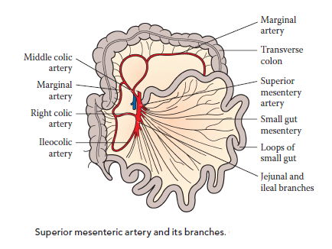

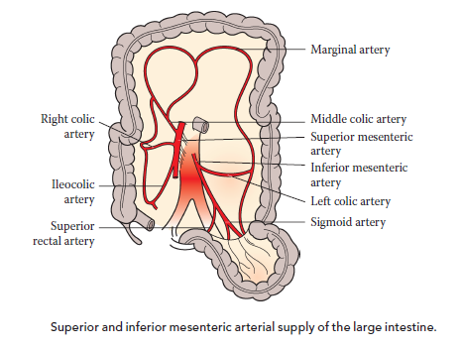

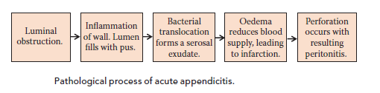

**Diagnosis**

* The diagnosis of appendicitis is a clinical one; however there are some tests that may be useful, particularly where the diagnosis is not clear-cut. These include:
* The performance of a full blood count (FBC) can be useful to determine whether or not the patient has a leucocytosis.
* A urinalysis to exclude urinary tract infection.
* Although appendicitis may cause a haematuria or pyuria with associated urinary symptoms.
* A pregnancy test in women of child-bearing age is mandatory to rule out an ectopic pregnancy.
* An ultrasound scan (USS) in women can be useful where the diagnosis of appendicitis is in doubt to exclude tubo-ovarian pathology as the cause of RIF pain
* A computed tomography (CT) scan can be useful to confirm the diagnosis, especially in the elderly where a caecal tumour may be causative, or in the obese where examination is difficult.
* Diagnostic laparoscopy allows immediate treatment if appendicitis is confirmed.
* Urea and electrolytes (U&E) should also be performed to assess hydration status.
* Remember to ask about previous abdominal surgeries (including right hemicolectomy), as it is embarrassing to quote appendicitis as a cause of RIF pain if the patient has already had the appendix removed!

**Management**

* Patients are often dehydrated at presentation and so require fluid resuscitation. IV fluids should be continued whilst the patient remains starved for theatre.

**Open appendicectomy**

* Usually performed in children.
* A Lanz incision is used for the best cosmetic result.
* If the appendix is found to be perforated or gangrenous, then peritoneal lavage is performed to remove any pus or contamination.
* Most patients can be discharged on the second or third day post-operatively.

**Laparoscopic appendicectomy**

* Improves diagnostic accuracy and minimises negative appendicectomy rates.
* It is indicated in patients who are unwell but there is question as to the diagnosis, and is particularly indicated in young women.
* It is useful in the obese where wound infections are more common and laparoscopic procedures have lower wound infection rates.
* There is now evidence to suggest that laparoscopic appendicectomy should be performed where expertise is available for this to be done.
* Laparoscopy has decreased length of stay in hospital, faster return to normal diet and activities and better post-operative pain.
* If the patient presents late (usually after several days of symptoms) with a palpable appendix mass, he or she requires CT scanning to determine whether there is an associated appendix abscess or a perforated caecal tumour.
* The initial management of an appendix abscess is conservative with IV fluids, antibiotics and observation. They may require radiological drainage.
* If there is deterioration, or frank perforation, surgery may still be required.

**Complications**

* Abscess formation; peri-appendicular, pelvic or sub-hepatic.
* Post-operative collection or abscess.
* Appendix stump blowout, leading to peritonitis.
* Wound problems, including infection or haematoma.
* Intestinal obstruction due to adhesion formation within the abdomen.
* Patients with a perforated appendix may occasionally need admission to intensive treatment unit (ITU).

**Pregnancy**

* Appendicitis is the most common non-gynecologic surgical emergency during pregnancy.
* It must be suspected in any pregnant woman with abdominal pain.
* Operation is indicated in pregnant patient as soon as the diagnosis of appendicitis is suspected. A negative laparotomy carries a risk of fetal loss of up to 3% .

**Deep Venous Thrombosis**

Deep venous thrombosis (DVT) is a common cause of death. The true incidence of DVT difficult to determine because its clinical diagnosis can be inaccurate and often occurring in the setting of other critical illness.

**Pathophysiology**

DVT starts as platelet nidus, usually in the venous valves of the calf. The thrombogenic nature of the nidus activates the clotting cascade, leading to platelet and fibrin accumulation. The fibrinolytic system is subsequently activated, with thrombus growth if thrombogenesis predominates over thrombolysis. A thrombus can detach from the endothelium and migrate into the pulmonary system, becoming a PE; alternatively, it can also organize and grow into the endothelium, resulting in venous incompetency and phlebitis. Thrombi localized into the endothelium, resulting in embloize than thrombi that extend to the thigh veins. Approximately 20% of cases of calf DVT propagate to the thigh, and 50% of cases of thigh or proximal DVT embolize.

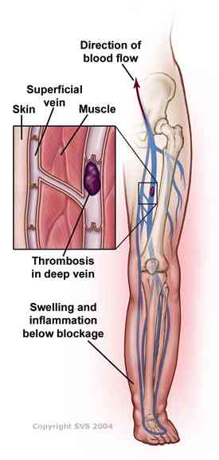

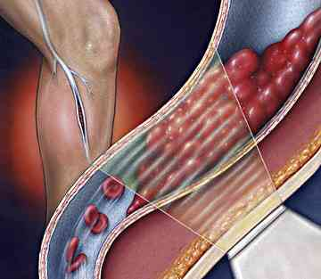

**Risk factors for DVT**

* Endothelial injury by malignancy:
* Adhesion of tumor cells to endothelium can lead to disruption of endothelial intracellular junctions and expose the highly thrombogenic subendothelial surface.
* Chemotherapeutic drugs, such as bleomycin, carmustine, vincristine and doxorubicin can also cause vascular endothelial cell damage.
* Venous stasis:
* This is caused by immobility, venous obstruction, increased venous pressure, and increased blood viscosity.
* Venous stasis promotes thrombus formation by reducing clearance of activated coagulation factors and by causing endothelial hypoxia, leading to reduced levels of surface-bound thrombomodulin and increased expression of TF.
* Surgery and critical illness. Major chest surgery, abdominal/ pelvic surgery, and lower extremity surgery have all been associated with increased risk of DVT development. Similarly, a prolonged non-ambulatory state, such as fracture of the hip, pelvis, or leg; multisystem trauma; neurologic injury; or other critical injury requiring bed rest can increase DVT risk.
* Oral contraceptives (OCPs) and estrogen hormone replacement therapy:These have been linked to increased risk of venous thrombus formation.
* Hypercoagulable states:
* Primary hypercoagulable states are inherited conditions that can lead to abnormal endothelial cell thromboregulation.
* Decreased thrombomodulin-dependent activation of protein C
* Impaired heparin binding of antithrombin III.
* Downregulation of membrane-associated plasmin production.
* Increased serum prothrombin levels.
* Decreased thrombogenic inhibitors.
* Secondary hypercoagulable states are states in which endothelial activation
* Antiphospholipid syndrome.
* Venous trauma.
* Surgery.
* Hyperhomocysteninemia
* Heparin-induced thrombopathy.
* Myloprolerative syndromes.
* Cancer.
* Chemotherapy agents: cyclophosphamide, MTX, and 5-flurouracil, cause a decrease in the plasma levels of proteins C and S.

**Clinical features**

DVT can be silent but typically symptoms and signs occur during the second postoperative week, although they may came earlier or later. The patient complains of pain in the calf, and on examination there is tenderness of the calf and swelling of the foot, often with edema, raised skin temp., and dilation of the superficial veins of the leg. This is accompanied by a mild pyrexia. If the pelvic veins or the femoral vein are affected, there is massive swelling of the whole lower limb.

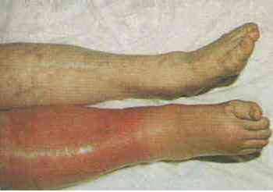

**Investigations**

* Venography: it is an invasive procedure.
* Duplex scanning: it can detect thrombi in all major veins at and above the knee. It is simple and noninvasive.
* Compression ultrasonogrphy: is highly sensitive in detecting thrombosis of the proximal veins but less sensitive in detecting calf vein thrombosis.

**Management**

**A. Prophylaxis**

* Treat avoidable risk factors.
* Active mobilization: stimulation of blood flow by encouraging early mobilization reduces the risks.
* Intermittent calf compression: using inflatable cushions wrapped around the lower legs may be used intra-operatively to reduce the incidence of thrombosis.
* Graded compression stockings and elevation of the legs to increase venous return are simple and effective.
* Low-dose unfractionated heparin: this is given SC at 5000 units 2 hrs. before surgery every 8 or12 hrs. Postoperatively. It should not be used for patients undergoing cerebral, ocular or spinal surgery.
* Low- molecular weight heparins: such as enoxaparin.
* Newer medications: such as the direct thrombin inhibitors represent a possible alternative to the unfractionated and LMWHs in the prevention of thromboembolic disease.

**B. Treatment**

When the diagnosis of DVT is made postoperatively, begin full-dose heparinization(bolus of 5000-10000IU, followed by continuous infusion of 1000-1500IU/hr) if surgical hemostasis is achieved. Once on therapeutic heparin (aPPT of 1.5-2), warfarin should be initiated and the dose adjusted to maintain an appropriate INR (ie, 2-3). Heparin and a therapeutic level of warfarin should overlap for at least 48 hrs. before discontinuing heparin. If edema is present, the patient should remain on bed rest with the affected limb elevated above the level of the heart for several days. The patient should remain on bed rest for 2-3 days even if no pain or edema is present and even if the aPPT is at a therapeutic range to allow fixation of the clot to the vessel wall. Administer 3-6 months of therapy in the case of proximal DVT, assuming that surgery was the only predisposing risk factor.

* Daltapain sodium is administered at 200 IU/kg/day SC. With a single dose not to exceed 18000 IU.
* Enoxaparin sodium is administered at 1mg/kg q12 hrs. SC. Or at 1.5mg/kg/day SC. The single daily dose should not exceed 150 mg.

***Cholelithiasis***

**Epidemiology**

* Gallstones are common:
* 10% of people over 50 years have gallstones.
* Incidence increases with age.
* Affects more women than men 2F:1M.

**Aetiology**

* Three types of gallstones:
* Cholesterol stones (20%).
* Bile pigment stones (5%).
* Mixed stones (75%).

**Clinical features**

* 80% are asymptomatic.
* There are several clinical presentations associated with gallstones (see Figure)

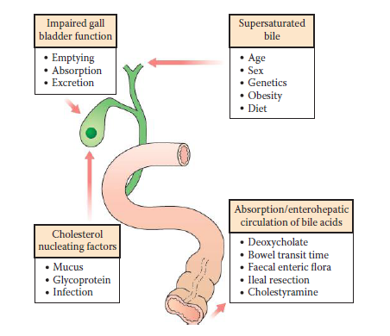

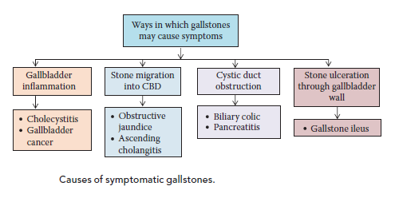

**Biliary colic**

* Pain occurring when the gallbladder contracts against an obstruction (e.g. a stone in Hartmann’s pouch or the cystic duct).
* Severe right upper quadrant (RUQ)/epigastric pain, lasting for a few hours.
* Usually precipitated by eating (often fatty foods).
* May be associated with nausea &/ or vomiting.
* Patient is usually systemically well (in contrast to acute cholecystitis)

**Acute cholecystitis**

* Prolonged gallbladder outlet obstruction, resulting in inflammation due to concentrated bile, initially resulting in chemical cholecystitis.
* May subsequently be complicated by infection, pus (empyema) or mucus (mucocele).
* Often a history of previous biliary colic.
* RUQ/epigastric pain that becomes more severe, constant and localised after a day or two.
* Associated fever, ↑ WCC, may be rigors and other features of sepsis.
* On examination there will be tenderness and guarding in the RUQ.
* Murphy’s sign positive.

**Chronic cholecystitis**

* Repeated episodes of inflammation resulting in chronic fibrosis and thickening of the entire gallbladder wall.
* Recurrent episodes of pain with or without fever.

**Diagnosis**

* Inflammatory markers (WCC, CRP) will usually be elevated in acute cholecystitis, cholangitis and pancreatitis.
* LFTs may show an obstructed picture. Serial measurements should be taken if obstructive jaundice is present to ensure its resolution or prompt further treatment if it remains elevated.
* Ultrasound scan (USS) is used to visualise the gallbladder and biliary tree, allowing diagnosis of stones, inflammation and duct dilatation.
* Plain abdominal x-ray is useful in gallstone ileus, as there will be evidence of small bowel obstruction, often with pneumobilia.
* MRCP allows better visualisation of the biliary tree and will demonstrate any gallstones within the CBD that may be causing obstruction (Figure 5.7), which will require removal (e.g. with ERCP or at surgery).
* ERCP is diagnostic for biliary tree dilatation and CBD stones, and is used therapeutically to remove obstructing CBD stones, insert stents and perform sphincterotomy (sphincter of Oddi).

**Treatment**

**Supportive measures**

* Intravenous fluids and analgesia.
* Antibiotics are required in patients with acute cholecystitis, cholangitis and acute severe pancreatitis.
* Vitamin K is used to correct coagulopathy caused by obstructive jaundice. ERCP may be used therapeutically in the presence of CBD obstruction
* Trawling of the duct to remove stones.
* Sphincterotomy to prevent further obstructive episodes.
* Insertion of stents to allow bile drainage in difficult cases.
* Percutaneous transhepatic cholangiography (PTC) is used in patients with severe biliary obstruction and sepsis who are unsuitable for ERCP or where it has been unsuccessful.
* Insertion of a percutaneous stent may relieve obstruction until sepsis subsides and the patient is well enough for alternative management.
* Complications include:
* Bleeding, infection (cholangitis), pancreatitis, perforation.

**Cholecystectomy**

* Indications:
* Acute or chronic cholecystitis, recurrent biliary colic, gallstoneinduced pancreatitis, biliary peritonitis due to perforation of the gallbladder or previous CBD obstruction.
* Usually performed laparoscopically.
* Conversion to open procedure is rare and should occur in <5% of elective cases and <10% of emergency cases.
* May be a day-case procedure in simple elective cases.
* There is evidence to suggest that index admission laparoscopic cholecystectomy (i.e. on the patient’s first admission with symptoms) is safe, prevents readmission and shortens overall hospital stay.
* On-table cholangiogram and duct exploration may be performed during laparoscopic cholecystectomy to identify and remove any stones.

***Nephrolithiasis***

Urinary stones belong to the group of biochemicals different inorganic and organic substances with a crystalline or amorphous structure are the major constituents of the stones. Urinary stones occur in all parts of the renal collecting system. Only about one-third of all urinary stones have a monomineral composition. The peak incidence of urinary calculi is in the third to fifth decades. Stones are more prevalent in men than in women and incidence is increased during the late summer months.

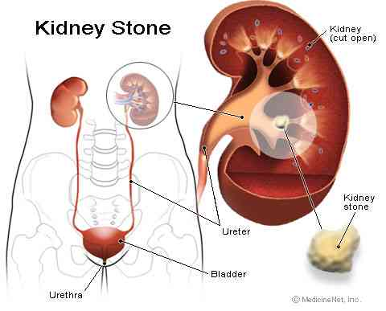

***Types of renal stones***

1*. Calcium stones:* are the most common (60%). These stones are composed of mixtures of calcium oxalate (CaOx) and calcium phosphate (CaP), only CaOx or rarely only CaP and higher rates of recurrence in stones with CaP occur. The average age of onset is the third to fourth decade. Approximately 50% of people who form a single calcium stone eventually form another within the next 10 years. The average rate of new stone formation in recurrent stone formers is about one stone every 2 or 3 years. Calcium stone disease is frequently familial.

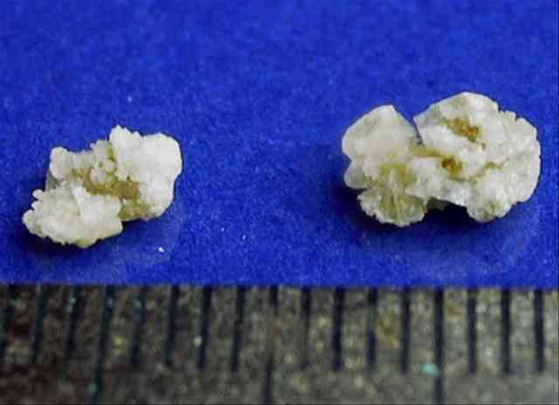

**2. *Uric acid stones****:* are radiolucent and are also more common in men. Half of patients with uric acid stones have gout; uric acid lithiasis is usually familial whether or not gout is present. Crystals of uric acid are precipitated when supersaturation with uric acid is high. The important factors are high excretion of urate, a small urine volume and a low urinary PH.

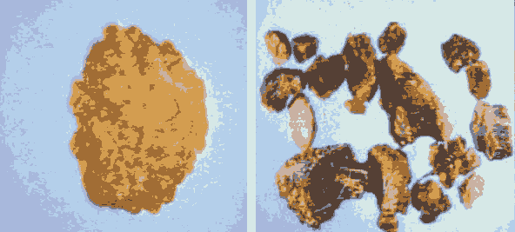

**3. *Struvite stones****:* are composed of a mixture of calcium, ammonium, and magnesium phosphate (triple phosphate stone) are common and potentially dangerous. These stones occur mainly in women or patients who require chronic bladder catheterization and result from urinary tract infection with urease-producing bacteria, usually *Proteus* species. The stones can grow to a large size and fill the renal pelvis and calyces to produce a “staghorn” appearance. They are radiopaque and have a variable internal density.

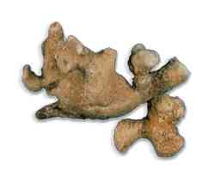

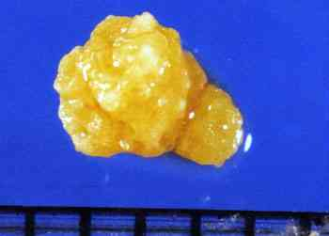

1. ***Cysteine stones:*** are uncommon; their radioopacity is due to the sulfur content. They appear in the urine as flat, hexagonal plates.

***Clinical features***

Pain is the presenting feature of the greatest majority of kidney stones, but if the calculus is embedded within the solid substance of the kidney it may be entirely symptom free. Impaction of the stone at the peliv-ureteric junction, or migration down the urter itself, produces the dreadful agony of uretric colic; the pain radiates from loin to groin, is of great severity and is accompanied by typical restlessness of the patient associated with nausea and vomiting, who is quite unable to lie still in bed. Haematuria, which may be microscopic or macroscopic, is frequently present.

***Investigation***

*1. Urine:* is tested for the presence of blood.

*2. Plain abdominal X-ray:* specifically looking at kidneys, urters and bladder will show the presence of stone in 90% of cases.

*3. CT scan*: is the investigation of choice to confirm the diagnosis of renal colic since it is rapid, is more sensitive at detecting a stone, and can diagnose alternative pathologies if present (e.g. torted ovarian cyst, ruptured aortic aneurysom).

***Investigation of the underlying cause***

*1. Urine microscopy and culture:* the urine is cultured for bacteria and examined microscopically for the presence of cystine crystals.

2. Analysis of the stone, whether passed spontaneously or removed surgically, should be performed.

*3. Uric acid estimation:* the serum uric acid is raised in gout with its associated uric acid stones.

*4. Serum calcium:* hypercalcaemia( a value above 2.75mmol/L) is associated suspicious of the presence of a parathyroid tumor, although the incidence of stones due to this cause is low.

*C****omplications****:*

1. *Hydronephrosis*: is a dilatation of the renal pelvis and calyces. It may be secondary to obstruction within the lumen as ureteric calculus; or in the wall as transitional cell tumor or outside the wall as retroperitoneal fibrosis. Hydronephrosis may be without obstruction. It may be unilateral(e.g. calculus stuck in one ureter) or bilateral(e.g. prostatic hypertrophy) with resultant bilateral hydronephrosis.

2. *Infection :* pyelonephritis, pyonephrosis.

3. *Anuuria:* due to either impaction of calculi in the urter on each side, or blockage of the urter in a remaining solitary kidney

***Therapeutic strategies***

***1. Calicum stones***

***A. Idiopathic Hypercalciuria*:** This condition appears to be hereditary. In some patients, primary intestinal hyperabsorption of calcium causes transient postprandial hypercalcemia that suppresses secretion of parathyroid hormone. In other patients, reabsorption of calcium by the renal tubules appears to be defective, and secondary hyperparathyroidism is evoked by urinary losses of calcium. Renal synthesis of 1,25-dihydroxyvitamin D is increased, enhancing intestinal absorption of calcium. Vitamin D overactivity, either through high calcitriol levels or excess vitamin D receptor, is a likely explanation for the hypercalciuria in many of these patients. Hypercalciuria contributes to stone formation by raising urine saturation with respect to calcium oxalate and calcium phosphate.

***Treatment***

For many years the standard therapy for hypercalciuria was dietary calcium restriction. However, recent studies have shown that low-calcium diets increase the risk of incident stone formation. In addition, hypercalciuric stone formers have reduced bone mineral density and an increased risk of fracture compared to the non-stone-forming population. Low calcium intake likely contributes to the low bone mineral density.

As a whole, low-calcium diets do not appear to be efficacious and carry a long-term risk of bone disease in the stone-forming population. Low-sodium and low-protein diets are a superior option in stone formers.

If diet therapy is not sufficient to prevent stones. Thiazide diuretics may be used to lower urine calcium and are effective in preventing the formation of stones. . Thiazide-induced hypokalemia should be aggressively treated since hypokalemia will reduce urine citrate, increasing urine calcium ion levels.

***B. Hyperuricosuria:*** About 20% of calcium oxalate stone formers are hyperuricosuric, primarily because of an excessive intake of purine from meat, fish, and poultry. The mechanism of stone formation is probably due to salting out calcium oxalate by urate. A low-purine diet is desirable but difficult for many patients to achieve. The alternative is allopurinol at a dose of 100 mg bid is usually sufficient.

***C. Primary Hyperparathyroidism:***  The diagnosis of this condition is established by documenting that hypercalcemia that cannot be otherwise explained is accompanied by inappropriately elevated serum concentrations of parathyroid hormone. Hypercalciuria, usually present, raises the urine supersaturation of calcium phosphate and/or calcium oxalate. Prompt diagnosis is important because parathyroidectomy should be carried out before renal damage or bone disease occurs.

***D. Hyperoxaluria:*** Oxalate is a metabolic end product in humans. Urine oxalate comes from diet and endogenous metabolic production, with approximately 40 to 50% originating from dietary sources. The upper limit of normal for oxalate excretion is generally considered to be 40 to 50 mg per day. Mild hyperoxaluria (50 to 80 mg/d) is usually caused by excessive intake of high-oxalate foods such as spinach, nuts, and chocolate. In addition, low-calcium diets may promote hyperoxaluria as there is less calcium binding oxalate in the intestine, increasing the amount of oxalate available for absorption. Enteric hyperoxaluria is a consequence of small bowel disease resulting in fat malabsorption. Oxalate excretion is often over 100 mg per day. Enteric hyperoxaluria may be caused by jejunoileal bypass for obesity, bacterial overgrowth syndromes, pancreatic insufficiency, or extensive small intestine involvement from Crohn’s disease. With fat malabsorption, calcium in the bowel lumen is bound by fatty acids instead of oxalate, which is left free for absorption in the colon. Delivery of unabsorbed fatty acids and bile salts to the colon may injure the colonic mucosa and enhance oxalate absorption. Hereditary hyperoxaluria states are rare causes of severe hyperoxaluria, often greater than 150 mg per day. Patients usually present with recurrent calcium oxalate stones during childhood. Type I hereditary hyperoxaluria is inherited as an autosomal recessive trait and is due to a deficiency in the peroxisomal enzyme alanine: glyoxylate aminotransferase. Type II is due to a deficiency of D-glyceric dehydrogenase. Severe hyperoxaluria from any cause can produce tubulointerstitial nephropathy and lead to stone formation.

***Treatment***

Patients with mild to moderate hyperoxaluria should be treated with a diet low in oxalate and with a normal intake of calcium and magnesium to reduce oxalate absorption. Enteric hyperoxaluria can be treated with the oxalate-binding resin cholestyramine at a dose of 8 to 16 g/d, correction of fat malabsorption, and a low-fat, low-oxalate diet. Calcium supplements, given with meals, precipitate oxalate in the gut lumen, providing an additional form of therapy. Treatment for hereditary

hyperoxaluria includes a high fluid intake, neutral phosphate, and pyridoxine (25 to 200 mg/d). Citrate supplementation may also have some benefit. Even with aggressive therapy, irreversible renal failure secondary to recurrent stone formation often occurs. Segmental liver transplant, to correct the enzyme defect, combined with a kidney transplant has been successfully utilized in patients with hereditary hyperoxaluria.

***E. Hypocitraturia:*** Urine citrate prevents calcium stone formation by creating a soluble complex with calcium, effectively reducing free urine calcium. Hypocitraturia is found in 15 to 60% of stone formers, either as a single disorder or in combination with other metabolic abnormalities. It can be secondary to systemic disorders, such as RTA, chronic diarrheal illness, or hypokalemia, or it may be a primary disorder, in which case it is called *idiopathic hypocitraturia*.

***Treatment***

Treatment is with alkali, which increases urine citrate excretion; generally bicarbonate or citrate salts are used. Potassium salts are preferred as sodium loading increases urinary excretion of calcium, reducing the effectiveness of treatment. Two randomized, placebo-controlled trials have demonstrated the effectiveness of citrate supplements in calcium oxalate stone formers.

***F. Idiopathic Calcium Lithiasis:*** Some patients have no metabolic cause for stones despite a thorough metabolic evaluation. The best treatment appears to be high fluid intake so that the urine specific gravity remains at 1.005 or below throughout the day and night. Thiazide diuretics, allopurinol, and citrate therapy may help reduce crystallization of calcium salts, but there are no prospective trials in this patient population. Oral phosphate at a dose of 2 g phosphorus daily may lower urine calcium and increase urine pyrophosphate and thereby reduce the rate of recurrence. Orthophosphate causes mild nausea and diarrhea, but tolerance may improve with continued intake.

***2. Uric acid stones***

These stones form because the urine becomes supersaturated with undissociated uric acid. In gout, idiopathic uric acid lithiasis, and dehydration, the average pH is usually below 5.4 and often below 5.0. Undissociated uric acid therefore predominates and is soluble in urine only in concentrations of 100 mg/L. Concentrations above this level represent supersaturation that causes crystals and stones to form. Hyperuricosuria, when present, increases supersaturation, but urine of low pH can be supersaturated with undissociated uric acid even though the daily excretion rate is normal. Myeloproliferative syndromes, chemotherapy of malignant tumors, and Lesch-Nyhan syndrome cause such massive production of uric acid and consequent hyperuricosuria that stones and uric acid sludge form even at a normal urine pH. Plugging of the renal collecting tubules by uric acid crystals can cause acute renal failure.

***Treatment***

The two goals of treatment are to raise urine pH and to lower excessive urine uric acid excretion to less than 1 g/d. Supplemental alkali, 1 to 3 mmol/kg of body weight per day, should be given in three or four evenly spaced, divided doses, one of which should be given at bedtime. The form of the alkali may be important. Potassium citrate may reduce the risk of calcium salts crystallizing when urine pH is increased, whereas sodium citrate or sodium bicarbonate may increase the risk. If the overnight urine pH is below 5.5, the evening dose of alkali may be raised or 250 mg acetazolamide added at bedtime. A low-purine diet should be instituted in those uric acid stone formers with hyperuricosuria. Patients who continue to form uric acid stones despite treatment with fluids, alkali, and a low-purine diet should have allopurinol added to their regimen. If hypercalciuria is also present, it should be specifically treated, as alkali alone could lead to calcium phosphate stone formation.

***3. Cystinuria and cystine stones***

In this autosomal recessive disorder, proximal tubular and jejunal transport of the dibasic amino acids cystine, lysine, arginine, and ornithine are defective, and excessive amounts are lost in the urine. Clinical disease is due solely to the insolubility of cystine, which forms stones.

***Treatment***

High fluid intake, even at night, is the cornerstone of therapy. Daily urine volume should exceed 3 L. Raising urine pH with alkali is helpful, provided the urine pH exceeds 7.5. A low-salt diet (100 mmol/d) can reduce cystine excretion up to 40%. Because side effects are frequent, drugs such as penicillamine and tiopronin, which form the soluble disulfide cysteine-drug complexes, should be used only when fluid loading, salt reduction, and alkali therapy are ineffective. Captopril, which has a free sulfhydryl group to bind cysteine, has been used in a limited number of patients with some success. Low-methionine diets have not proved to be practical for clinical use, but patients should avoid protein gluttony.

**4. *Struvite stones***

These stones are a result of urinary infection with bacteria, usually *Proteus* species, which possess urease, an enzyme that degrades urea to NH3 and CO2. The NH3 hydrolyzes to NH4 and raises urine pH to 8 or 9. The CO2 hydrates to H2CO3 and then dissociates to CO3 2 that precipitates with calcium as CaCO3. The NH4 precipitates PO43‑ and Mg2_ to form MgNH4PO4 (struvite). The result is a stone of calcium carbonate admixed with struvite. Struvite does not form in urine in the absence of infection, because NH4 concentration is low in urine that is alkaline in response to physiologic stimuli. Chronic *Proteus* infection can occur because of impaired urinary drainage, urologic instrumentation or surgery, and especially with chronic antibiotic treatment, which can favor the dominance of *Proteus* in the urinary tract.

***Treatment***

Complete removal of the stone with subsequent sterilization of the urinary tract is the treatment of choice for patients who can tolerate the procedures. Irrigation of the renal pelvis and calyces with hemiacidrin, a solution that dissolves struvite, can reduce recurrence after surgery. Newer procedures such as lithotripsy and percutaneous nephrolithotomy, alone or in combination, have largely replaced open surgery. Antimicrobial treatment is best reserved for dealing with acute infection and for maintenance of sterile urine after surgery. For patients who are not candidates for surgical removal of stone, acetohydroxamic acid, an inhibitor of urease, can be used. Though effective in treating the stones, acetohydroxamic acid has many side effects, such as headache, tremor, and thrombophlebitis that limit its use.

***Hyperthyroidism***

Synonymous with ‘overactive thyroid’ and ‘thyrotoxicosis’.

**Epidemiology**

Incidence of 0.2–0.3% of men and 2–3% women.

**Aetiology**

Graves’ disease (autoimmune)

Occurs in females, aged 20–40.

**Clinical Features of Hyperthyroidism**

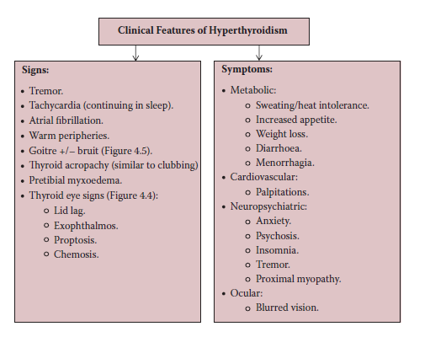

* The body produces antibodies that are structurally similar to the binding site of TSH, causing excessive release of T3 and T4 by the thyroid.
* There is an association with other autoimmune conditions (e.g., type I diabetes mellitus, vitiligo, Addison’s disease).
* May occur following infection with *Yersinia* or *E. coli*.
* Eye signs (exophthalmos, lid lag) are more common in Graves’ disease.
* May have a smooth, enlarged thyroid gland.
* Hyperthyroidism is usually due to an inherent thyroid abnormality; pituitary causes are rare.



**Toxic multi-nodular goiter**

* Occurs in older women.
* Areas of hyper- and hypoplasia within the gland.
* Palpable nodular goitre.

**Toxic adenoma**

* Causes ~5% of hyperthyroidism.
* Will not remit after anti-thyroid medication.
* Focal point of enlargement palpable within the gland.
* Post-partum thyroiditis.
* De Quervain’s thyroiditis (following acute inflammation).
* Testicular or ovarian tumors.
* Pituitary adenoma.
* Overdose of thyroxine.



**Diagnosis**

* Hyperthyroidism is confirmed by thyroid function tests (TFTs):
* ↓TSH (<0.5 mU/L);
* ↑T3 and T4 (except in rare pituitary or gonadal causes).
* In Graves’ disease, thyroid peroxidase (TPO) and thyroglobulin antibodies can be measured.

**Imaging**

* Thyroid scintogram uses radioactive iodine to identify overactive areas within the gland (‘hot nodules’).
* Ultrasound scans (USS) and computed tomography (CT) allow detail of the gland and identification of compression of adjacent structures.

**Biopsy**

* Allows histological analysis.
* Often USS-guided.

**Treatment**

**Medication**

* Anti-thyroid drugs can be used definitively or in preparation for surgery.
* Carbimazole (first line) or propylthiouracil
* Acts by interfering with hormone synthesis.
* ‘Block and replace’ (high-dose anti-thyroid drugs to completely suppress hormone production alongside replacement thyroxine) or suppression with lower doses, aiming for lower hormone levels.
* Complication of carbimazole therapy:
* Agranulocytosis (severe bone marrow suppression); therefore any infections must be thoroughly investigated during treatment.
* Control of symptoms, such as palpitations and tremor, may be provided by beta-blockade with propranolol.
* Achieves control in ~50% after 1 year of treatment.

**Radio-iodine**

* As the thyroid is the only organ to take up iodine, radioactive isotopes (I131) can be given to destroy the thyroid gland.
* It is contra-indicated in children and pregnancy.

**Surgery**

* May be partial or total excision depending on the cause.
* In a subtotal thyroidectomy the posterior rim is left so to avoid damage to the parathyroid glands.
* Four main indications for surgery over medical therapy:
* when a quick, effective treatment is desired (e.g. in young women with Graves’ disease);
* when anti-thyroid drugs have proved ineffective;
* toxic multi-nodular goitre (better medical and cosmetic outcome);
* toxic solitary nodule (often resistant to medical treatment).
* Pre-operative considerations:
* Thyroid function should be normalised as much as possible to avoid the dangers of thyrotoxicosis and thyroid storm.
* Anti-thyroid drugs are often stopped 10–14 days pre-operatively as they increase vascularity to the gland.
* Complications:
* Hypothyroidism occurs in ~10% at 1 year and increases with time.
* Transient hypocalcaemia occurs ~10%, or permanently in ~1%. It is due to inadvertent damage to, or removal of, the parathyroid glands.
* Hyperthyroidism—Late recurrence due to inadequate excision.
* Thyroid crisis (rare). May occur in any hyperthyroid patient due to infection, surgery or stress.
* There is hyperpyrexia, tachycardia and mania. It may cause death due to heart failure.
* Treatment is with urgent propranolol, potassium iodide, anti-thyroid drugs and corticosteroids, along with supportive measures.
* Recurrent laryngeal nerve injury occurs in 2–3%. May cause slight ‘hoarseness’ of voice to complete loss of vocal function and critical airway narrowing. Damage to the external nerve will cause a change in the quality of the voice.
* Tracheal damage or pneumothorax may occur acutely due to direct surgical damage or due to tracheomalacia, following many years of tracheal compression from a goitre.
* Haemorrhage—A potential complication of any surgery; in the neck this is an emergency, as it may cause tracheal compression. The wound is usually stitched with one continuous suture that may be pulled out in one go if there is life-threatening compression.

**Prognosis**

* Slight increase in mortality in the first year following diagnosis of hyperthyroidism; the reason for this is unknown.
* Adequately treated hyperthyroidism results in an increased risk of osteoporosis.

***Colorectal cancer***

**Epidemiology**

* Colorectal cancer is the third most common cancer diagnosis in the UK.
* It is the second commonest cause of cancer death.
* M:F ratio = M > F.
* It rarely occurs in the under 50s, and is commonest in the over 60s.

**Aetiology**

* The exact cause is unknown, but there are thought to be several aetiological factors.

|  |  |
| --- | --- |
| Increased risk | Decreased risk |
| Diet low in fibre. | Exercise. |
| High-fat and meat diet. | Diet rich in fruit and vegetables. |
| Inflammatory bowel disease. | Aspirin and non-steroidal anti-inflammatory drug (NSAID) use. |
| Familial syndromes. | HRT. |
| Family history (1 first-degreerelative 1:17 risk). |
| Poor glycaemic control in diabetics. |

**Pathology**

* Histopathologically 98% are adenocarcinomas with characteristic ‘signet ring cells’ (mucin within the cell).
* They may be well, moderately or poorly differentiated.
* Macroscopically may be papilliferous, polypoid, ulcerated, annular or diffuse.
* Tumours initially invade the lumen, but extend through the bowel wall layers, and eventually through the serosa.
* The tumor may then spread locally to adjacent organs.
* Lymphatic spread is to the mesenteric and para-aortic nodes.
* Haematogenous spread is to the liver and lungs.
* Metastases to other sites is uncommon.
* As many as 25% of patients with colorectal cancer have distant metastases at presentation.

**Clinical features**

* Patients may be symptomatic or present through the colorectal cancer screening program (faecal occult blood testing).
* Clinical presentations will vary according to the site of the tumor.

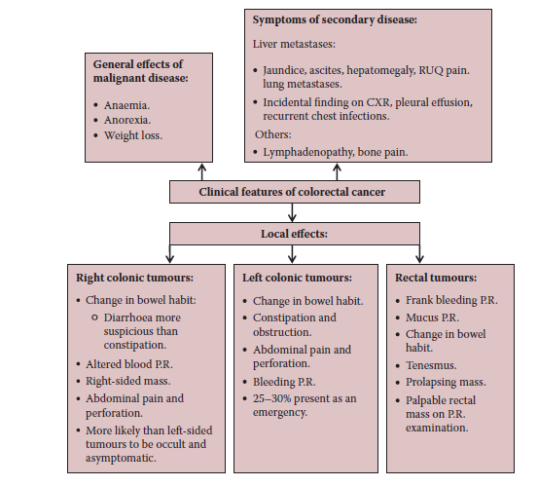

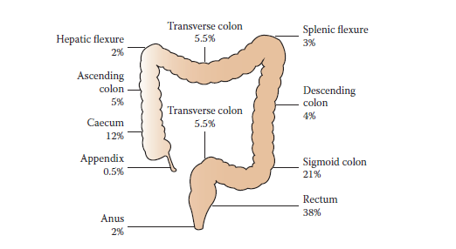

**Diagnosis**

* Blood tests of use are:
* FBC (may show anaemia);
* U&E (useful pre-operatively or in the acute setting);
* LFT (may be deranged in the presence of liver metastases);
* Carcinoembryonic antigen (CEA) should be taken as a baseline after confirmation of the diagnosis.
* At initial consultation patients should have proctoscopy and rigid sigmoidoscopy (may allow tumour visualisation in low rectal tumors or show evidence of blood/slime from above; however usually normal).
* Colonoscopy allows visualisation of the entire colon and biopsy.
* Barium enema may show the typical ‘apple core’ lesion of CRC.
* A negative barium study cannot exclude a small tumor.
* Biopsies are required to give the definitive cellular diagnosis.



**Staging**

* Commonly classified according to the modified Duke’s criteria.
* Most commonly performed with CT scanning.
* Ultrasound or magnetic resonance imaging (MRI) may better show small liver metastases and chest x-ray may be used to show lung metastases.
* MRI or trans-rectal USS is used to assess pelvic extent and lymph node status in rectal cancers.
* PET scanning may also be used to look for extra-hepatic metastases.

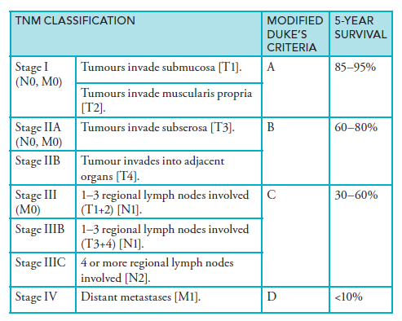

**Treatment**

**Surgery**

* 80% of colorectal cancers will be amenable to resection.
* May be performed via laparotomy or laparoscopy.
* The resection is based on the mesenteric blood vessels.
* Bowel resection with lymphadenectomy is the only curative procedure.
* For the types of resection.
* For unresectable tumors palliative procedures to prevent obstruction include:
* endoluminal stents;
* defunctioning stoma;
* surgical bypass;
* debulking palliative resection.
* Some hepatic and, to a lesser extent, pulmonary metastases may be resectable.

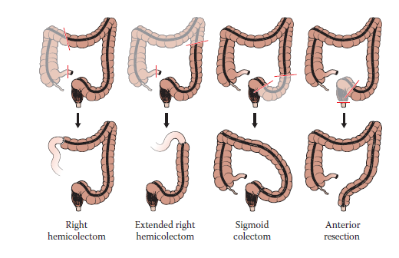

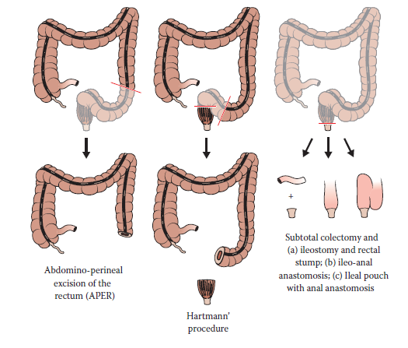

**Chemotherapy**

* Used in palliation of inoperable disease.
* Used as a neoadjuvant agent to downstage liver metastases prior to surgery.
* Used post-operatively (adjuvant) in patients with Duke’s C disease.
* It is not recommended in Duke’s A cancer, but the benefit in Duke’s B is still unclear, and so it may be used if there are poor prognostic indicators.
* Most regimes involve folinic acid and IV fluorouracil (or capecitabine, which is the oral prodrug of fluorouracil) plus another agent (e.g. oxaliplatin, irinotecan and cetuximab).

**Radiotherapy**

* May be given pre-operatively to downstage a rectal tumor, making it easier to remove with clear margins.
* It also reduces local recurrence rates.
* In smaller, node positive tumors, ‘short course’ radiotherapy is given every day, lasting for 5 days.
* In larger, bulky tumors that are invading the circumferential resection margin (CRM), ‘long course’ radiotherapy is given 5 days a week, lasting for up to 6 weeks.
* Long-course radiotherapy is usually given in combination with chemotherapy.
* Fluorouracil (5FU) helps sensitize cells to the effect of radiotherapy.
* Post-operatively, radiotherapy is used in patients who are judged to be at risk of local recurrence following final histological examination:
* If the tumor was large and difficult to remove.
* If the resection margin was not clear.
* If the tumor had invaded through the bowel wall or there was lymph node involvement.
* It is not used in colon cancer due to the variable positions and risk of small bowel injury.

**Prognosis**

* Survival depends on the stage of tumor.
* Follow-up should be offered to all patients and patients undergoing curative resection should be offered:
* A minimum of two CT chest, abdomen, pelvis in the first 3 years.
* Regular CEA tests (6 monthly for 3 years).
* Surveillance colonoscopy should be offered at 1 year and then again at 5 years.
* Follow-up should be stopped when the risk of investigation outweighs the benefits (length of follow-up is often determined by local cancer networks).

***Burns***

**Definition**

* Damage to skin and subcutaneous tissue in response to thermal, electrical, chemical, frictional, cold or radiation injury.
* By far the commonest type in the UK is a thermal burn, caused mostly by dry burn, e.g. flame, but can be from a wet burn, e.g. scalding.

**Assessment of extent of burn**

**Size of burn**

* The patient’s palm is ~1% of his or her total body surface area (TBSA) and can be useful to determine extent of small or very large burns.
* Wallace’s rule of 9’s is useful in initial assessment.
* It is important to use the appropriate chart for the patient’s age.

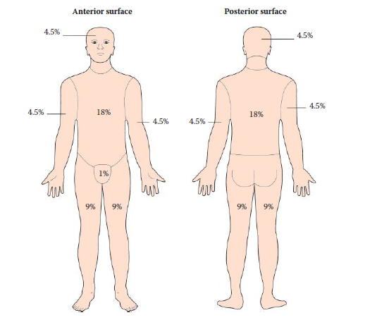The ‘rule of 9’s’ method for calculating the proportion of the total body Surface area that has been burnt.

**Depth of burn**

* Difficult to assess accurately since burns tend to be dynamic and evolve over time.
* Figures show the characteristics of different burn depths.

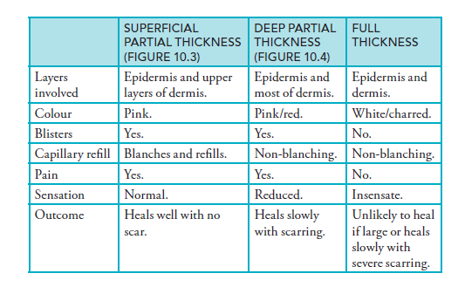





A mixture of partial-thickness and full-thickness burns.

**Initial management of acute burn**

* Like any emergency, management should take the ABC approach.

*MICRO-facts*

Signs of potential inhalation injury:

* Burns on neck, around mouth, on palate or nasal passages.
* Soot in oropharynx or nostrils.
* Hoarse voice.
* Hypoxia.
* Carboxyhaemoglobin.
* Stridor, tachypnoea and dyspnoea are late signs.

**Airway and breathing**

* If suspected smoke inhalation, early intubation is indicated to prevent airway obstruction and death.
* If severe airway obstruction, a tracheostomy may be needed.
* High-flow oxygen through non-rebreathing mask.
* Perform ABG and check carbon monoxide levels.

**Fluid resuscitation**

* Burn injuries lead to large inflammatory exudation of proteins and solutes into the extravascular space.
* This occurs within the first 6–12 hours post-injury (not post-arrival into the emergency department!) and starts to slow by 36 hours
* Fluid loss is dependent on size of burn:
* ≥15% total body surface area (TBSA) in adults and ≥10% in children will lead to circulatory shock.
* Insert a large-bore cannula and catheterize (to monitor output; keep urine output 0.5–1 mL/hour in adults, 1–2 mL/hour in children).
* Use the Parkland formula to calculate the fluid requirements (usually Hartmann’s solution).
* Give half in the first 8 hours (from the time of injury), and half in the next 16 hours.

**Analgesia**

* Cool wound with running water for 10 minutes.
* Temporary use of cling-film as dressing reduces evaporation and pain.
* If small burn, simple oral analgesia may be sufficient.
* If large burn, IV opiate analgesia will be needed (do not use IM route).

**Nutrition**

* Burn injuries lead to a highly catabolic state.
* If burns >20% TBSA, insert a nasogastric (NG) tube within 6 hours to prevent stress ulceration of the stomach (Curling’s ulcers).

**Management of the burn wound**

* Depends on burn depth.
* Assess if an escharotomy is needed:
* An escharotomy is an incision along the full length of the burn to relieve compression due to oedema in circumferential full-thickness burns.
* The incision is in the mid-axial line and extends down to the fascia.
* Necessary if blood flow to a limb is occluded or respiratory movement restricted.
* Escharotomies should be performed in an operating theatre by a burns specialist if at all possible.
* If assessment indicates that escharotomy may be required, discuss **urgently** with the local burns unit and arrange transfer.
* After escharotomy the principles of management are the same regardless of the size of the burn.

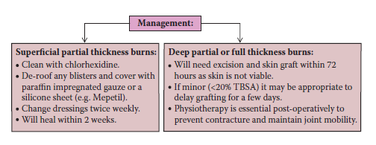

***Breast cancer***

**Epidemiology**

* Breast cancer is the most common cancer diagnosed in women in the UK, affecting over 40,000 women and resulting in 13,000 deaths per year.
* 1 in 8 women will develop breast cancer in their lifetime.
* Peak incidence is in the seventh decade.

**Aetiology**

* Aetiological factors for the development of breast cancer are shown in Figure.

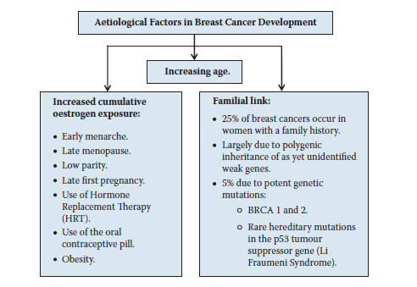

**Clinical features**

* Painless lump in the breast.
* Distortion or tethering of the breast tissue or overlying skin.
* Peau d’orange (skin edema caused by dermal lymphatic infiltration).
* Nipple retraction or inversion (as seen in Figure 3.5).
* Nipple discharge, especially if blood-stained.
* Asymmetric breast nodularity.
* Paget’s disease of the nipple (looks very much like eczema).
* May also present with signs of metastatic disease in 5% of cases:
* pathological fractures;
* bone pain;
* jaundice;
* cough or breathlessness.
* May be asymptomatic at presentation

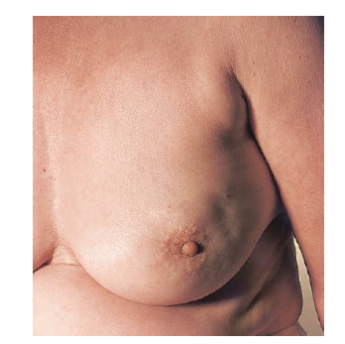

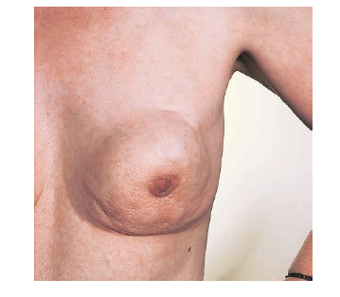

**Diagnosis**

* Diagnosis is by triple assessment.
* Other tests may be indicated once triple assessment has been performed. These may include:
* Breast MRI to look for multi-focality, lobular cancer, or assess disease extent in women with breast implants.
* In women with signs of more advanced cancer (nodal disease or locally advanced):
* CT scan to stage for lung, liver and bone metastases;
* isotope bone scan to stage for bone metastases.

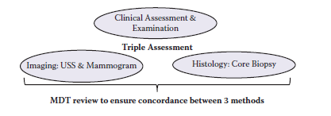

**Histological grading**

* Graded from 1 to 3 based on degree of:
* gland acinus formation;
* nuclear pleomorphism;
* mitosis count.
* Higher grades are associated with increased risk of distant metastatic spread, decreased cancer-specific survival and decreased disease-free survival.

**Tumor receptor status**

* Breast cancer cells may express two different cellular receptors that have both prognostic and therapeutic significance: ER and HER2

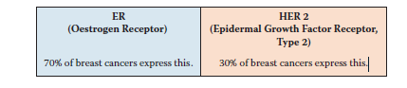

**Staging**

* Breast cancer staging is by the tumour, nodes, metastases (TNM) staging system.

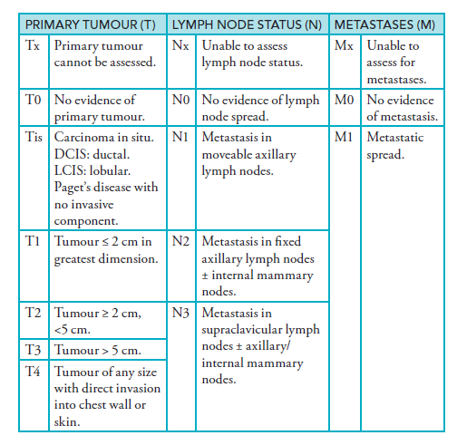

**Management**

**Surgery**

* The primary treatment modality for breast cancer in most women with operable disease is surgery. This takes two main forms: breast conservation surgery and mastectomy.
* Breast conservation surgery (wide local excision).
* The tumour is excised with a 0.5–1 cm margin of normal breast tissue.
* Up to 20% of breast volume may be removed without causing significant distortion.
* Breast reshaping may be required to reduce distortion.
* Post-operative radiotherapy is given to the affected breast.
* 10–12% 20-year recurrence rates.
* Mastectomy.
* Excision of the entire breast.
* Standard mastectomy may be used, which includes removal of a skin ellipse across the whole width of the breast.
* Skin-sparing mastectomy may be performed (through a range of incisions to retain more skin and even the nipple), with immediate reconstruction. This gives enhanced cosmetic outcomes.
* All women who undergo mastectomy should be considered for breast reconstruction, although only 15% of women will choose to have a reconstruction.
* The majority of women who have a mastectomy have breast prosthesis to wear inside their bra to restore clothed cosmesis.
* For those who want reconstruction there may be several options:
* Delayed or immediate, depending on the need for further treatment and patient wishes.
* Silicone implant-based reconstruction may be used, either immediately or following tissue expansion.
* Autogenous reconstruction involves transfer of a flap of skin, muscle and fat from a donor site, such as the back or abdomen.
* Axillary lymph node surgery.
* Axillary node biopsy is required in all patients with invasive breast cancer.
* Pre-operative imaging and biopsy of abnormal nodes is performed on all patients and identifies >50% of those who have nodal spread.
* Axillary node sampling removes four nodes from the affected axilla.
* The false negative rate is ~5%.
* Arm lymphoedema rate of 1–2%.
* Sentinel lymph node biopsy involves injection of blue dye (Figure 3.8) and radioactive tracer into the breast tissue. This drains into the lymphatic supply, allowing identification of lymph nodes due to either their blue colour or via an intra-operative Gieger counter.
* The false negative rate is also ~5%.
* Arm lymphoedema rate of 1–2%.
* Axillary node clearance is performed if there is confirmed metastatic lymph node spread.
* It may be done at the time of primary surgery if pre-operative staging with US and biopsy confirms nodal disease, or a second procedure may be needed at a later date if axillary sampling sentinel node biopsy confirms nodal spread.
* It involves removal of all axillary tissue up to the level of the axillary vein.
* It is associated with a 15% risk of arm lymphoedema, which is why it is not performed routinely on all women with breast cancer.

**Adjuvant therapies**

* Many women are offered additional therapies to help reduce the risk of recurrence (see Table).
* Decisions regarding adjuvant therapies are made in conjunction with the MDT, based on the stage and biology of the disease and the patient’s tolerances and wishes.
* Radiotherapy.
* Is given post-operatively to all patients who undergo breast conservation surgery and reduces recurrence rates from ~35% to 10–12%.
* Post-mastectomy radiotherapy is required in ~20% of cases if the tumour is high grade, heavily node positive or in large or inflammatory cancers.
* Radiation is given every day for 3–5 weeks.
* Side effects include fatigue, local skin irritation, oedema and pain. There is ~1 in 1000 risk of radiation-induced cancer at 5–15 years.

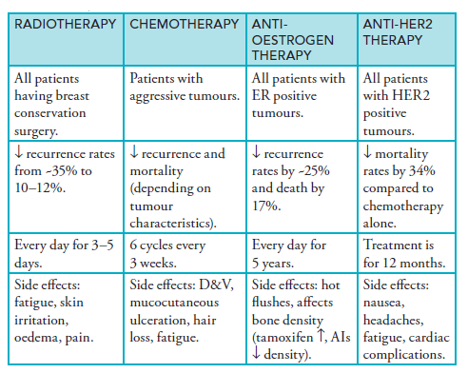

* Chemotherapy.
* Is given post-operatively to patients with aggressive tumours, in particular to patients with:
* young age;
* high tumor grade, node positive, or large primary cancer;
* ER negative cancers;
* HER-2 positive cancers;
* Triple negative cancers.
* Side effects include mucocutaneous ulceration, nausea, vomiting, diarrhoea, hair loss and fatigue.
* May be associated with more serious complications, such as neutropenic sepsis and bleeding as a result of bone marrow suppression.
* May also result in infertility (from premature ovarian failure), increased risk of osteoporosis and cardiovascular disease.
* Common agents include a combination of anthracyclines (e.g. doxorubicin), cyclophosphamides and taxanes.
* Adjuvant anti-oestrogen therapy.
* ER receptor status is determined for all breast cancers and if positive, patients are treated with anti-oestrogen therapy.
* Tamoxifen is used in pre-menopausal women for a period of 5 years.
* It is a selective oestrogen receptor modulator and has an ER antagonist effect on breast cancer cells but an ER agonist effect on endometrial cells and bone.
* Side effects include hot flushes, which are common, and a small increased risk of endometrial cancer from 1:100 000 to 2:100 000).
* It has a bone density protective effect.
* Aromatase inhibitors (e.g. Arimidex, Letrozole, Exemestane) are used in post-menopausal women, again for 5 years.
* These drugs block the peripheral conversion of androgens to oestrogens, the main source of oestrogen in post-menopausal women. Oestrogen levels are thereby reduced to very low levels.
* Side effects include hot flushes, joint pains and an increased risk of osteoporosis (bone density scans are required during therapy).
* Adjuvant Anti-HER-2 directed therapy.
* HER-2 (epidermal growth factor, EGFR-2) receptor is expressed in ⅓ of breast cancers and is a poor prognostic factor.
* Trastuzumab (HerceptinR) is a monoclonal antibody that binds to HER-2 and reduces tumors growth.
* Treatment with trastuzumab is for 12 months in patients with HER-2 positive tumors.

***Hernia***

***Definition***

A hernia is the protrusion of an organ or part of an organ through a defect in the wall of the cavity containing it, into an abnormal position. The term is usually used with reference to the abdomen.

**Abdominal wall hernias**

Most hernias occur as a diverticulum of the peritoneal cavity and therefore have a sac of parietal peritoneum. The common verities of hernias through the abdominal wall in order of frequency are as follows:

* inguinal (indirect or direct)
* femoral
* umblical and para-umbilical
* incisional
* ventral and epigastric

**Aetiology**

Hernias occur at sites of weakness in the abdominal wall. This weakness may be congenital as persistence of the processus vaginalis of testicular descent giving rise to congenital inguinal hernia, or failure of complete closure of the umbilical scar. It may occur at the site of penetration of structures through the abdominal wall as the femoral canal, or the layers of the abdominal wall may be weakened following a surgical incision (incisional hernia), either by poor healing as a result of infection, haematoma formation or poor technique, or by damage to nerves that that results in paralysis of the abdominal muscles.

Hernias should also be thought of as portents of other diseases or conditions as they are often associated with pathological increases I intra-abdominal pressure by conditions such as the following:

* Chronic cough, secondary to chronic bronchitis.
* Constipation: perhaps due to colonic carcinoma.
* Urinary obstruction due to prostatic disease.
* Pregnancy.
* Abdominal distention with ascites.
* Weal abdominal muscles as in gross obesity or muscle wasting in cachexia.

***Appendix***

***Table I : Perioperative drug management for patients with hypertension***

|  |  |  |  |  |
| --- | --- | --- | --- | --- |
| **Drug** | **Day before surgery** | **Day of surgery** | **During surgery** | **After procedure** |
| *Β-blockers* | Usual dose | Usual dose on morning of surgery with sip of water | IV bolus or infusion | Continue IV dose until medication can be taken PO |
| *Calcium channel blockers* | Usual dose | Usual dose on morning of surgery with sip of water | IV bolus or infusion | Continue IV dose until medication can be taken PO |
| *ACE-inhibitors* | Usual dose | Usual dose on morning of surgery with sip of water | IV formulations | Continue IV dose until medication can be taken PO |
| *Diuretics* | Stop day before |  | IV Β-blockers/IV Calcium channel blockers | Restart when patient on oral liquids |
| *Potassium supplements* | Stop day before; consider checking potassium level |  |  | Restart when patient on oral liquids |
| *Central-acting sympatholytics* | Usual dose | Usual dose on morning of surgery with sip of water | Transdermal clonidine/IV methyl dopa | Restart when patient on oral liquids |
| *Peripheral sympatholytics* | Usual dose | Usual dose on morning of surgery with sip of water | Any IV formulation | Restart when patient on oral liquids |
| *Α-blockers* | Usual dose | Usual dose on morning of surgery with sip of water | Any IV formulation | Restart when patient on oral liquids |
| *vasodilators* | Usual dose | Usual dose on morning of surgery with sip of water | Any IV formulation | Continue IV dose until medication can be taken PO |

***Table II : Perioperative drug management for patients with CAD***

|  |  |  |  |  |
| --- | --- | --- | --- | --- |
| **After procedure** | **During surgery** | **After procedure** | **Day before surgery** | **Drug** |
| Continue IV dose if needed or until medication can be taken PO | IV infusion if frank ischemia | Usual dose | Usual dose | *Nitroglycerin* |
| Usual dose + B-blockers | Usual dose + B-blockers | Usual dose + B-blockers | Usual dose | *Beta-blockers* |
| Continue IV dose if needed or until medication can be taken PO | Usual dose morning of surgery | Usual dose morning of surgery | Usual dose | *Calcium channel blockers* |
| Restart postoperatively at discretion of surgeon |  |  | Discontinue 1 week before surgery | *Aspirin* |
| Restart postoperatively at discretion of surgeon |  |  | Discontinue 1 week before surgery | *Ticlopidine* |

|  |  |  |  |  |  |
| --- | --- | --- | --- | --- | --- |
| **Substitute drug if needed** | **After surgery** | **During surgery** | **Day of surgery** | **Day before surgery** | **Drug** |
|  | Continue IV dose until medication can be taken PO | IV phenytoin | Usual dose on morning of surgery with sip of water | Usual dose | *Phenytoin* |
|  | Continue IV dose until medication can be taken PO | IV phenobarbital | Usual dose on morning of surgery with sip of wate | Usual dose | *Phenobarbital* |
| phenytoin or phenobarbital | Continue IV dose until medication can be taken PO | IV phenytoin or IV phenobarbital | PO phenytoin or phenobarbital | PO loading dose of phenytoin or phenobarbital | *Carbamazapine* |
| phenytoin or phenobarbital | Continue IV dose until medication can be taken P | PO phenytoin or phenobarbital | PO phenytoin or phenobarbital | PO loading dose of phenytoin or phenobarbital | *Valproic acid* |

***Table III : Perioperative drug management for patients with epilpsey.***

***Table IV : Perioperative drug management for patients on NSAIDs***

|  |  |  |  |  |  |
| --- | --- | --- | --- | --- | --- |
| ***Substitute drug if needed*** | ***After procedure*** | ***During surgery*** | ***Day of surgery*** | ***Day before surgery*** | ***Drug*** |
| Low dose steroids | IM prepration until patient is on oral liquids |  |  | Discontinue 1 week before surgery | NSAIDs with long half-life |
| Low dose steroids | IM prepration until patient is on oral liquids |  |  | Discontinue 2-3 days before surgery | NSAIDs with short half-life |

***Table V: Classification of surgical wounds***

|  |  |  |  |  |
| --- | --- | --- | --- | --- |
| **Usual organism** | **Wound infection rate(%)** | **Example of typical procedures** | **Definition** | **Wound class** |
| S. aureus | 2 | Wide local excision of breast mass | Nontraumatic, elective surgery; no entry of GI, biliary, tracheobronchial, respiratory, or GU tracts | *Clean* |
| Related to the viscus entered | <10 | Gastroctomy, hysterectomy | Respiratory, genitourinary, GI tract entered but minimal contamination | *Clean-containtated* |
| Depends on underlying disease | 20 | Ruptured appendix; resection of unprepared bowel | Open, fresh, traumatic wounds; uncontrolled spillage from an unprepared hollow viscus; minor break in sterile technique | *Contaminated* |
| Depends on underlying disease | 28-70 | Intestinal fistula resection | Open, traumatic, dirty wounds; traumatic perforated viscus; pus in the operative field | *Dirty* |

***Table VI : Recommendations for antibiotic prophylaxis***

|  |  |  |  |
| --- | --- | --- | --- |
| **Adult dose before surgery** | **Recommended antibiotics** | **Likely pathogens** | **Nature of operation** |
| 1-2 g IV  1 g IV  1.5 g IV | Cefazolin  Vancomycin  cefuroxime | Staphylococci, conynbacteria, enteric Gram-ve bacilli | *Cardiac; prosthetic valve and other procedures* |
| 1-2 g IV  1-2 g IV  1-2 g IV | Cefazolin  Vancomycin  Cefoxitin | Staphylococci, streptococci, enteric Gram-ve bacilli, clostridia | *Vascular: peripheral bypass or aortic surgery with prosthetic graft* |
| 1-2 g IV  1-2 g IV | Cefazolin  Vancomycin | Staphylococci | *Orthopedic: total joint replacement or internal fixation of fractures* |
| 1-2 g IV  1.5-3 g IV  600-900 mg/ IV  1.5mg/kg IV | Cefazolin  Amipcillin-sulbactam  Clindamycin  Gentamycin | Oral anaerobes, enteric Gram-ve bacilli, staphylococci | *Head and neck, entering oral cavity or pharynx* |
| 1-2 g IV | Cefazolin | Enteric Gram-ve bacilli, Gram+ve cocci | *Gasrtoduodenal(high-risk patient)* |
| 1-2 g IV  1-2 g IV  1-2 g IV | Cefazolin  Cefoxitin  Cefotatan | Enteric Gram-ve bacilli, enterococci, clostridia | *Biliary* |
| 1 g of each at 1 PM, 2PM, AND 11 PM the day before an 8AM operation | Oral: neomycin+erythromycin base | Enteric Gram-ve bacilli,, anaerobes, enterococci | *Colorectal* |
| 1-2 g IV  1-2 g IV | Cefoxitin  Cefotatan | Enteric Gram-ve bacilli,, anaerobes, enterococci | *Appendectomy (no perforation* |
| 1-2 g IV  1-2 g IV  1-2 g IV | Cefazolin  Cefoxitin  Cefotatan | Enteric Gram-ve bacilli ,group B streptocooci, anaerobes, enterococci | *Vaginal or abdominal hysterectomy* |
| 1g IV after cord clamped | Cefazolin | Same as for hysterectomy | *Cesarean section(high risk patient)* |
| 1g IV q8h  1.5-3 g IV q 6h | Cefazolin or  Amipcillin-sulbactam | Staphylococci, group A streptococci, clostridia | *Traumatic wound* |

***Table VII: Recommendations for preoperative and postoperative anticoagulation in patients taking oral anticoagulants***

|  |  |  |
| --- | --- | --- |
| ***Postoperative*** | ***Preoperative*** | ***Indications*** |
|  | IV heparin  No therapy | *Acute venous thromboembolism*  *Within 1 mo of surgery*  *Within 3 mo of surgery* |
|  | No therapy | *Recurrent venous thromboembolism* |
|  | IV heparin | *Acute arterial embolism (within 30 days)* |
|  | No therapy | *Mechanical heart valve* |
|  | No therapy | *Nonvalvular atrial fibrillation* |

***Table VIII: Prophylaxis for DVT and pulmonary embolism***

|  |  |  |
| --- | --- | --- |
| Prophylaxis | Surgery type | *Patient group* |
| None | Minor | *Low risk* |
| GCS, SC every -12, IPC | Major | *Low or moderate risk* |
| SC every-7 o LMWH | Major | *High risk* |
| SCevery-8/12 or LMWH +IPC | Major | *Highest risk* |

*GCS:* graded compression stockings*.*

*IPC:* intermittent pneumatic compression.

*Low risk:* age less than 40 years and no risk factors*.*

*Moderate risk:* major surgery and age less than 40 years minor procedure with risk factors or between 40 and 60 years of age.

*High risk:* major procedure over 40 years, multiple risk factors present, major procedure.

***Table IX: Estimation of intraoperative fluid loss and guide for replacement***

|  |  |
| --- | --- |
| Maintenance IVF× hr NPO + preexisting deficit related to disease state | *Preoperative deficit* |
| Maintenance IVF× duration of case | *Maintenance fluids* |
| 1-3 mL/kg/hr for minor procedure(small incision)  3-7 mL/kg/hr for moderate procedure(medium incision)  9-11mL/kg/hr for mextensive procedure(large incision) | *Third space and insensible losses* |
| 1 ml blood or colloid per 1mlblood loss, or 3 ml crystalloid per 1ml blood loss. | *Blood loss* |

***Refrences***

* ***Jenna Morgan,Harriet Walker, Andrew Viggars, :Surgery on the Move-CRC Press (2014)***
* ***Mary E. Klingensmith, Li Ern Chen, Sean C. Glasgow, etal. In: The Washington Manual Of Surgery. 5th Ed, Wolters Kluwer/Lippincott Williams & Wilkins.USA.2008.***
* ***Dennis L.Kasper, Eugene Braunwald, Anthony S. Fauci,etal. In: Principls of Internal Medicine. 16th Ed,Mc Graw-Hill.USA.2005***
* ***Anmar Hassan Kashkool, Al-Sabbagh May, Al-Rawaq Kh. The Possible Protective Effects of Antioxidant Drugs (Vitamin E and C) Against The Toxicity of Doxurubicin in Breast Cancer Patients.MS.c.2008.***
* ***Harlod Ellis,Sir Roy Calne, Christopher Waston.In: General Surgery.11th Ed, Blackwell Publishing,UK.2006.***
* ***Preoperative care .*** [***www.surgeryencyclopedia.com***](http://www.surgeryencyclopedia.com)
* ***Quinn AC, Brown JH, Wallace PG, Asbury AJ. Studies in postoperative sequelae. Nausea and vomiting-still a problem. Anaesthesia 49, 62-65 (1994).***
* ***Kenny GN. Risk factors for postoperative nausea and vomiting. Anaesthesia, 49, suppl 6-10 (1994).***
* ***Watcha MF, White PF. Postoperative nausea and vomiting. Its etiology, treatment and prevention. Anesthesiology 78, 403-406 (1993).***
* ***Benton IB, Sneyd JR.  Epidemiological aspects of PONV and assessment of risk.  In: The effective management of post-operative nausea and vomiting.  Eds Strunin, L Rowbotham, DJ and Miles A.  Aesculapius Medical Press, 3-12 (1999)***
* ***Jolley S.  Managing post-operative nausea and vomiting.  Nursing Standard 15 (No 40), 47-54 (2001)***
* ***Perioperative Management of the Geriatric Patient.*** *Author: Tulay Ersan, MD,* ***Chief of Geriatrics, Department of Internal Medicine, Division of Geriatrics, Monmouth Medical Center.***[***Contributor Information and Disclosures***](javascript:showcontent('active','authordisclosures');)***.Updated: Feb 3, 2010.***
* ***Perioperative Medication Management.****Author: Nafisa K Kuwajerwala, MD,* ***Staff Surgeon, Breast Oncology, William Beaumont Hospital. PLLC.***[***Contributor Information and Disclosures***](javascript:showcontent('active','authordisclosures');)***.Updated: Aug 19, 2008***