**Pituitary gland disorders**

* The pituitary gland is referred to as the “**master gland”** because it regulates many other glands & body systems. The pituitary is very small nearly the size of **a pea**, weighing between 0.4 and 1 g in adults. It is located at the base of the brain in proximity to the nasal cavity divided into two distinct regions, the **anterior lobe**, or adenohypophysis, and **the posterior lobe**, or the neurohypophysis.
* The posterior pituitary is **innervated** by nervous stimulation from the **hypothalamus**, resulting in the release of specific hormones to exert **direct tissue effects**.
* The posterior lobe secretes two major hormones: **oxytocin & vasopressin [**also named **arginine vasopressin (AVP), antidiuretic hormone (ADH)** & **argipressin**].
* Oxytocin causes **contraction** of the smooth muscles in the breast during **lactation** & plays a role in **uterine** contraction during **parturition.** Vasopressin is essential for proper **fluid balance** and acts on the **renal collecting ducts** to conserve water.
* The anterior pituitary lobe is under the control of several **releasing** and **inhibiting** hormones secreted from the **hypothalamus** via **a portal vein system**. The anterior pituitary lobe secretes **six major polypeptide hormones:**

1. Growth hormone (GH) or somatotropin,
2. Adrenocorticotropic hormone (ACTH) or corticotropin,
3. Thyroid-stimulating hormone (TSH) or thyrotropin,
4. Prolactin,
5. Follicle-stimulating hormone (FSH), and
6. Luteinizing hormone (LH).

**Hormonal feedback regulatory system**

The **hypothalamus** is responsible for the synthesis and release of hormones that **regulate** the pituitary gland. Stimulation or inhibition of the pituitary hormones ends up with specific responses in peripheral target glands. In response, these glands secrete hormones that exert a **negative feedback** on other hormones in the hypothalamic–pituitary axis (Fig-1). This negative feedback serves to maintain body system homeostasis. In general, **high** circulating hormone levels **inhibit** the release of hypothalamic and anterior pituitary hormones.

**Damage** and **destruction** of the pituitary gland may result in **secondary** hypothyroidism, **secondary** hypogonadism, **secondary** adrenal insufficiency, growth hormone **(GH) deficiency**, or **hypoprolactinemia**, either separately or more than one condition occurring simultaneously due to insufficiency of one or more than one of anterior pituitary hormones, **but** sometimes there is insufficiency of **all** pituitary hormones (i.e., **panhypopituitarism**). A tumor (**adenoma)** located in the pituitary gland may result in **excess** secretion of a hormone or may physically compress the gland and suppress adequate release of one or more hormones.



**Growth hormone (somatotrophin)**

Upon stimulation by **GHRH**, somatotropes release GH into the circulation, thereby stimulating the **liver** and other peripheral **target tissues** to produce insulin-like growth factors (IGFs). These IGFs, also known as **somatomedins**, are of two types: **IGF-I** and **IGF-II**.

**IGF-I** is the hormone generally responsible for growth of **bone** and **other tissues**. **High** levels of IGF-I **inhibit GH** secretion through another hypothalamic hormone **somatostatin**, which inhibit GHRH secretion at the hypothalamus.

Secretion of GH is lowest during infancy, increases during childhood, peaks during adolescence, and then declines gradually during the middle years.

**Growth hormone excess**

**Acromegaly** is a rare pathologic condition characterized by excessive production of GH **after** closure of epiphyses of long bones. **Gigantism** which is even **rarer** than acromegaly is the excess secretion of GH **prior to** epiphyseal closure **in children**.

Patients diagnosed with acromegaly are reported to have a twofold to threefold increase in mortality, usually related to ***cardiovascular, respiratory, or neoplastic diseases****.* The most common cause of excess GH secretion in acromegaly is a **GH-secreting pituitary adenoma**, accounting for approximately 98% of all cases.

**Clinical Presentation of Acromegaly**:

**General:**

The patient will experience slow development of **soft-tissue overgrowth** affecting many body systems. Signs and symptoms may gradually progress **over 7 to 10 years**.

**Symptoms:**

Symptoms related to local effects of the GH secreting tumor, such as **headache** and **visual disturbances**. Other symptoms related to elevated GH and IGF-Iinclude **excessive sweating**, **joint pain**, and paresthesias.

**Signs:**

The patient may exhibit **coarsening** of **facial features**, **increased hand volume**, **increased ring size**, **increased** shoe size, an **enlarged** tongue, **enlarged** nose & forehead, Abnormal enlargement of various organs (**organomegaly)** such as liver, spleen, and heart.

**Laboratory tests:**

In **normal subjects**, serum GH & IGF-I are **depressed** to **undetectable** levels following an oral glucose tolerance test (OGTT), while these patients show failure of this response due to **autonomous secretion**. Hyperglycemia may be present in 50% of patients.

**Additional clinical consequences:**

1- Cardiovascular diseases as hypertension, coronary heart disease (CHD), cardiomyopathy, and left ventricular hypertrophy (LVH).

2- Osteoarthritis and joint damage develops in up to **90%** of patients.

3- Type 2 diabetes develops in approximately 25% of patients.

4- Patients with acromegaly may have an increased risk for development of esophageal, colon, and stomach cancer.

**Treatment:**

* The primary goals are to reduce GH and IGF-I levels, improve the clinical signs and symptoms, and decrease mortality.
* Most patients with acromegaly are successfully treated with **transsphenoidal surgical resection** of the GH-secreting **adenoma**.
* For patients who are poor surgical candidates, those who have not responded to surgical intervention, or others who refuse surgical treatment, **radiation therapy** may be considered. Radiation, however, may take several years to relieve the symptoms of acromegaly.
* Drug therapy is considered when

1. surgery and irradiation are contraindicated,
2. rapid control of symptoms is indicated, or
3. other treatments have failed to normalize GH and IGF-I concentrations.

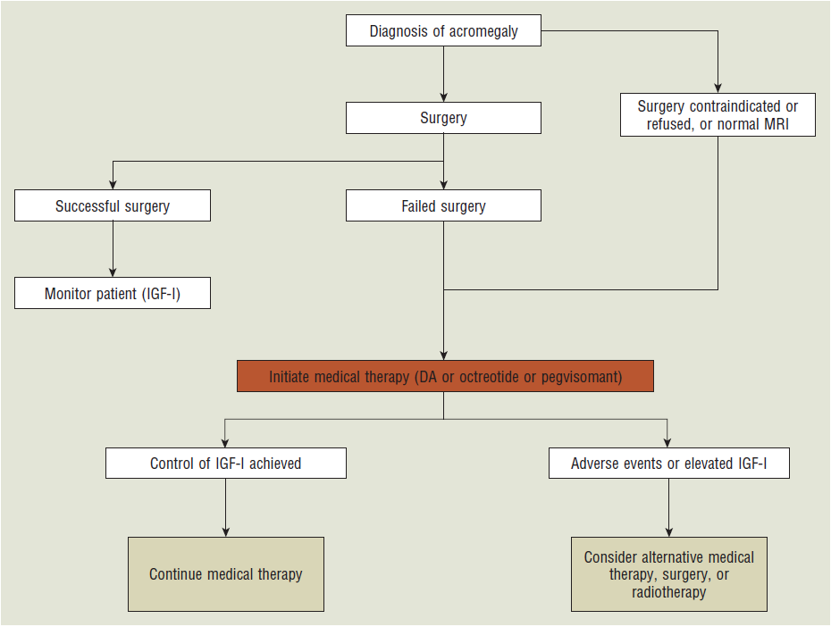

**1- Dopamine agonists:**

* In **normal** healthy adults, dopamine agonists **increase** GH production. However, for patients with acromegaly, induce **paradoxical decrease in GH production.** Most clinical experience with dopamine agonists in acromegaly is with **bromocriptine.**
* For treatment of acromegaly, bromocriptine is initiated at a dose of 1.25 mg at **bedtime** and is increased by 1.25 mg increments every 4 days as needed. Clinical studies have shown that dosages >20 or 30 mg daily do not offer additional benefits in the suppression of GH.
* When used for treatment of acromegaly, the duration of action of bromocriptine is **shorter** than that for treatment of hyperprolactinemia. Therefore, the total daily dose of bromocriptine should be divided into **three or four doses**.

**2- Somatostatin analogues:**

* **Octreotide** is a long-acting somatostatin analog that is approximately **40 times more potent** than is endogenous somatostatin.
* It is started at a dose of 50 mcg every 8 hours, then increasing the dose to 100 mcg every 8 hours after 1 week, to improve the patient’s tolerance of adverse gastrointestinal effects. The dose can be increased by increments of 50 mcg every 1 to 2 weeks based on mean serum GH and IGF-I concentrations.

**3- Growth hormone receptor antagonist:**

* **Pegvisomant** binds to GH receptors in the liver and inhibits IGF-I. It does not inhibit GH production; rather, it **blocks the physiologic effects of GH on target tissues**.
* Therefore, **GH** concentrations **remain elevated** during therapy, and response to treatment is evidenced by a reduction in IGF-I concentrations.

**GH Deficiency**

**Short stature** is a condition defined by **subnormal rate of growth** following otherwise **normal** birth weight. Normal growth is defined as more than 5 cm per year in mid-childhood. A **true lack of GH** is among the **least common** causes and is known as growth hormone deficient (GHD) short stature. It is important to exclude hypothyroidism, cushing syndrome & other cause of short stature.

Several medications such as somatostatin analogs, gonadotrophin releasing hormone (**GnRH) agonists**, glucocorticoids & cimetidine may induce GH insufficiency.

**Clinical Presentation of Short Stature:**

**General:**

Suboptimum rate of growth with **normal body proportions**.

**Signs:**

Children with GH deficient short stature may also present with central obesity, prominence of the forehead, immaturity of the face & delayed skeletal maturation.

**Laboratory tests:**

* Normal subjects show elevated GH levels following **stimulation tests**, but the **patients** will exhibit none or very small increase following this test.
* Reduced IGF-I levels may be present. Because
* GH deficiency may be **accompanied** by loss of other pituitary hormones; hypoglycemia and hypothyroidism may be noted.

**Treatment:**

1. **Recombinant GH (somatropin)** is currently considered the **mainstay** of therapy for treatment of GHD short stature by **IM** or **SC** injection. GH replacement therapy should be **initiated** as **early** as possible after diagnosis of GH insufficiency and **continued until a desirable height** is reached or growth velocity has decreased to <2.5 cm per year after the pubertal growth spurt.
2. **Recombinant IGF-I** has been recently approved by the FDA for the treatment of children with short stature due to **severe primary IGF-I deficiency** or **GH gene deletion** by neutralizing antibodies to GH.
3. **GH releasing hormone**: a synthetic GHRH product known as **sermorelin** currently is FDA approved for the treatment of idiopathic GH deficiency in children. Sermorelin is administered daily by subcutaneous injection. No serious adverse events have been identified.

**Hyperprolactinemia**

* Persistent elevation of serum **prolactin** usually affects women of **reproductive age.**
* Prolactin concentrations >20 mcg/L observed on multiple occasions are generally considered indicative of this condition.
* Hyperprolactinemia most commonly affects women and is **very rare** in men.

**Clinical Presentation of Hyperprolactinemia:**

**Signs and symptoms**

Symptoms related to **local effects** of the prolactin secreting **tumor**, such as headache and visual disturbances that result from tumor compression of the optic chiasm.

**Female** patients experience oligomenorrhea, **amenorrhea**, **galactorrhea**, **infertility**, decreased libido, hirsutism, and acne.

**Male** patients experience decreased libido, erectile dysfunction, **infertility**, **galactorrhea**, and **gynecomastia.**

**Laboratory tests:**

Prolactin serum concentrations at rest will be >20 mcg/L on multiple occasions.

**Additional clinical sequelae:**

Prolonged suppression of estrogen in premenopausal women with hyperprolactinemia leads to **decreases in bone mineral density** and significant risk for development of **osteoporosis**.

**Treatment:**

The **goal of therapy** is to normalize prolactin serum concentrations and re-establish gonadotropin secretion to restore fertility and reduce the risk of osteoporosis. The treatment of hyperprolactinemia depends on the **underlying cause**.

In **drug-induced hyperprolactinemia**, discontinuation of offending medication & initiation of an alternative usually normalizes serum prolactin concentrations.

If a therapeutic alternative does not exist, therapy with **dopamine agonists** is warranted & **sex-steroid replacement** also should be considered.

**Transsphenoidal surgery** for removal of **prolactinomas** is reserved for patients: 1) who are **refractory to or cannot** tolerate dopamine agonists and 2) for **very large tumors** that cause severe compression of adjacent tissues.

**Radiation therapy** may require several years for effective tumor shrinkage and reduction in serum prolactin concentrations and usually is used only in conjunction with surgery.

**Dopamine agonists:**

Very effective in **normalizing prolactin** serum concentrations 3 to 6 months of therapy.

**1-Bromocriptine**

* Inhibits the release of prolactin via its hypothalamic receptors. It normalizes prolactin serum levels, restores gonadotropin production, and **shrinks** pituitary **tumor size**.
* It is initiated at a dose of 1.25 to 2.5 mg once daily at bedtime to minimize adverse effects. The dose can be gradually increased by 1.25-mg increments every week. Usual therapeutic doses range from 2.5 to 15 mg/day.
* The most common adverse effects include CNS symptoms such as headache, lightheadedness, & dizziness. GI effects such as nausea, abdominal pain, and diarrhea also are common.
* Most clinicians **discontinue therapy** as soon as pregnancy is detected because the effects of bromocriptine on **gonadal function** and fertility of the offspring remain unknown.

**2- Cabergoline**

* Is a **long-acting** dopamine agonist with **high** selectivity for dopamine D2-receptors with the advantage of **less frequent dosing**
* It has replaced bromocriptine as the agent of choice. Cabergoline has proved effective in female & male patients who are intolerant or resistant to bromocriptine.
* The initial dose of **cabergoline** is 0.5 mg once weekly. This dose may be increased by 0.5-mg increments at 4-week intervals based on serum prolactin concentrations. The usual dose is 1 to 2 mg weekly; however, doses as high as 4.5 mg weekly have been used.
* The most common adverse effects are nausea, vomiting, headache, and dizziness.
* Several case reports of women who received cabergoline therapy in pregnancy have **not documented** an increased risk of spontaneous abortion or congenital abnormalities. However, prospective data in large numbers of pregnancies are lacking.

**Panhypopituitarism**

A condition of **complete (panhypopituitarism) or partial loss of anterior & posterior pituitary hormones** resulting in a complex disorder characterized by multiple pituitary hormone deficiencies

Patients with panhypopituitarism may have:

ACTH deficiency, gonadotropin deficiency, GH deficiency, hypothyroidism, and **hypo- or hyperprolactinemia**

Pharmacologic treatment of panhypopituitarism is essential and consists of **replacemen**t of specific pituitary hormones after careful assessment of individual deficiencies.

Replacement most often consists of **glucocorticoids, thyroid hormone preparations, and sex steroids.** Administration of **recombinant GH** also may be necessary.

Patients with panhypopituitarism will need lifelong replacement therapy and constant monitoring of multiple homeostatic functions.